Experiment Title: Develop a personal portfolio webpage using basic HTML and CSS

Aim:
To design and develop a personal portfolio webpage using basic HTML and CSS showcasing personal details, education, skills, projects, and contact information.
Tools Required:
- Web browser (Chrome/Firefox)
- Text editor (VS Code/Notepad++)
- GitHub (optional for hosting)
Procedure:
- Create a folder named portfolio.
- Inside the folder, create two files:
  - index.html
  - style.css
- Write the basic structure of an HTML document in index.html.
- Link the CSS file inside the HTML using the <link> tag.
- Add sections to the HTML file:
  - Header (Name, Title)
  - About Me
  - Education
  - Skills
  - Projects
  - Contact
- Style the webpage using style.css with selectors for each section.
- Save and run the HTML file in a browser.
- Verify that all sections are styled properly and display expected content.

Source Code:
index.html:
<!DOCTYPE html>
<html lang="en">
<head>
<meta charset="UTF-8">
<title>Udayakumar P | Portfolio</title>
<link rel="stylesheet" href="style.css">
</head>
<body>

<header>
<h1>Praneel Kumar Peruru</h1>
<p>Assistant Professor of CAI</p>
</header>

<section id="about">
<h2>About Me</h2>
<p>I am working as Assistant Professor in the department of CSE (AI) at MITS Deemed-To-Be-University, Madanapalle, Andhra Pradesh</p>
</section>

<section id="education">
<h2>Education</h2>
<ul>
<li>Pursuing PhD in CSE, JNTUA</li>
<li>M.Tech in Computer Science, Anna University</li>
<li>B.Tech in Computer Science, Anna University</li>
</ul>
</section>

<section id="skills">
<h2>Skills</h2>
<ul>
<li>Python, C, C++</li>
<li>Networking</li>
<li>Wordpress, HTML</li>
<li>Web Hosting</li>
</ul>
</section>

<section id="projects">
<h2>Projects</h2>
<ul>
<li>Image Processing Techniques for Smart and Healthcare systems</li>
</ul>
</section>

<section id="contact">
<h2>Contact</h2>
<p>Email: praneelkumarp@mits.ac.in</p>
<p>LinkedIn: <a href="https://linkedin.com/in/praneel-kumar-peruru">Profile</a></p>
<p>GitHub: <a href="https://github.com/praneelkumarp">Profile</a></p>
</section>

<footer>
<p>&copy; 2025 Praneel Kumar Peruru. All rights reserved.</p>
</footer>

</body>
</html>

style.css:

body {
font-family: Arial, sans-serif;
margin: 0;
background-color: #f2f2f2;
color: #333;
}

header {
background-color: #007acc;
color: white;
padding: 30px;
text-align: center;
}

section {
padding: 20px;
background-color: white;
margin: 20px;
border-radius: 10px;
box-shadow: 0 2px 5px rgba(0,0,0,0.1);
}

h2 {
color: #007acc;
}

ul {
list-style: square;
padding-left: 20px;
}

footer {
background-color: #333;
color: white;
text-align: center;
padding: 10px;
}

Expected Output:

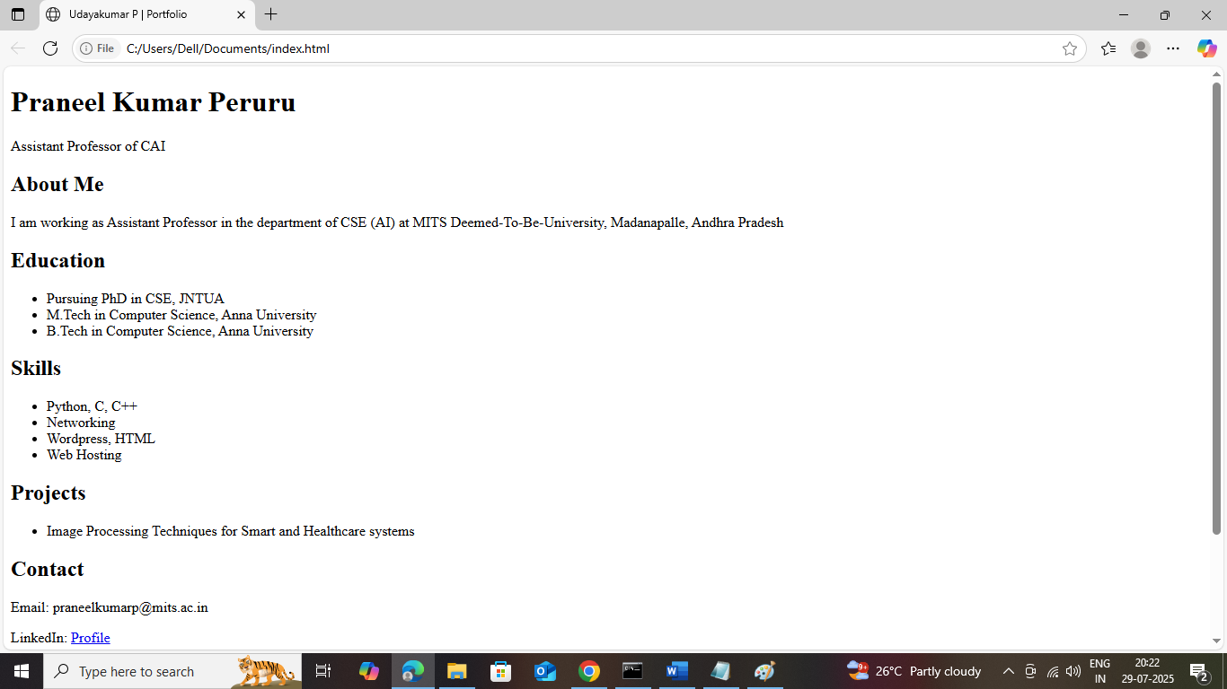
Result:
The personal portfolio webpage was successfully created using basic HTML and CSS. The webpage is structured, readable, and displays the required sections such as About, Education, Skills, Projects, and Contact.

