PHASE 1 – Creating a Custom Application
Create an Application
Project: Employee Raise Issue – Record Producer & Service Portal Integration
Documentation Type: Phase-wise Implementation Guide
Note: Screenshot placeholders are intentionally included for project evidence/documentation.

1. Objective
Create a custom ServiceNow application that provides the foundation for the Employee Raise Issue solution. The application scope will be used for the custom tables, modules, and functionality developed in later phases.

2. Application Configuration
- Application Name: Employee Center
- Application Type / Scope: Scoped
- Platform: ServiceNow App Engine / ServiceNow Studio

3. Navigation Steps
- Navigate to All → App Engine → ServiceNow Studio.
- Click Create and select App.
- Enter Employee Center as the application name.
- Select Scoped as the application scope.
- Click Continue.
- Return to the application home page and reload the page.
- Verify that Employee Center appears as the current application.

ServiceNow Studio – Create Application
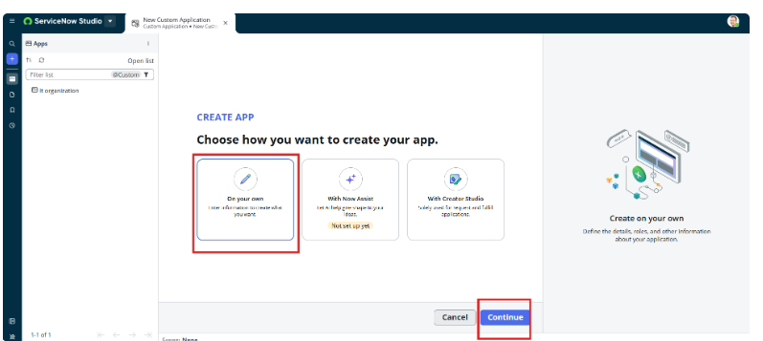


4. Expected Result
The Employee Center scoped application is created successfully and is available as the current application for subsequent development.

