PHASE 2 – Creating a Custom Table and Fields
Employee Raise Issue Table and Fields
Project: Employee Raise Issue – Record Producer & Service Portal Integration
Documentation Type: Phase-wise Implementation Guide
Note: Screenshot placeholders are intentionally included for project evidence/documentation.

1. Objective
Create a custom table to store employee-raised issues and define the fields required to capture requester, category, subcategory, description, state, priority, and assignment information.

2. Create the Custom Table
- Navigate to System Definition → Tables.
- Click New in the top-right corner.
- Set Label to Employee raises issue.
- The table Name will be generated automatically.
- Under Controls, enable Auto number.
- Save the table using the form/context menu.

Employee Raise Issue – Table Creation
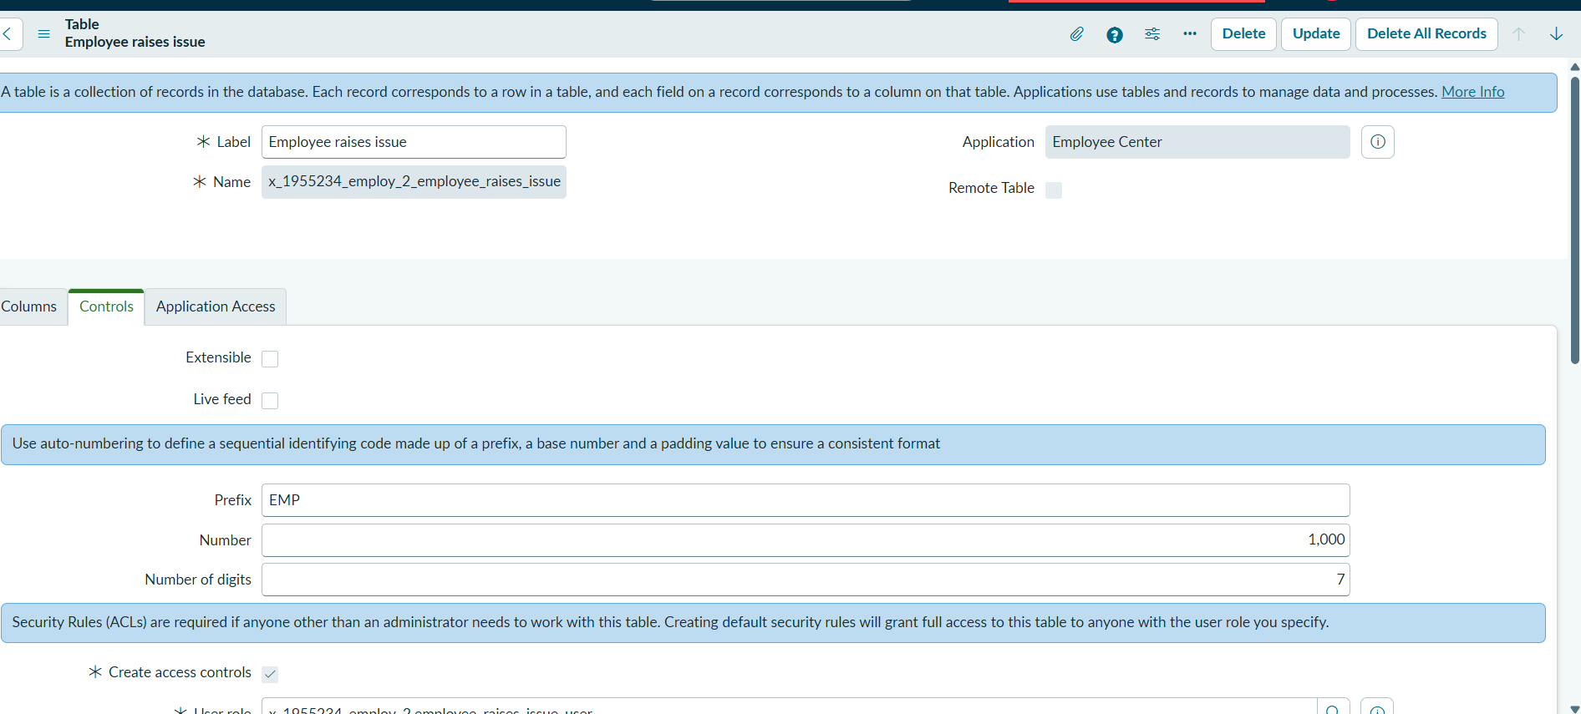

3. Configure Fields
Open the table form. Under Related Links, select Show Form. Use Configure → Form Design to create the required fields.
Field Label | Type | Configuration / Notes
Number | Auto-Number | Automatically generated record number.
Requester | Reference | Reference to sys_user table.
Category | Choice | Network, Hardware, Software, Access.
Subcategory | Choice | VPN, Laptop, Server, Forgot password.
Short description | String | Short description of the issue.
State | Choice | New, In progress, Resolved, Closed.
Priority | Choice | Critical, High, Medium, Low.
Assignment Group | Reference | Reference to sys_user_group table.
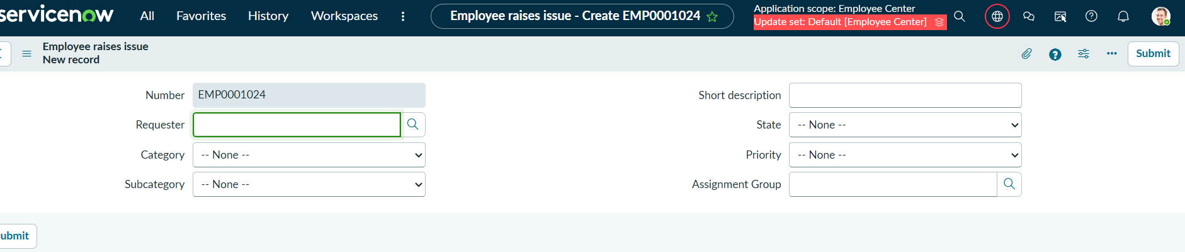

Employee Raise Issue – Choice and Reference Fields
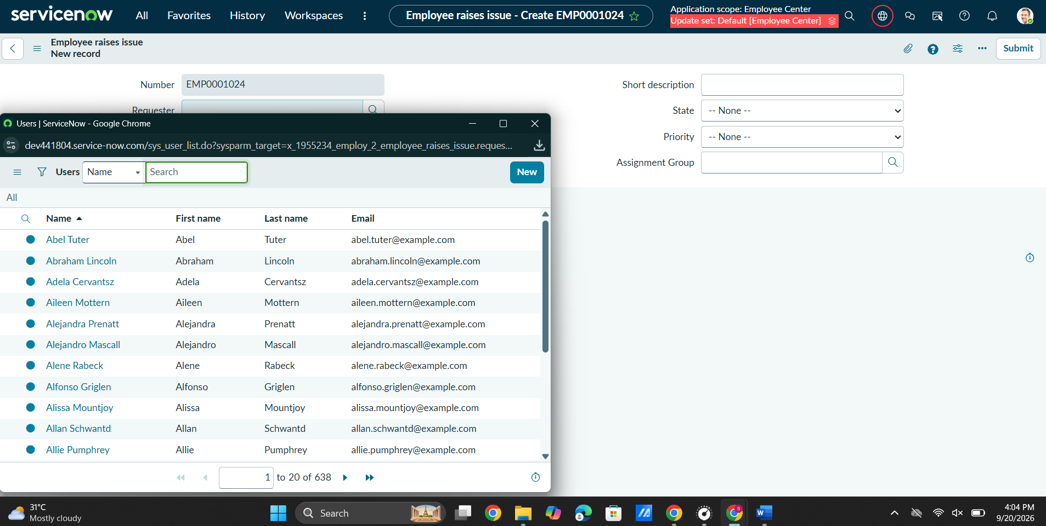

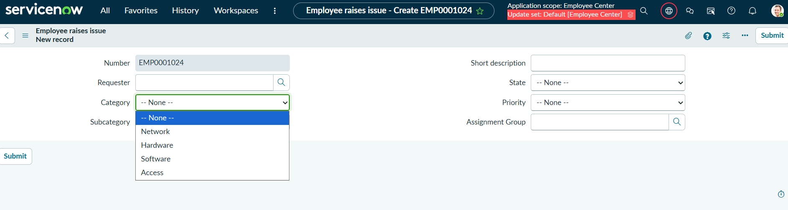

The custom Employee Raise Issue table is created with all required fields and reference/choice configurations.

