PHASE 3 – Creating UI Policies and Dependency
Dynamic Form Behavior
Project: Employee Raise Issue – Record Producer & Service Portal Integration
Documentation Type: Phase-wise Implementation Guide
Note: Screenshot placeholders are intentionally included for project evidence/documentation.

1. Objective
Configure UI Policies and a dependent choice relationship so the Employee Raise Issue form dynamically enforces field behavior and displays appropriate subcategory choices.

2. UI Policy – Short Description Mandatory
- Navigate to All → search for UI Policies.
- Click New.
- Set Table to Employee Raise Issue.
- Set Short description to: When the state changes to New, short description is mandatory.
- Set the condition: State is New.
- Save the UI Policy.
- Under UI Policy Actions, click New.
- Select Field = Short description.
- Set Mandatory = True.
- Leave Visible and Read only unchanged.
- Submit the action and update the UI Policy.
- Open the form, reload it, select State = New, and verify that Short description becomes mandatory.
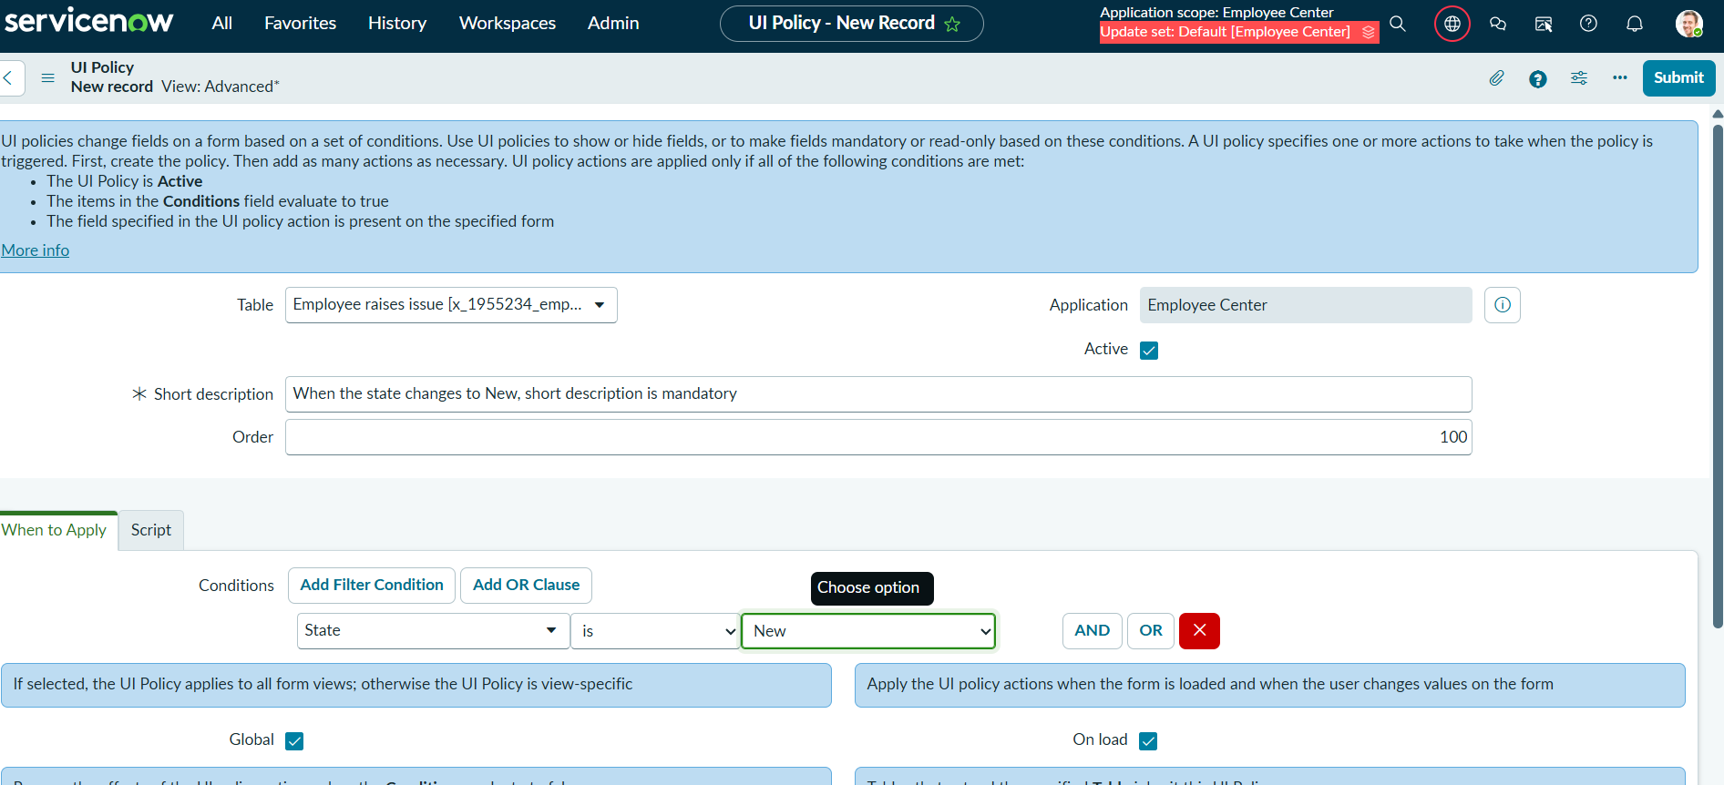
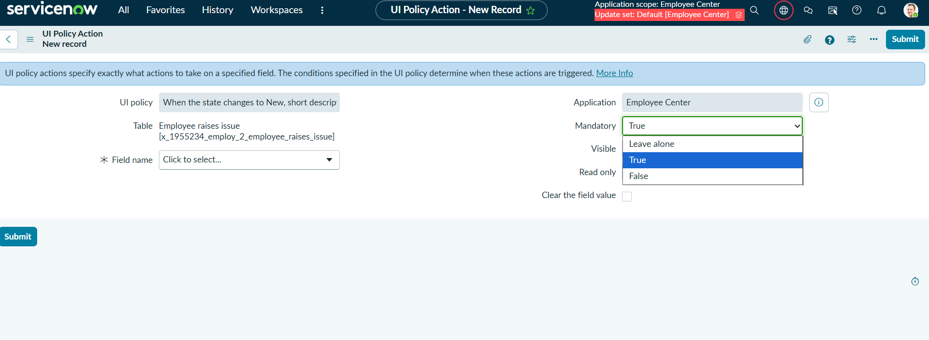

3. UI Policy – Number Field Read Only
- Create another UI Policy for Employee Raise Issue.
- Set the Short description/name to indicate that the Number field is read only.
- Do not apply a filter condition.
- Save the policy.
- Under UI Policy Actions, create a new action.
- Select Field = Number.
- Set Read only = True.
- Leave Mandatory and Visible unchanged.
- Submit and update the policy.
- 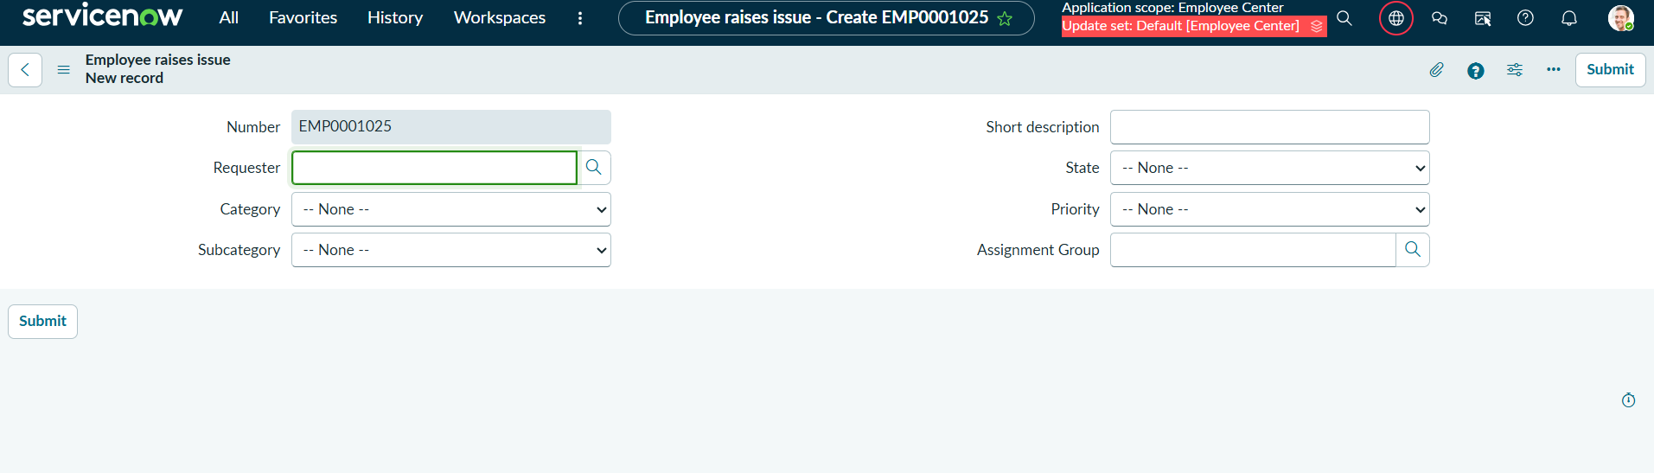

4. Configure Dependent Choice – Subcategory Based on Category
- Open the Employee Raise Issue table form.
- Right-click the Subcategory field and select Configure Dictionary.
- Open Advanced view from Related Links.
- Set the dependent field to Category.
- Open the Choice section from Related Links.
- Configure the backend choice values for Subcategory.
Category | Subcategory
Network | VPN
Hardware | Laptop
Software | Server
Access | Forgot password

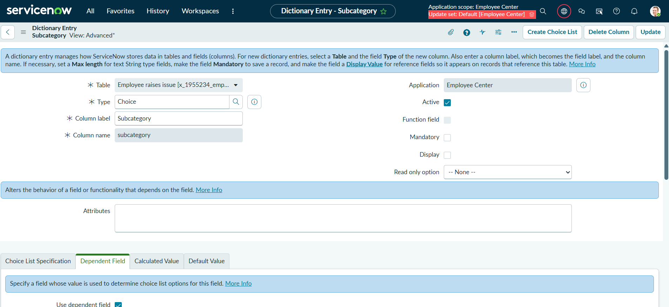

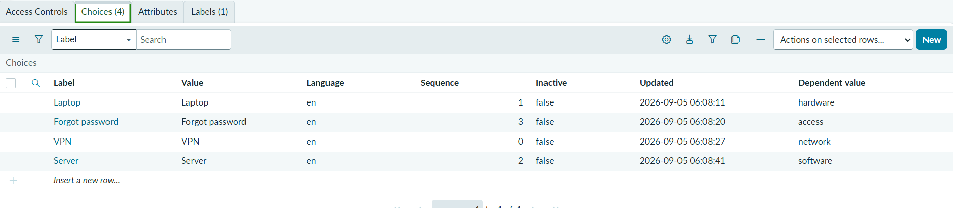5. Expected Result
The form dynamically enforces the configured UI rules, the Number field is read only, Short description becomes mandatory for State = New, and Subcategory choices are filtered based on Category.

