PHASE 4 – Creating a Record Producer
Raise Employee Issue Record Producer
Project: Employee Raise Issue – Record Producer & Service Portal Integration
Documentation Type: Phase-wise Implementation Guide
Note: Screenshot placeholders are intentionally included for project evidence/documentation.

1. Objective
Create a Record Producer that allows employees to submit Employee Raise Issue records through a simple Service Portal interface. Variables are mapped directly to fields in the Employee Raise Issue table.

2. Record Producer Configuration
- Navigate to All → Service Catalog → Catalog Definition → Record Producers.
- Click New.
- Name: Raise Employee Issue.
- Table: Employee Raise Issue.
- Enter a suitable description in What it will contain.
- In Accessibility, select Catalog = Service Catalog.
- Set Category = Service.
- Add an appropriate image in the Picture field.
- Enter the table name as the Meta name, where required.
- Save the Record Producer.
Record Producer – Basic Configuration
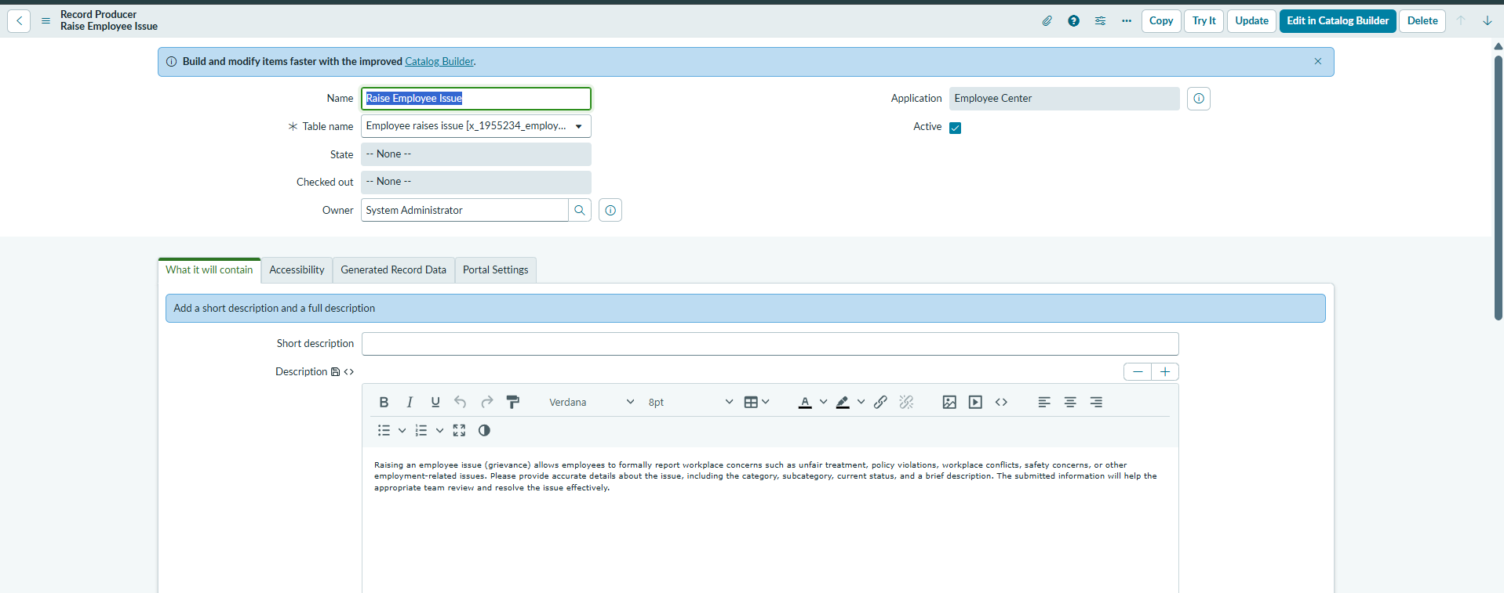

3. Create Variables
Under Related Links, open Variables and create the following five variables. Enable Map to Field and select the corresponding target field.
Variable / Question | Type | Mapped Field | Order
What is the Requester name | Reference (sys_user) | Requester | 100
Which Category | Choice | Category | 200
What is Subcategory | Choice | Subcategory | 300
Which State is this issue | Choice | State | 400
Short description | Single Line Text / String | Short description | 500

4. Choice Values
- Category: Network, Software, Hardware, Access.
- Subcategory: VPN, Laptop, Server, Forgot password.
- State: New, In progress, Resolved, Closed.
Record Producer – Variables
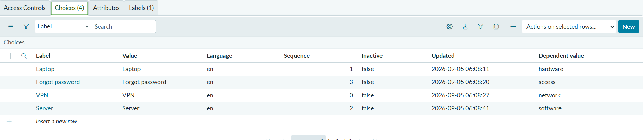
Record Producer – Variable Mapping
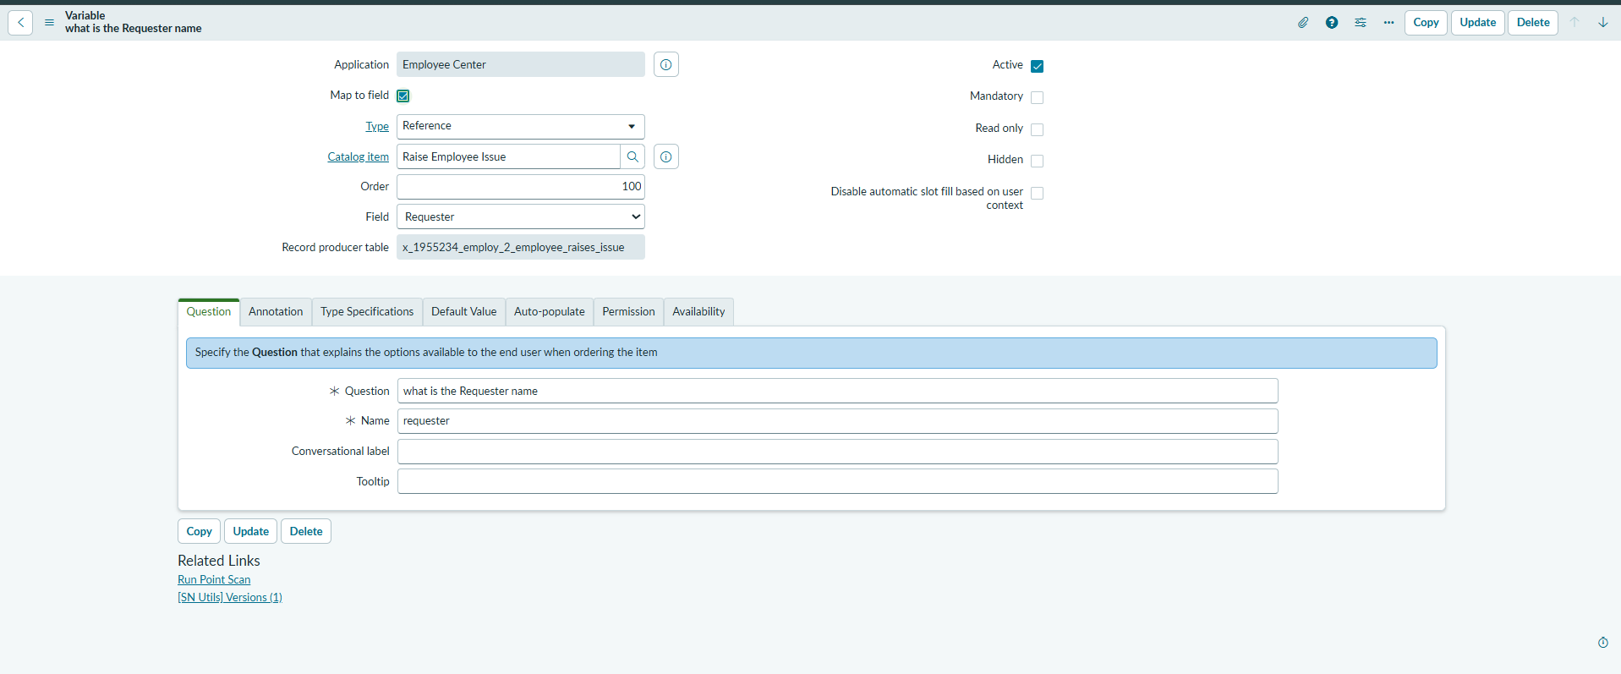

5. Service Portal Verification
Open the ServiceNow instance with the Service Portal suffix (for example, add /sp to the instance URL) and search for the Record Producer/table to verify how the catalog item is displayed.
Record Producer Displayed in Service Portal
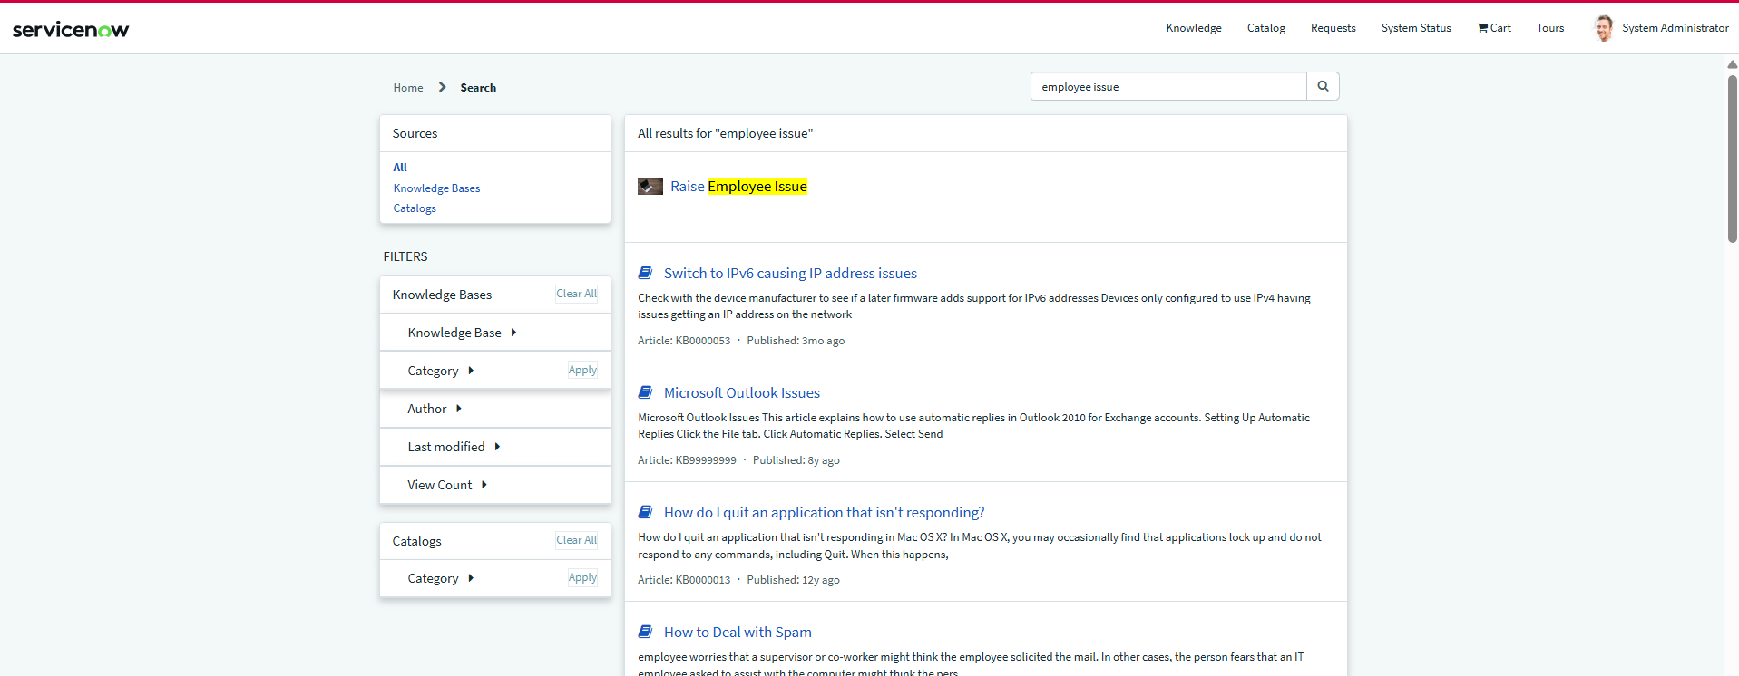

6. Expected Result
Employees can access Raise Employee Issue, enter the required information, and submit the form. The mapped variables create a record in the Employee Raise Issue table.
