PHASE 5 – Creating a New Service Portal
Requesting Portal and Employee Center Portal Page
Project: Employee Raise Issue – Record Producer & Service Portal Integration
Documentation Type: Phase-wise Implementation Guide
Note: Screenshot placeholders are intentionally included for project evidence/documentation.

1. Objective
Create a dedicated Service Portal where employees can access the Raise Employee Issue Record Producer through a user-friendly interface.

2. Create the Service Portal
- Navigate to Service Portal → Service Portal Configuration.
- Open Service Portals and click New.
- Title: Requesting portal.
- URL suffix: employee_request.
- Homepage: ec_standard_home.
- KB home page: esc_knowledge_home.
- Login page: login.
- Upload an appropriate logo.
- Main menu: Employee Center Menu.
- 404 Page: 404.
- Theme: Employee Center Coral Theme.
- Save the portal.
Service Portal – Requesting Portal Configuration
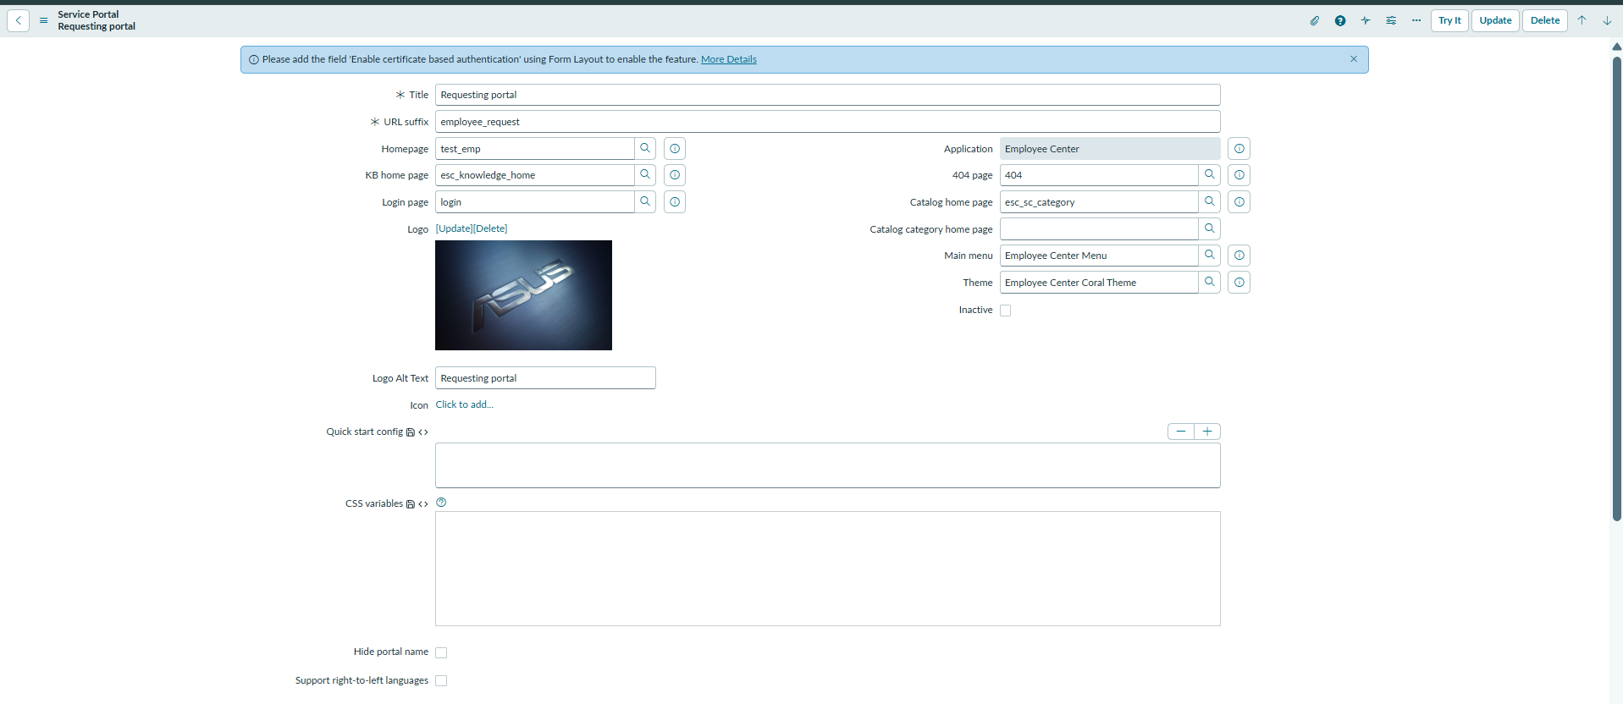

3. Create Employee Center Portal Page
- Navigate to All → Service Portal.
- Select Pages.
- Click New.
- Title: Employee Center Portal Page.
- ID: employee_center_portal_page.
- Save the page using the context menu.
Employee Center Portal Page – Page Configuration
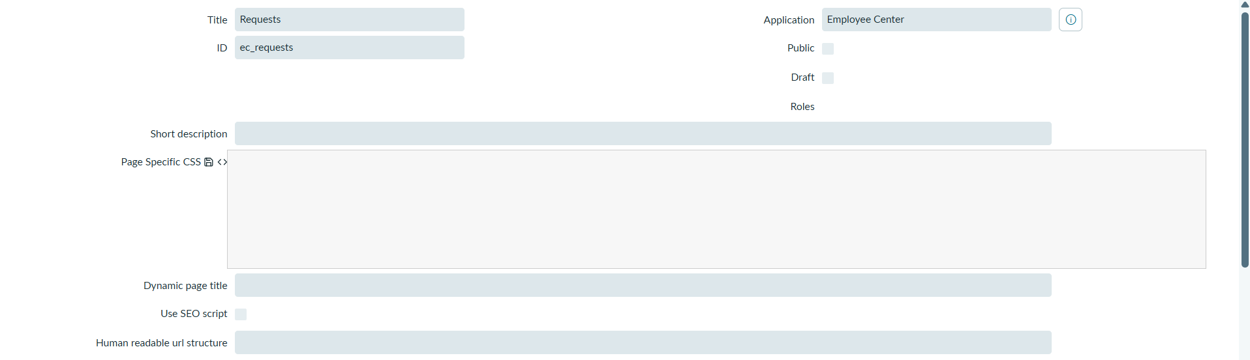

4. Expected Result
A dedicated employee_request portal is created, along with a custom Employee Center Portal Page that can be used for the widget-based user interface.

