PHASE 6 – Creating Widgets and Adding to the Page
Custom Service Portal Widgets
Project: Employee Raise Issue – Record Producer & Service Portal Integration
Documentation Type: Phase-wise Implementation Guide
Note: Screenshot placeholders are intentionally included for project evidence/documentation.

1. Objective
Create custom Service Portal widgets and place them on the Employee Center Portal Page. One widget provides service information and another provides a direct link to the Raise Employee Issue Record Producer.

2. Widget 1 – Commercial Widget
- Navigate to Service Portal Configuration → Service Portals → Widget Editor.
- Click Create a new widget.
- Name the widget Commercial widget.
- Click Submit.
- Enable the required HTML and CSS templates.
- Use Preview to verify the widget appearance.

HTML
<div class="commercial-widget">
<h2>Our Commercial Services</h2>
<p>We provide end-to-end IT services, support, and issue resolution
through a streamlined Service Portal experience.</p>
<ul>
<li>✔ 24/7 Customer Support</li>
<li>✔ Faster Issue Resolution</li>
<li>✔ Transparent Tracking</li>
<li>✔ Secure & Reliable</li>
</ul>
</div>
Commercial Widget – Preview
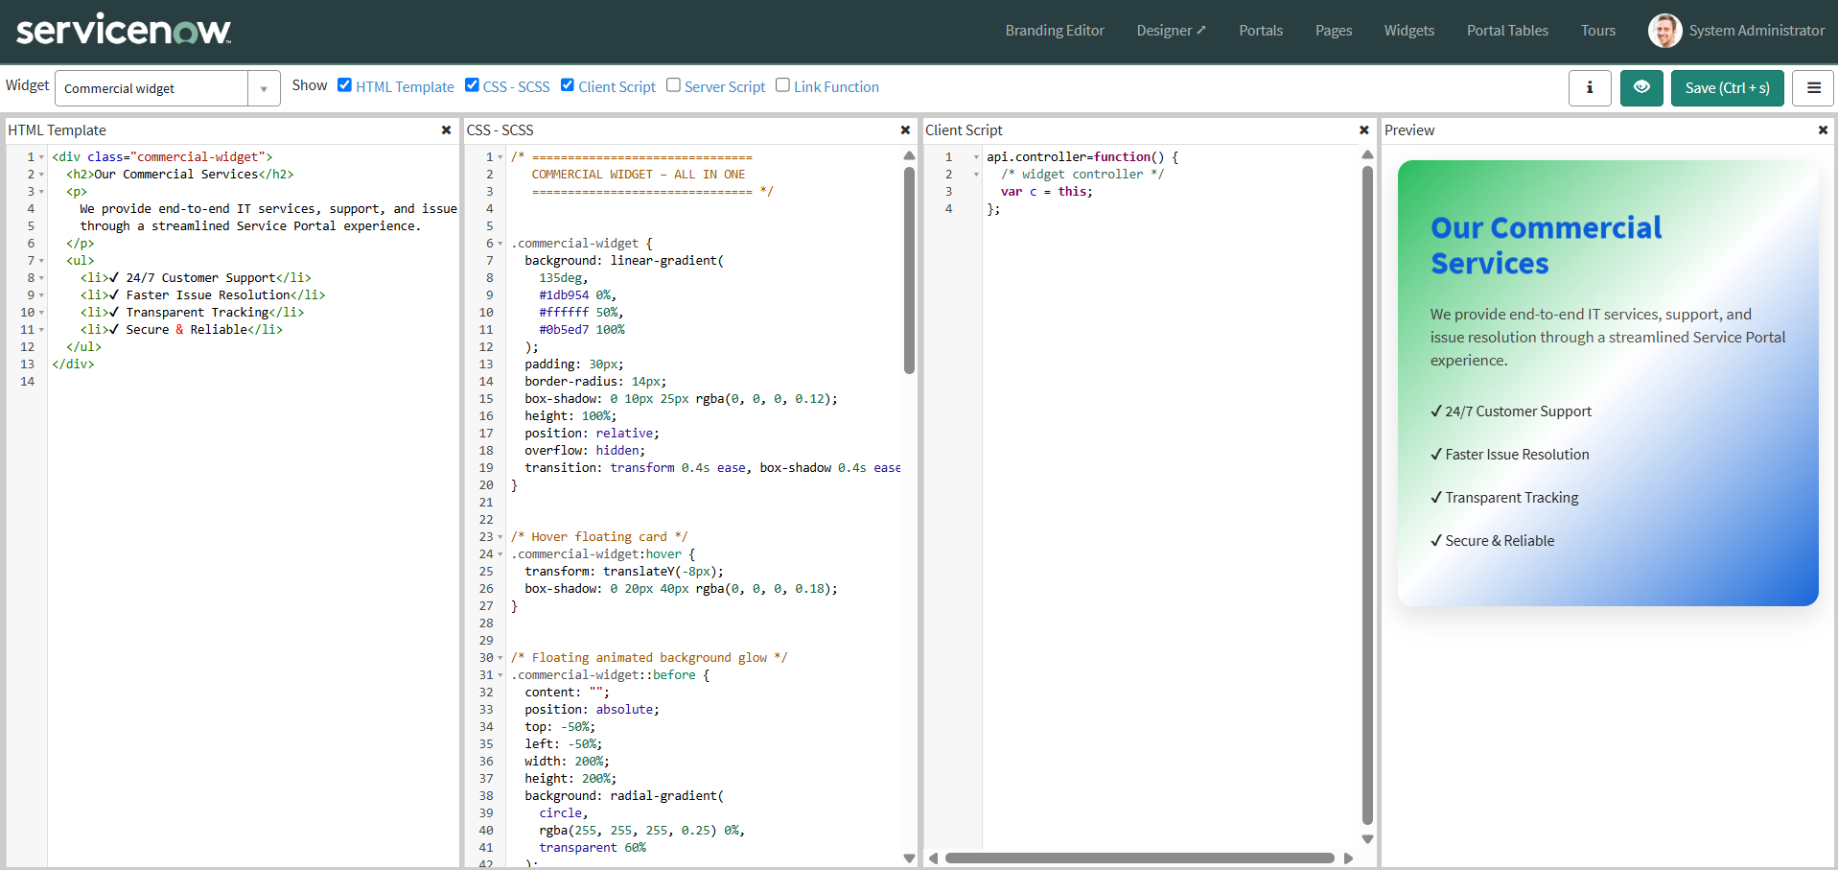

3. Widget 2 – Link Redirect / Raise Ticket Widget
- Open Widget Editor and create a new widget.
- Name: Link redirect.
- Enable HTML, CSS, and Client Script.
- Use the Client Script to navigate to the Record Producer using its sys_id.
- Enable Preview and verify the widget.

HTML
<a href="javascript:void(0)" class="raise-ticket-widget"
ng-click="c.openRecordProducer()">
<div class="overlay">
<h2>Raise an Issue</h2>
<p>Submit your request or complaint</p>
<span class="premium-btn">Raise Ticket →</span>
</div>
</a>

CSS
/* Raise Ticket Widget – add the provided styling in the widget CSS section.
Use the supplied background image, overlay, hover, button, glow animation,
and responsive visual styling from the project implementation. */

Client Script
function ($scope, $location) {
var c = this;
var RECORD_PRODUCER_SYS_ID = 'PASTE_YOUR_RECORD_PRODUCER_SYS_ID_HERE';
c.openRecordProducer = function () {
$location.url(
'sp?id=sc_cat_item&sys_id=' + RECORD_PRODUCER_SYS_ID
);
};
}
Important: Replace PASTE_YOUR_RECORD_PRODUCER_SYS_ID_HERE with the sys_id of your own Raise Employee Issue Record Producer.
Link Redirect Widget – HTML/CSS/Client Script
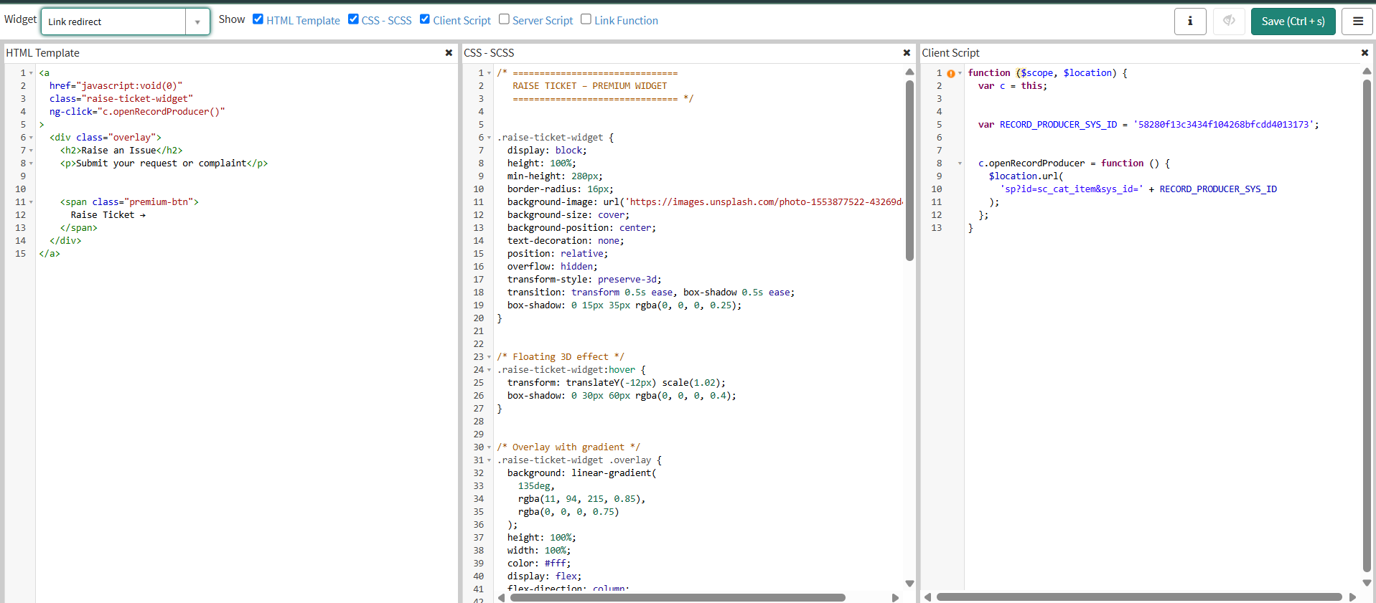
Link Redirect Widget – Preview

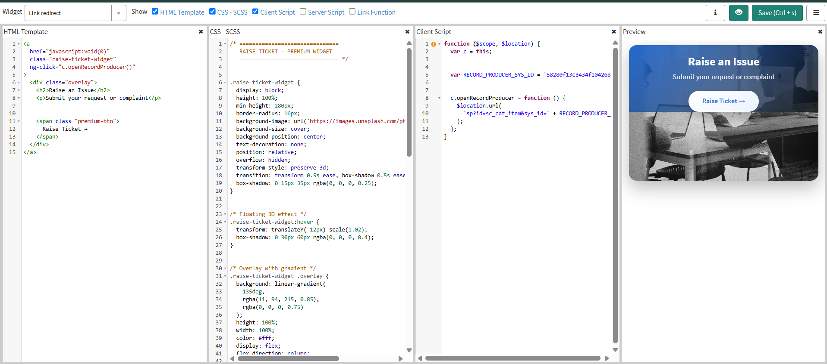

4. Add Widgets to the Portal Page
- Navigate to Service Portal Configuration.
- Open the Designer.
- Search for and select the Employee Center homepage / required Employee Center Portal Page.
- Create a container with the required 6 × 6 layout.
- Search for the created widgets.
- Drag and drop the Commercial widget and Link redirect widget into the desired columns.
- Save and preview the page.
Service Portal Designer – Widget Placement
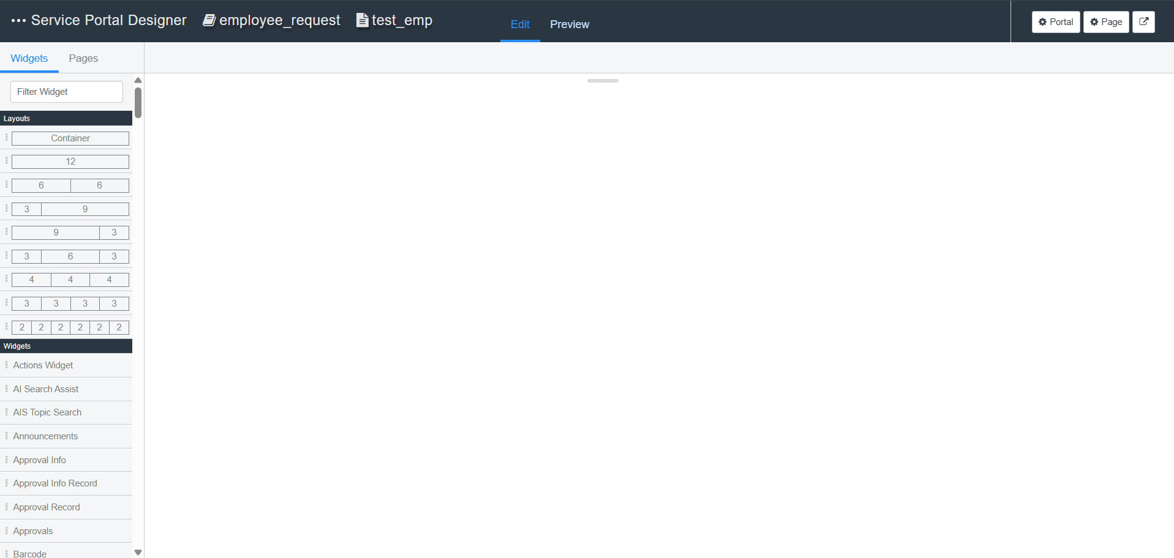
Employee Center Portal Page – Final Widget Layout
