PHASE 7 – Testing and Validation
End-to-End Testing
Project: Employee Raise Issue – Record Producer & Service Portal Integration
Documentation Type: Phase-wise Implementation Guide
Note: Screenshot placeholders are intentionally included for project evidence/documentation.

1. Objective
Validate the complete Employee Raise Issue solution from the Service Portal through Record Producer submission and verify that the configured table fields, UI Policies, and dependency behavior work correctly.

2. Open the Portal
- Open a new browser tab.
- Navigate to the configured portal URL, for example: https://<your-instance>/employee_request.
- Verify that the portal loads successfully.
- Confirm that the configured logo, image, theme, menu, and homepage are displayed.
Employee Request Portal – Home Page
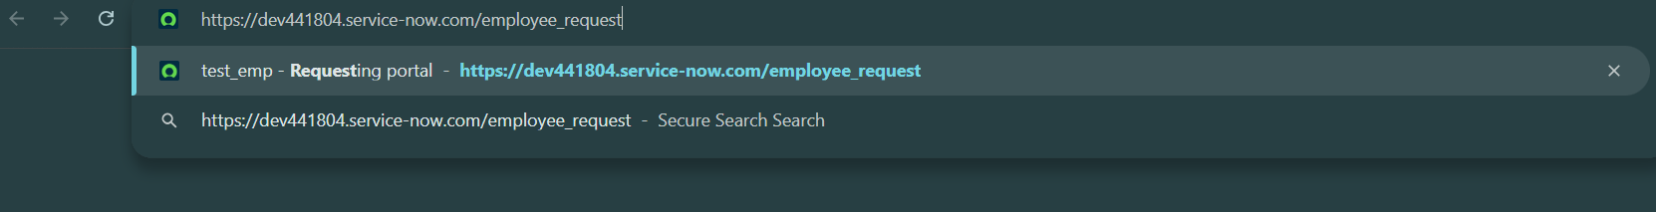

3. Validate Custom Widgets
- Scroll to the widget section.
- Move the cursor over the widgets and verify the hover/floating effects.
- Click the Raise Ticket button.
- Verify that the Employee Raise Issue Record Producer opens.
Portal – Commercial Widget
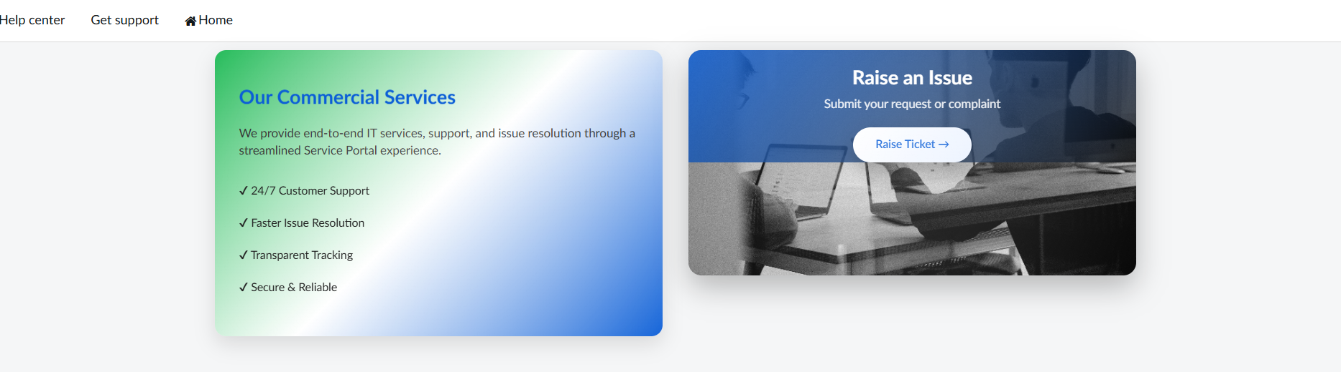
Portal – Raise Ticket Widget
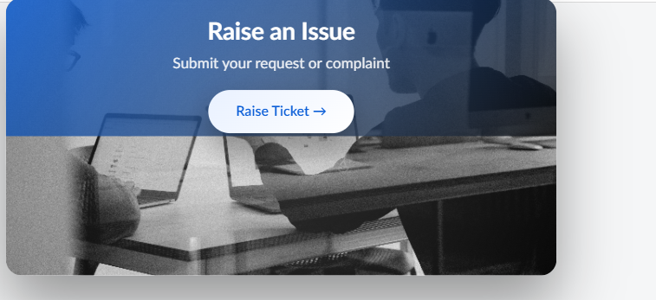

4. Validate Record Producer
- Enter or select the Requester.
- Select a Category.
- Verify that Subcategory options change according to the selected Category.
- Select the required State.
- Enter a Short description.
- Submit the Record Producer.
- Verify that the Employee Raise Issue record is created.
Record Producer – Data Entry
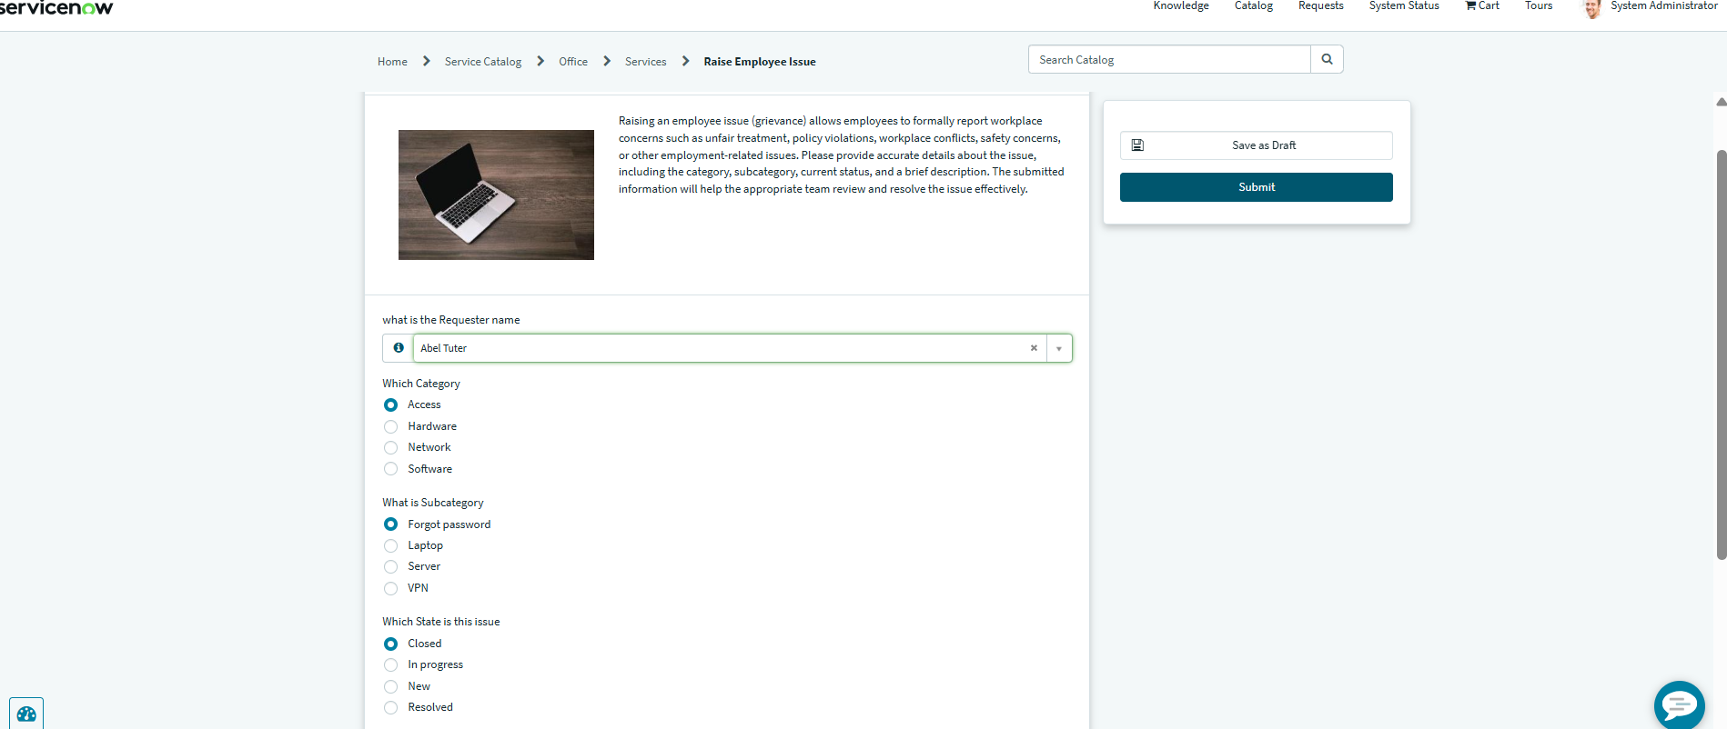
Record Producer – Dependent Subcategory Validation

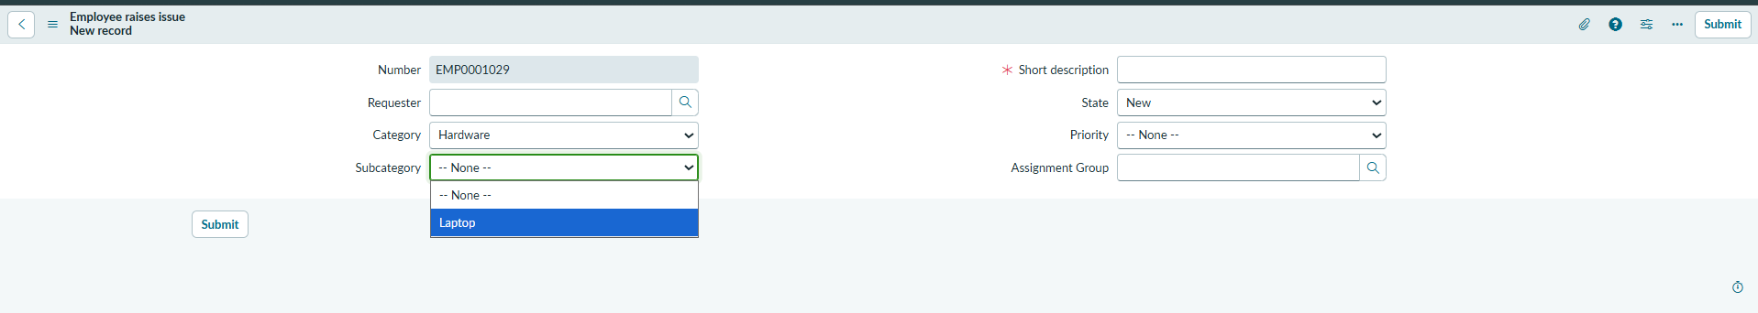
Record Created – Employee Raise Issue Table
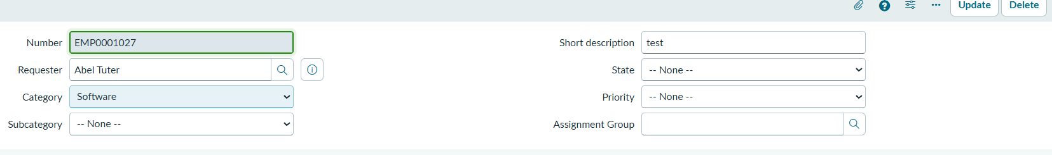

5. Validate UI Policies
- Set State to New and verify that Short description becomes mandatory.
- Verify that the Number field is read only.
- Verify that the form behavior matches the configured UI Policies.
UI Policy – Mandatory Short Description
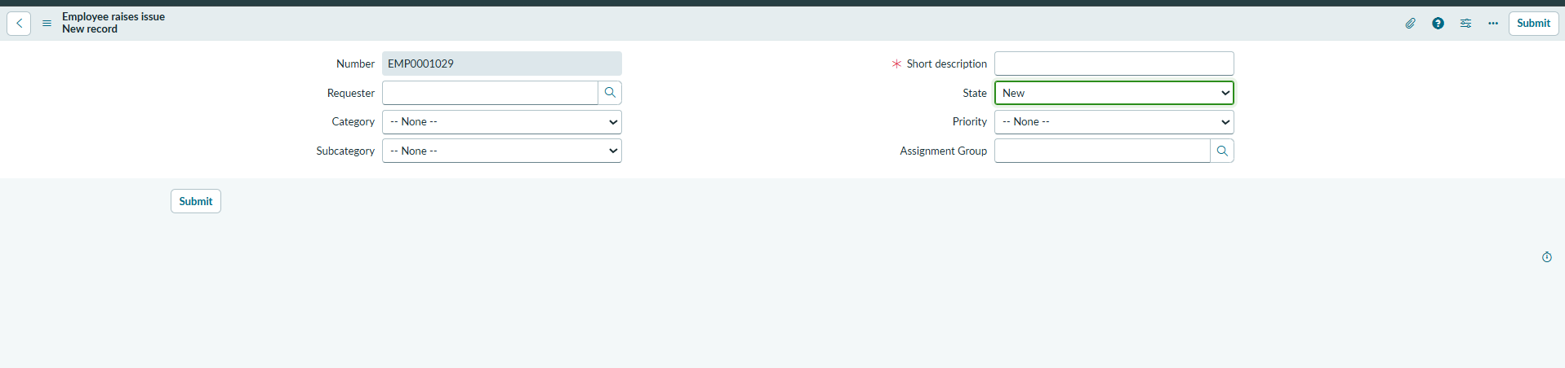

Number Field – Read Only

