PHASE 2 – CREATING A CUSTOM TABLE AND FIELDS
Employee Raise Issue – Record Producer & Service Portal Integration

Description
This phase creates a custom table to store employee-raised issues with structured fields, choice controls, and reference relationships.

1. Create the Employee Raise Issue Table
- Navigate to Tables.
- Under System Definition, open Tables.
- Click New in the top-right corner.
- Set Label to Employee raises issue.
- Allow the Name field to auto-populate.
- Under Controls, enable Auto number.
- Save the form using the context menu.

2. Create Fields Using Form Design
- Under Related Links, click Show Form.
- Open the context menu.
- Select Configure → Form Design.
- Create the required fields with the specified labels and types.
- Save the form after adding all fields.

Configuration / Field Details
Field / Configuration | Value
Number | Auto-Number
Requester | Reference – sys_user
Category | Choice – Network, Hardware, Software, Access
Subcategory | Choice – VPN, Laptop, Server, Forgot password
Short description | String
State | Choice – New, In progress, Resolved, Closed
Priority | Choice – Critical, High, Medium, Low
Assignment Group | Reference – sys_user_group
New Employee Raise Issue Table
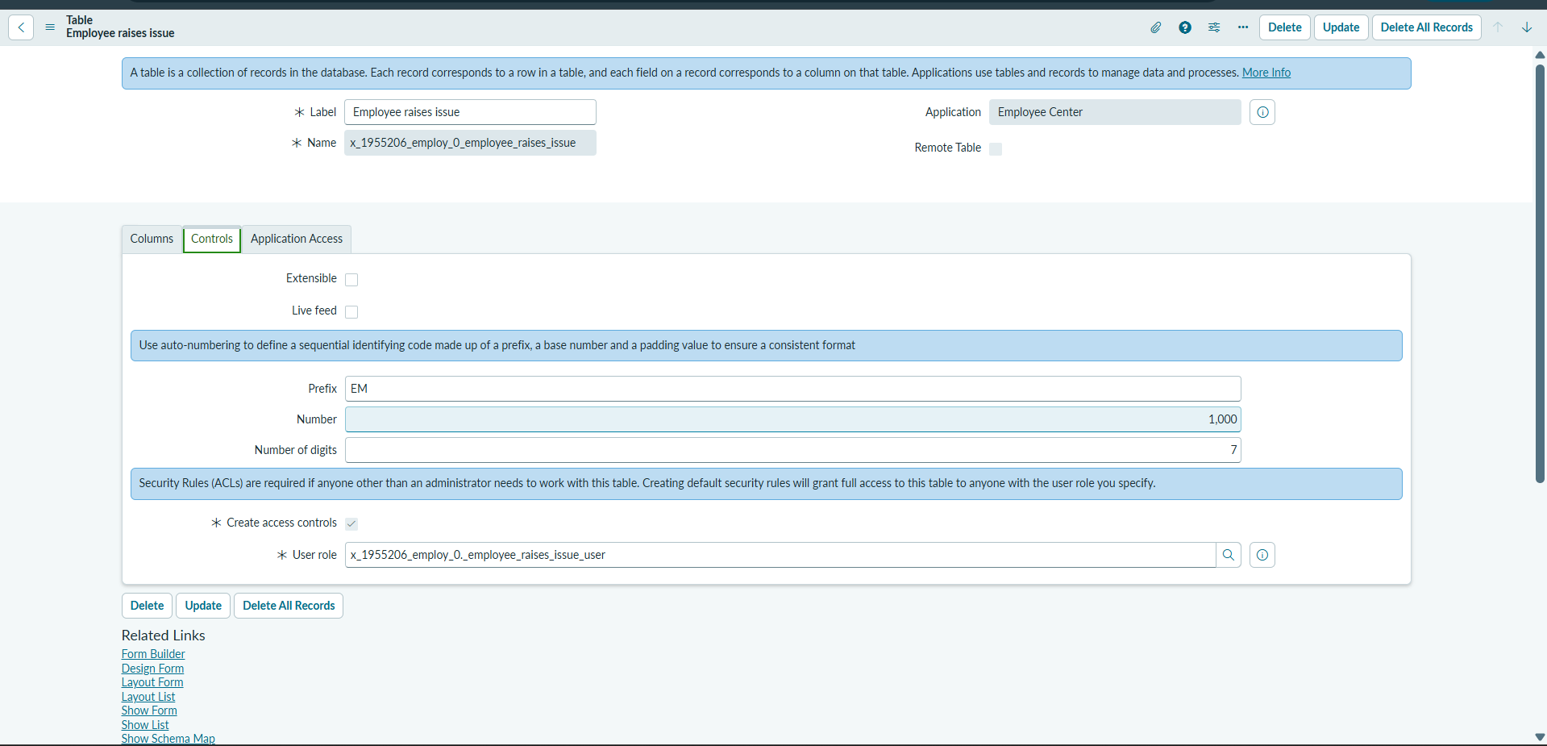

Employee Raise Issue Table – Fields
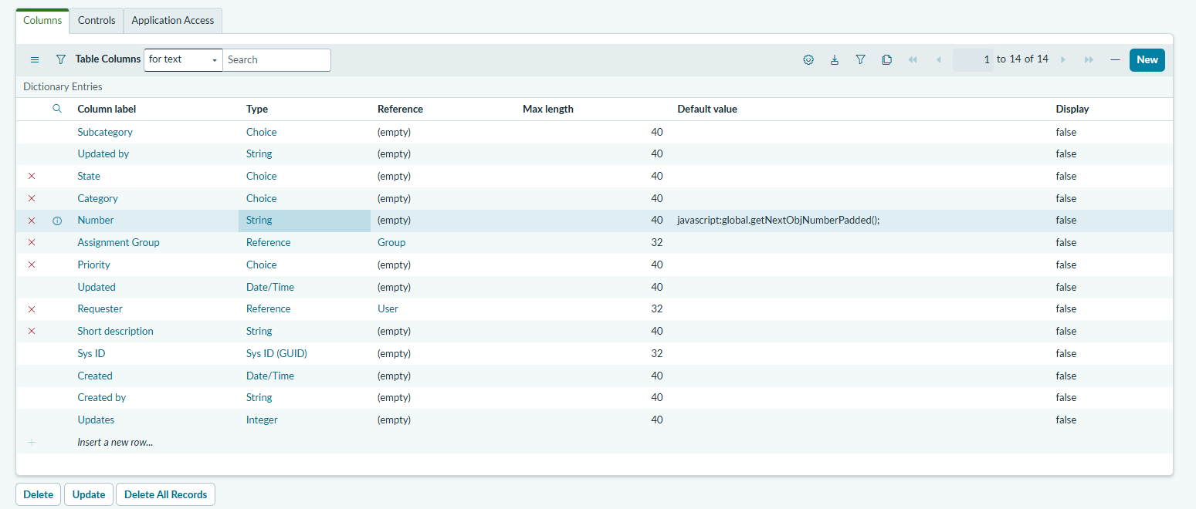

Employee Raise Issue Form 