PHASE 3 – CREATING UI POLICIES AND DEPENDENCY
Employee Raise Issue – Record Producer & Service Portal Integration

Description
This phase controls form behavior dynamically based on user input. UI Policies make fields mandatory or read-only, while the dependent choice relationship controls which Subcategory values are displayed.

1. UI Policy – Short Description Mandatory
- Go to All menus → search UI Policies.
- Click New.
- Table: Employee Raise issue.
- Set the condition: State is New.
- Save the UI Policy.
- Under UI Policy Actions, click New.
- Field: Short description.
- Mandatory: True.
- Leave Visible and Read only unchanged.
- Submit the action and update the UI Policy.
- Open the form, reload it, select State = New, and verify that Short description becomes mandatory.

2. UI Policy – Number Read Only
- Navigate to UI Policies and click New.
- Table: Employee Raise issue.
- Short description: Number field will be read only.
- Do not apply a filter condition.
- Save the UI Policy.
- Under UI Policy Actions, click New.
- Field: Number.
- Read only: True.
- Leave Mandatory and Visible unchanged.
- Submit and update the UI Policy.

3. Create Category → Subcategory Dependency
- Open the Employee Raise Issue table form.
- Right-click the Subcategory field and select Configure Dictionary.
- Open the Advanced view.
- Set the Dependent field to Category.
- Under Related Links, open the Choices section.
- Configure Subcategory choices with the appropriate backend values.
- Test that the displayed Subcategory depends on the selected Category.

Configuration / Field Details
Field / Configuration | Value
Network | VPN
Hardware | Laptop
Software | Server
Access | Forgot password

UI Policy – State is New
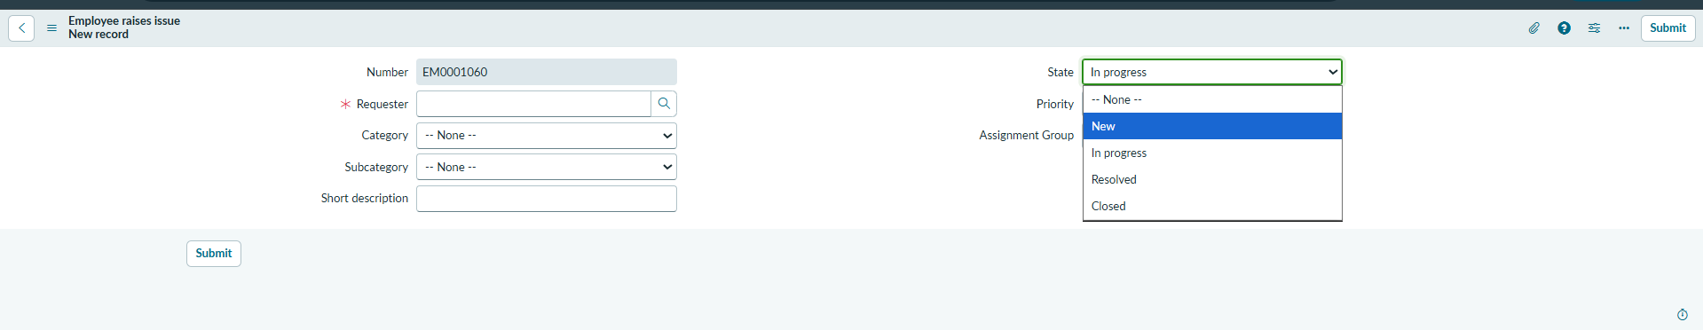

UI Policy Action – Short Description Mandatory
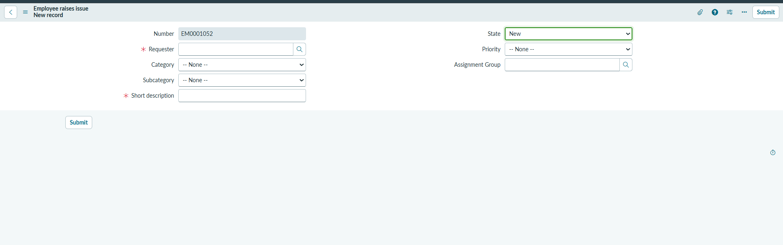

UI Policy – Number Read Only
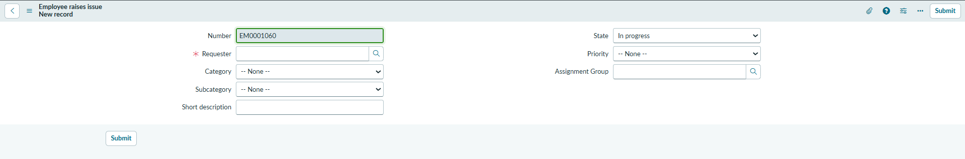

Dictionary – Dependent Field Configuration
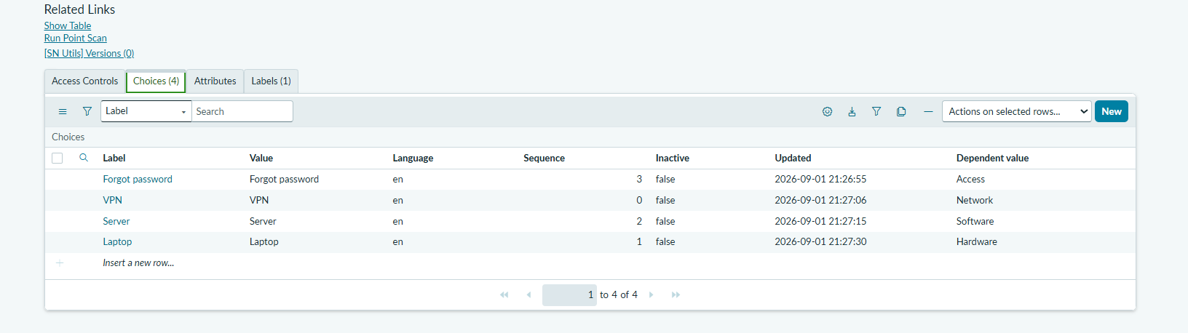

Category and Subcategory Dependency on Form
