PHASE 4 – CREATING A RECORD PRODUCER
Employee Raise Issue – Record Producer & Service Portal Integration

Description
This phase creates a Record Producer that allows employees to submit Employee Raise Issue requests from the Service Portal. Variables are mapped to fields in the target table so that submissions create backend records automatically.

1. Create the Record Producer
- Navigate to All menus → Service Catalog → Catalog Definition → Record Producers.
- Click New.
- Name: Raise Employee Issue.
- Table: Employee Raise issue.
- Enter a suitable description in What it will contain.
- Catalog: Service Catalog.
- Category: Service.
- Add an image in the Picture field.
- Set the Meta name to the table name as required.
- Save the Record Producer.

2. Create and Map Variables
- Under Related Links, open the Variables section and click New.
- Choose the variable type based on the target table field.
- Enable Map to Field.
- Select the corresponding target field.
- Use order values such as 100, 200, 300, 400 and 500.
- Enter the Question text; Name is generated automatically.
- Create five variables and save them.

Configuration / Field Details
Variable | Type | Mapped Field / Notes
What is the Requester name | Reference | Requester / sys_user
Which Category | Choice | Category – Network, Software, Hardware, Access
What is Subcategory | Choice | Subcategory – VPN, Laptop, Server, Forgot password
Which State is this issue | Choice | State – New, In progress, Resolved, Closed
Short description | Single line text | Short description / String
Record Producer – Basic Configuration
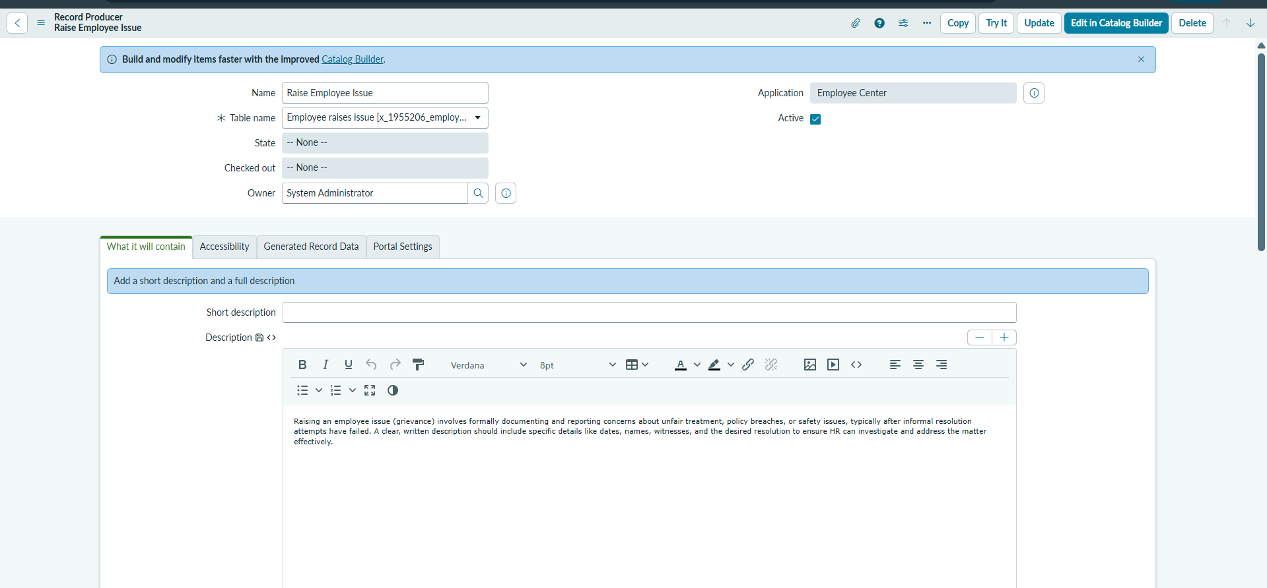

Record Producer Variables
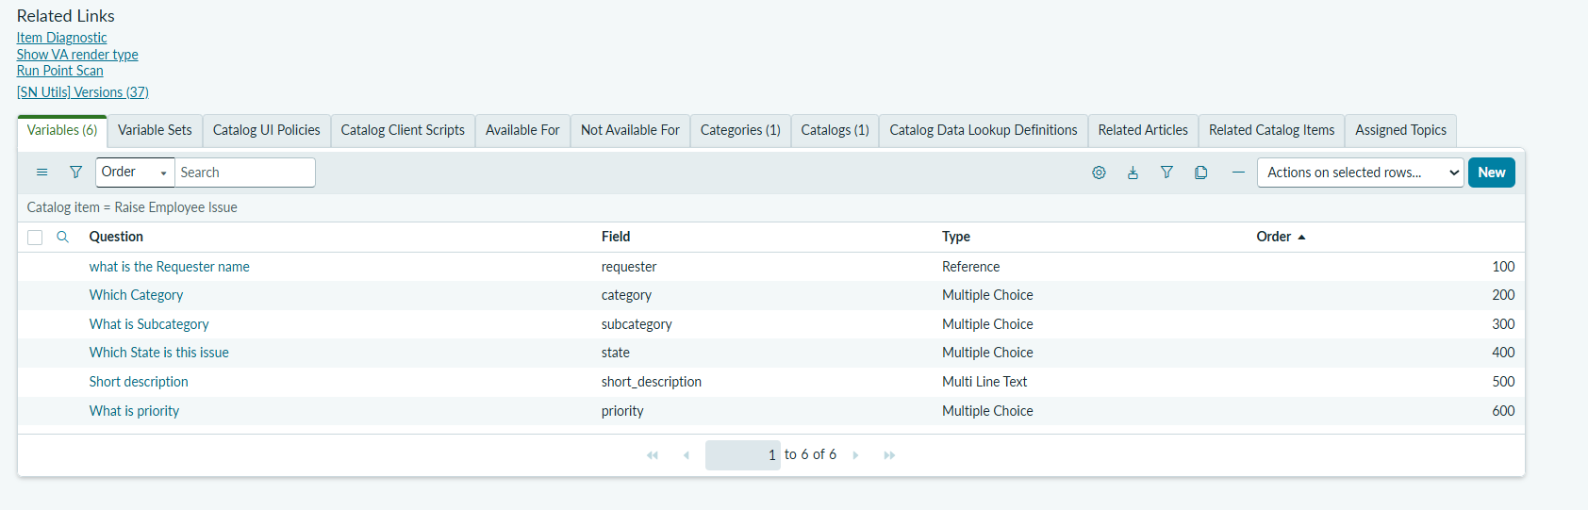

Variable Mapping to Employee Raise Issue Fields
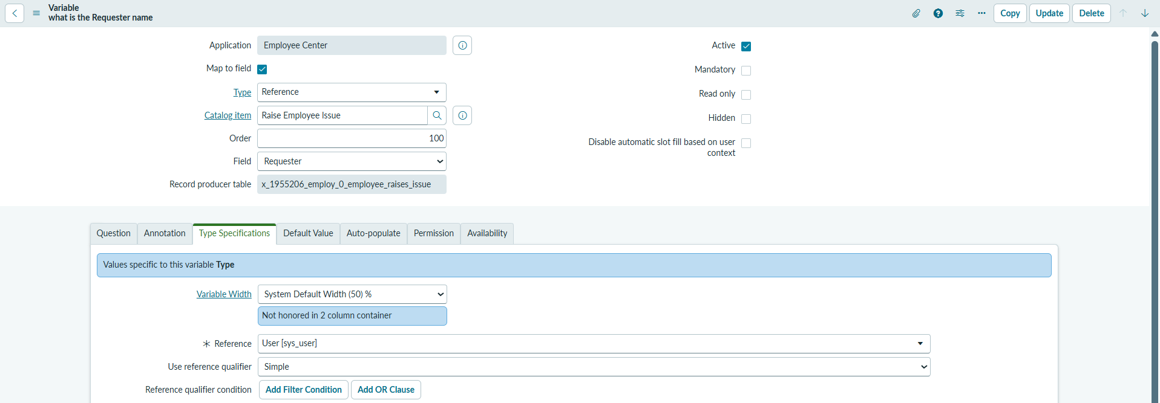

Raise Employee Issue Record Producer on Service Portal
