PHASE 5 – CREATING A NEW SERVICE PORTAL
Employee Raise Issue – Record Producer & Service Portal Integration

Description
A dedicated Service Portal is created so employees can access the Raise Employee Issue Record Producer through a clean and user-friendly interface.

1. Create the Portal
- Navigate to Service Portal Configuration under Service Portal.
- Click New.
- Enter the portal configuration values listed below.
- Save the portal.

2. Create Employee Center Portal Page
- Navigate to All Menu → Service Portal.
- Open the Pages module.
- Click New.
- Title: Employee Center Portal Page.
- ID: employee_center_portal_page.
- Save the page using the context menu.

Configuration / Field Details
Field / Configuration | Value
Title | Requesting portal
URL suffix | employee_request
Homepage | test_employe
KB home page | esc_knowledge_home
Login page | login
Logo | Upload project logo
Main menu | Employee Center Menu
404 Page | 404
Theme | Employee Center Coral Theme
Service Portal Configuration – Requesting Portal
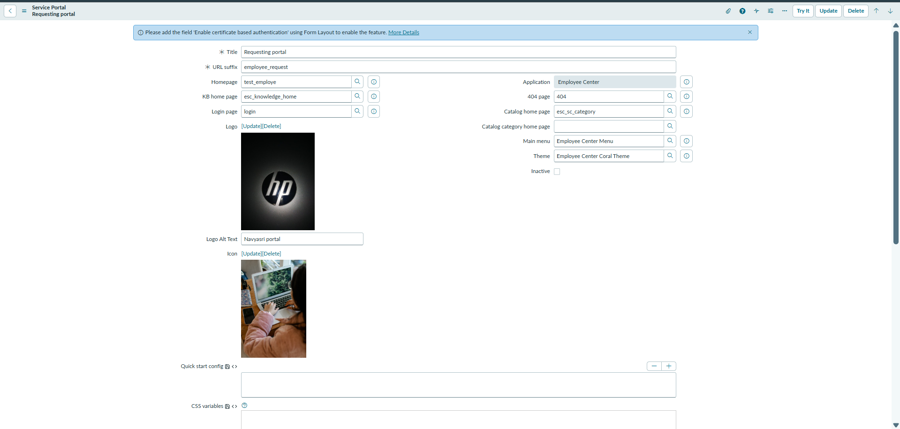

Employee Center Portal Page Configuration
