PHASE 6 – CREATING WIDGETS AND ADDING TO THE PAGE
Employee Raise Issue – Record Producer & Service Portal Integration

Description
This phase creates two custom Service Portal widgets. The first provides an informational services panel, while the second provides a Raise an Issue action that redirects the user to the Record Producer.

1. Left Widget – Commercial Widget
- Navigate to Service Portal Configuration → Service Portals → Widget Editor.
- Click Create a new widget.
- Widget name: Commercial widget.
- Click Submit.
- Add the provided HTML and CSS.
- Enable the required template sections.
- Use Preview to verify the appearance.
- Save the widget.

2. Right Widget – Link Redirect
- Open Widget Editor and click Create a new widget.
- Widget name: Link redirect.
- Click Submit.
- Add HTML, CSS and Client Script.
- Enable the required template sections.
- Use Preview to verify the widget.
- Save the widget.

3. Add Both Widgets to the Page
- Use the Employee Center portal page.
- Navigate to Service Portal Configuration → Service Portal → Designer.
- Search for the Employee Center homepage/page.
- Create a container using a 6 × 6 layout.
- Search for the Commercial widget and Link redirect widget.
- Drag and drop them into the desired left and right positions.
- Save and preview the page.

Important Widget Notes
The Commercial widget uses HTML/CSS for the visual services panel. The Link redirect widget uses HTML, CSS and a Client Script. The Client Script uses the Record Producer sys_id to open the Raise Employee Issue Record Producer.
Record Producer Sys ID used in the project:
ae2cd61183433210de6fc590ceaad3a4
Commercial Widget – Widget Editor
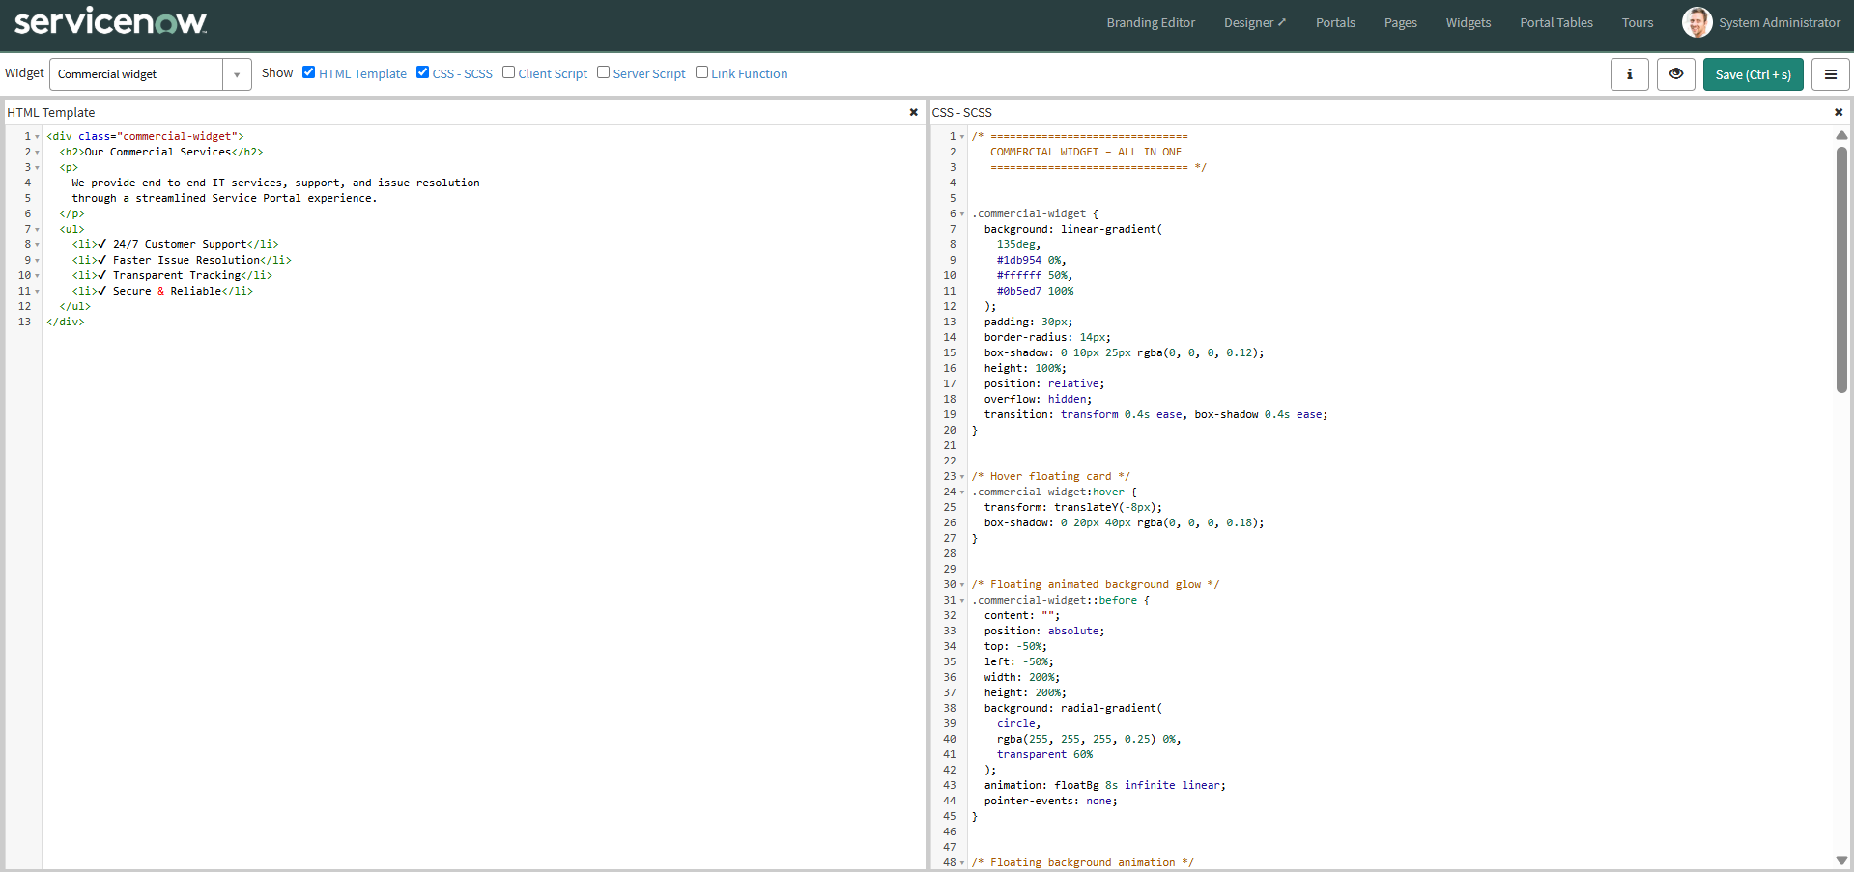
Commercial Widget – Preview
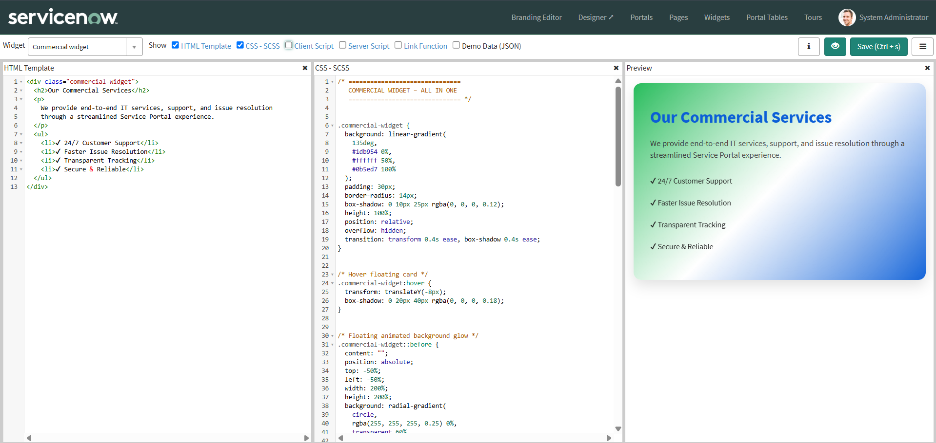

Link Redirect Widget – HTML/CSS/Client Script
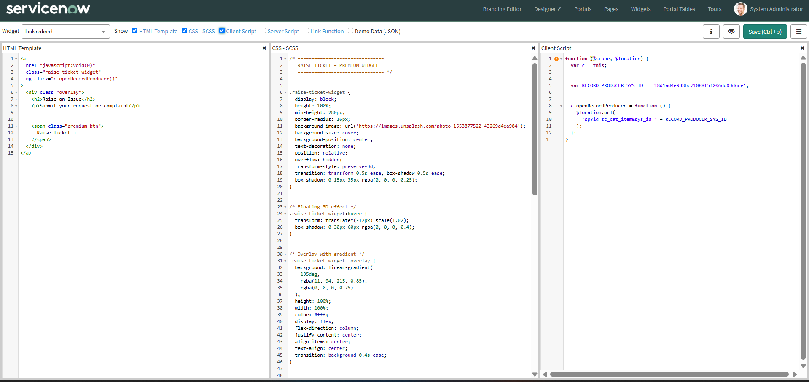

Raise Ticket Widget – Preview
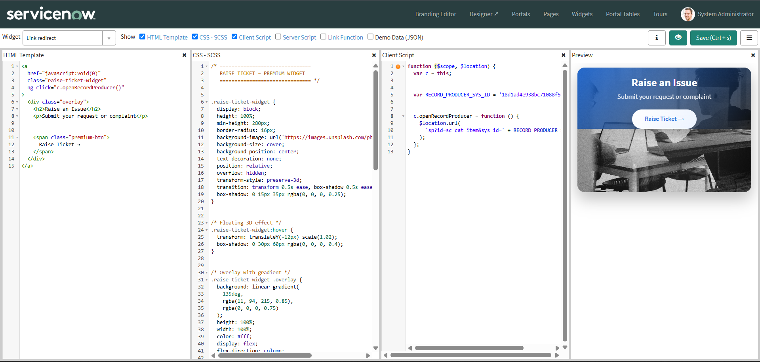

Both Custom Widgets Added to the Page
