PHASE 7 – TESTING AND VALIDATION
Employee Raise Issue – Record Producer & Service Portal Integration

Description
This phase validates the complete Employee Raise Issue solution from an end-user perspective. It confirms that the portal, widgets, Record Producer, custom fields, UI Policies and dependency behavior work together as intended.

1. Open the Employee Requesting Portal
- Open a new browser tab.
- Open the configured portal URL: /employee_request.
- Verify that the portal logo, image and icon elements are displayed.
- Scroll to the section containing the custom widgets.
- Move the cursor over the widgets to verify the floating / hover effects.

2. Test the Raise Ticket Flow
- Click the Raise Ticket button.
- Verify that the widget opens the Raise Employee Issue Record Producer.
- Fill in Requester, Category, Subcategory, State and Short Description.
- Verify that Subcategory changes according to Category.
- Set State to New and verify Short description becomes mandatory.
- Verify the Number field is read-only.
- Submit the Record Producer.
- Open the Employee Raise Issue table and verify the new backend record.

3. Validation Checklist
- Custom Employee Center scoped application created.
- Employee Raise Issue custom table created.
- Auto-numbering configured.
- Reference and choice fields configured.
- Short Description mandatory behavior tested.
- Number read-only behavior tested.
- Category → Subcategory dependency tested.
- Raise Employee Issue Record Producer created and mapped.
- Requesting portal and portal page created.
- Both custom widgets created and added.
- End-to-end submission tested successfully.
Requesting Portal – Homepage
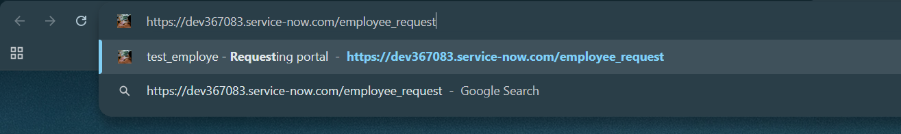

Custom Widgets Displayed on Portal
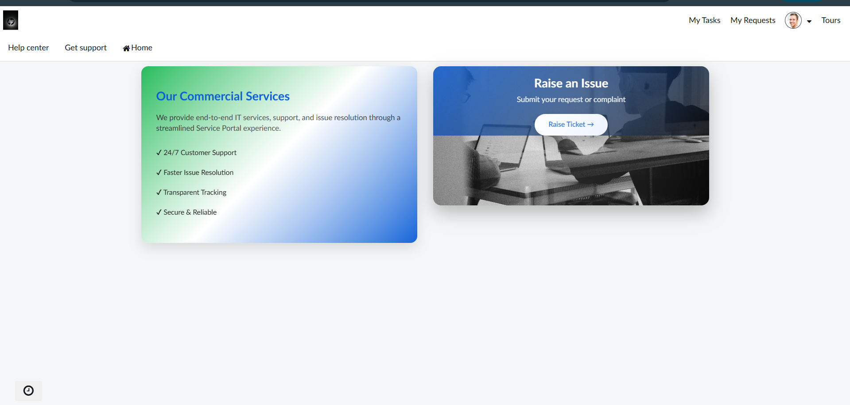

Record Producer Form – Before Submission
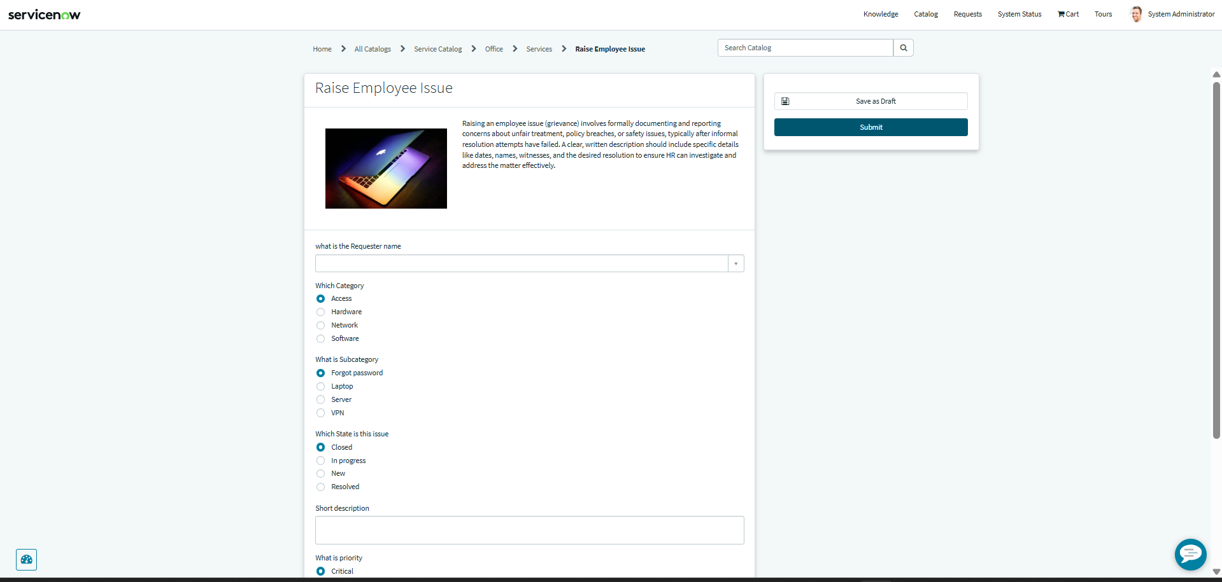

Category / Subcategory Dependency Test
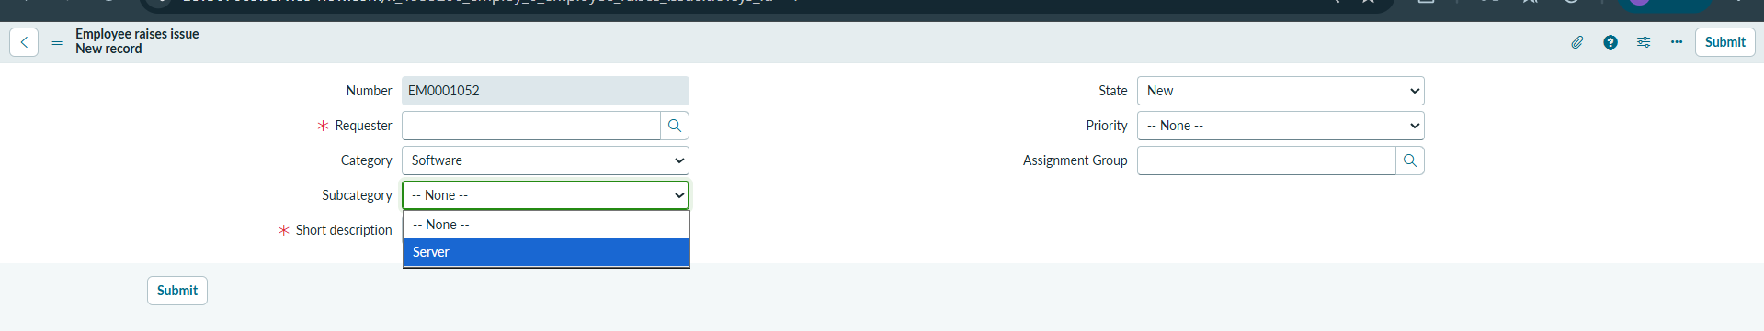

Short Description Mandatory Test
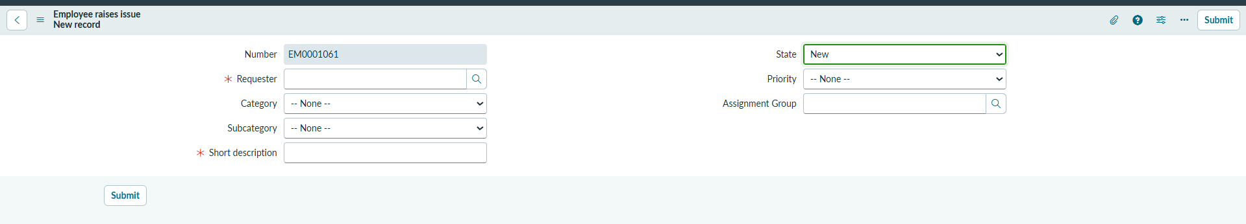

Number Field Read-Only Test
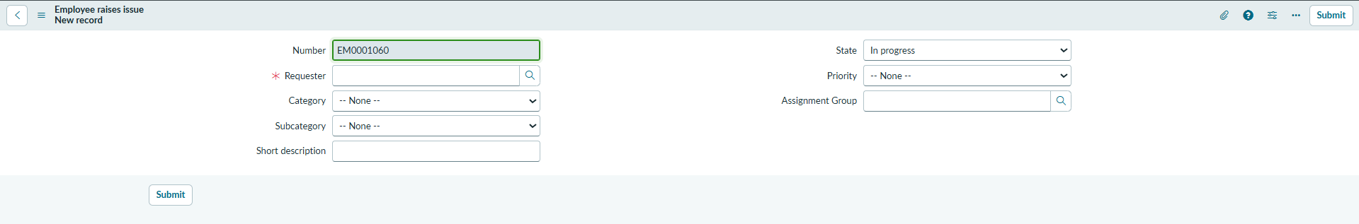

Submitted Employee Raise Issue Record
