SO DO PHAN TICH THIET KE
HE THONG THONG TIN
Game nông trại pixel-art Chill Chill
DFD - ERD - Use Case - Class Diagram
System Architecture - Workflow
Phien ban 1.4.3 | MIT License

MUC LUC
1. Gioi thieu va Pham vi He thong
2. So do Ngu canh (Context Diagram - DFD Level 0)
3. So do Luong du lieu muc 1 (DFD Level 1)
4. So do Thuc the - Quan he (ERD)
5. So do Use Case
6. So do Kien truc He thong (4 lop)
7. So do Lop (Class Diagram)
8. So do Luong Overnight Pass
9. So do Vong lap Hang ngay
10. Tong ket va Nhan xet

1. GIOI THIEU VA PHAM VI HE THONG
Tai lieu nay trinh bay cac so do phan tich thiet ke he thong thong tin (System Analysis and Design) cho game nong trai pixel-art Sprout Hollow. Cac so do duoc xay dung dua tren cac tai lieu ky thuat chinh cua du an: README.md, DESIGN.md, GAMEPLAY.md, PROGRESSION.md, ARCHITECTURE.md va package.json.

1.1. Pham vi he thong
Sprout Hollow la tro choi nong trai cho desktop (Windows chinh, Android qua Capacitor), xay dung tren nen tang Electron + TypeScript + Vite. He thong quan ly mot trang trai ao trong mot thung lung co rung, cho phep nguoi choi:
- Canh tac dat, gieo hat, tuoi nuoc, thu hoach 15 loai cay trong qua 4 mua
- Nuoi 12 loai dong vat trong cac chuong (ga, vit, tho, bo, de, cuu, lon)
- Dat 30 loai may moc san xuat tao thanh chuoi 3 cap (lua mi -> bot mi -> banh mi)
- Mua ban voi cua hang, tham gia giao don hang
- Qua dem (Overnight Pass) cap nhat trang thai tu dong
- Luu/tai game qua file JSON (Desktop) hoac SharedPreferences (Android)

1.2. Cac loai so do trong tai lieu
STT | Ten so do | Muc dich
1 | Context Diagram (DFD Level 0) | The hien he thong voi cac tac nhan (Actor) ben ngoai
2 | DFD Level 1 | Phan ra he thong thanh cac tien trinh chuc nang
3 | ERD | Mo hinh du lieu: cac thuc the, thuoc tinh va quan he
4 | Use Case Diagram | Cac chuc nang nguoi choi co the thuc hien
5 | System Architecture | Kien truc 4 lop cua he thong
6 | Class Diagram | Cau truc GameState va cac lop lien quan
7 | Overnight Flow | Luong xu ly qua dem
8 | Daily Game Loop | Vong lap hang ngay cua game

2. SO DO NGU CANH (Context Diagram - DFD Level 0)
So do ngu canh (Context Diagram) la muc cao nhat trong phan cap DFD. No the hien he thong nhu mot "hop den" (black box) duy nhat, chi ra cac tac nhan ben ngoai va cac luong du lieu trao doi voi he thong.
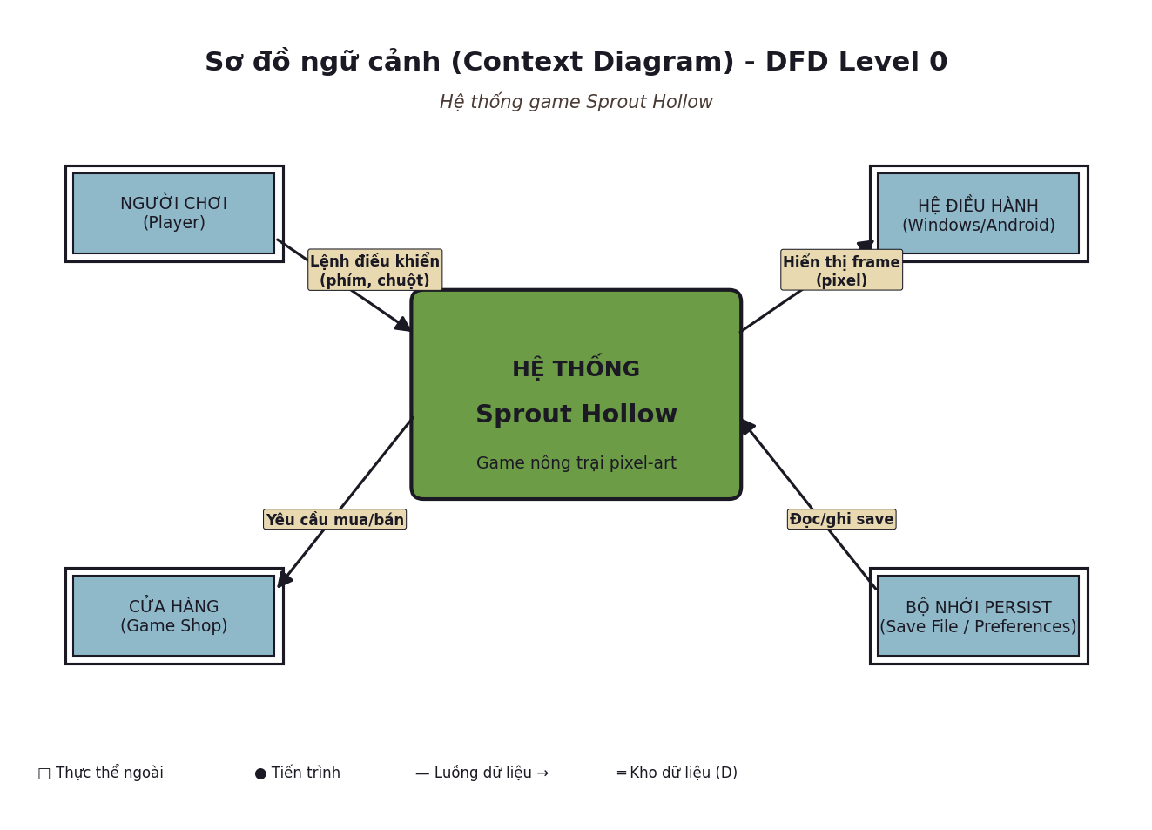
Hinh 1: So do ngu canh cua he thong Sprout Hollow

2.1. Phan tich
Cac tac nhan ben ngoai:
- Nguoi choi (Player): Tuong tac truc tiep qua phim, chuot hoac cam ung. Gui lenh dieu khien, yeu cau mua ban
- He dieu hanh (Windows/Android): Cap nhat OS, luu/ghi save, phan hoi cam ung (Android)
- Cua hang (Game Shop): Noi giao dich mua hat vong nong cu, ban san pham
- Bo nho persist (Save File / SharedPreferences): Luu tru trang thai game qua cac phien
Cac luong du lieu chinh:
- Lenh dieu khien (phim, chuot, cam ung) tu nguoi choi vao he thong
- Hien thi frame pixel tu he thong ra man hinh
- Yeu cau mua/ban giua nguoi choi va cua hang
- Doc/ghi save file giua he thong va bo nho persist
Luu y: Shop va Save File duoc mo ta nhu cac tac nhan ben ngoai de the hien su trao doi du lieu, nhung ve ban chat chung van la cac module cua he thong (src/game/shop.ts va src/renderer/bridge.ts). Cach bieu dien nay giup lam ro ranh gioi luong du lieu.

3. SO DO LUONG DU LIEU MUC 1 (DFD Level 1)
So do DFD Level 1 phan ra he thong thanh cac tien trinh (process) chuc nang rieng biet. Moi vong tron dai dien cho mot chuc nang cua he thong, cac kho du lieu (D1-D4) noi luu tru thong tin can thiet, cac luong du lieu noi cac thanh phan voi nhau.
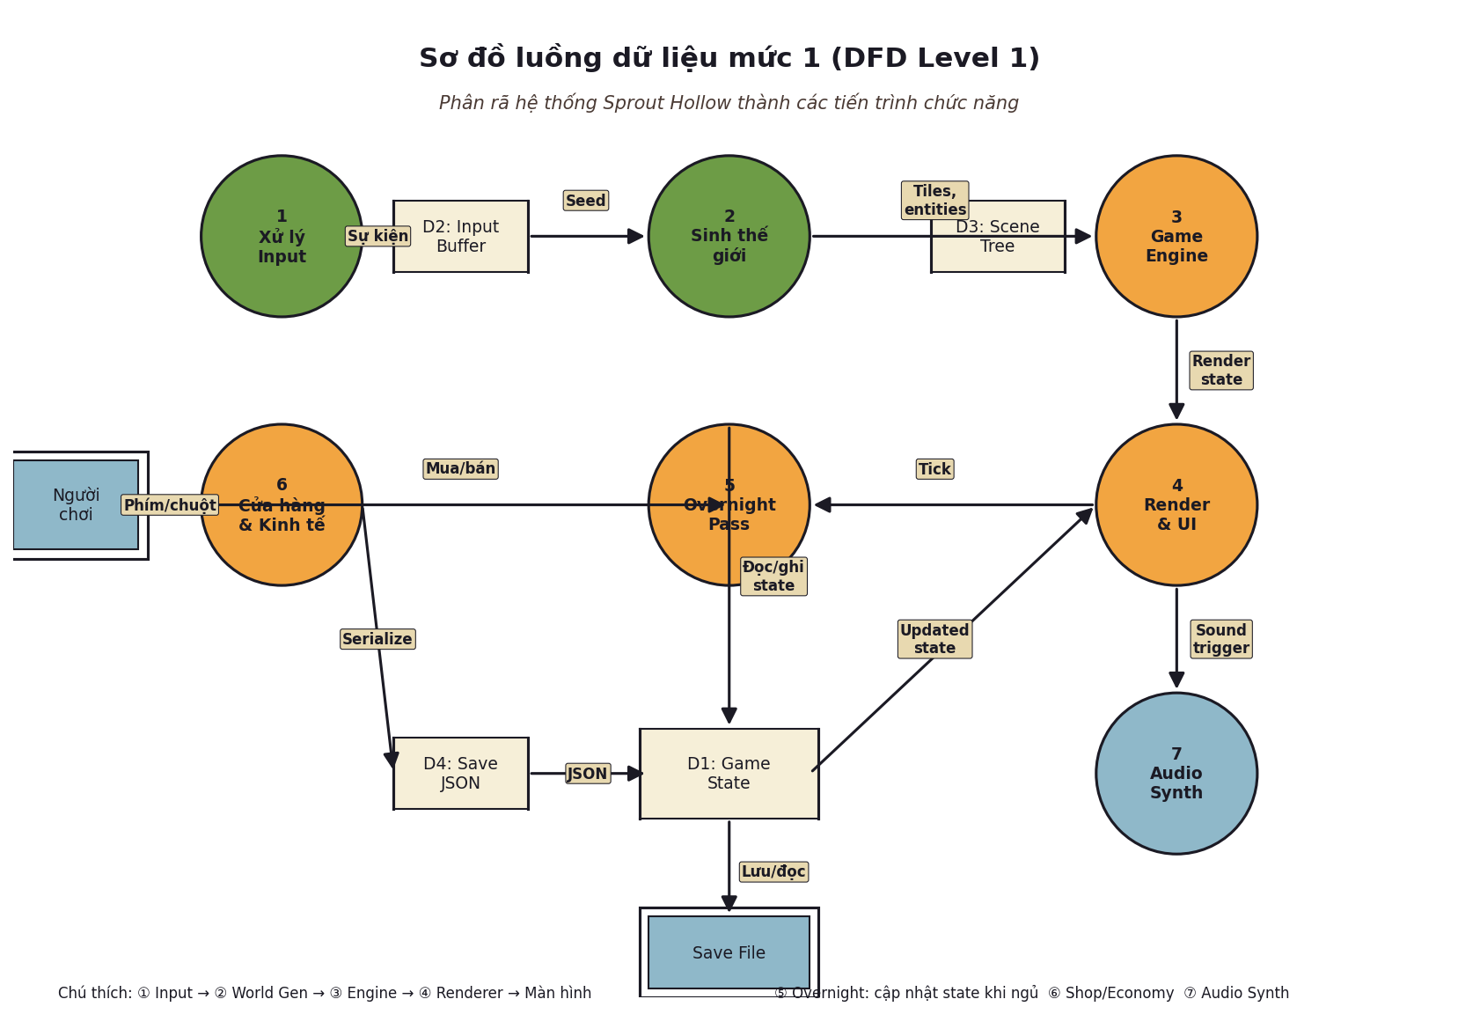
Hinh 2: So do DFD Level 1 voi 7 tien trinh va 4 kho du lieu

3.1. Cac tien trinh (Process)
ID | Ten tien trinh | Chuc nang
P1 | Xu ly Input | Nhan va giai ma su kien tu ban phim, chuot, cam ung thanh cac lenh game (walk, use, sleep...)
P2 | Sinh the gioi | Tu seed + salt, sinh ra cac tile, cay, da, nuoc, go... xac dinh ban do ban dau
P3 | Game Engine | Xu ly logic game: cap nhat trang thai, thuc hien hanh dong, tick dong ho, kiem tra dieu kien
P4 | Render va UI | Ve frame moi len canvas 640x448, xu ly cac panel UI, di chuyen camera
P5 | Overnight Pass | Xu ly qua dem: cho an, tinh tinh ban, chay may, giai quyet dong vat ngoai troi
P6 | Cua hang & Kinh te | Xu ly mua ban, tinh toan gia ca theo chat luong, thuong XP
P7 | Audio Synth | Tong hop am thanh tu oscillator WebAudio theo su kien (till, water, harvest, sell...)

3.2. Cac kho du lieu (Data Store)
ID | Mota
D1 | GameState: Trang thai tong the cua game - seed, day, season, year, gold, energy, tiles, buildings, animals, machines, bag, progression
D2 | Input Buffer: Vung dem cac su kien input dang cho xu ly (phim nhan, chuot click, cam ung)
D3 | Scene Tree: Cay scene hien tai dang render (world scene, interior scene, panel)
D4 | Save JSON: File save game duoc serialize thanh JSON, luu o thu muc app data

4. SO DO THUC THE - QUAN HE (ERD)
So do ERD (Entity Relationship Diagram) mo ta cau truc du lieu cua he thong. No liet ke cac thuc the (entity) chinh, cac thuoc tinh (attribute) cua chung va moi quan he giua chung. Day la mo hinh du lieu trien khai trong src/game/state.ts va cac file lien quan.
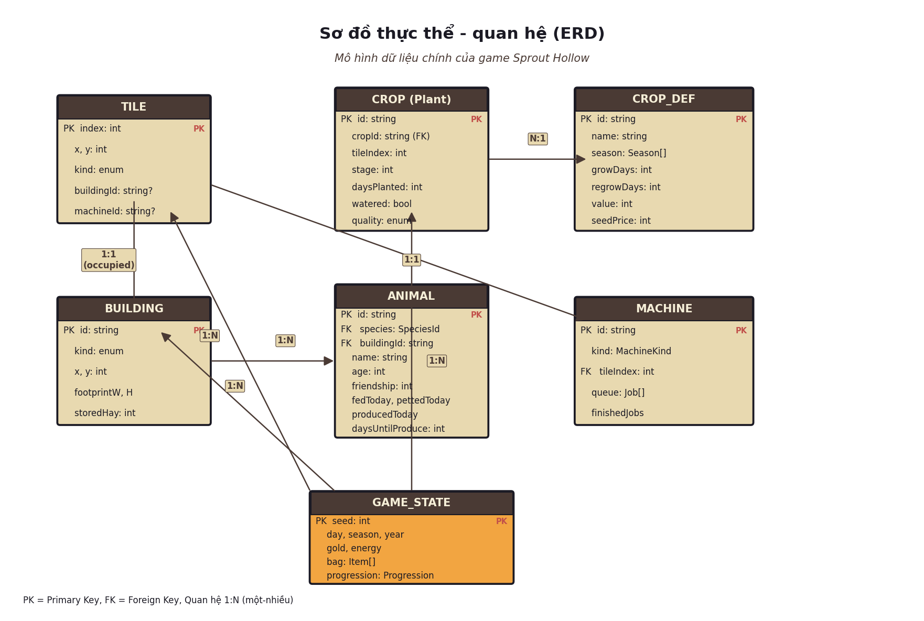
Hinh 3: So do ERD voi cac thuc the chinh va quan he

4.1. Cac thuc the (Entity)
GameState (thuc the goc):
Luu tru toan bo trang thai cua game. Co chua cac tham so tong quat (seed, day, season, year, gold, energy) va lien ket den cac thuc the con (tile, crop, building, animal, machine). Day la "kho du lieu" tong the cua game.
Tile (o dat):
Dai dien cho mot o dat co kich thuoc 16x16 pixel trong luoi 20x20 cua farm. Moi tile co mot loai (kind) - grass, soil, water, rock, log, weeds... va co the chua building hoac machine (neu khac null).
Crop / Plant (cay trong):
Thuc the dai dien cho mot cay dang moc tren mot tile. Co tham chieu den CropDef (dinh nghia loai cay), theo doi stage, so ngay da trong, trang thai tuoi nuoc, chat luong cuoi cung.
Building (toa nha):
Cac toa nha nhu Coop, Barn, Silo, Greenhouse... co kich thuoc (footprint) va vi tri (x, y) tren luoi. Co the chua hay (storedHay) cho silo hoac cho phep nuoi dong vat.
Animal (dong vat):
Moi con dong vat co species, name, age, friendship, cac co fedToday/pettedToday/producedToday va bo dem ngay cho san pham tiep theo. Lien ket den Building de biet dang o chuong nao.
Machine (may moc):
May dat tren mot tile, co hang doi (queue) cac cong viec (Job). Moi Job co nguyen lieu dau vao, thoi gian xu ly va san pham dau ra. May tu dong hoan thanh qua overnight pass.

4.2. Cac quan he (Relationship)
Quan he | Loai | Mota
GameState - Tile | 1:N | Mot GameState co nhieu Tile (mac dinh 400 o = 20x20)
GameState - Crop | 1:N | Mot GameState co nhieu Cay dang trong tren cac tile
GameState - Building | 1:N | Mot GameState co nhieu toa nha da dat
GameState - Machine | 1:N | Mot GameState co nhieu may dat tren cac tile
Building - Animal | 1:N | Mot toa nha (Coop, Barn) co the chua nhieu dong vat
Crop - CropDef | N:1 | Nhieu cay cung loai tham chieu den mot CropDef (dinh nghia)

5. SO DO USE CASE
So do Use Case the hien cac chuc nang (use case) ma he thong cung cap va cac tac nhan (actor) tuong tac voi chung. Trong Sprout Hollow, tac nhan chinh la Nguoi choi va He thong (tu dong khi nguoi choi di ngu).
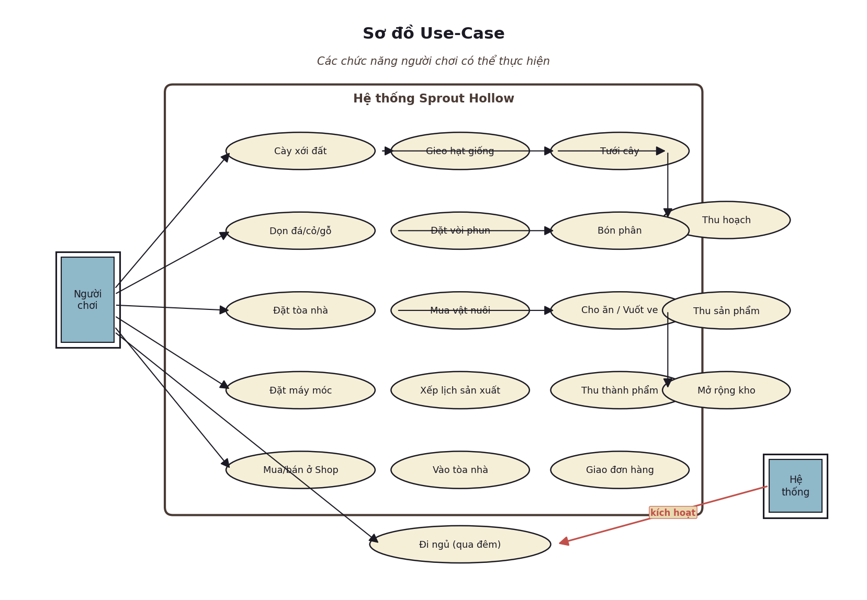
Hinh 4: So do Use Case voi 18 chuc nang chinh

5.1. Cac nhom chuc nang
Canh tac (Farming):
Cac chuc nang lien quan den viec trong trot: Cay dat, Gieo hat, Tuoi cay, Thu hoach, Don da/co/go, Dat voi phun, Bon phan.
Xay dung (Building):
Dat toa nha, Mua vat nuoi, Cho an / Vuot ve, Thu san pham, Mo rong kho, Vao toa nha.
San xuat (Production):
Dat may moc, Xep lich san xuat, Thu thanh pham (them ca Q/E de chon hat giong trong bang cua hang).
Kinh te (Economy):
Mua/Ban o Shop, Giao don hang (delivery orders), Giao crate cho thuyen (boat crates).
Thoi gian (Time):
Di ngu (N) - kich hoat Overnight Pass, cap nhat trang thai tu dong va sinh DayReport.

5.2. Quan he giua Actor va Use Case
Nguoi choi (Player):
- Tuong tac truc tiep voi 17 use case thong qua input (phim/chuot/cam ung)
- Thuc hien hanh dong canh tac, xay dung, san xuat va giao dich
He thong (System):
- Tu dong kich hoat Overnight Pass khi nguoi choi di ngu
- Cap nhat trang thai qua dem: cho an, san xuat, qua mua...

6. SO DO KIEN TRUC HE THONG (4 LOP)
Kien truc 4 lop cua Sprout Hollow dam bao su tach biet ro rang giua cac thanh phan. Moi ten lua phu thuoc chi theo mot huong (top-down), giup he thong de kiem thu, de bao tri va de mo rong. Day la triet ly "purity rule" cua du an.
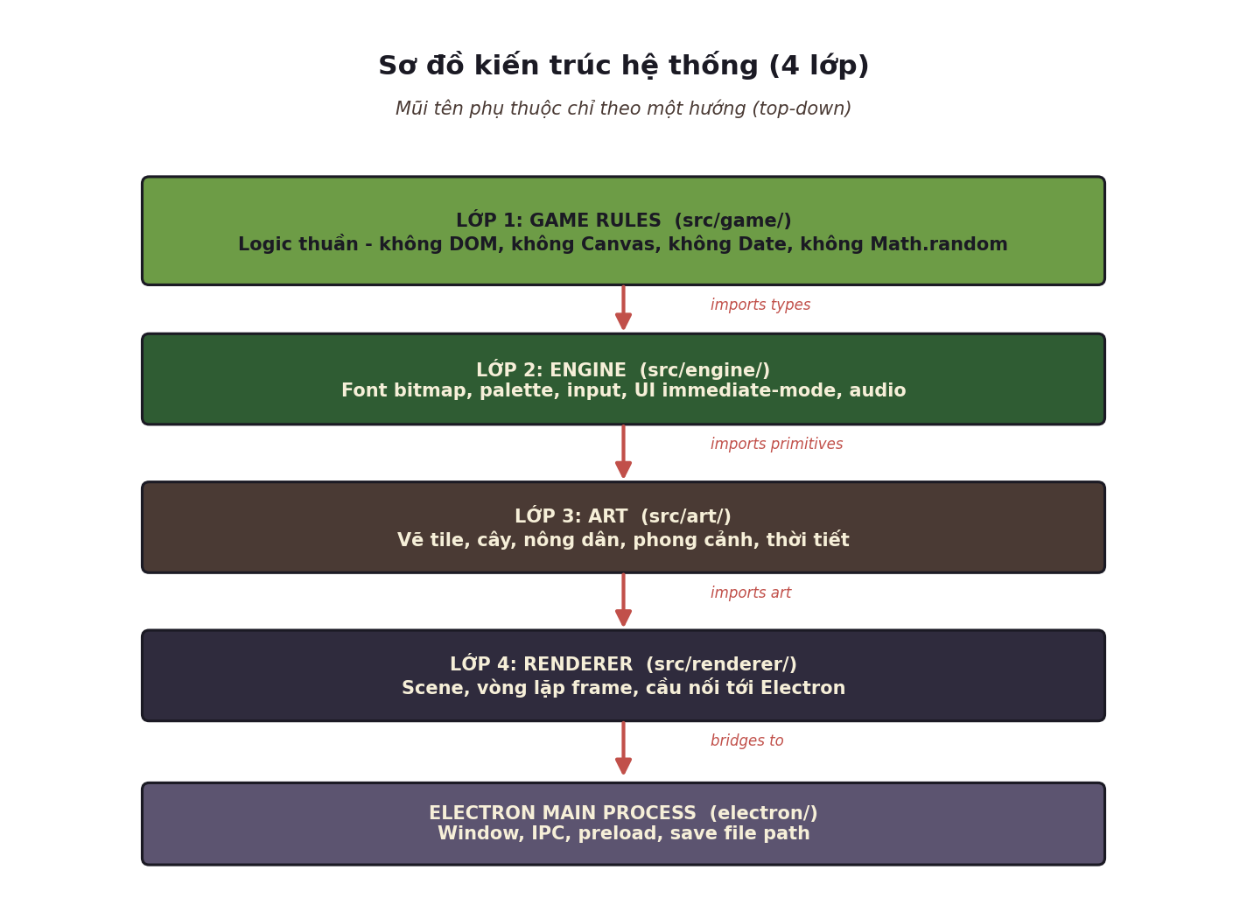
Hinh 5: Kien truc 4 lop voi cac mui ten phu thuoc mot chieu

6.1. Chi tiet cac lop
Lop 1 - Game Rules (src/game/):
Lop tren cung, chua toan bo logic game. Dac biet: KHONG co canvas, KHONG co DOM, KHONG co Date.now(), KHONG co Math.random(). Tat ca su ngau nhien deu qua rng.ts duoc seed tu state.seed. Day la lop "pure" co the unit test hoan toan.
Cac file quan trong: actions.ts, crops.ts, livestock.ts, machines.ts, production.ts, shop.ts, save.ts, progression.ts, time.ts
Lop 2 - Engine (src/engine/):
Cung cap cac nguyen thuy pixel chung: palette (PALETTE constant), font bitmap 5x7, cac helper ve (fillRect, drawText, drawLine), input handler, UI immediate-mode (khong DOM), audio synthesizer. Layer nay khong biet gi ve cay, mua hay nong nghiep.
Cac file quan trong: palette.ts, font.ts, drawing.ts, input.ts, ui.ts, audio.ts
Lop 3 - Art (src/art/):
Ve cac khai niem game thanh pixel: tiles (co, dat, nuoc, da), plants (cay theo stage), farmer (nong dan, di bo 4 huong), scenery (cay, da, ho, hang rao), weather (mua, tuyet, gio). Layer nay import game types va engine primitives.
Cac file quan trong: tiles.ts, plants.ts, farmer.ts, scenery.ts, weather.ts
Lop 4 - Renderer (src/renderer/):
Scene (world, interior, panel), vong lap frame 60 FPS, can cau noi toi Electron main process (IPC, save file path). Layer nay dung engine va art de render ra canvas cuoi cung.
Cac file quan trong: main.ts, scene.ts, bridge.ts, announce.ts
Electron Main Process (electron/):
Process rieng, khong import bat ky lop nao o tren. Chi chiu trach nhiem tao window, xu ly IPC va luu/ghi file save.

6.2. Quy tac phu thuoc mot chieu
Mui ten phu thuoc chi luon chi theo mot huong: game KHONG biet engine, engine KHONG biet art, art KHONG biet renderer. Dieu nay dam bao:
- Lop co the test doc lap (vi du: game/test/ test logic game ma khong can Electron)
- Co the swap renderer (vi du: thay Canvas bang WebGL hoac server-side) ma khong can sua logic game
- Game logic khong phu thuoc vao framework (Electron, Vite) nen co the chay tren nhieu nen tang

7. SO DO LOP (Class Diagram)
So do lop the hien cac lop chinh trong mo hinh du lieu GameState va moi quan he giua chung. Day la cac lop da duoc dinh nghia trong TypeScript (src/game/), khong phai cac class OOP truyen thong ma la cac type/interface voi associated functions.
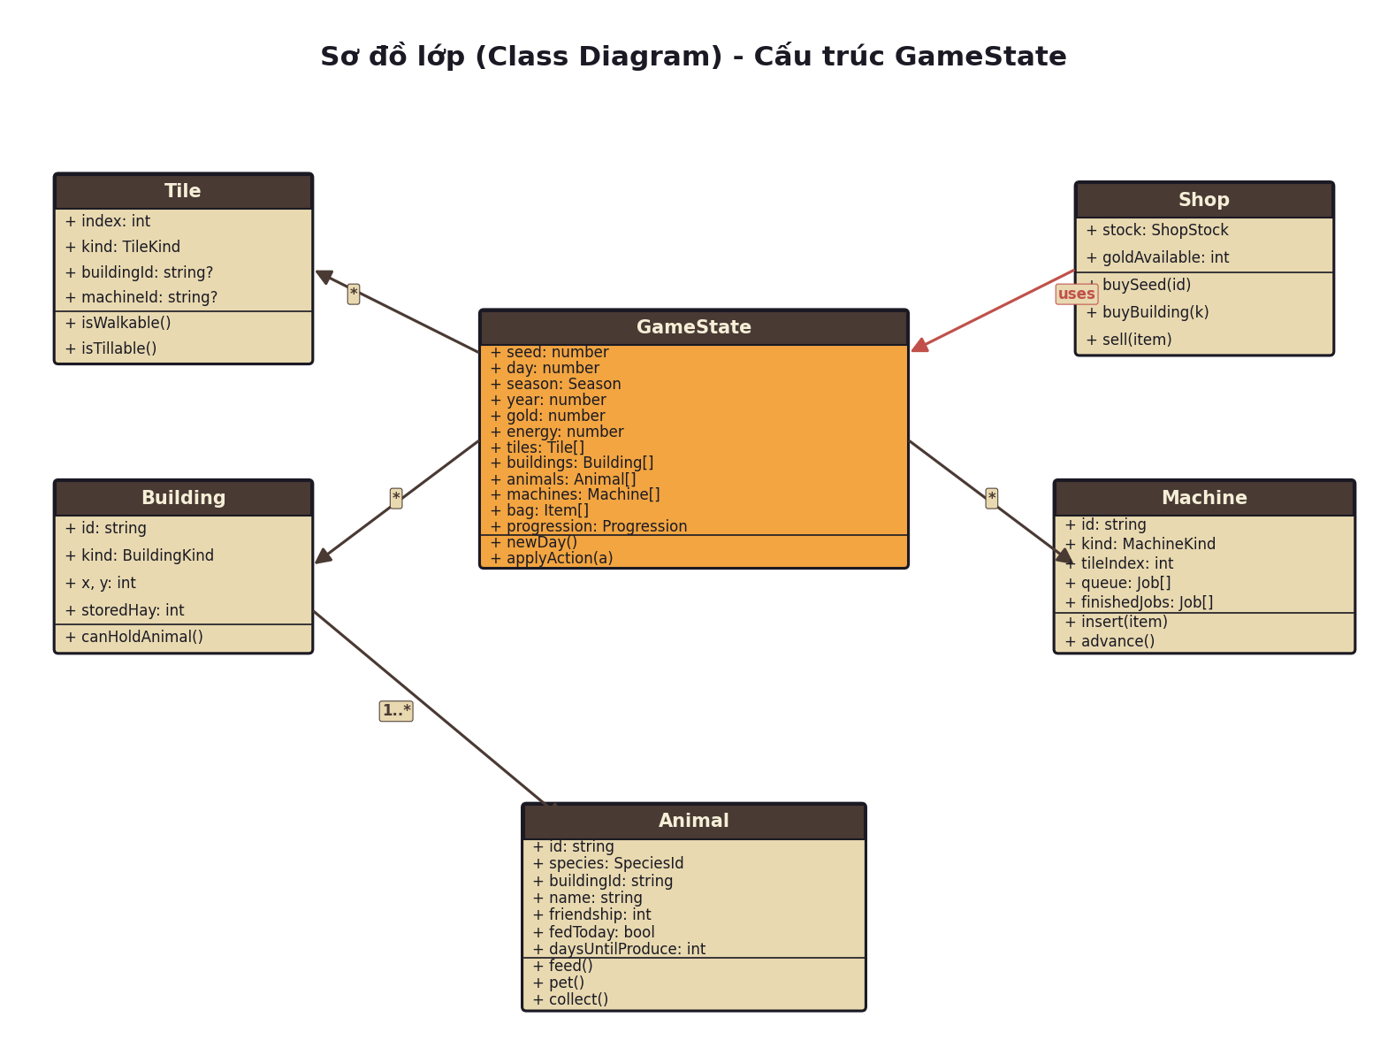
Hinh 6: So do lop voi GameState o trung tam va cac lop lien quan

7.1. Cac lop chinh
GameState (lop trung tam):
Chua toan bo trang thai cua game. Cac thuoc tinh: seed, day, season, year, gold, energy, tiles, buildings, animals, machines, bag, progression. Phuong thuc chinh: newDay(), applyAction().
Tile:
Dai dien cho mot o dat 16x16 pixel. Co index, kind (loai), buildingId, machineId (neu co). Phuong thuc: isWalkable(), isTillable().
Building:
Toa nha (Coop, Barn, Silo...). Co id, kind, vi tri (x,y), storedHay. Phuong thuc: canHoldAnimal().
Animal:
Dong vat. Co id, species, buildingId, name, age, friendship, cac bo co trang thai hang ngay (fedToday, pettedToday, producedToday), bo dem ngay cho san pham. Phuong thuc: feed(), pet(), collect().
Machine:
May dat tren tile. Co id, kind, tileIndex, hang doi queue (Job[]), cac job da hoan thanh (finishedJobs). Phuong thuc: insert(item), advance().
Shop:
Cua hang. Co stock (theo mua), goldAvailable. Phuong thuc: buySeed(), buyBuilding(), sell(). Tuong tac voi GameState de lay vang va them item.

7.2. Quan he giua cac lop
- GameState 1..* Tile: Mot GameState chua mot mang cac Tile (400 o mac dinh)
- GameState 1..* Building: Mot GameState co nhieu toa nha da dat
- GameState 1..* Machine: Mot GameState co nhieu may
- Building 1..* Animal: Mot toa nha co the chua nhieu dong vat
- Shop uses GameState: Shop doc va ghi GameState de thuc hien giao dich

8. SO DO LUONG OVERNIGHT PASS
Khi nguoi choi nhan phim N (Di ngu), ham sleep() se thuc hien mot loat pass xu ly qua dem theo thu tu cu the, duoc quy trong tai lieu GAMEPLAY.md. So do duoi day the hien luong xu ly chi tiet.
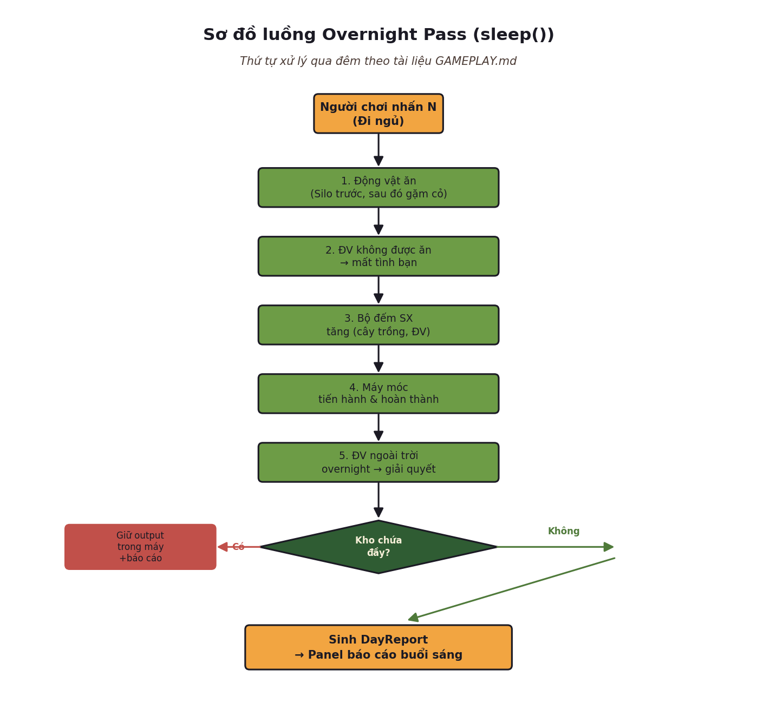
Hinh 7: So do luong xu ly qua dem (Overnight Pass)

8.1. Cac buoc xu ly qua dem
Buoc | Mota chi tiet
Buoc 1 | Dong vat an (Silo truoc, sau do gam co neu mua cho phep): Trong mua dong khong co co, tat ca phai an hay tu silo
Buoc 2 | Dong vat khong duoc cho an -> mat tinh ban: Friendship giam theo cong thuc o livestock.ts
Buoc 3 | Bo dem san xuat tang: Bo dem daysUntilProduce cua dong vat va stage cua cay deu giam theo thoi gian
Buoc 4 | May moc tien hanh va hoan thanh: advance() moi may, neu xong thi them vao finishedJobs (neu kho chua day) hoac giu trong may (neu kho day)
Buoc 5 | Dong vat ngoai troi qua dem: Neu khong ve chuong, mat tinh ban va co the bi om (unwell) sang ngay hom sau
Buoc 6 | Sinh DayReport: Tao bao cao voi cac truong fed, unfed, produced, machinesFinished, animalsUnwell. Hien thi panel bao cao buoi sang

8.2. Xu ly kho chua day
Mot diem quan trong: neu may hoan thanh san pham nhung kho chua (silo/barn) da day, san pham KHONG bi mat ma duoc GIU TRONG MAY. Day report se bao cho nguoi choi biet may dang giu hang, tranh tinh trang harvest "bay hoi" ma khong ro ly do.

9. SO DO VONG LAP HANG NGAY (Daily Game Loop)
Vong lap hang ngay la trung tam cua game. Moi ngay chay tu 6:00 SA den 2:00 SA (20 gio in-game), trong do nguoi choi thuc hien cac hanh dong canh tac, san xuat va tuong tac truoc khi di ngu de chuyen sang ngay moi.
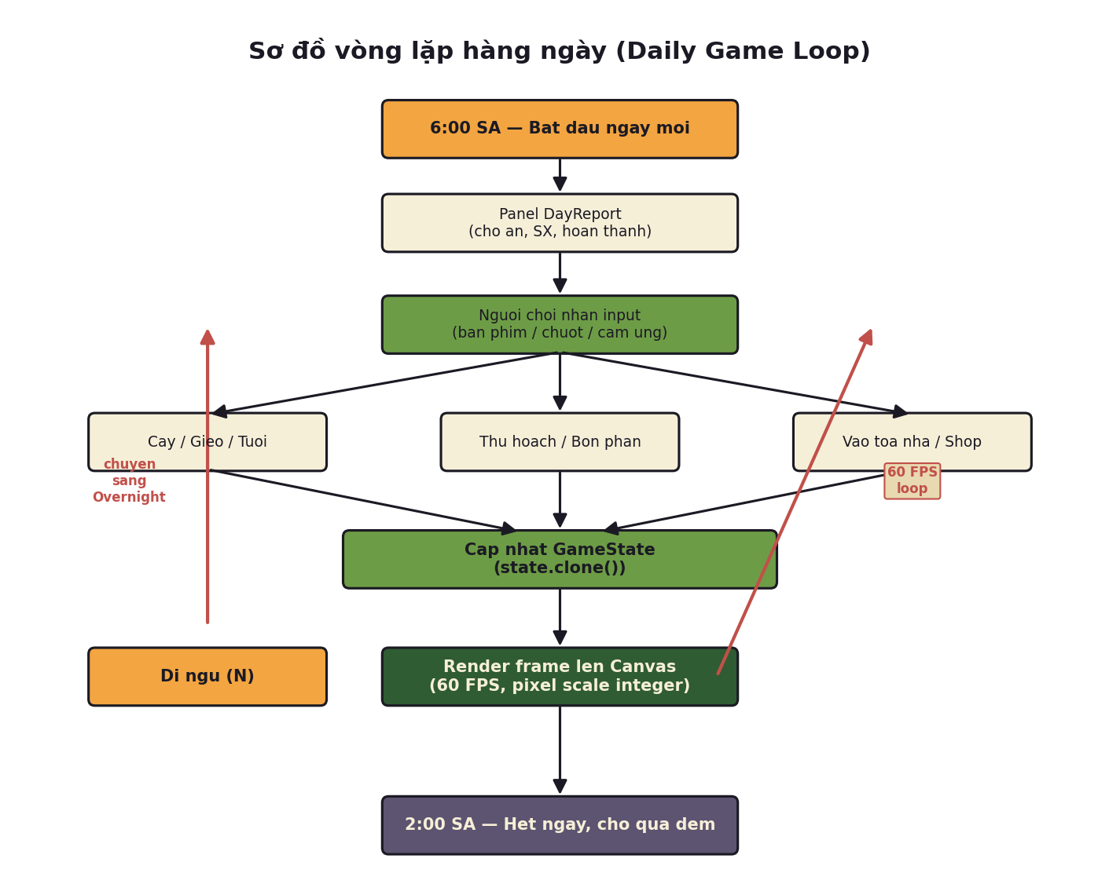
Hinh 8: So do vong lap hang ngay cua game

9.1. Luong chinh
Vong lap 60 FPS (render):
- Buoc 1: Nhan input tu nguoi choi (phim, chuot, cam ung)
- Buoc 3: Game Engine xu ly, cap nhat GameState (state.clone())
- Buoc 4: Render frame moi len canvas (pixel scale nguyen)
Vong lap hang ngay (logic):
- 6:00 SA: Bat dau ngay moi, hien panel DayReport neu qua dem co su kien
- Trong ngay: Nguoi choi tu do tuong tac - cay dat, gieo hat, tuoi nuoc, thu hoach, vao toa nha, mua ban o shop, dat may...
- Nhan N (Di ngu): Chuyen sang Overnight Pass, cap nhat trang thai qua dem
- 2:00 SA: Ket thuc ngay, cho qua dem
Cac hanh dong co the trong ngay:
Loai | Hanh dong cu the
Canh tac | Cay dat (hoe) - Gieo hat (seeds) - Tuoi nuoc (can) - Thu hoach - Bon phan - Dat voi phun
Xay dung | Dat toa nha - Di chuyen toa nha - Pha do toa nha - Mua vat nuoi - Cho an / Vuot ve - Thu san pham
San xuat | Dat may moc - Chen item vao may - Thu thanh pham (auto khi xong qua dem)

Giao dich:
Mua hat giong, voi phun, phan bon o Shop (phim B) - Ban san pham (rau, qua, trung, sua...) o Shop hoac thong qua Delivery Order va Boat Crate.

10. TONG KET VA NHAN XET

10.1. Cac dac diem noi bat cua he thong
- Kien truc 4 lop mot chieu: Dam bao tinh modun hoa cao, de test va mo rong
- Tinh quyet dinh hoan toan: Cung mot save luon cho cung mot tran trai, khong phu thuoc dong ho he thong
- Khong tai san ngoai: Tat ca sprite, font, am thanh deu duoc sinh tu code, giup tai lieu build nho (~80K dong code)
- Ho tro day du kha nang tiep can: Phim ban phim, screen reader, prefers-reduced-motion
- He thong gameplay sau: 15 cay, 12 dong vat, 30 may, chuoi 3 cap, 4 mua, 100+ level

10.2. Diem manh cua thiet ke he thong
- Tach biet ro rang giua logic game va trinh bay (separation of concerns)
- Lop game co the test hoan toan trong Node.js ma khong can browser/Electron
- Renderer co the duoc thay the (Canvas hien tai co the chuyen sang WebGL/Server) ma khong can sua logic
- He thong luu/tai game don gian (JSON serialize/deserialize), khong can database
- Audio tong hop tu WebAudio nen khong can file am thanh

10.3. Diem co the cai thien
- Moi quan he giua cac lop con co the phuc tap hon khi game mo rong (can can nhac them cac pattern nhu ECS neu scale)
- GameState hien tai co the rat lon khi nhieu vat the, can toi uu hoac clone
- Can them cac co che dong bo khi multiplayer (neu phat trien)
- He thong save hien tai chi luu 1 file, can ho tro nhieu slot save

10.4. Tai lieu lien quan
Trong thu muc docs/ cua du an:
- ARCHITECTURE.md - Module contract va quy tac phu thuoc
- GAMEPLAY.md - Chi tiet ve vat nuoi, toa nha va may moc
- PROGRESSION.md - He thong level, kho chua va vung dat
- ECONOMY.md - Can bằng kinh te, gia ca
- INTERIORS.md - Dat diem can cho cac toa nha noi
- DESIGN.md - Triet ly thiet ke nghe thuat va am thanh
- README.md - Tong quan, cach build va su dung

— Het tai lieu —

Tai lieu duoc tao tu dong tu cac file trong thu muc docs/ va source code cua du an.

