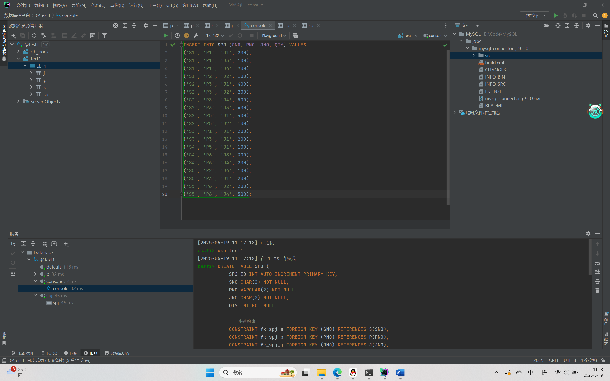

供应商表S
零件表P
工程项目表J

求供应工程J1零件的供应商代码SNO。
SELECT DISTINCT SNO
FROM SPJ
WHERE JNO = 'J1';
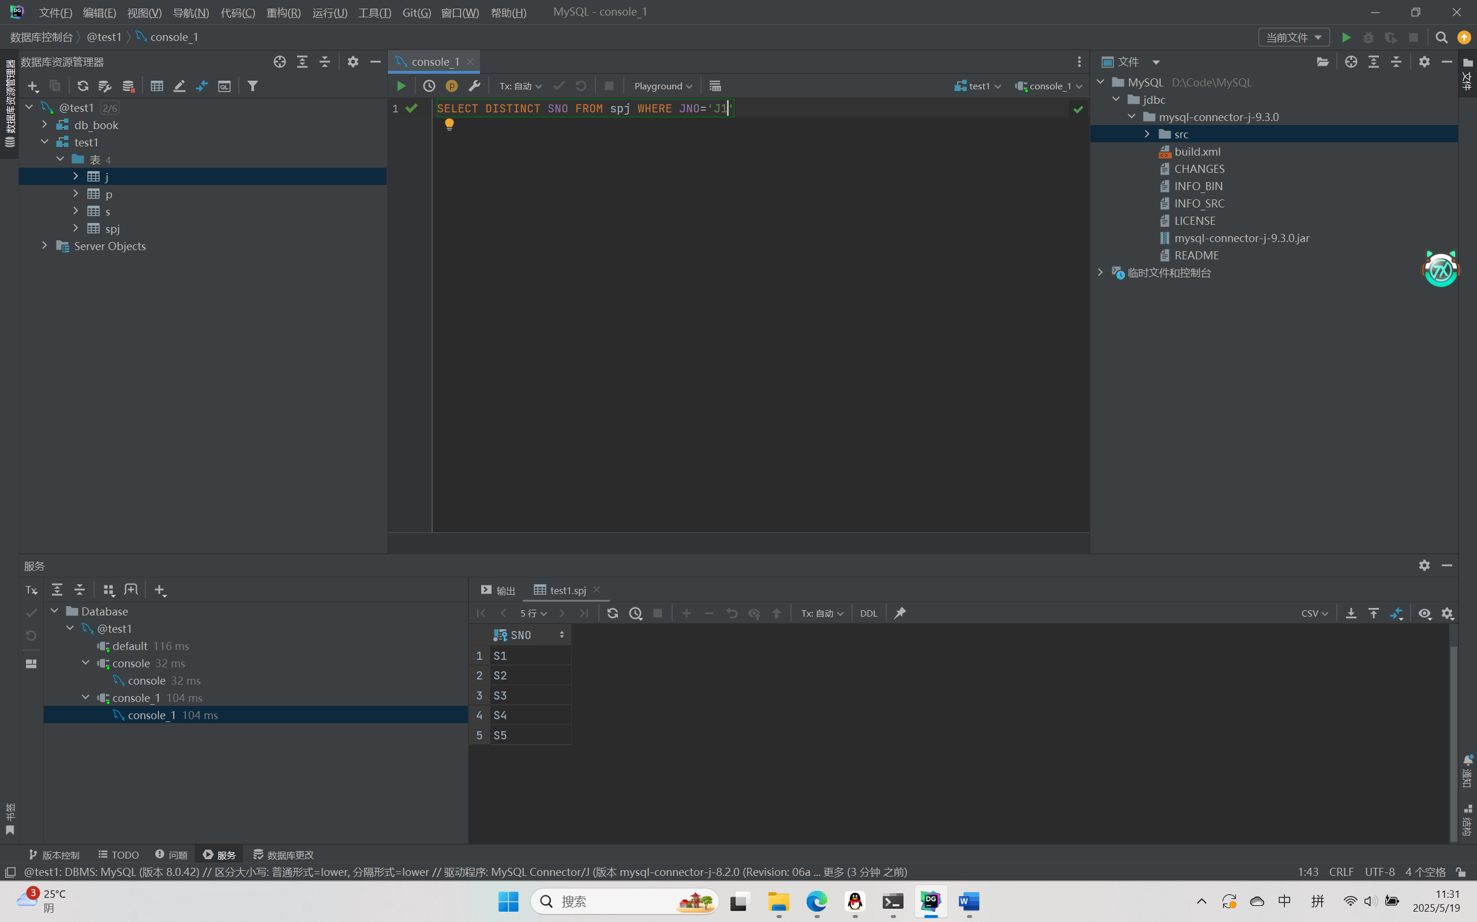

求供应工程J1零件P1的供应商代码SNO。
SELECT DISTINCT SNO
FROM SPJ
WHERE JNO = 'J1' AND PNO = 'P1';
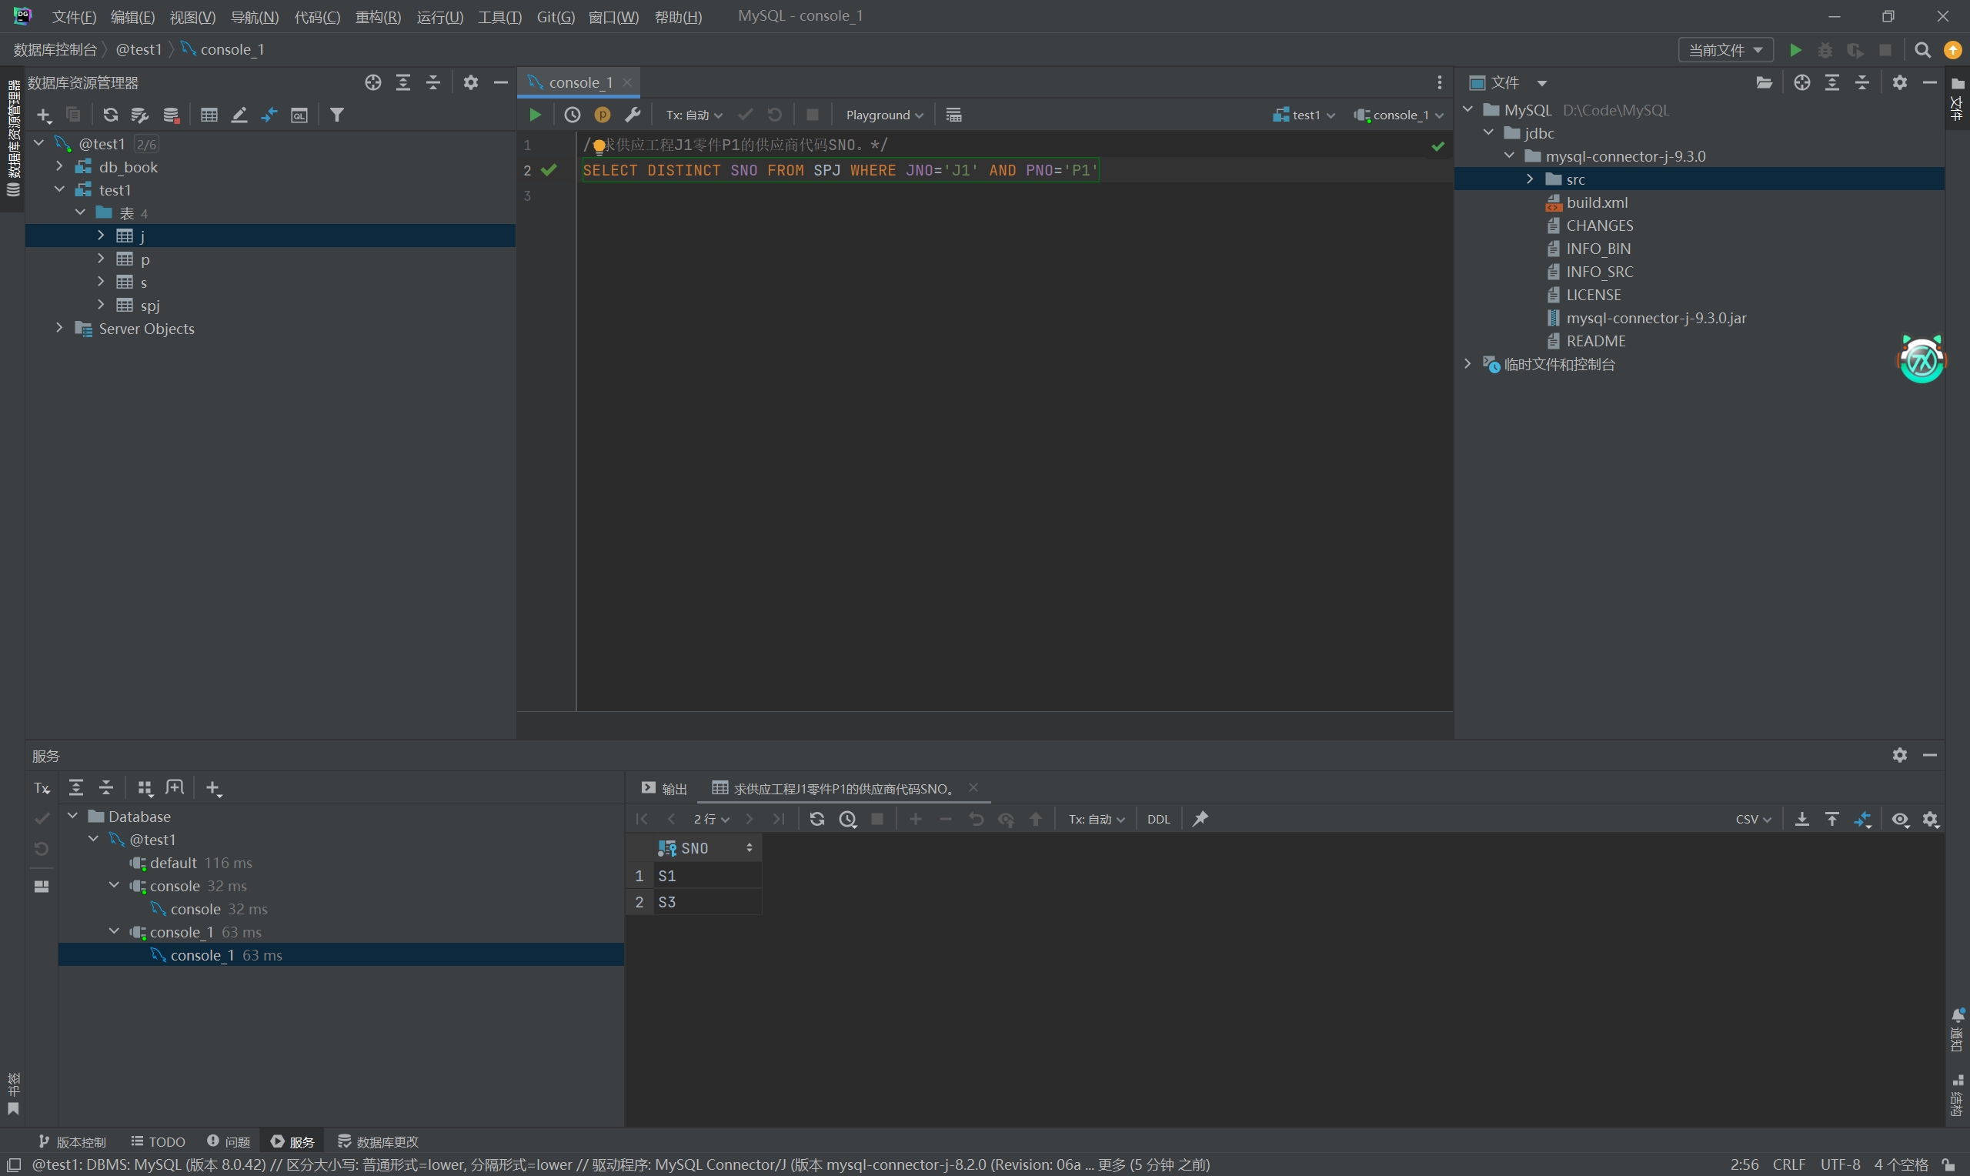

求供应工程J1零件为红色的供应商代码SNO。
SELECT DISTINCT SPJ.SNO
FROM SPJ
JOIN P ON SPJ.PNO = P.PNO
WHERE SPJ.JNO = 'J1' AND P.COLOR =’红’;
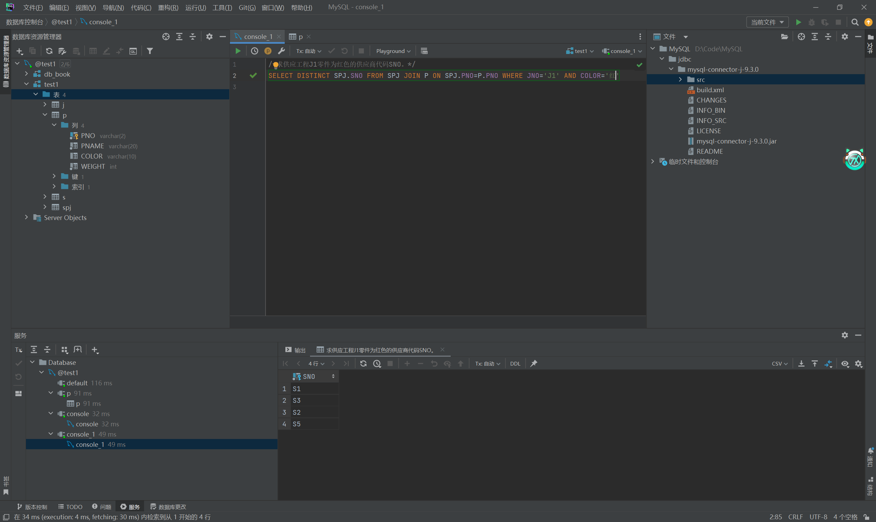

求没有使用天津供应商生产的红色零件的工程号JNO。
SELECT JNO
FROM J
WHERE JNO NOT IN (
SELECT DISTINCT SPJ.JNO
FROM SPJ
JOIN P ON SPJ.PNO = P.PNO
JOIN S ON SPJ.SNO = S.SNO
WHERE S.CITY = '天津' AND P.COLOR = ‘红’
);
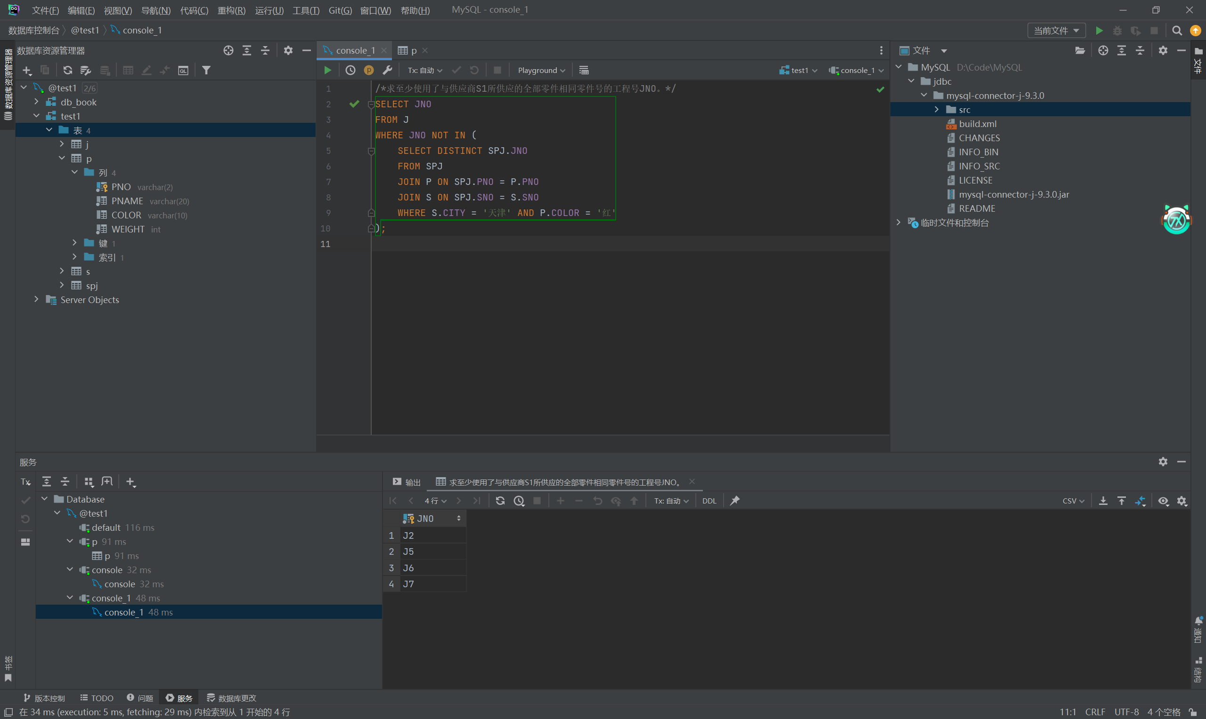

求至少使用了与供应商S1所供应的全部零件相同零件号的工程号JNO
就是找使用了供应商S1供应的全部零件的工程号JNO
SELECT JNO
FROM SPJ AS SPJ2
WHERE NOT EXISTS (
SELECT PNO
FROM SPJ AS SPJ1
WHERE SPJ1.SNO = 'S1'
AND NOT EXISTS (
SELECT 1
FROM SPJ AS SPJ3
WHERE SPJ3.JNO = SPJ2.JNO
AND SPJ3.PNO = SPJ1.PNO
)
)
GROUP BY JNO;
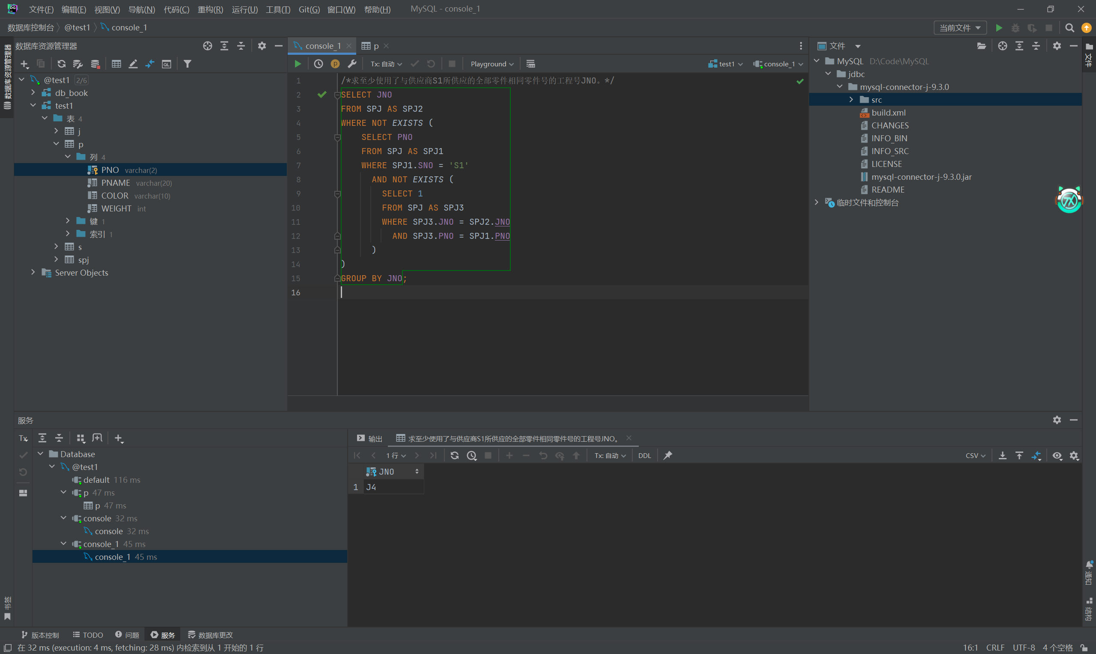

- 找出所有供应商的姓名和所在城市。
供应商表S
零件表P
工程项目表J

Select SNAME as "姓名", CITY as "城市" from s;
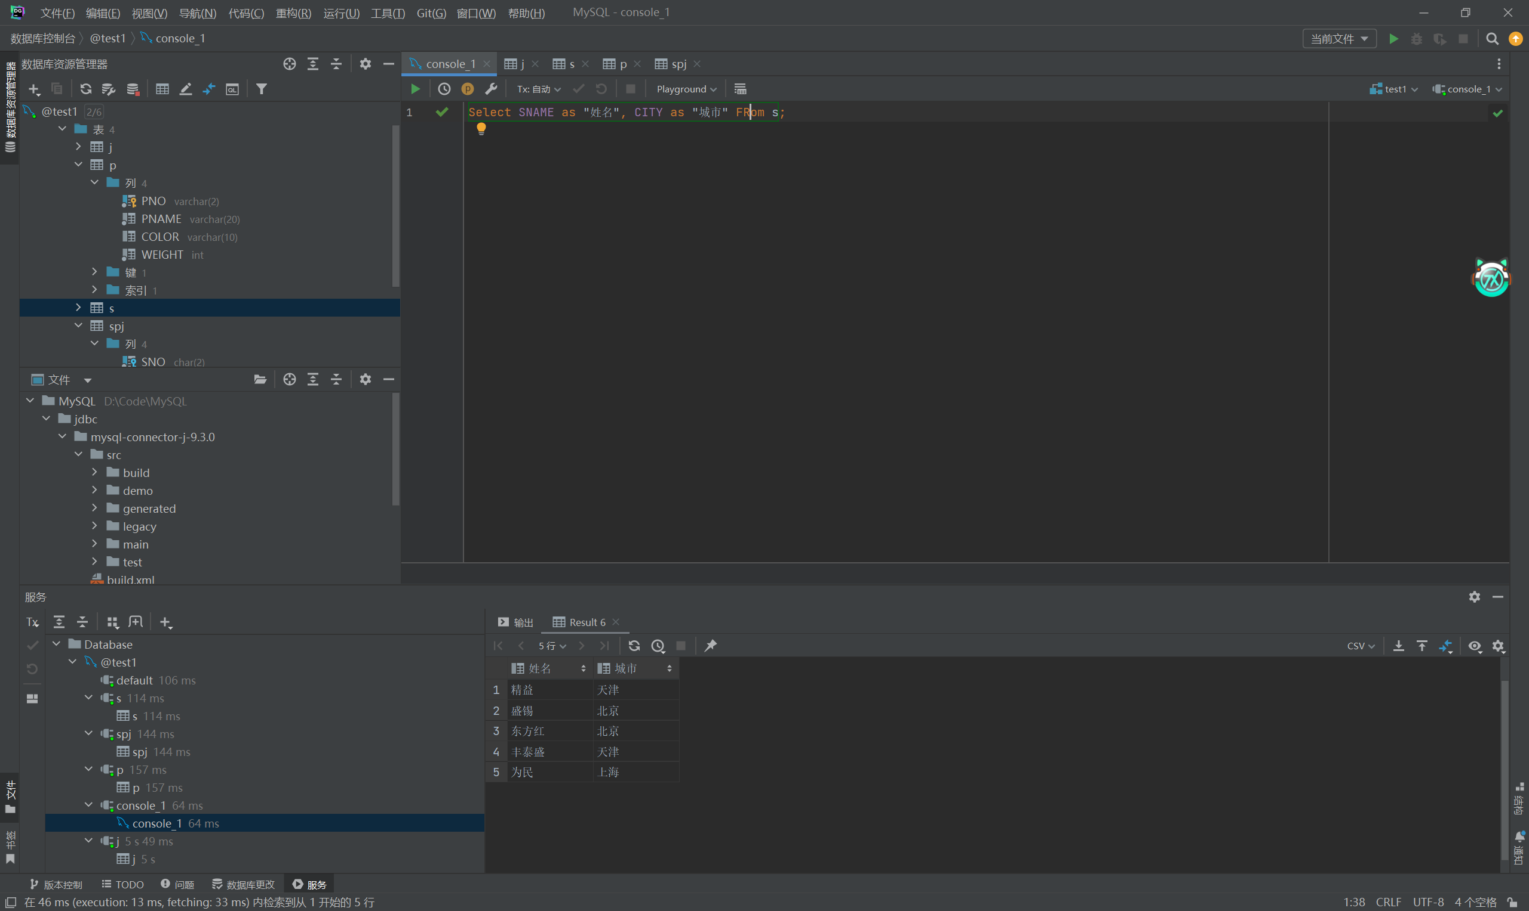

- 找出所有零件的名称、颜色、重量。
Select PNAME as "名称", COLOR as "颜色", WEIGHT as "重量" FRom p
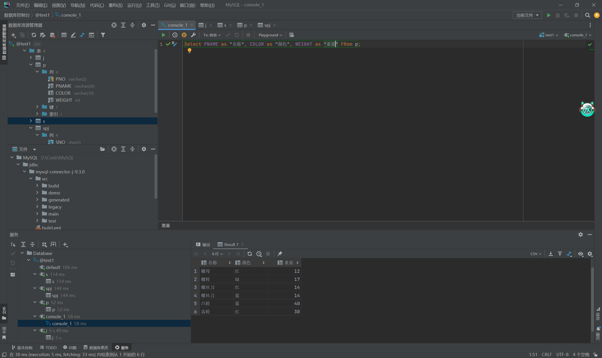

- 找出使用供应商S1所供应零件的工程代码。
select DISTINCT JNO from spj where spj.PNO in (select PNO from spj where SNO='S1')
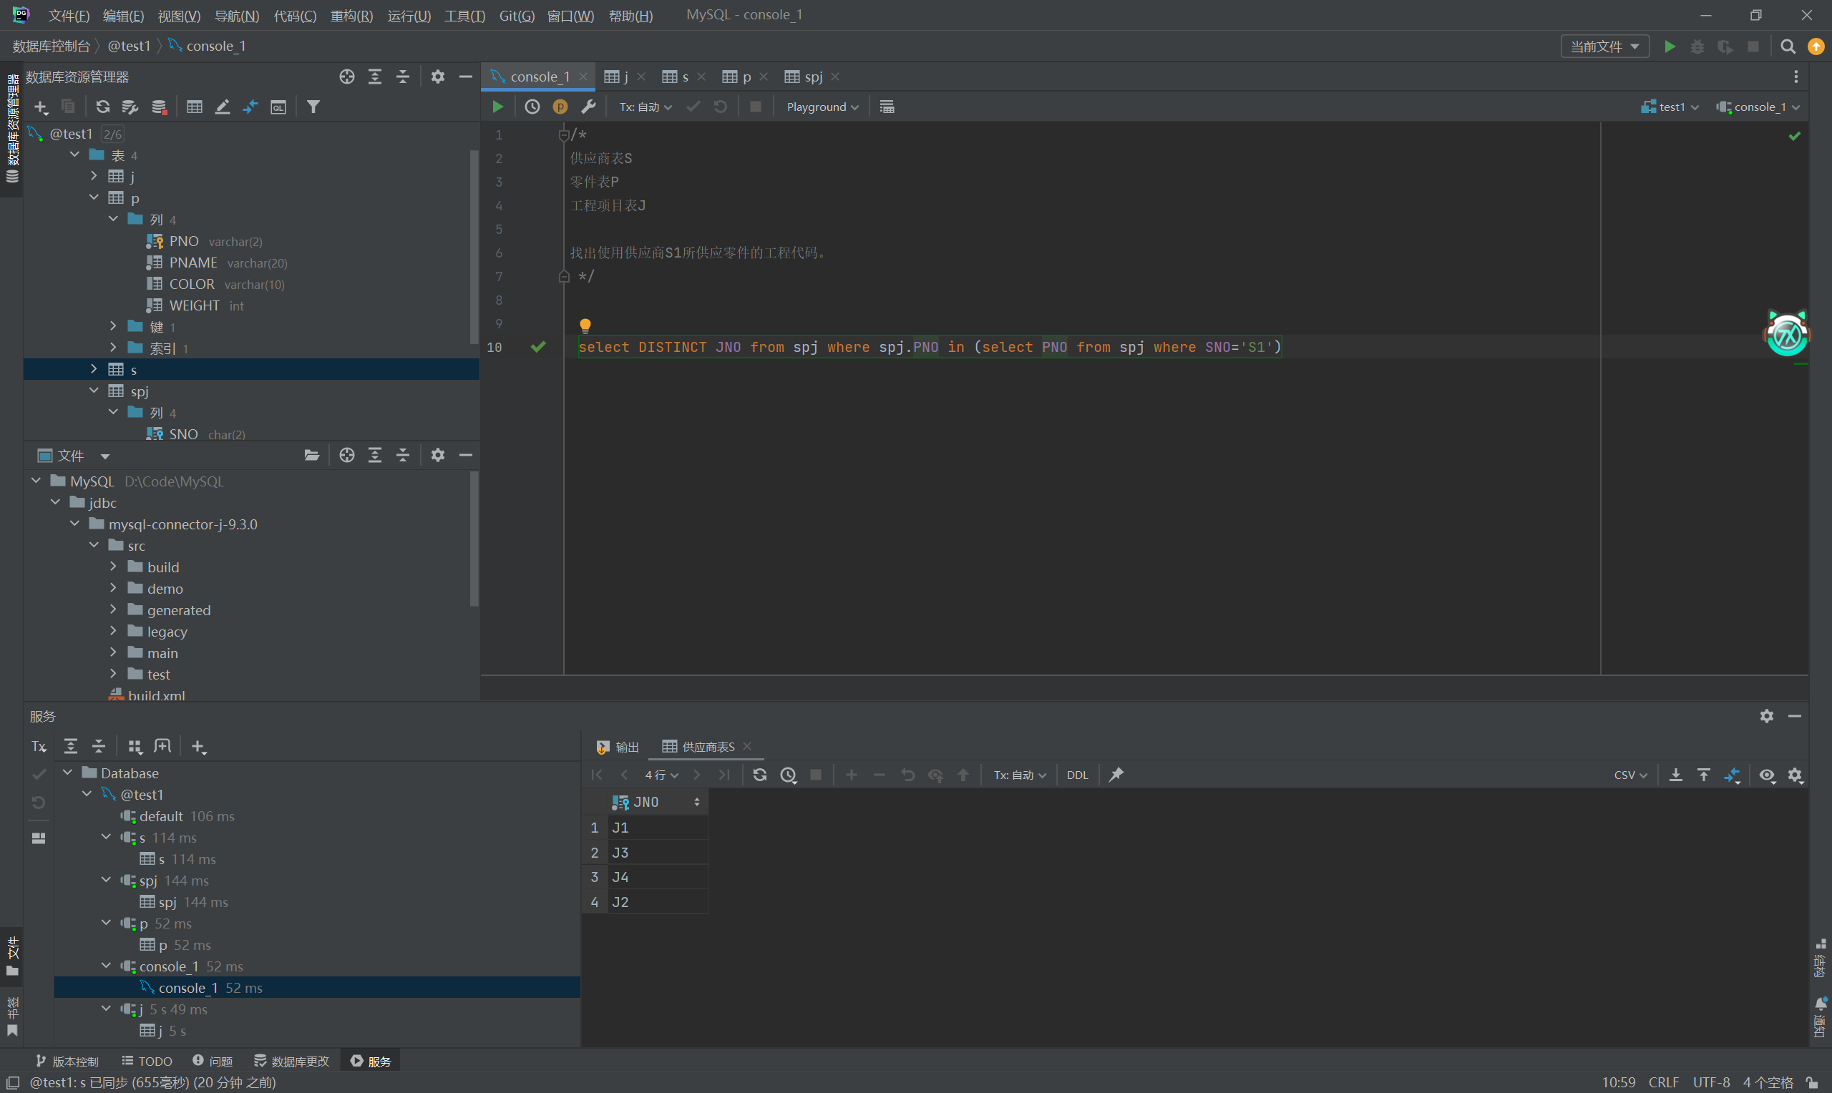

- 找出工程项目J2使用的各种零件的名称及其数量。
select p.PNAME as "名称",sum(spj.QTY) as "数量" from spj join p on p.PNO =spj.PNO where spj.JNO='J2' group by PNAME;
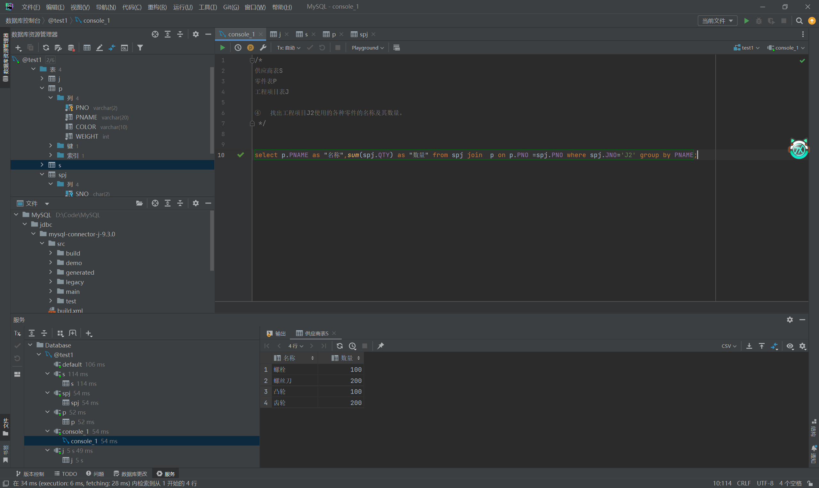

- 找出上海厂商供应的所有零件代码。
select distinct spj.PNO from spj join s on spj.SNO = s.SNO where s.CITY='上海'
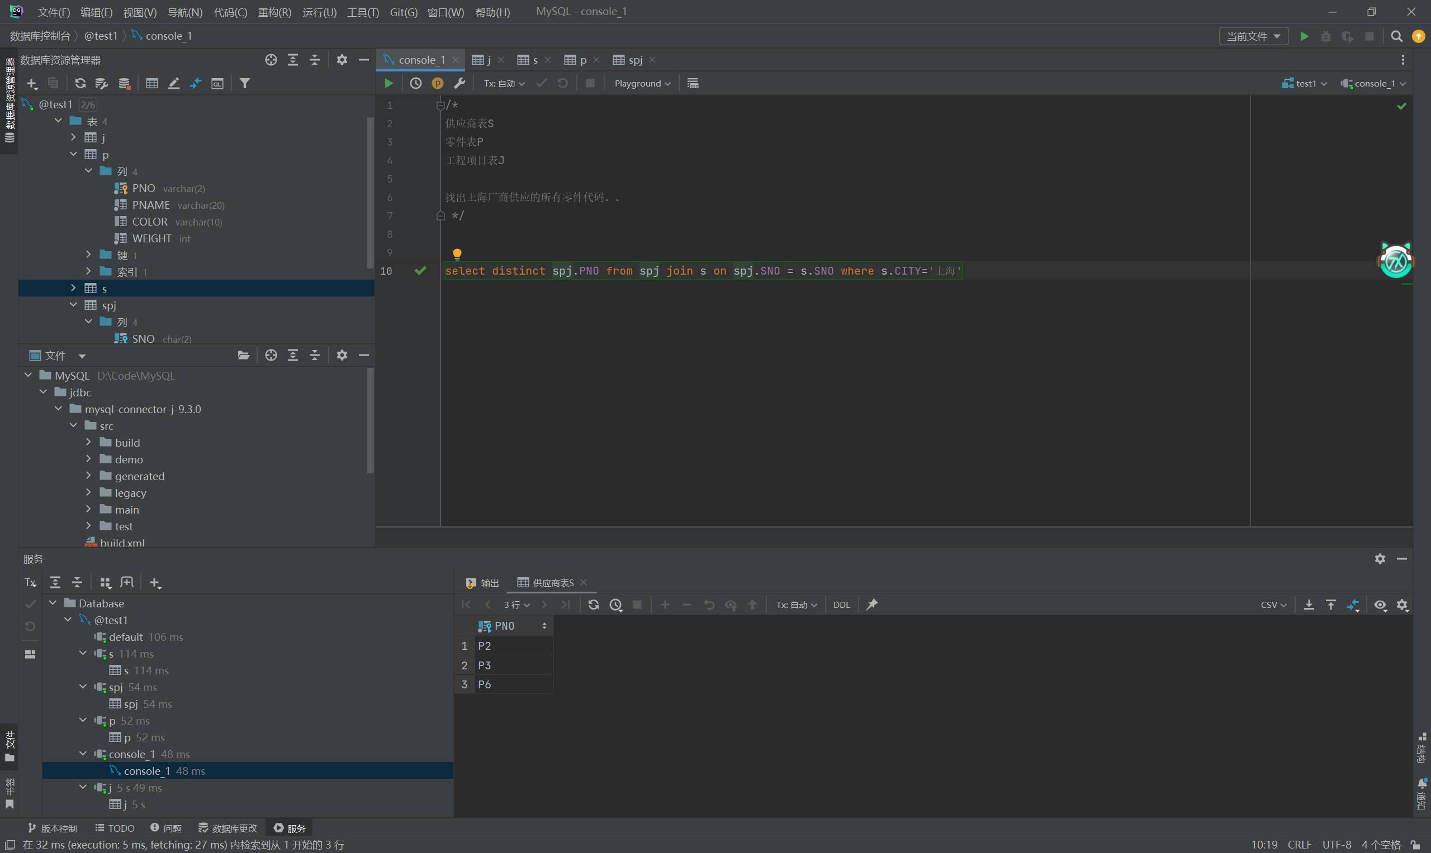
- 找出使用上海产的零件的工程名称。
select distinct j.JNAME from j join spj on j.JNO = spj.JNO join s on s.SNO = spj.SNO where s.CITY = '上海'
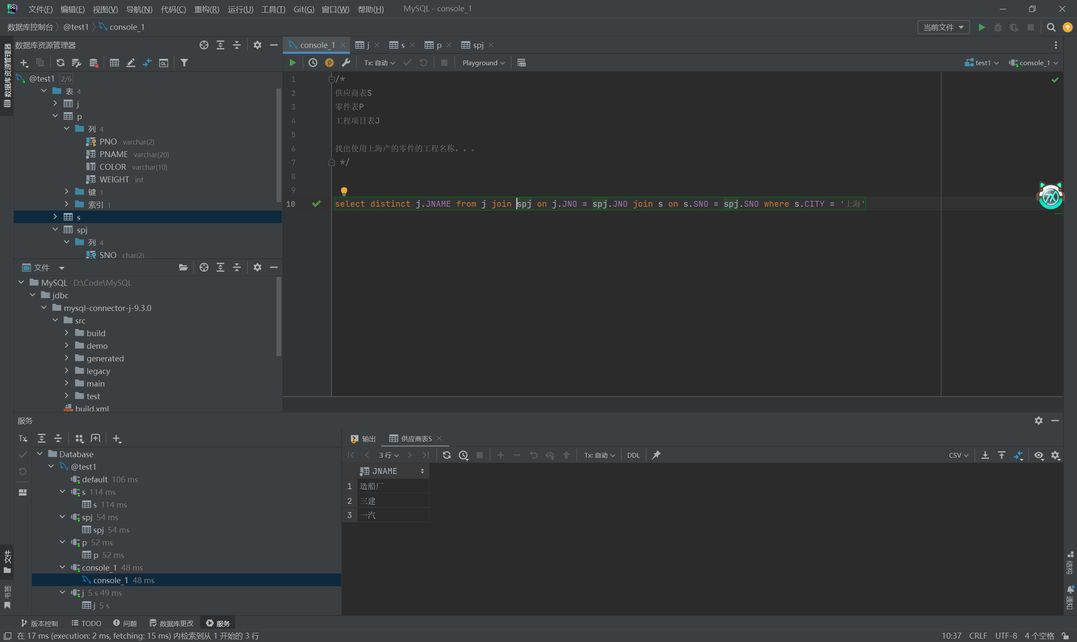
- 找出没有使用天津产的零件的工程代码。
select distinct j.JNAME from j join spj on j.JNO=spj.JNO join s on s.SNO=spj.SNO where s.CITY !='天津'
返回所有使用了非天津供应商提供的零件的工程，但这并不等同于“没有使用天津产的零件”的工程
SELECT DISTINCT j.JNO
FROM j
WHERE NOT EXISTS (
SELECT 1
FROM spj
JOIN s ON spj.SNO = s.SNO
WHERE spj.JNO = j.JNO AND s.CITY = '天津'
);
这个才对
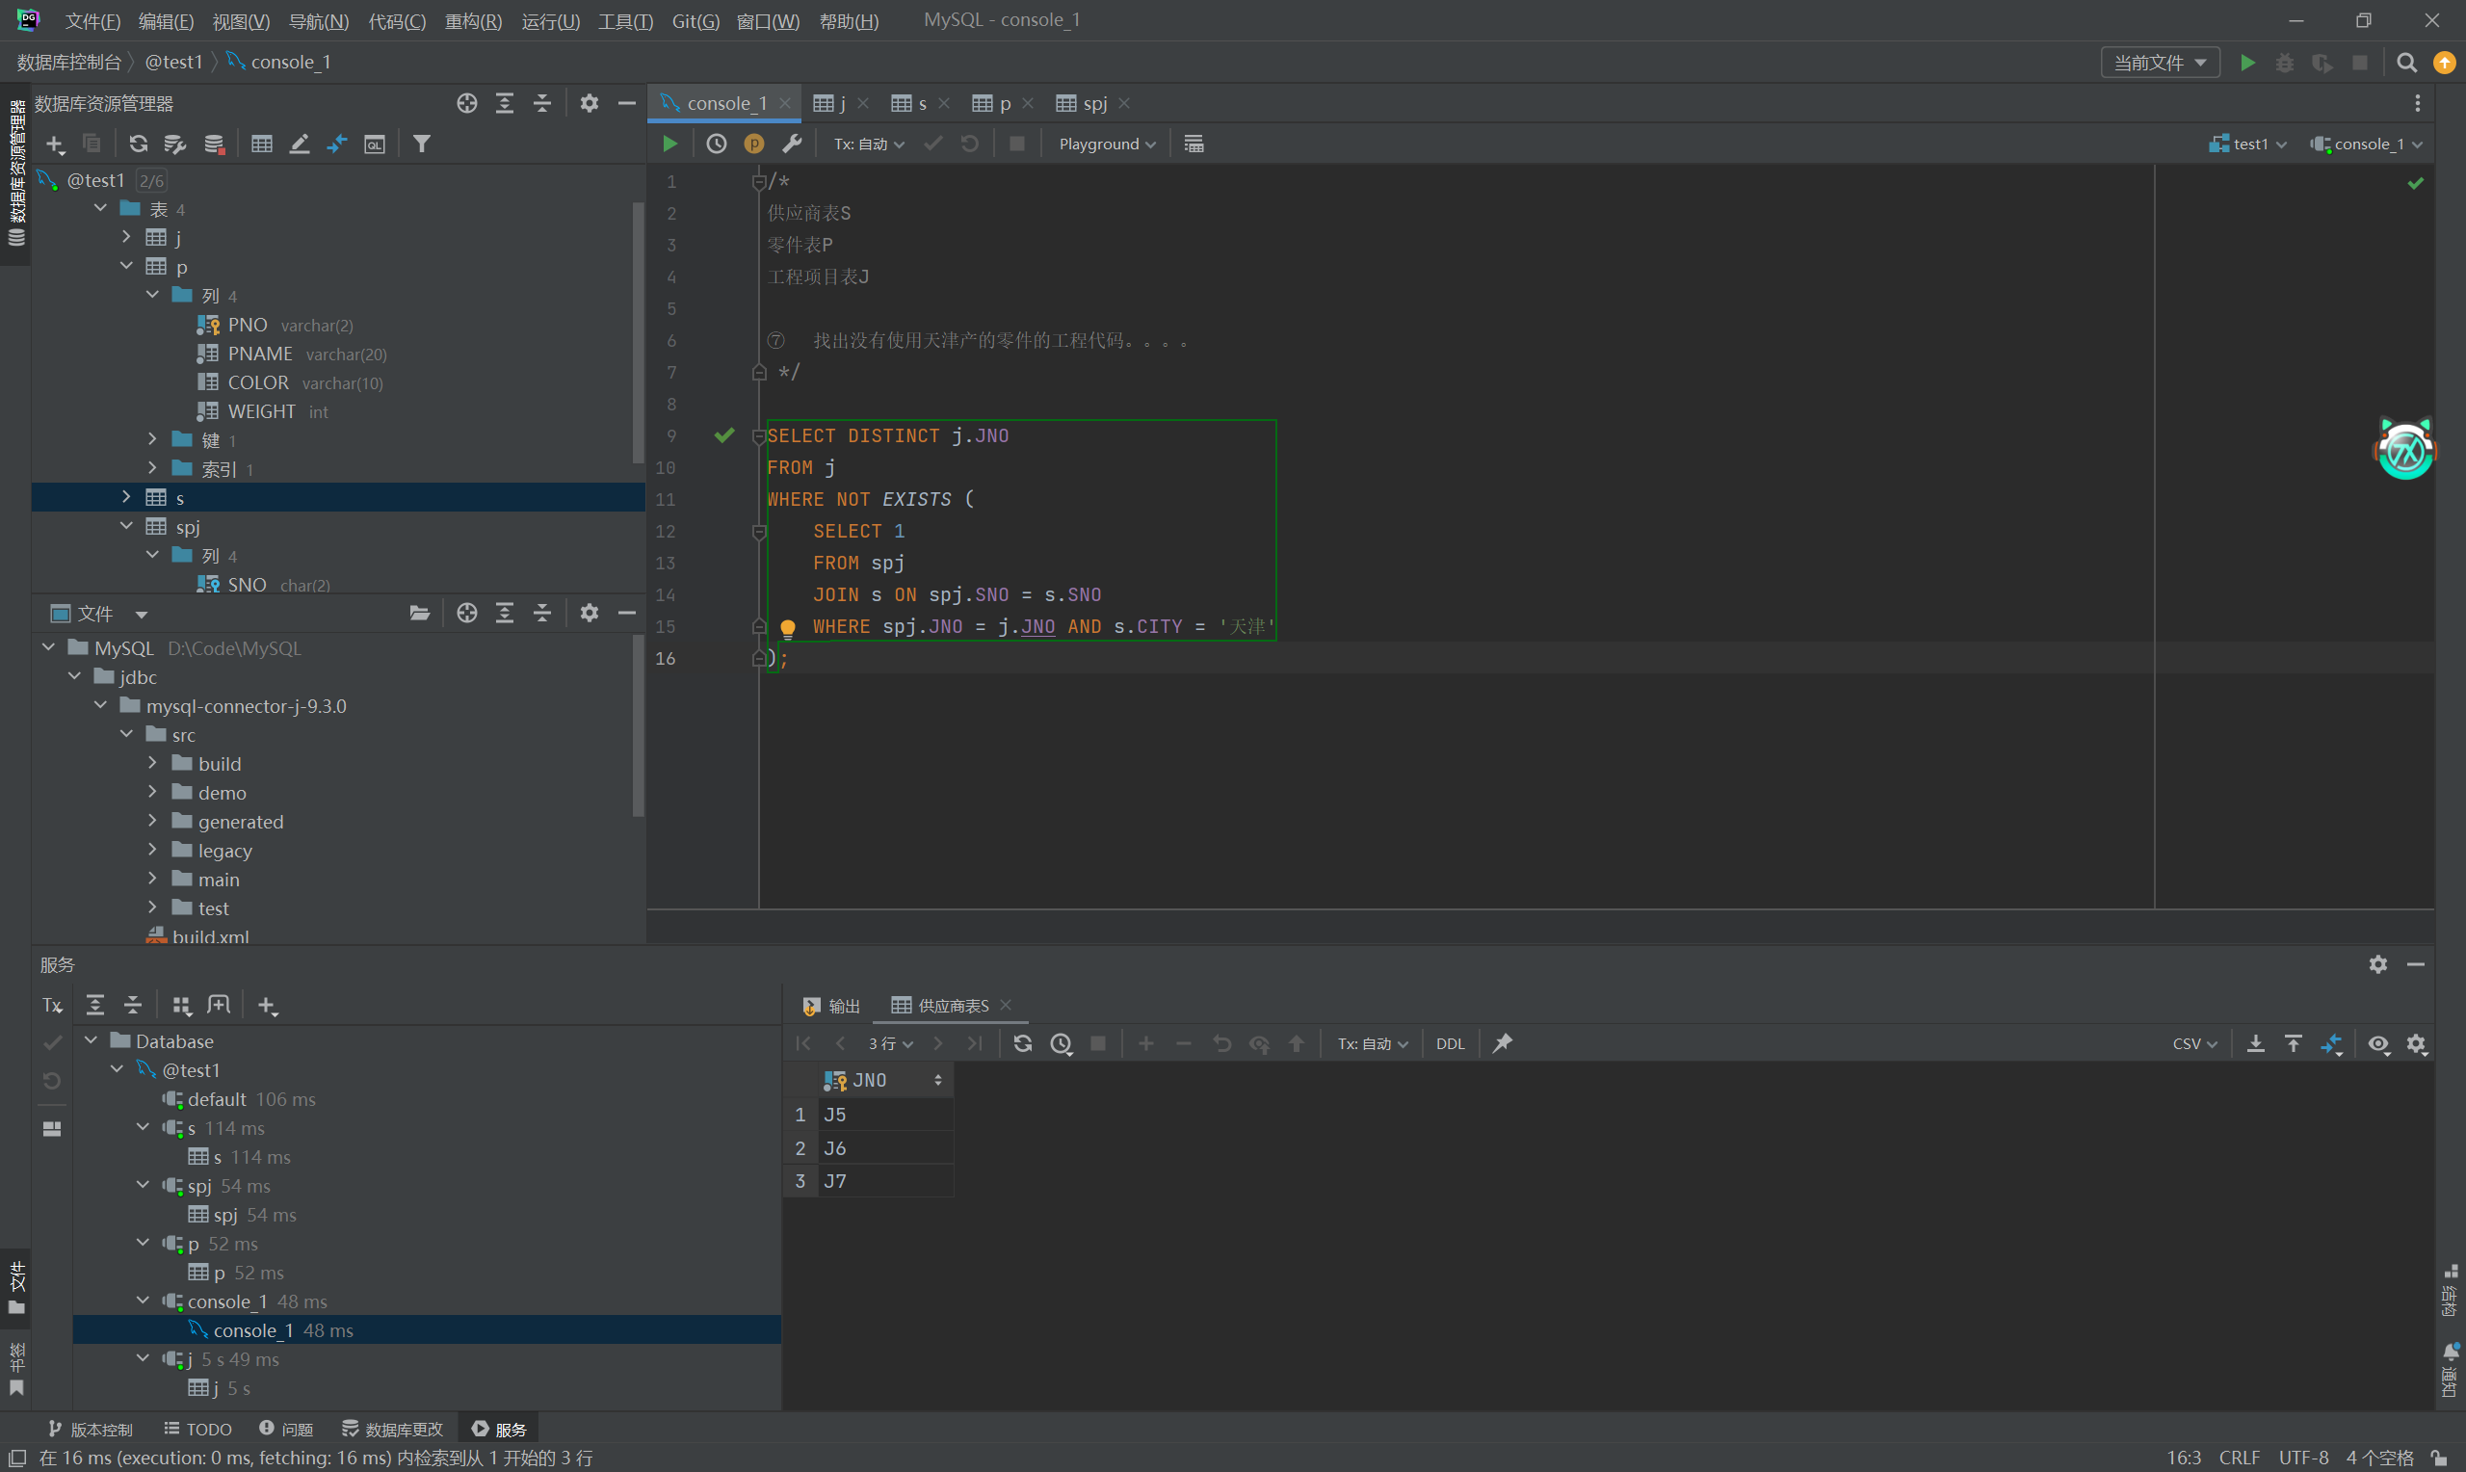

- 把全部红色零件的颜色改成蓝色。
update p set COLOR='蓝' where COLOR='红'
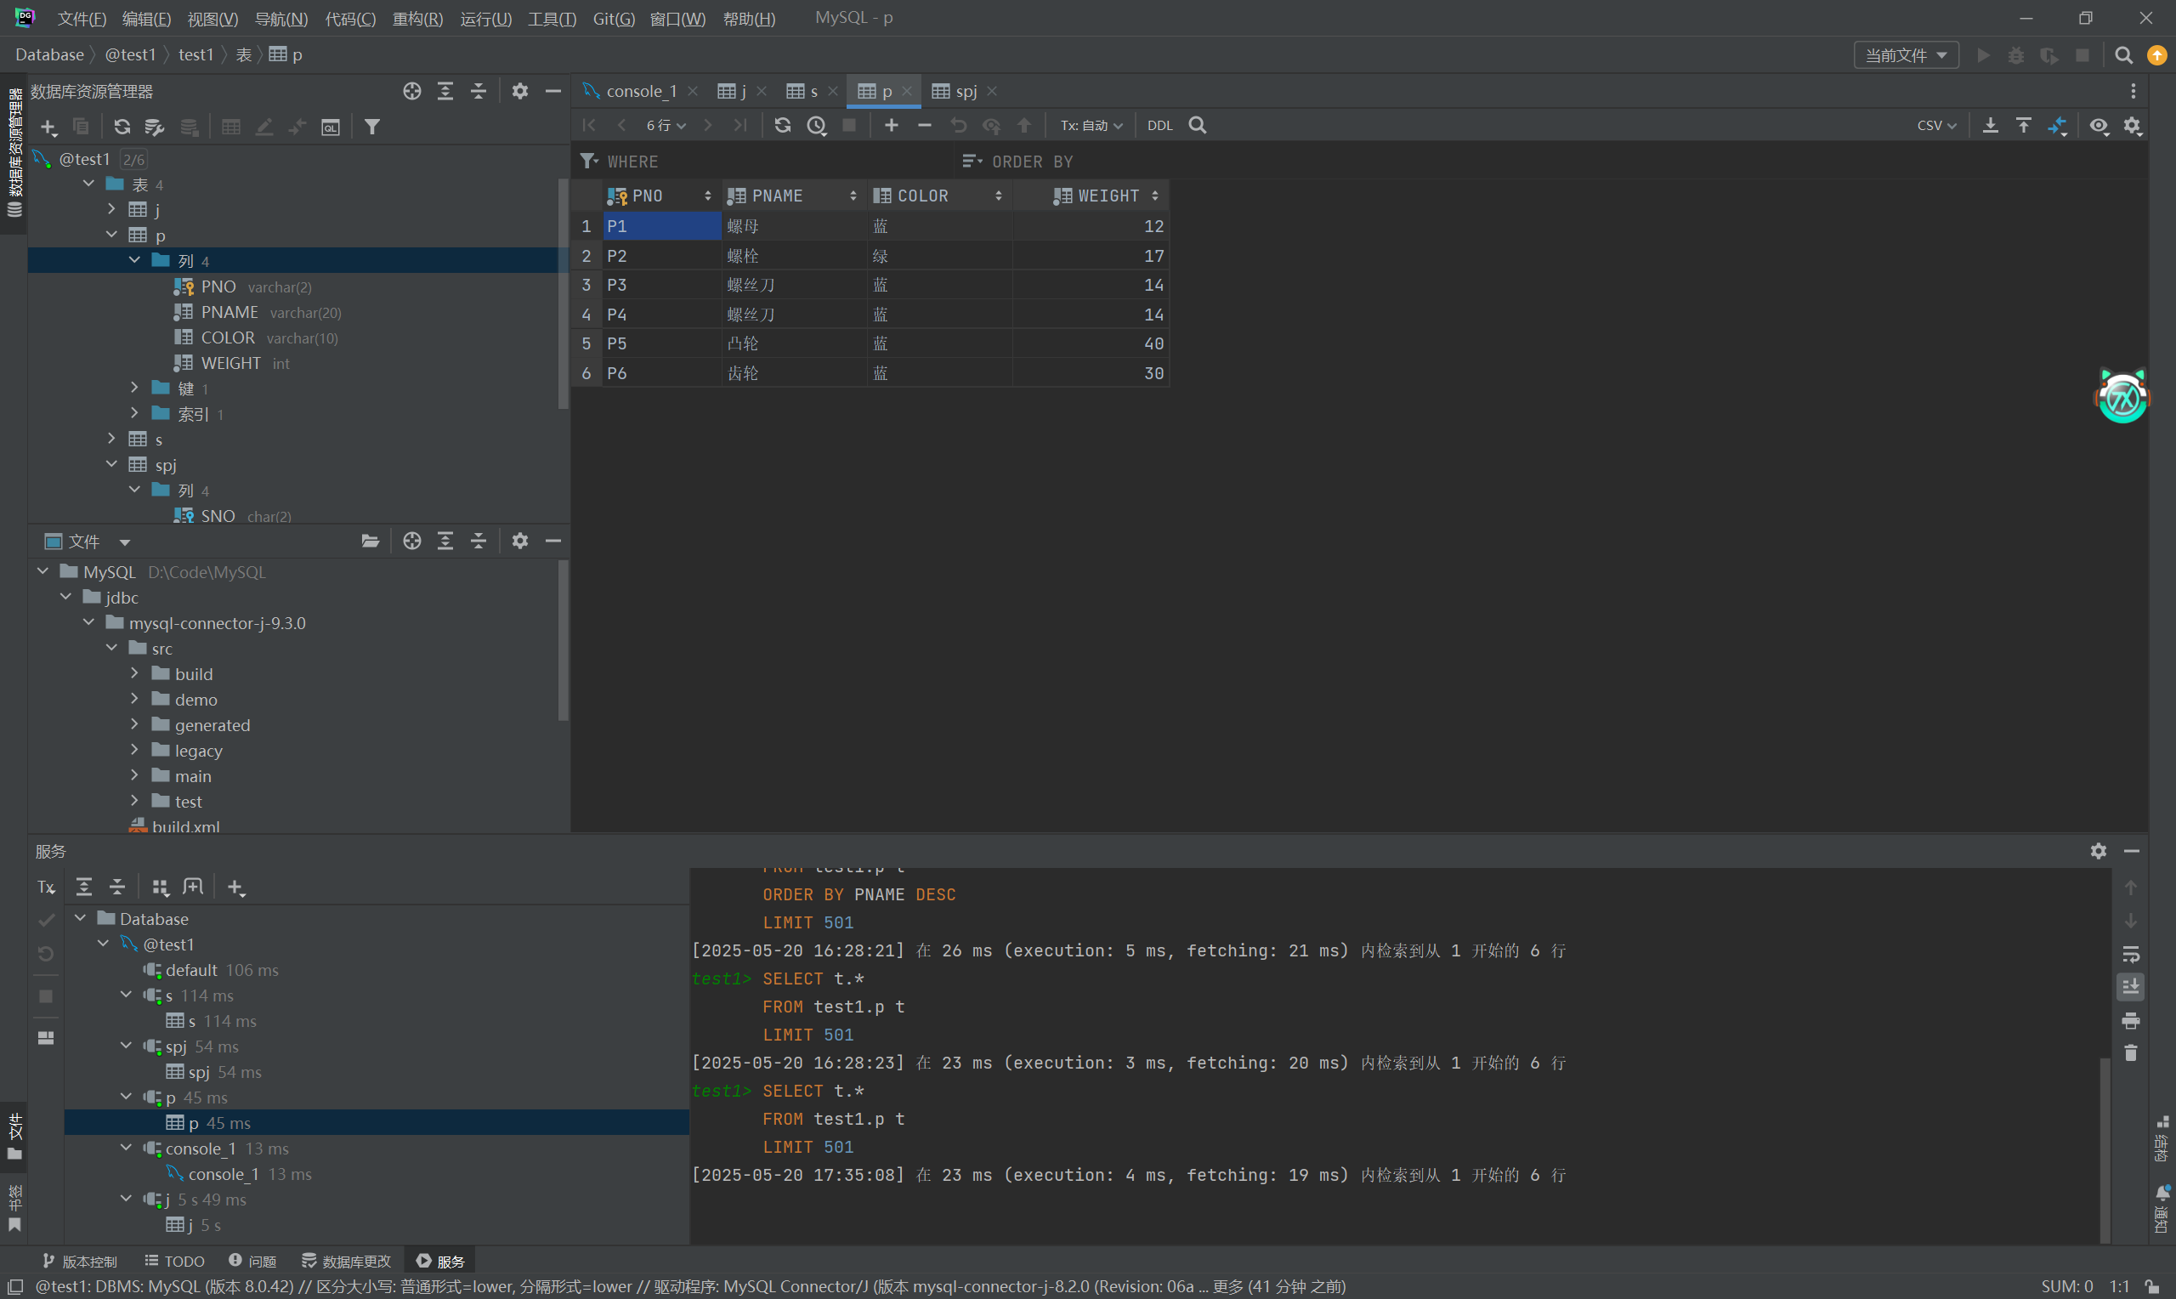

- 把由S5供给J2的零件P6改为由S3供应。
update spj set SNO='S3' where spj.SNO='S5' and spj.PNO='P6' and spj.JNO='J2'
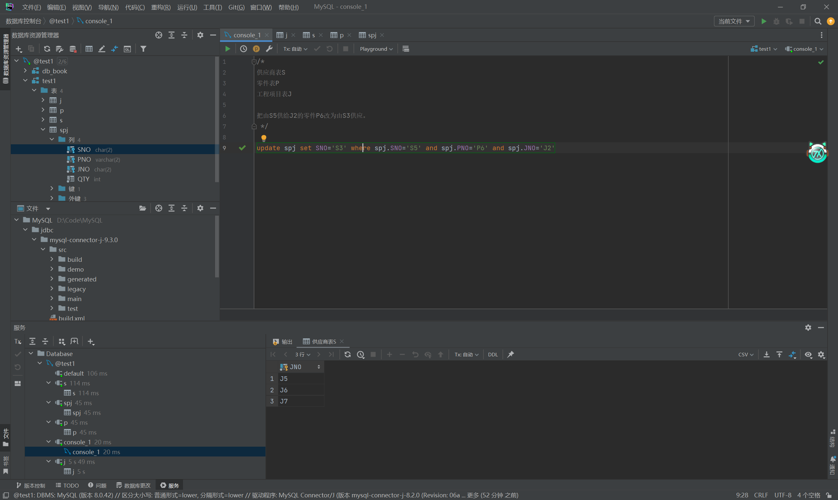

- 从供应商关系中删除S2的记录，并从供应情况关系中删除相应的记录。‘’‘
-- 第一步：删除 SPJ 表中与 S2 相关的记录
DELETE FROM SPJ
WHERE SNO = 'S2';
-- 第二步：删除 S 表中的 S2 供应商记录
DELETE FROM S
WHERE SNO = 'S2';
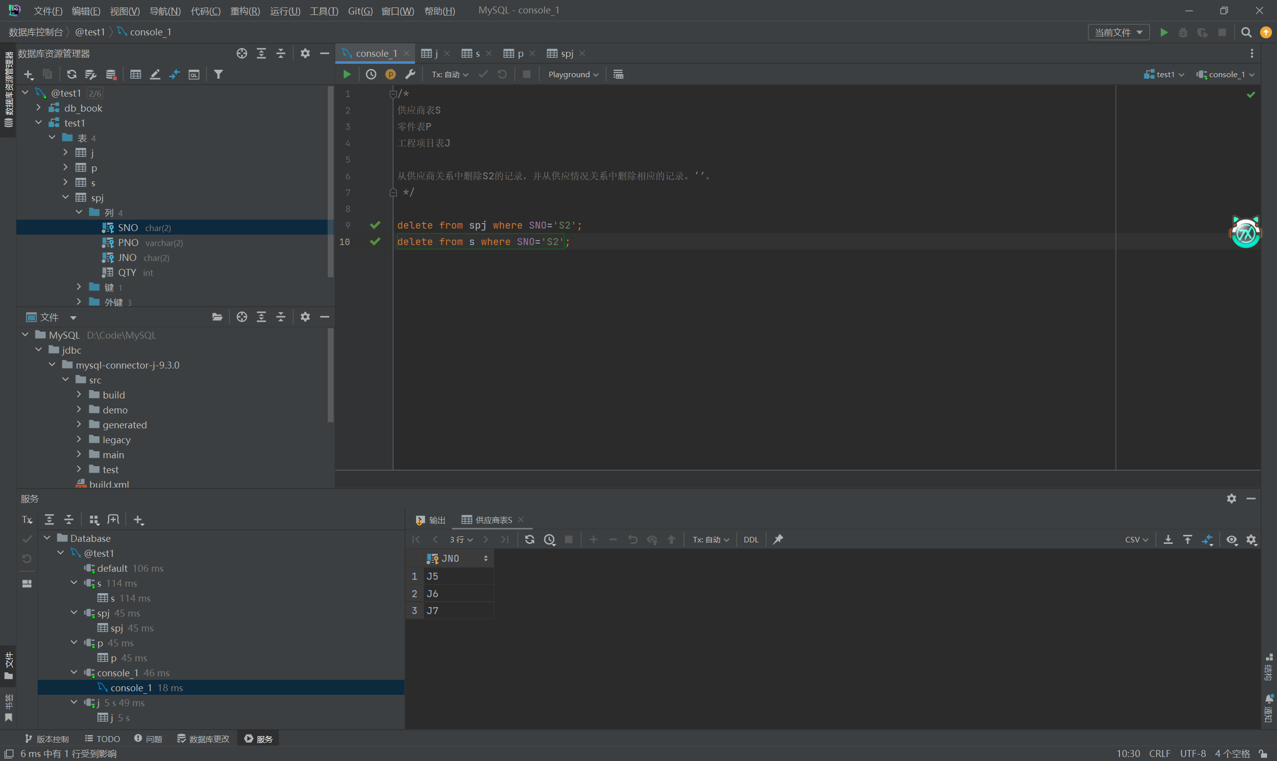

- 请将（S2,J6，P4，200）插入供应情况关系。
输入
INSERT INTO spj(SNO, PNO, JNO, QTY)VALUES ('S2', 'P4', 'J6', 200);报错
原因是spj 表中的 SNO 字段引用了 s 表中的 SNO，如果S 表中没有 SNO = 'S2' 的记录，就会报错，所以首先检查
SELECT * FROM S WHERE SNO = 'S2'; 没查到
SELECT * FROM P WHERE PNO = 'P4';查到了
SELECT * FROM J WHERE JNO = 'J6';查到了
先插入’S2’
INSERT INTO S (SNO, SNAME, STATUS, CITY)VALUES ('S2', '供应商S2', 20, '北京');
最后
INSERT INTO spj(SNO, PNO, JNO, QTY)VALUES ('S2', 'P4', 'J6', 200);
