**Concept Map**

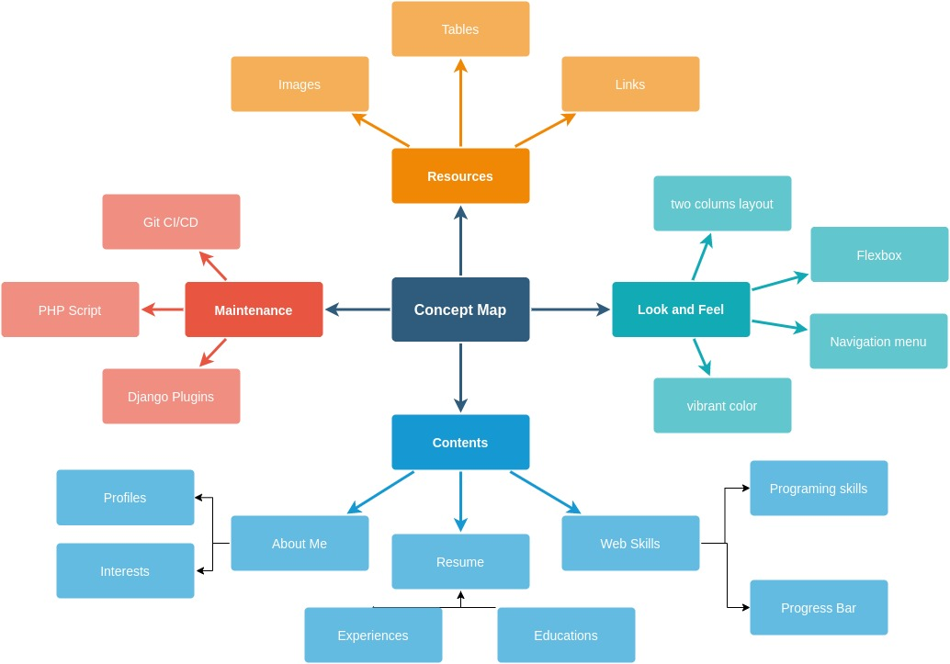

**Navigation Map**

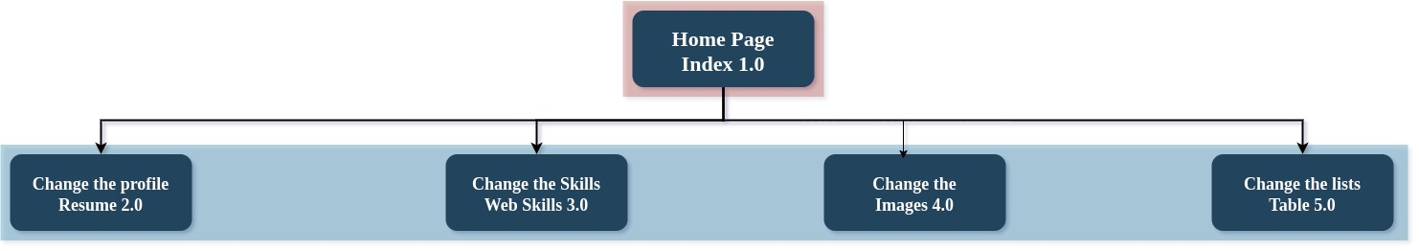

**Structure Chart**

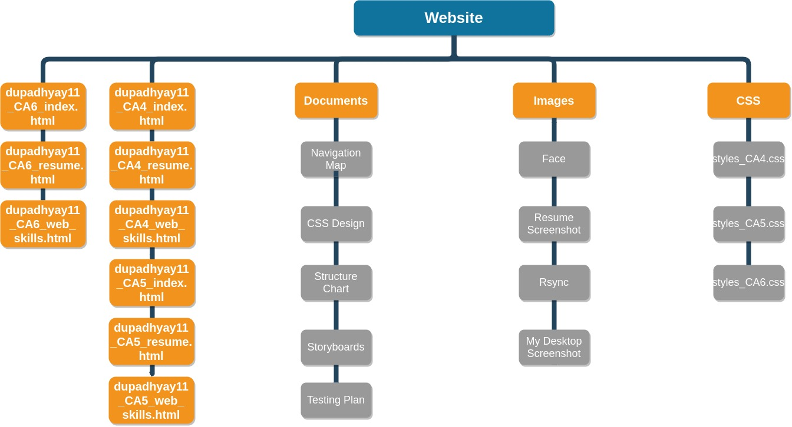

**Testing Plan**

Testing for this Website is as follows:

* Validation of HTML / CSS Files

1. All HTML5 files will be validated using <https://validator.w3.org/>
2. All CSS3 files will be validated using https://jigsaw.w3.org

* Testing Look and Feel of the websites in different browsers

1. 640 x 480 pixels
2. 1280 X 1024 pixels,
3. Responsive across all browser, try resizing websites
4. Compatibility across browser [Firefox, Google Chrome, Opera, Chromium]

* Test all hyperlinks on site

1. All internal links (site navigation)
2. All external hyperlinks.

* Testing media functionality on site

1. Images,
2. Videos

**Storyboards**

Homepage – index.html

|  |  |
| --- | --- |
| Graphics | Background use colors, Navigation bars use colors, all used via CSS file |
| Text | Different fonts and text sizes are used in the page via external or internal CSS |
| Links | Links used in navigation to move around web pages are used and external links like from Youtube is embedded into the page for video functionality |

|  |  |
| --- | --- |
| Title | Author Name and Page Name |
| Description | Home Page / About Page |
| Contents | A brief introduction about author background, interests and opinions. |
| Interaction | Youtube link has been embedded for interaction with authors video |
| Navigation | Navigation of all the webpages are linked in the navigation bar |

Resume – resume.html

|  |  |
| --- | --- |
| Title | Author Name and Page Name |
| Description | Resume Page |
| Contents | About Me, Work Experience, Educational Background, Hobbies, Languages, Planned Units / Expecting outcome from the course in the future career |
| Interaction | Resume can be downloaded with a link |
| Navigation | One page layout with tables format |

Web Skills – web_skills.html

|  |  |
| --- | --- |
| Title | Author Name and Page Name |
| Description | Web Skills |
| Contents | Skills, progress bar to show skills in specific programming platform |
| Interactions | Progress bar |
| Navigation | Simple one page layout |

Issues