Project Screenshots

Home Screens
- NutriAssist landing page
- Personalized nutrition assistant introduction
- Login and Get Started navigation
- Nutrition overview preview
- Features section highlighting the application functionality

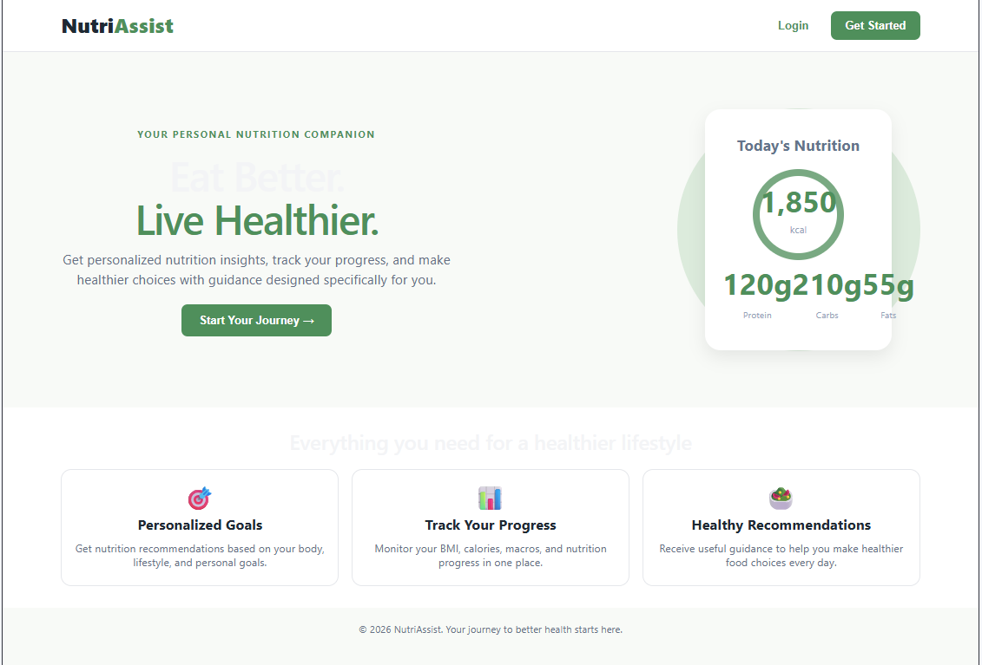

Registration Screens
- Create Account page
- User registration form
- Personal information input
- Age, weight, height, gender, and activity level selection
- Successful registration confirmation

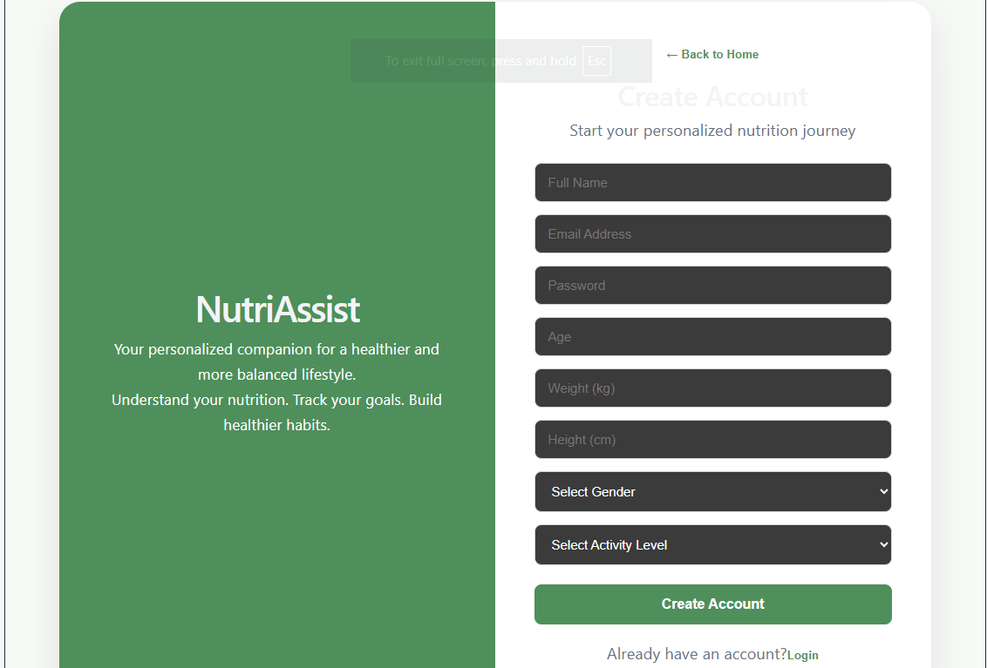

Login Screens
- User login page
- Email and password authentication
- Successful login and navigation to the dashboard
- Login validation and error handling
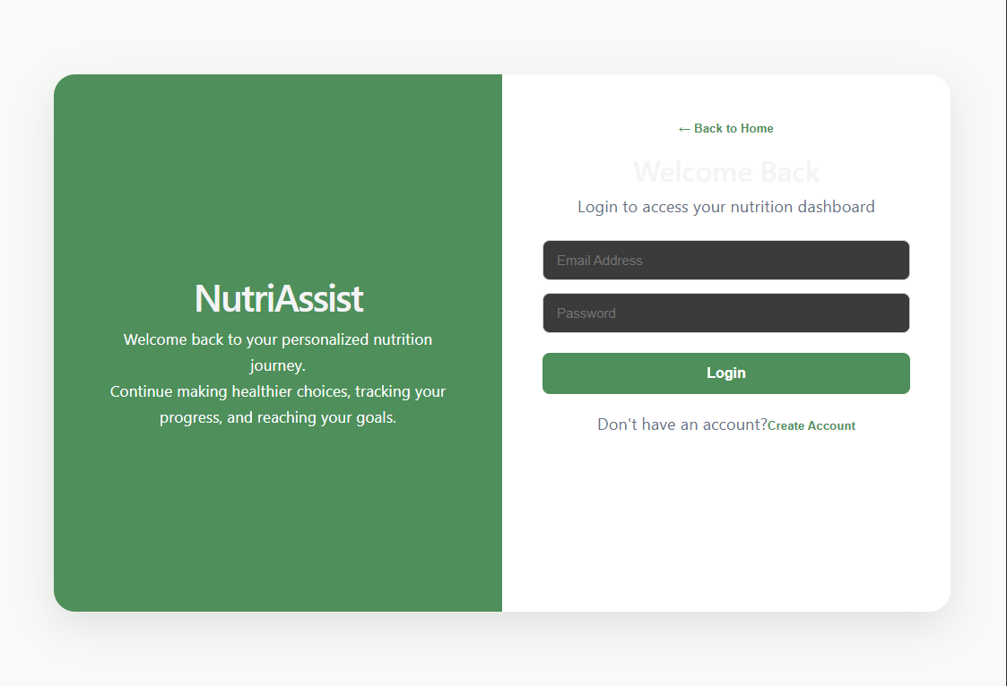
Dashboard Screens
- Personalized welcome message
- User profile information
- Age, weight, height, and activity level display,Nutrition goal selection
- Weight Loss, Maintenance, and Weight Gain options
- Navigation to Food Tracker, Diet Plans, and Progress Reports
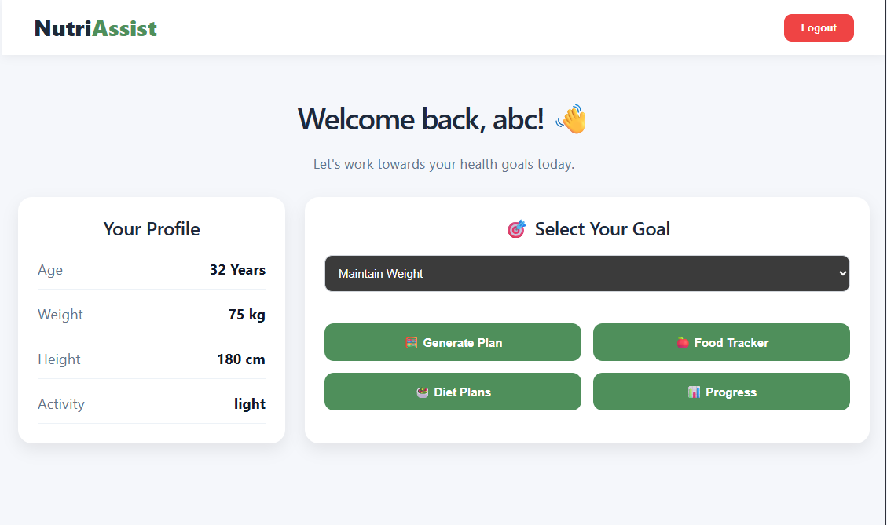
Nutrition Plan Screens
- Personalized nutrition plan generation
- BMI calculation
- BMI category
- Daily calorie requirements
- Protein, carbohydrate, and fat targets
- Personalized nutrition recommendations
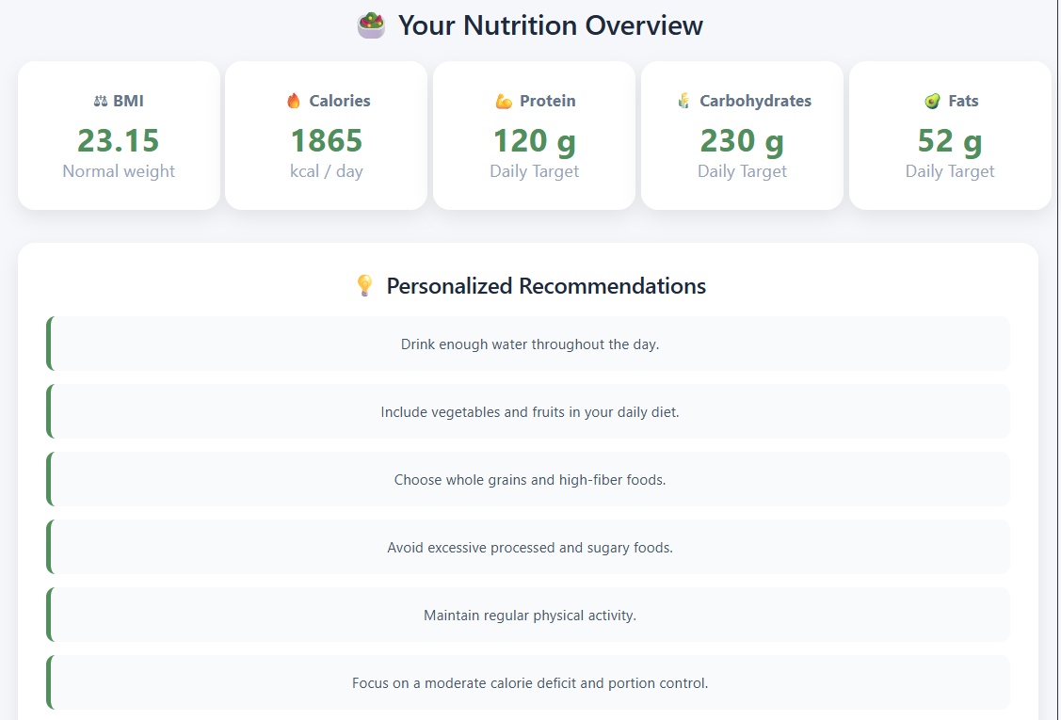
Food Tracker Screens
- Add food entries
- Record food consumed by the user
- Track daily food intake
- View nutritional information
- Manage and delete food records
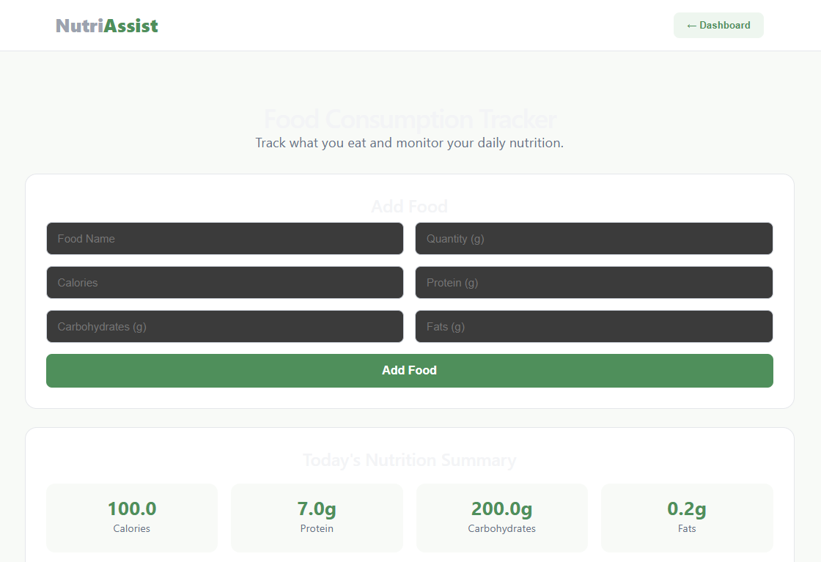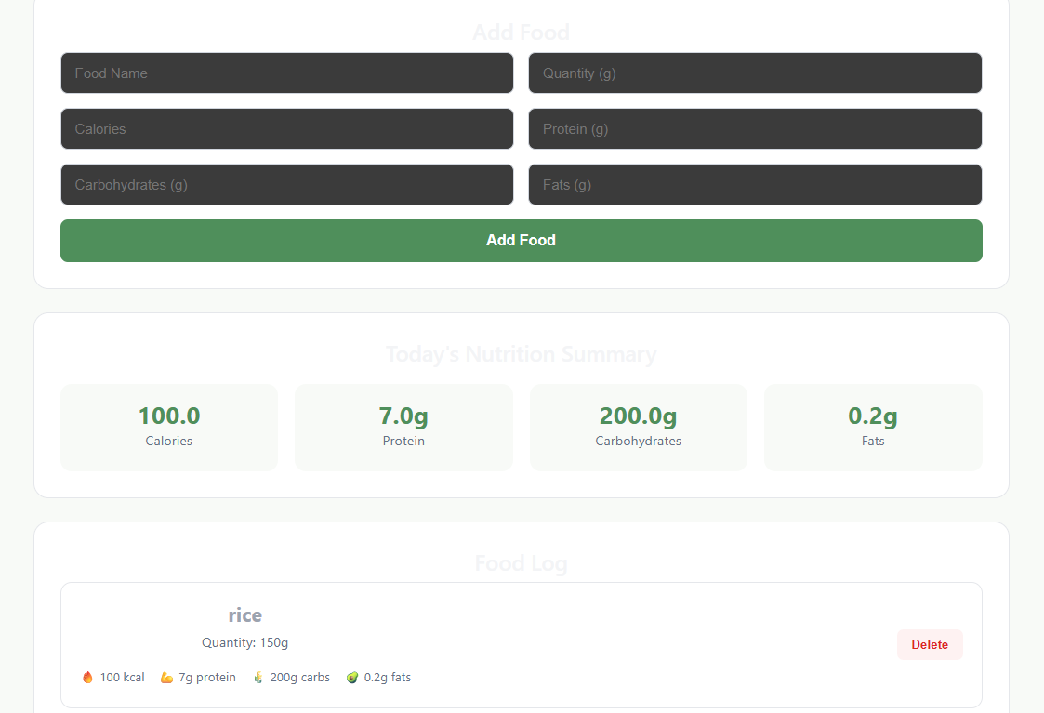
Diet Plan Screens
- Create personalized diet plans
- Add meal information
- Specify meal type and nutritional details
- View saved diet plans
- Delete existing diet plans
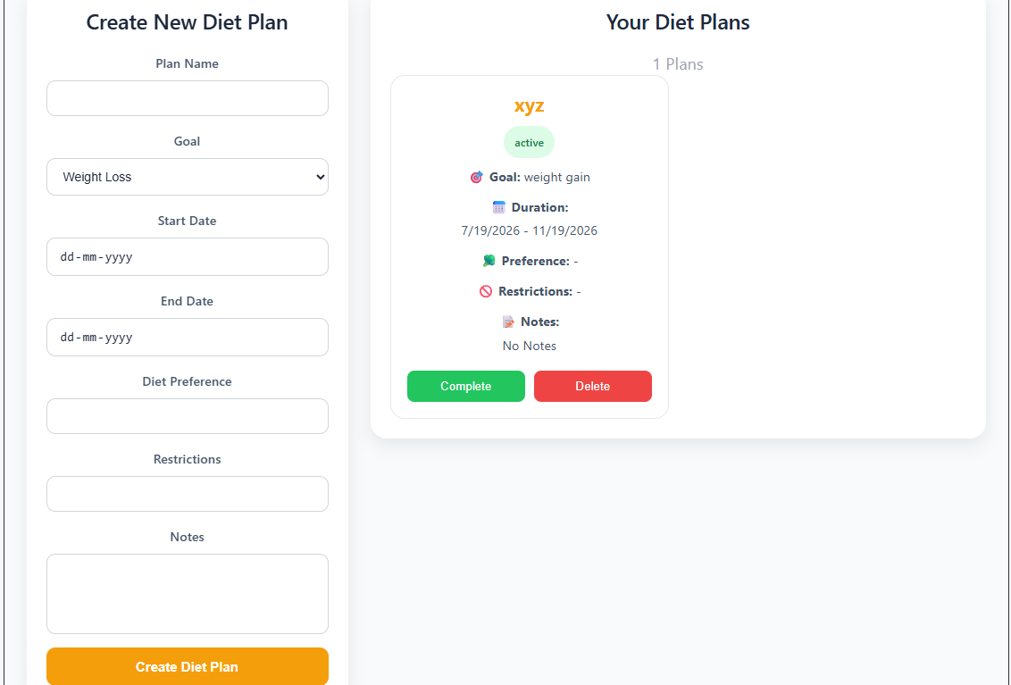
Progress & Reports Screens
- Track nutrition progress
- View BMI and calorie information
- Monitor food and nutrition records
- View progress reports and summaries
