Full Stack Development with MERN
Project Documenta on Format

1. INTRODUCTION
- Project Title: ShopEZ: One-Stop Shop for Online Purchases
- Team Members: Pranathi Yarragolla – team lead
Shaik Parveen – member
Puvvulla Devi Sri – member
Penti Nageswari - member

2. PROJECT OVERVIEW

1. Purpose
The purpose of this project is to design and develop a fully func onal e-commerce website that provides users with a seamless online shopping experience. The pla orm aims to bridge the gap between consumers and sellers by offering a convenient, secure, and user-friendly interface for browsing, selec ng, and purchasing products. It is built using the MERN (MongoDB, Express.js, React, Node.js) stack to ensure scalability, real- me performance, and maintainability.
This project is intended to streamline the en re shopping process—from product discovery and cart management to order placement and payment—while ensuring robust user authen ca on, responsive design, and efficient backend management. The goal is to replicate and enhance the essen al features of leading e-commerce pla orms, making it adaptable for various product categories and business models.

2. Features
- User Authen ca on & Authoriza on
  - Secure registra on and login system
○. JWT-based authen ca on
○. Role-based access control (Admin/User)
- Product Catalog
  - Dynamic lis ng of products with images, descrip ons, and prices
○. Filtering and sor ng by categories, brands, and price range
○. Product detail page with specifica ons and reviews
- Shopping Cart
  - Add/remove items to/from cart
○. Quan ty management
○. Real- me cart updates and total price calcula on
- Search Func onality
  - Keyword-based product search
○. Autocomplete sugges ons for faster naviga on
- Order Management
  - Checkout flow with order summary
○. Address and payment informa on collec on
○. Order tracking and history
- Admin Dashboard
  - Product management (add, edit, delete products)
○. User management and analy cs
○. Order management with delivery status updates
- Responsive UI
○. Fully responsive design for desktops, tablets, and mobile devices
○. Clean and intui ve user interface using modern CSS and design libraries
- Secure Payment Integra on (Op onal/Planned Feature)
○. Integra on with payment gateways (e.g., Razorpay, Stripe, etc.)
○. Secure handling of payment transac ons 9. Wishlist & Favorites (Op onal)
○. Users can save favorite products for later
10.No fica ons
○ Success and error alerts for user ac ons
○ Op onal email no fica ons for orders

3. ARCHITECTURE

1. Frontend Architecture (React.js)
The frontend is designed as a Single Page Applica on (SPA) using React.js to ensure seamless user interac on and a dynamic experience. It adheres to a component-based architecture where each UI element is modular and reusable.
Key Features:
- Component Hierarchy: The applica on is broken into reusable components like Header, Footer, ProductCard, LoginForm, Dashboard, etc., following a clean and maintainable structure.
- Client-Side Rou ng: Implemented using react-router-dom, enabling smooth naviga on between routes such as /login, /register, /products, /cart, and /admin.
- State Management: Redux Toolkit is used to manage global applica on state. AsyncThunk handles asynchronous opera ons such as API calls and state updates.
- Authen ca on Handling: JWT tokens (Access and Refresh) are stored securely (e.g., in memory or localStorage) and a ached to requests using axios interceptors.
- Responsive UI: Designed using Tailwind CSS to ensure responsiveness and consistency across various screen sizes and devices.
- Error & No fica on Handling: Integrated toast no fica ons to provide feedback on successful or failed user ac ons.

2. Backend Architecture (Node.js and Express.js)
The backend is developed using Node.js and Express.js, structured in a RESTful API format. It is responsible for user authen ca on, CRUD opera ons, order processing, and email no fica ons. Key Components:
- Modular Rou ng: Organized routes for users, products, categories, orders, and admin func onali es.
- Controllers and Middleware:
  - Controllers handle request logic and valida on.
○ Middleware ensures route protec on (authen ca on and authoriza on), input valida on, and error handling.
- Authen ca on System:
  - JWT tokens are used for secure, stateless authen ca on.
○ Passwords are hashed using bcryptjs before storage.
- Security Prac ces:
○ Middleware protects against unauthorized access.
○ Environment variables are managed securely using .env files.
- Email Integra on: Nodemailer is used to send password reset emails and order confirma on messages.
- Deployment-Ready: Backend is structured to support produc on deployment, with appropriate logging, error responses, and configura on support.

3. Database Architecture (MongoDB)
MongoDB is used as the primary database for ShopEZ, providing a scalable and flexible NoSQL structure. Mongoose ODM (Object Data Modeling) library is used to define schemas and handle data opera ons.
Primary Collec ons:
- Users
  - Fields: name, email, hashedPassword, role, address, resetToken, resetTokenExpiry
○. Contains authen ca on and authoriza on data.
- Products
  - Fields: tle, descrip on, price, image, category, stock, colors, createdAt ○. Holds all product-related data and varia ons.
- Orders
  - Fields: userId, items, totalAmount, shippingAddress, paymentStatus, orderStatus, createdAt
○. Manages order records placed by users.
- Categories
  - Fields: name, descrip on
○. Used for product classifica on.
- Wishlists
  - Fields: userId, products[]
○. Tracks user-selected products for future purchases. Database Opera ons:
- Create, Read, Update, and Delete (CRUD) func onali es for each collec on.
- Aggrega on pipelines are used for filtering and searching data efficiently.
- Rela ons (e.g., referencing userId in Orders) are maintained using MongoDB references.
- Indexing is applied on frequently queried fields such as email, product name,
and category.

4. SETUP INSTRUCTIONS

1. Prerequisites
1. So ware Requirements
Tool | Version  (Recommended) | Descrip on
Node.js | v16.x or later | JavaScript run me to run backend and  React
npm | Comes with Node.js | Package manager for dependencies
MongoDB | v6.x or Atlas (Cloud) | NoSQL database for storing project data
Git | Latest | To clone the Git repository
VS Code | Latest | Code editor (op onal but recommended)
Verifica on of installa ons:
node -v npm -v mongo --version git –version

2. Installa on Steps
To run the ShopEZ e-commerce web applica on on your local machine, follow these step-by-step instruc ons. The project uses the MERN stack — consis ng of MongoDB, Express.js, React.js, and Node.js — and includes both a user-facing store and an admin panel for backend management. Step 1: Clone the Git Repository
- Begin by cloning the project repository from GitHub using the following command:
git clone <rh ps://github.com/bidisha-
biswas0610/SMARTBRIDGE_MERN_Project_ECommerceWebsite_ShopE
Z.git>
- Once the repository is cloned, navigate into the main project directory: cd E-Commerce Website
Step 2: Backend Setup (Node.js + Express.js)
The backend is responsible for handling API requests, user authen ca on, order processing, and more.
- Navigate to the backend folder: cd Backend
- Install all required backend dependencies: npm install
- Create a .env file in the Backend directory to store environment variables securely:
touch .env
- Add the following configura ons to your .env file:
PORT=5000
MONGO_URI=mongodb_connec on_string
JWT_SECRET=jwt_secret
EMAIL_USER=email@example.com
EMAIL_PASS=email_password
- Start the backend server: npm run server
By default, the backend server will start at h p://localhost:5000.
Step 3: Frontend Setup (React.js + Tailwind CSS)
The frontend includes the customer shopping experience and the admin dashboard, all built using React.
- Navigate to the frontend folder:
cd ../Frontend
- Install frontend dependencies:
npm install
- Create a .env file in the Frontend directory:
touch .env
- Add the API base URL to the .env file:
VITE_API_URL=h p://localhost:5000
- Start the React development server:
npm run dev
The frontend should now be accessible on h p://localhost:5173.
Step 4: MongoDB Database Setup
ShopEZ uses MongoDB to store data such as product lis ngs, user informa on, orders, and wishlist items.
You have two op ons:
- Op on 1 (Local): Install MongoDB on your machine and use:
MONGO_URI=mongodb://127.0.0.1:27017/shopez
- Op on 2 (Cloud): Use MongoDB Atlas and provide your connec on URI in the Backend .env file.
Make sure the database is accessible and collec ons like users, products, orders, and categories are created through backend API calls or seed data.

5. FOLDER STRUCTURE
1. Frontend (Client):
/Frontend
/node_modules
/public
/src
/app
/Features
/Pages
/assets
/u ls
App.jsx App.css constants.js index.css main.jsx
Folder/File | Descrip on
/node_modules | Contains all the frontend dependencies installed via npm. Not manually edited.
/public | Sta c files like favicon, manifest, and index.html reside here. They are accessible directly via the browser.
/src | Core applica on source code resides here.
/app | Configura on for the Redux store setup and slice integra on.

/Features | Houses Redux slices and logic for state management.
/Pages | Individual page components (e.g., Home, Login, Register, ProductList, Checkout). These are routed components.
/assets | Stores all sta c files such as images, logos, and icons.
/u ls | U lity/helper func ons used across the app (e.g., date forma er, validators, etc.).
App.jsx | Root component that wraps the whole applica on, includes layout and rou ng logic.
App.css | Main styling file for general app-level styling.
constants.js | Contains constant values used throughout the frontend (e.g., URLs, roles, enums).
index.css | Global styling or Tailwind CSS base styles.
main.jsx | Entry point of the React app; renders the App component into the DOM.
2. Backend (Server)
/Backend
/controllers
/db
/node_modules
/router
/models
/middleware
/service index.js brand.json category.json constants.js products.json package-lock.json package.json

Folder/File | Descrip on
/controllers | Contains controller files responsible for handling the logic behind each route (e.g., productController, authController).
/db | Database connec on setup (e.g., MongoDB configura on and ini aliza on).

/node_modules | Contains all backend dependencies installed via npm.
/router | Defines all API routes (e.g., authRoutes.js, productRoutes.js).
/models | Mongoose schema defini ons for collec ons like User, Product, Order, etc.

/middleware | Contains middleware for authen ca on, error handling, etc.
/service | Business logic or helper services (e.g., mailService)
index.js | Main server entry point; ini alizes Express app and connects to the database.
brand.json, category.json, products.json | Sta c JSON datasets used for tes ng or ini al seeding of product data.
constants.js | Applica on-wide constants like status codes, roles, environment se ngs.
package-lock.json | Lockfile to ensure consistent dependency versions.
package.json | Lists dependencies, scripts, and metadata about the backend project.

6. RUNNING THE APPLICATION

1. Backend (Server)
To run the backend of the ShopEZ applica on, follow these steps:
Step 1: Navigate to the Backend Directory
- Open the terminal and move into the backend folder using the command: cd Backend

Step 2: Install Dependencies
- Run the following command to install the necessary Node.js packages listed in package.json: npm install
Step 3: Environment Configura on
- Create a .env file in the root of the Backend directory and define all necessary environment variables, such as:
○ PORT: The port number on which the backend server should run.
○ MONGO_URI: The connec on string to the MongoDB database.
○ ACCESS_TOKEN_SECRET and REFRESH_TOKEN_SECRET: Used for JWT authen ca on.
○ EMAIL_USER and EMAIL_PASS: For sending transac onal emails.
○ BASE_URL: Frontend base URL.
Step 4: Start the Server
- Once the environment is configured, run the following command to start the backend server:
npm start

2. Frontend (Client)
To run the frontend of the applica on, follow these steps:
Step 1: Navigate to the Frontend Directory:
- In a new terminal window, move into the frontend folder: cd Frontend Step 2: Install Dependencies:
- Install the required frontend packages using: npm install
Step 3: Run the Frontend Development Server
- Start the frontend using the development command (typically for Vite or React):
npm run dev
This will start the frontend server, usually accessible at h p://localhost:5173.
Step 4: Access the Applica on:
- Open a browser and navigate to the frontend URL. From there, we can:
○ Register/Login as a user.
○ Browse products and view product details.
○ Add products to the cart and place orders.
○ Access admin func onali es if logged in as an admin.

7. API DOCUMENTATION

1. User Routes
- Register a New User
    - Method: POST
    - URL: /api/users/register
    - Headers: Content-Type: applica on/json
    - Body Parameters:
{
"name": "Shubham Mehta",
"email": "shubhammehta212@gmail.com",
"password": "1234567890"
}
    - Success Response:
{
"message": "User registered successfully",
"user": { "id": "abc123", "name": "Shubham Mehta", "email":
"shubhammehta212@gmail.com" },
"token": "JWT_TOKEN"
}
    - Error Response
{
"error": "Email already in use"
}
- User Login
  - Method: POST
  - URL: /api/users/login
  - Headers: Content-Type: applica on/json
  - Body Parameters:
{
"email": "shubhammehta212@gmail.com",
"password": "1234567890"
}
  - Success Response:
{
"token": "JWT_TOKEN",
"user": { "id": "abc123", "name": "Shubham Mehta" }
}
  - Error Response:
{
"error": "Invalid email or password"
}

2. Product Routes
- Get All Products
  - Method: GET
  - URL: /api/products
  - Headers: None
  - Success Response:
[
{ "id": "p1", "name": "iPhone 16", "price": 771, "stock": 10 },
...
]
- Get Product by ID
  - Method: GET ● URL: /api/products/:id
  - Success Response:
{
"id": "p1",
"name": "iPhone 16",
"descrip on": "Latest Apple iPhone",
"price": 771
}
  - Error Response:
{
"error": "Product not found"
}

3. Cart Routes
- Add to Cart
  - Method: POST
  - URL: /api/cart/add
  - Headers: Authoriza on: Bearer JWT_TOKEN
  - Body Parameters:
{
"productId": "p1",
"quan ty": 2
}
  - Success Response:
{
"message": "Item added to cart"
}
- View Cart
  - Method: GET
  - URL: /api/cart
  - Headers: Authoriza on: Bearer JWT_TOKEN
  - Success Response:
{
"cartItems": [
{ "productId": "p1", "name": "iPhone 16", "quan ty": 2 }
]
}

4. Order Routes
- Place Order
  - Method: POST
  - URL: /api/orders
  - Headers: Authoriza on: Bearer JWT_TOKEN
  - Body Parameters:
{
"items": [{ "productId": "p1", "quan ty": 2 }],
"shippingAddress": "123 Street, City",
"paymentMethod": "Cash"
}
  - Success Response:
{
"message": "Order placed successfully",
"orderId": "o123"
}
- Get User Orders
  - Method: GET
  - URL: /api/orders/myorders ● Headers: Authoriza on: Bearer JWT_TOKEN
  - Success Response:
[
{ "orderId": "o123", "status": "Processing" },
...
]

5. Authen ca on Routes
- Register User
  - Method: POST
  - URL: /api/auth/register
  - Body Parameters:
{
"name": "Shubham Mehta",
"email": "shubhammehta212@gmail.com",
"password": "1234567890"
}
  - Success Response:
{
"message": "User registered successfully",
"token": "JWT_TOKEN"
}
- Login User
  - Method: POST
  - URL: /api/auth/login
  - Body Parameters:
{
"email": "shubhammehta212@gmail.com",
"password": "1234567890"
}
  - Success Response:
{
"message": "Login successful",
"token": "JWT_TOKEN"
}

6. Wishlist Routes
- Add to Wishlist
  - Method: POST
  - URL: /api/wishlist
  - Headers: Authoriza on: Bearer JWT_TOKEN
  - Body Parameters:
{
"productId": "p1"
}
  - Success Response:
{
"message": "Product added to wishlist"
}
- Get Wishlist
  - Method: GET
  - URL: /api/wishlist
  - Headers: Authoriza on: Bearer JWT_TOKEN
  - Success Response:
[
{ "productId": "p1", "productName": "iPhone 16" },
...
]
- Remove from Wishlist
  - Method: DELETE
  - URL: /api/wishlist/:productId
  - Headers: Authoriza on: Bearer JWT_TOKEN
  - Success Response:
{
"message": "Product removed from wishlist"
}

7. Admin Dashboard Routes
- Get All Users
  - Method: GET
  - URL: /api/admin/users
  - Headers: Authoriza on: Bearer JWT_TOKEN (Admin Only)
  - Success Response:
[
{ "userId": "abc123", "name": "Shubham Mehta", "email": "shubhammehta212@gmail.com" },
...
]
- Get All Orders
  - Method: GET
  - URL: /api/admin/orders
  - Headers: Authoriza on: Bearer JWT_TOKEN (Admin Only)
  - Success Response:
[
{ "orderId": "o123", "status": "fulfilled" },
...
]
- Update Order Status
  - Method: PUT
  - URL: /api/admin/orders/:orderId
  - Headers: Authoriza on: Bearer JWT_TOKEN (Admin Only)
  - Body Parameters:
{
"status": "fulfilled"
}
  - Success Response:
{
"message": "Order status updated"
}

8. Brand Routes
- Get All Brands
  - Method: GET
  - URL: /api/brands
  - Success Response:
[
{ "brandId": "b1", "brandName": "Apple" },
...
]
- Add New Brand (Admin) ● Method: POST
  - URL: /api/brands
  - Headers: Authoriza on: Bearer JWT_TOKEN (Admin Only) ● Body Parameters:
{
"brandName": "Sony"
}
  - Success Response:
{
"message": "Brand added successfully"
}

9. Category Routes
- Get All Categories
  - Method: GET
  - URL: /api/categories
  - Success Response:
[
{ "categoryId": "c1", "categoryName": "Mobiles" },
...
]
- Add New Category (Admin) ● Method: POST
  - URL: /api/categories
  - Headers: Authoriza on: Bearer JWT_TOKEN (Admin Only)
  - Body Parameters:
{
"categoryName": "Accessories"
}
  - Success Response:
{
"message": "Category added successfully"
}

8. AUTHENTICATION

1. JWT-Based Authen ca on
- Authen ca on in ShopEZ is handled using JWT (JSON Web Tokens) stored in cookies.
- A er login or registra on, an accessToken, refreshToken, and loggedInUserInfo are set as cookies on the client.
- The accessToken is used for authorizing API requests.
- The refreshToken is used to renew expired access tokens without requiring re-
login.
1. How it Works
- verifyJWT middleware checks if the accessToken, refreshToken, and loggedInUserInfo cookies are present.
- It verifies the accessToken using ACCESS_TOKEN_SECRET. If expired or invalid, it calls the renewTokens() func on.
- The renewTokens() method:
○ Verifies the refreshToken using REFRESH_TOKEN_SECRET.
○ If valid, it generates new access and refresh tokens, stores them, and con nues the request.
- The user ID and role are extracted and a ached to the request via req.body.user.

2. Role-Based Access Control (RBAC)
- Role support includes:
- user: Can access user-level endpoints (cart, wishlist, orders, profile).
- admin: Can access admin-level features (product, brand, category, user management).
- verifyAdminJWT is a dedicated middleware that:
- Checks if the logged-in user's role is admin.
- If not, it blocks the request with a 401 Unauthorized error.
if(role !== "admin") { return next(new ApiError(401, "Unauthorized"));
}

3. Token Expira on & Refresh Handling
- Token Expiry Se ngs:
- accessToken: 10 minutes (maxAge: 600000) ● refreshToken: 20 minutes (maxAge: 1200000) ● When the accessToken expires:
- The renewTokens() func on is triggered automa cally.
- It checks the refreshToken and user ID.
- New tokens are generated and stored in cookies without affec ng the user experience.
- This ensures seamless and secure sessions for users.

4. Token Flow (Middleware)
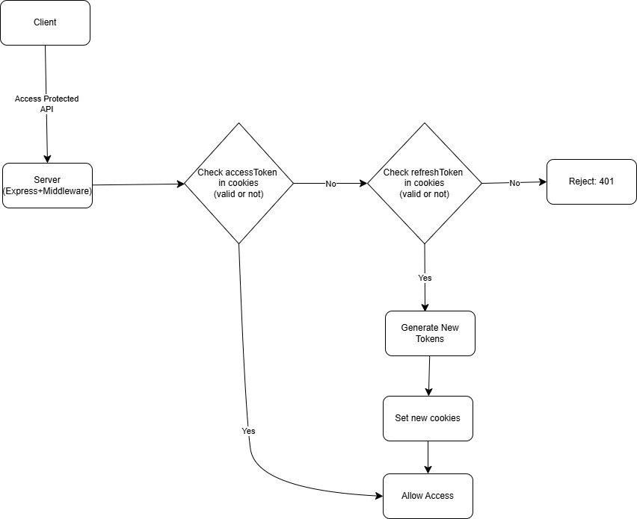

5. Middleware Files
File | Purpose
auth.middleware.js | Handles token verifica on, renewal, and RBAC for both users and admins.
pagina on.middleware.js | Adds pagina on logic to any route fetching long lists (e.g., products, orders).

6. Example Protected Endpoints
Endpoint | Role | Middleware
GET /api/user/profile | user | verifyJWT
POST /api/orders | user | verifyJWT
POST /api/admin/product | admin | verifyAdminJWT
GET /api/admin/users | admin | verifyAdminJWT

9. USER INTERFACE

1. Landing Page
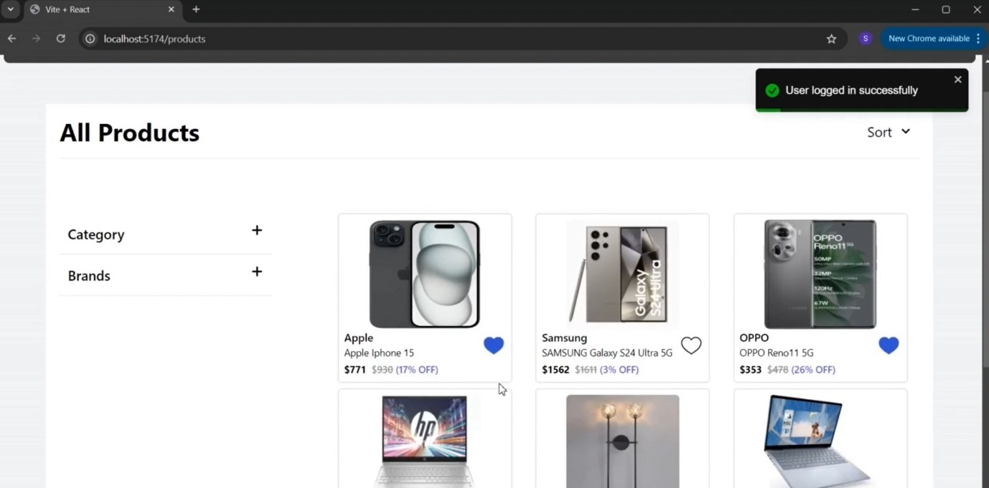

2. Login
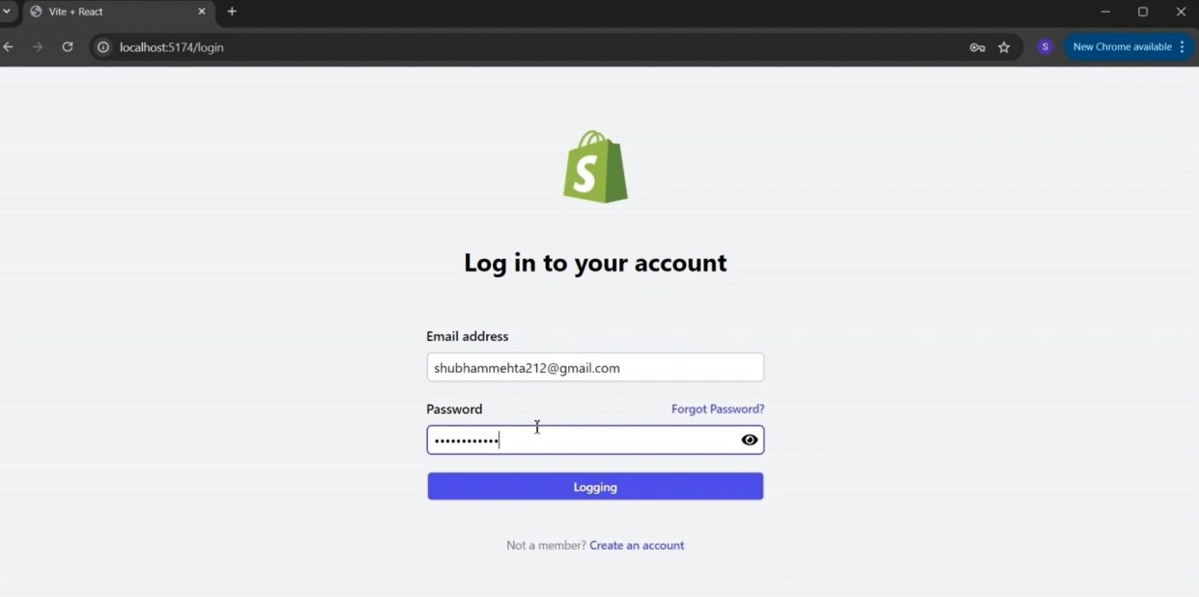

3. User Dashboard
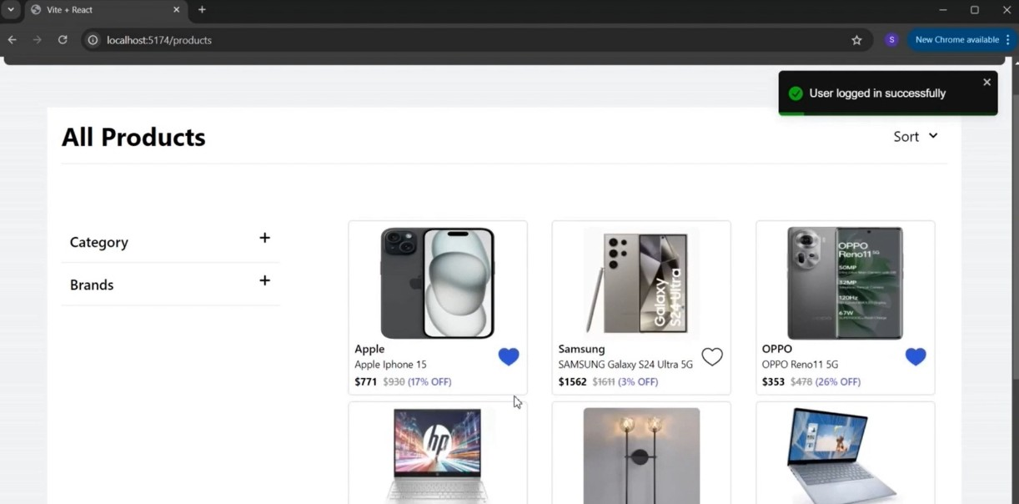

4. Order History
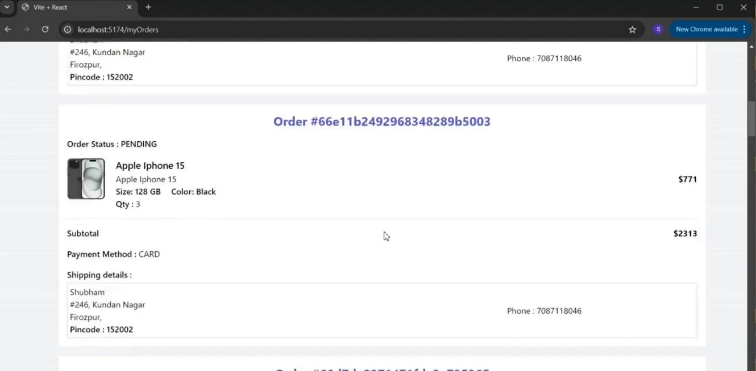

5. Wishlist
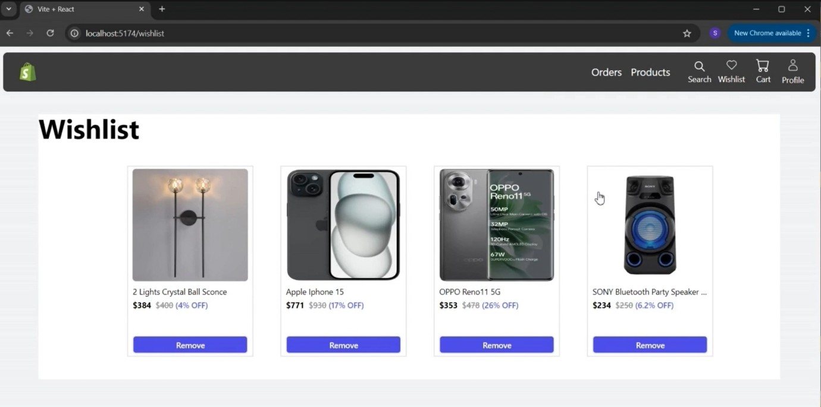

6. Individual Products Page
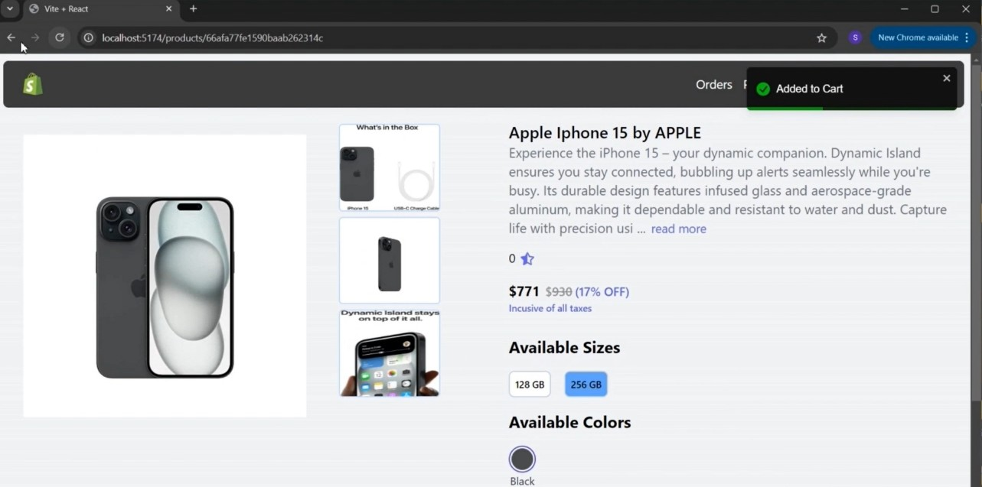

7. Cart
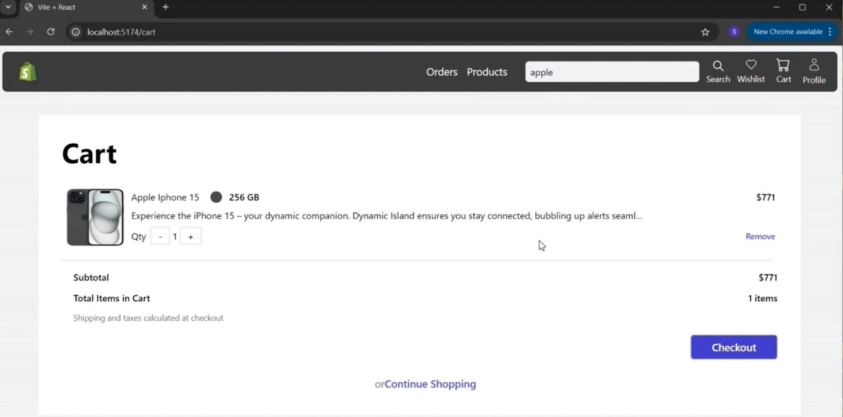

8. Checkout
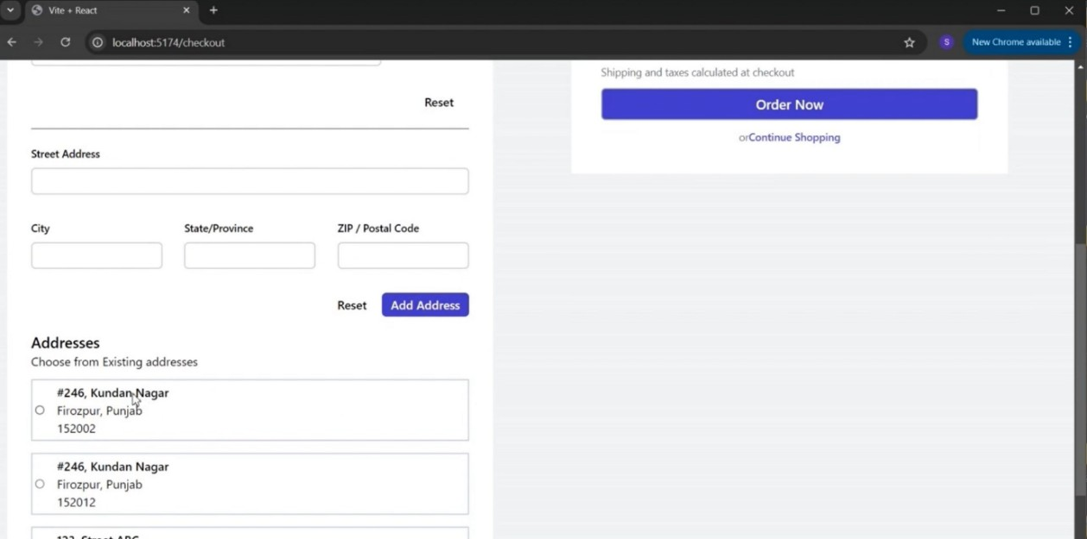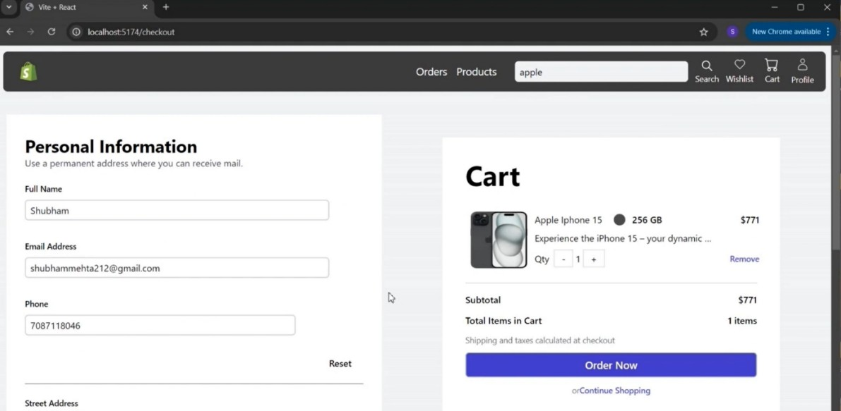
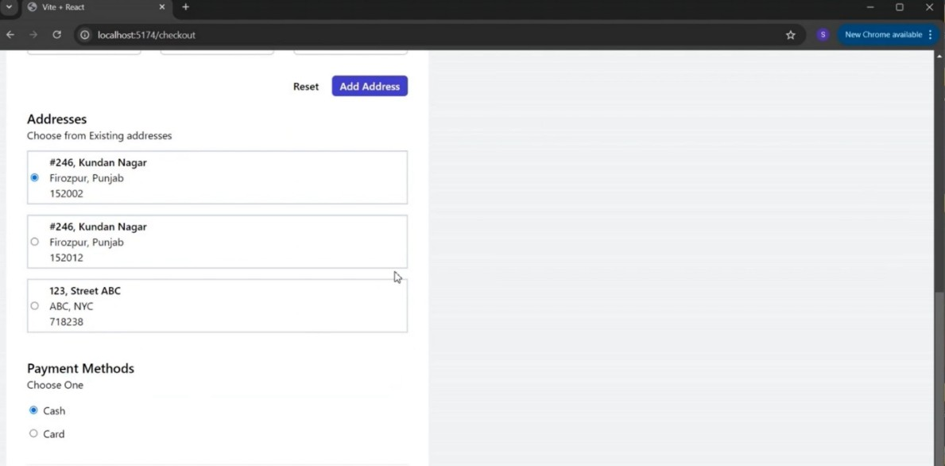

9. Admin Dashboard
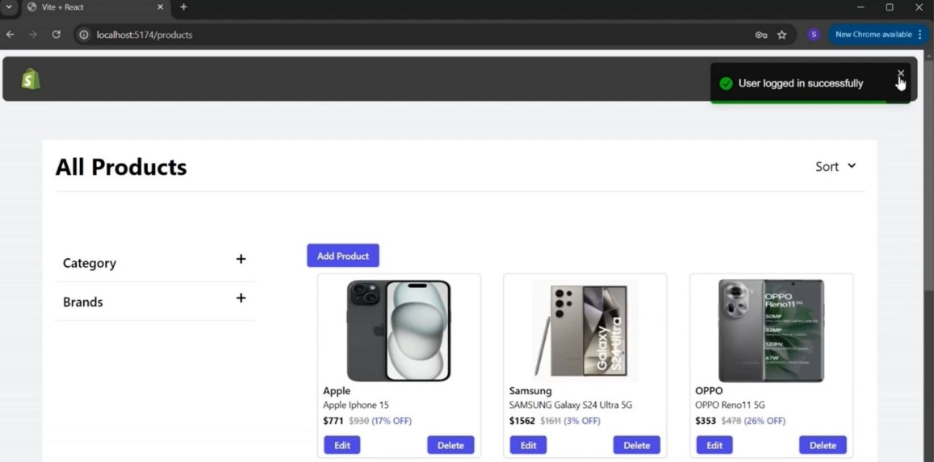

10. Admin Profile
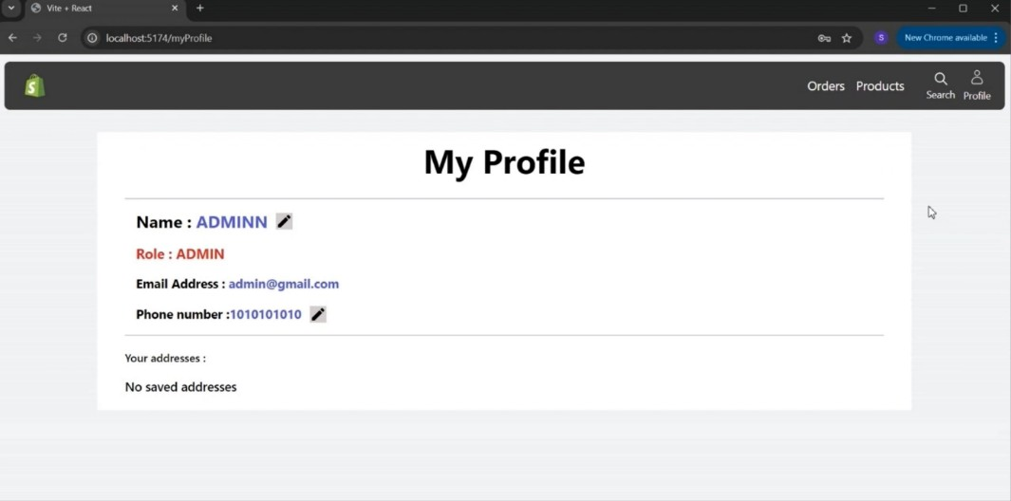

11. Edit Product Form
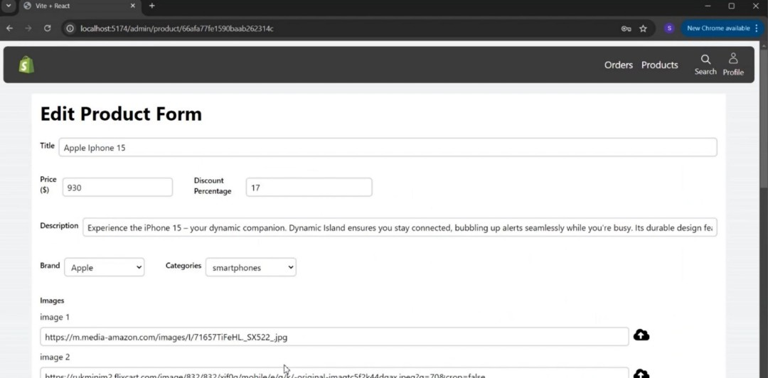
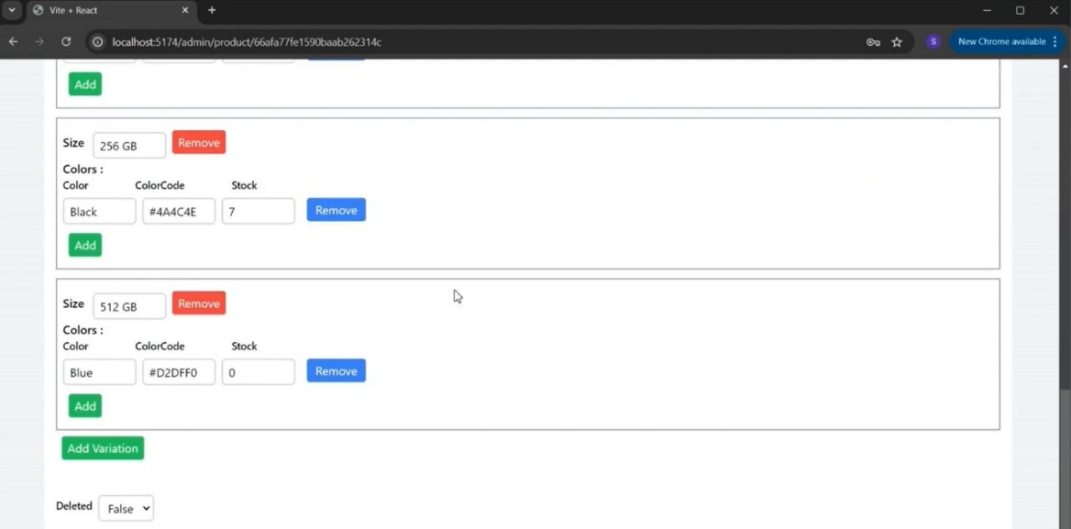

12. Create Product Form
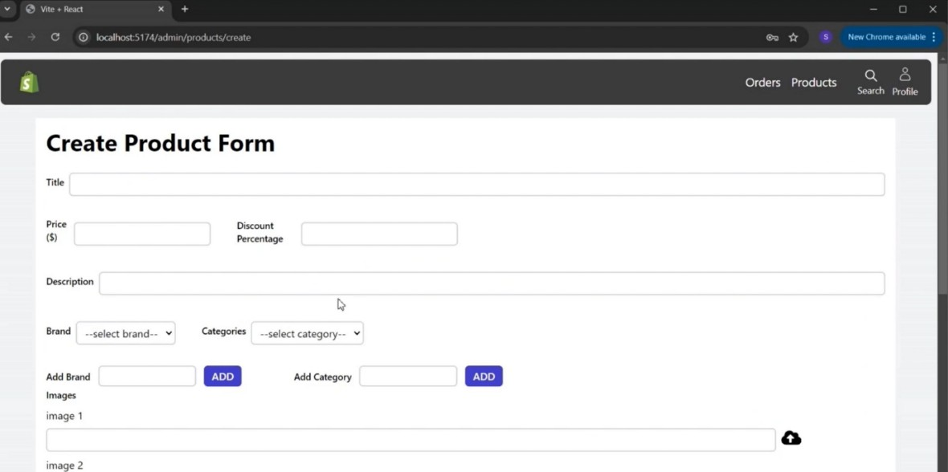
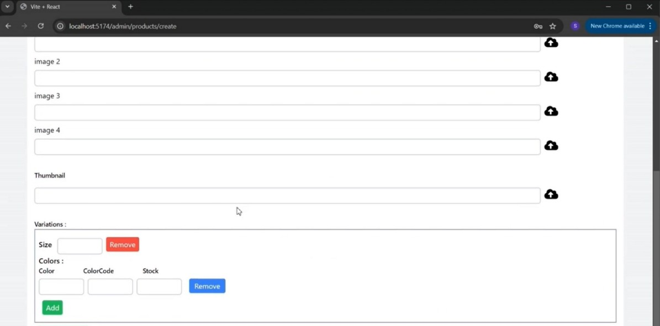

13. Logout
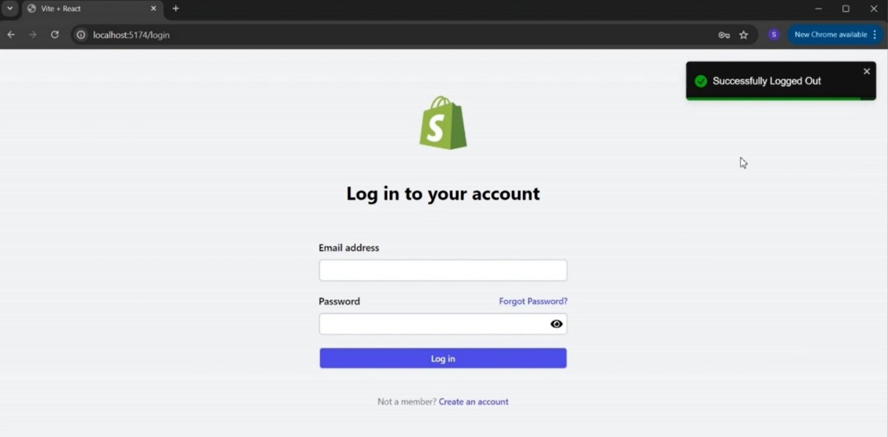

10. TESTING 1. FUNCTIONAL AND PERFORMANCE TESTING

1. Performance Tes ng (GenAI Func onal & Performance Tes ng)
2. Test Scenarios & Results
Test  Case  ID | Scenario (What to test) | Test Steps (How to test) | Expected Result | Actual Result | Pass/Fail
FT-  01 | Text Input Valida on (e.g., topic, job tle) | Enter valid and invalid text in input fields | Valid inputs accepted, errors for invalid inputs | Valid inputs generated content; invalid entries showed proper | Pass
FT-  02 | Number Input Valida on (e.g., word count, | Enter numbers within and outside the | Accepts valid values, shows error for out-ofrange | Accepts numbers in range; error shown for out-of-range values | Pass
FT-  03 | i )  Content  Genera on  (e.g., blog, | lid Provide complete inputs and | Correct content is generated based on input | Accurate content generated matching the input context | Pass
FT-  04 | d i  API Connec on  Check | li k  Check if API key is correct and model | API responds successfully | Connec on stable; API responded on every  call | Pass
PT-  01 | Response Time  Test | d Use a mer to check content genera on | Should be under 3 seconds | Average response me: 2.4 seconds | Pass
PT-  02 | API Speed Test | Send mul ple  API calls at the  same me | API should not slow down | API handled 5+ concurrent calls without delay or | Pass
PT-  03 | Image Upload  Load Test  (Admin- | Upload mul ple PDFs and check | Images should upload quickly without delay or errors. The product | f il  Admin uploaded mul ple high-res images without delay | Pass
P d t i h ld b t d h P d t

11. DEMO
To offer a clear understanding of the pla orm’s func onality and user experience, we have prepared a demo video showcasing the end-to-end flow of the ShopEZ applica on. The video highlights both user-side opera ons—like browsing products, adding items to the cart, logging in, placing orders—as well as admin-side capabili es, including managing products, upda ng order statuses, and overseeing user data. This visual walkthrough serves as a comprehensive guide for stakeholders, evaluators, or contributors to grasp how the applica on operates in realme. It also demonstrates the responsiveness and interac ve nature of the UI across different pages.
Click here to watch the demo video

12. KNOWN ISSUES
Despite thorough development and tes ng, a few known issues and limita ons currently exist in the ShopEZ pla orm:

1. Token Expiry Edge Case
- If the refresh token expires during user ac vity, re-authen ca on might be required manually.
- Auto-logout mechanism is planned but not yet implemented.

2. Cart Not Synced Across Devices
● Cart items are stored locally; logging in from a different device may not retain previous cart contents.

3. Limited Inventory Updates
● Inventory does not automa cally update when an order is placed; relies on manual or delayed updates.

4. Responsiveness Issues on Older Devices
● Some UI components may break on smaller or older mobile devices due to limited media query handling.

5. Slow Loading on Ini al Render
● The homepage can have a slight delay during the first load due to large JSON file parsing (products, brands).

6. No Real-Time Order Status
● Order status updates are not pushed in real- me. Users must refresh the page to view updates.

7. Password Reset Not Fully Func onal
● The "Forgot Password" feature is under development and currently nonfunc onal.

13. FUTURE ENHANCEMENTS
While the current version of ShopEZ delivers core func onali es for an e-commerce pla orm, there are several areas that can be enhanced or expanded upon in future itera ons:

1. Enhanced Payment Integra on
- Integrate real- me payment gateways like Razorpay, Stripe, or PayPal for secure and smooth transac ons.
- Enable support for UPI, Net Banking, and Wallets.

2. Mobile Applica on Development
- Develop a dedicated mobile app using React Na ve or Flu er to improve accessibility and reach.
- Provide push no fica ons for order updates and offers.

3. Smart Recommenda on System
● Use machine learning to recommend products based on user behavior, search history, and purchase trends.

4. Advanced Search & Filters
● Implement Elas csearch or Algolia for be er product discovery through full-text search, voice search, and advanced filters.

5. Inventory & Order Management for Sellers
● Allow vendors or sellers to manage their own products, track inventory, and view orders from a separate dashboard.

6. Admin Analy cs Dashboard
● Add data visualiza ons for sales trends, customer ac vity, and inventory using tools like Chart.js or Recharts.

7. Mul -language & Currency Support
● Enable users to view the site in their preferred language and currency to support a global audience.

8. Enhanced Security Features
● Add 2FA (Two-Factor Authen ca on), CAPTCHA on login, and real- me threat monitoring.

9. Invoice Genera on & Order Tracking
● Automa cally generate PDF invoices and allow users to track their orders in realme with shipment status.

10. Accessibility & Performance Improvements
● Improve site accessibility (WCAG compliance) and op mize performance with lazy loading, caching, and CDN.

