Source allocation and retrieval control for question answering over annual reports and regulations

Abstract
Retrieval over annual reports and regulations must preserve the distinction between company disclosures and normative evidence. We evaluate source allocation and retrieval control through a primary study of 60 questions from 20 companies and a supplementary test on four new companies across two report years. Two human reviewers assessed 386 valid outputs from 400 planned primary responses. Separate source retrieval improves the observed company-macro score by 0.250 on an eight-point scale, with a historical 95% bootstrap interval of [0.167, 0.333]. Role prompting on identical evidence adds −0.008 [−0.050, 0.025]. Although separate retrieval raises two-source presence from 68.3% to 100%, designated evidence-location coverage does not improve overall. Context replay and score diagnostics expose candidate omissions and rating ceilings. The supplementary test executes five conditions on eight disclosure-extraction questions, including a three-call retrieval agent, equal-call fixed-context revision, and fixed query expansion. With failures retained and a transparently corrected reference set, three-field exact match is 6/8 for single-call K3, 6/8 for revision, 4/8 for the agent, and 5/8 for fixed expansion. A traced agent failure displaces useful initial evidence. One reference-label omission is preserved as an explicit post-output erratum. Local Qwen inference fails before producing answers, leaving cross-family performance unverified. These results support a bounded benefit from source allocation while showing that additional retrieval and more elaborate prompting require separate evidence of value.
Keywords: retrieval augmented generation; financial documents; regulatory evidence; retrieval agents; reference quality; reproducible evaluation

1 Introduction
Answering a question about a company's governance requires separating what the company reports from what a regulation requires. An annual report can support a statement about a disclosed committee, distribution proposal, or internal-control process. It cannot, by itself, establish the relevant legal requirement. Conversely, a regulation describes an obligation but does not establish that a particular company fulfilled it. A useful document-question-answering system must retrieve evidence for both roles and preserve the distinction when a link is missing. This is a practical information-processing problem even when the underlying language model already knows common governance terminology.
Retrieval-augmented generation (RAG) provides a means of conditioning a language model on external documents [1]. In a heterogeneous corpus, however, a common relevance ranking does not necessarily preserve the evidence roles needed by the answer. A source type with stronger lexical or semantic similarity may occupy most of a limited context. Source-specific retrieval quotas can protect access to the other type, but they can also displace useful passages. More balanced context composition is therefore a mechanism to test, rather than sufficient evidence of better retrieval or better answers.
The same distinction applies to prompting and tool use. Asking a model to separate facts from requirements can change the organization of its response without changing the supporting material. Allowing it to search again can expand its evidence, but it also adds calls, latency, and opportunities for failure. A comparison that changes retrieval, prompting, and computational budget together cannot identify which change contributed to the outcome. Equally, a coarse evaluator can award similar scores to an answer that lists every meeting and one that provides only an incomplete summary.
We investigate these issues through a controlled empirical study of annual reports and regulatory documents. The primary study compares a common candidate pool, separate retrieval scopes, and a role-constrained prompt applied to exactly the same evidence. It includes simplified retrieval configurations, source removal, and a comparison of two hosted model aliases from the same family. Two human reviewers assessed the actual outputs against source material. Subsequent analyses examine the dimensions of the scores, company-level sensitivity, context packing, and the difference between source presence and reference-location coverage.
The original evaluation and an initial two-company extension were already exposed during system development. We therefore add a separate test on four companies outside the original twenty. Both years of each new company's annual report are parsed and chunked with the same implementation. The test compares a bounded retrieval agent with three-call fixed-context revision and a predefined query-expansion baseline. It uses explicit reference fields and deterministic scoring rather than another aggregate language-model score. A pinned local Qwen execution was attempted but failed before producing answers; the cross-family gap remains explicit.
Our contribution is an auditable empirical separation of source supply, target-evidence coverage, and generated-answer quality. We do not introduce a newly trained retriever, a new foundation model, or a faithful reproduction of a published trained agent. The main positive result concerns source organization in this particular task; the absence of stable role-prompt gains and the limitations of more complex retrieval are equally central. The additional test asks whether the selected controller remains useful on new companies under stricter, explicitly bounded extraction metrics.
The study addresses four questions. RQ1 asks whether separate source retrieval improves observed answer quality relative to merged retrieval. RQ2 asks whether source-role prompting adds benefit when the evidence is held identical. RQ3 examines how retrieval simplification, source absence, and evaluator behavior change the interpretation. RQ4 tests whether adaptive query planning improves extraction on new companies relative to fixed evidence and fixed query expansion across two report years. The empirical outcomes concern evidence, answers, and execution rather than component counts.

2 Related work
Financial question answering has long required reasoning over document structure rather than isolated prose. FinQA evaluates numerical reasoning in financial reports [2], while TAT-QA combines tabular and textual evidence [3]. HiREC studies hierarchical retrieval and evidence curation for standardized financial documents [4]. These works establish that financial-document retrieval, structured evidence, and supplementary querying are existing research directions. Our task differs in requiring an explicit separation between company disclosure and normative material, while the new holdout deliberately narrows evaluation to verifiable disclosure fields.
Domain knowledge can enter RAG through structured facts, ontologies, or direct document retrieval. Siddharth and Luo use engineering design knowledge [5], and Yang et al. survey combinations of language models and knowledge-based methods [6]. Alier et al. study ontology-guided augmentation for domain-specific retrieval difficulties [11]. The present system operates on source documents and their locations; reference answers are retained for evaluation and are not inserted into its retrieval queries or runtime knowledge store.
Sparse and dense retrieval offer different relevance signals. BM25 uses term statistics [7], DPR develops learned passage representations [8], and the Qwen3 embedding family includes embedding and reranking models [9]. Reciprocal rank fusion is an established alternative for combining ranks [10]. Our primary configuration uses fixed weighted scores, and the new-company test uses SQLite FTS5 BM25 [25]. These implementations are described separately because a common label such as “BM25” does not make their tokenization, term statistics, filtering, or candidate ordering identical. No unexecuted fusion method is assigned an experimental result.
Self-RAG learns retrieval and critique behavior [12], CRAG introduces corrective processing of retrieved information [13], and Adaptive-RAG selects retrieval strategies according to question complexity [14]. Adaptive iterative retrieval further studies the relationship between repeated retrieval and generation [15]. ReAct interleaves reasoning and actions [16]. These methods motivate stronger controls, but replacing their trained components with a generic reflection prompt would not constitute reproduction. Our bounded agent has two query-planning calls, real local retrieval actions, and one final answer call. The equal-call revision baseline isolates the value of changing the evidence, and fixed expansion tests whether predetermined topic queries explain a similar gain.
CoLE organizes legal-expert prompting [17], while knowledge-enhanced multi-agent debate uses external knowledge in agent interaction [18]. The current runtime is a single-model controller and does not implement inter-agent communication. Evaluation work also cautions against collapsing different notions of correctness. ALCE studies generated text and citations [19], RAGAs supports automated RAG evaluation [20], and RAGChecker separates retrieval and generation diagnostics [21]. LegalBench-RAG evaluates relevant evidence localization in legal documents [22]. Our original page-level references are not exhaustive passage relevance judgments, and our supplementary field references are not an independently adjudicated benchmark. We therefore avoid converting either into an unsupported claim of comprehensive recall or legal correctness.
Long-context studies show that the presence and position of information can affect its use [23]. This motivates recording the exact packed context rather than only the number of retrieved passages. It also motivates reporting both retrieval opportunities and answer outcomes: failure to reproduce a name may reflect missing evidence, a poorly represented table, an incomplete generated answer, or an inadequate reference. The present analyses retain these possibilities instead of identifying a single cause from an aggregate score.

3 System and controlled interventions
A public query consists of a company identifier, report year, and question text. The retrieval corpus contains annual-report documents and regulatory sources. Annual-report eligibility is constrained by company and report year; regulatory eligibility follows the available source metadata. The primary questions contain no independently established event date. Consequently, the experiment retains all 5,994 eligible regulatory chunks with unknown temporal applicability and does not demonstrate effective date filtering. Report year is not substituted for an event date.
Table 1. Evaluation layers and their units. The supplementary reference correction is explicit.
Layer | Scope | Outcome | Interpretive boundary
Primary human review | 20 companies; 60 questions; 386/400 valid outputs | Four ordinal dimensions; paired company differences | Exploratory ratings; missing outputs analyzed separately
Context replay | 1,800 cached and 600 fresh sparse contexts | Source allocation and reference locations | No new generation or semantic recall labels
Earlier extension | 2 exposed companies; 12 questions | 48 judge-scored outputs and repair cases | Development exposure and judge ceilings
New-company test | 4 companies; 2 years; 8 questions × 5 conditions | Field F1 and exact match; failures retained | AI-extracted references; one post-output erratum
Each document is associated with a source address, declared identity, version information where available, and a SHA256 file digest. Annual-report passages preserve a physical PDF page and their extraction metadata. Text-only regulations retain their own source identity and text location rather than a fabricated PDF page. The packed context assigns annual evidence an A identifier and regulatory evidence an R identifier. Saved requests, context hashes, source records, and responses provide a path from a generated citation back to the material actually supplied.
This path establishes provenance, not entailment. A valid citation identifier can point to an irrelevant passage. A correctly quoted rule can have the wrong effective date or an inapplicable exception. A report can describe a policy without establishing that the policy was implemented. The system is therefore instructed to distinguish disclosure, normative requirements, and matters that cannot be confirmed. It is not used to certify legal compliance or the company's underlying governance quality.
In the primary hybrid retriever, sparse and dense scores are normalized by the maximum score within each returned channel and combined with weights 0.3 and 0.7, respectively. This is maximum normalization, not min–max normalization. Each channel initially retrieves up to twice the requested top-k; a union of up to four times top-k enters the reranker, subject to candidate availability. The embedding and reranker revisions are fixed. The weights are prototype settings and were not established as optimal by this evaluation.

Figure 1. Source-specific retrieval and provenance records. Evidence availability and claim support are evaluated separately.
G1 ranks eligible annual and regulatory passages in a common pool with a total candidate limit of ten. G2 searches the two scopes separately, retaining up to five candidates from each before deterministic packing. G3 uses exactly the G2 context but adds a source-role-constrained generation prompt. Thus G2 versus G1 changes source allocation within the same eligible corpus and maximum context budget. G3 versus G2 changes the prompt while preserving the evidence byte for byte. Equal token ceilings do not make the actual contexts equal in length.
The context packer visits candidates in their recorded order and adds complete chunks while the fixed reference tokenizer remains within 6,000 tokens. It skips chunks that would exceed the cap rather than silently truncating their text. Evidence identifiers are assigned only to included chunks. The reference tokenizer is an accounting device and is not asserted to be the provider's tokenizer. This design makes packing decisions reproducible while leaving retrieval quality and generation quality as separate empirical questions.
Two simplified configurations remove reranking or retain only sparse retrieval. Source-removal tests delete all annual or all regulatory evidence from a selected twenty-question subset without a replacement search. Remaining text and identifiers are preserved. Removal changes both information and actual context length, so it is not a pure test of a source label. The hosted service comparison reuses the selected subset with another Kimi alias; unresolved checkpoint identity and unmatched reasoning defaults prevent interpreting it as an isolated comparison of model weights.
Table 2. Primary interventions. All main conditions share the eligible corpus and a 6,000-reference-token ceiling.
Condition | Retrieval intervention | Prompt or evidence control
G1 merged | Common candidate pool; at most 10 | Generic cited answer
G2 dual | At most 5 annual + 5 regulatory | Same generic answer instruction
G3 role | Exactly the G2 context | Explicit source-role constraints
No reranker | Hybrid candidates without reranking | Role-constrained prompt
BM25 only | Sparse retrieval only | Role-constrained prompt
No annual / no regulation | Remove one role from 20 selected contexts | No replacement search
K2.8 service subset | Reuse selected prompts and contexts | 20 questions per G1/G2/G3
For the supplementary agent, two planning rounds each propose at most two queries. Each query executes actual retrieval over the same eligible scopes. New hits are placed before prior hits, duplicates are removed, and at most twenty candidates are repacked under the unchanged reference ceiling. The final call extracts an answer from the resulting context. Fixed-context revision instead preserves the initial context for all three calls and appends the previous answer. Fixed expansion uses four predetermined audit-committee queries arranged in two rounds, followed by a single generation. These controls distinguish additional generation, extra retrieval, and adaptive query selection without claiming equal realized compute.

4 Primary evaluation protocol
The primary retrieval scope comprises 39 annual-report sources with 13,038 chunks and 87 regulatory sources with 5,994 chunks. These are the eligible sources identified in the frozen index after superseded entries are excluded. The question set contains twenty companies, each with three questions about its 2024 report: dividend disclosure, audit committees, and internal control. Its 180 reference points are associated with 123 distinct reference records through 256 question–evidence links. These references identify reviewed target evidence rather than all possible valid supporting passages.
The planned generation inventory contains 180 main comparisons, 120 retrieval ablations, forty source-removal cases, and sixty second-service cases, for a total of 400. The final selected-output view contains 386 structurally valid responses. The first main attempt produced 147 valid outputs out of 180, and a preserved recovery pass increased that number to 178. Recovery does not overwrite the first-attempt view. Failure records include service timeouts, connection failures, and JSON parsing problems. Primary quality analyses do not assign a zero quality score to a missing output.
Table 3. Primary output inventory and descriptive scores. Scores condition on valid reviewed outputs.
Configuration | Planned | Valid | Mean score / 8
G1 merged | 60 | 60 | 7.292
G2 dual | 60 | 59 | 7.550
G3 role | 60 | 59 | 7.554
No reranker | 60 | 55 | 7.812
BM25 only | 60 | 54 | 7.850
No annual | 20 | 20 | 6.675
No regulation | 20 | 20 | 6.925
K2.8 G1 | 20 | 20 | 7.325
K2.8 G2 | 20 | 19 | 7.579
K2.8 G3 | 20 | 20 | 7.600
Primary generation used temperature 1, a 16,384-token output ceiling, a 600-second request timeout, and no automatic SDK retries. A scheduling seed of 42 randomized execution order; it was not passed as a model sampling seed. Embedding and reranking used the recorded local CUDA configuration, whereas generation ran at the remote provider. Local GPU specifications do not determine server inference latency. Preparation-time parameter corrections and response truncations remain in the execution record rather than being removed from the reported history.
Two reviewers independently checked actual answers against original sources using four dimensions: company facts, regulatory evidence, citation support, and uncertainty handling. Each dimension takes 0, 1, 2, or unresolved U. For an output with two complete numeric assessments, we average the reviewers and sum the four dimensions, yielding a score from zero to eight. The accepted submissions contain no U values. The accepted rating files identify both assessments as human source checks; no additional adjudication was performed. The mean retains both judgments but does not turn disagreement into consensus.
Questions within the same company are correlated. We first calculate paired differences for observed matched questions within each company and then weight companies equally. The historical main intervals use 2,000 company-bootstrap draws with seed 42. Additional dimension and topic analyses use 10,000 draws with seed 20261023. These are exploratory pointwise percentile intervals without multiplicity adjustment. Averaging the reviewers and selecting sensitivity analyses after scores were visible also makes the analysis exploratory. Shared regulatory sources can induce dependence across companies that company resampling does not eliminate.
Let d(c) denote the average paired score difference among observed question pairs in company c. The reported company-macro contrast is Δ = [d(1) + ... + d(C)] / C, where C is the number of represented companies. This equal-company estimand differs from the full-inventory question-weighted missingness bounds.
Missingness is examined separately. For a planned question with a known baseline score and a missing treatment, the unknown difference ranges from the negative baseline score to eight minus that score; analogous bounds apply when only the treatment is known. If both are missing, the interval is minus eight to eight. Averaging these endpoints gives a sharp algebraic bound for the full planned question-weighted difference. It is not a confidence interval and does not estimate the same quantity as an observed company-macro bootstrap interval. Complete-question and complete-company subsets provide additional descriptions but remain selected on successful execution.
Retrieval replay changes packing budgets and candidate quotas without generating new answers. Sixty questions, two source-allocation strategies, three candidate quotas, and five reference ceilings produce 1,800 contexts. All 120 default contexts are reproduced exactly. A separate fresh sparse-retrieval run creates another 600 contexts across the two strategies and five budgets. The fresh sparse run uses the project's original BM25 implementation and is distinct from both the cached neural ranking and the later FTS5 holdout.
Reference-location coverage requires the recorded source digest and physical PDF page. One text-only regulatory reference instead uses whole-source identity and is reused across twenty internal-control questions. We report this coarse unit separately from PDF-page coverage. Source identity can miss alternative valid versions, while a page hit can include irrelevant text. Neither this measure nor a twelve-character overlap diagnostic is treated as semantic recall, nDCG, or complete citation correctness.

5 Findings from the primary study
Separate retrieval yields a positive observed company-macro difference of 0.250 points on the eight-point scale relative to merged retrieval, with a historical 95% interval of [0.167, 0.333]. The two reviewers' corresponding differences are 0.267 and 0.233. This supports a limited benefit for source allocation in the evaluated task. It does not imply a large practical effect, improvement on every question, or validated legal applicability.
Adding role prompting to the identical dual-source evidence gives a difference of −0.008, with interval [−0.050, 0.025]. Among 58 observed pairs, there is one win, 56 ties, and one loss. The role prompt changes output structure, but this coarse human scale does not show a stable quality gain. The comparison should not be reframed as evidence that all role prompts are ineffective: it concerns one prompt and one set of contexts, with limited scale resolution.
Table 4. Primary observed paired contrasts. Historical pointwise 95% company-bootstrap intervals are exploratory.
Contrast | Paired n | Company Δ | 95% interval | Wins / ties / losses
G2 − G1 | 59 | +0.250 | [+0.167, +0.333] | 18 / 41 / 0
G3 − G2 | 58 | −0.008 | [−0.050, +0.025] | 1 / 56 / 1
G3 − G1 | 59 | +0.267 | [+0.183, +0.350] | 19 / 39 / 1
G3 − no reranker | 54 | −0.300 | [−0.404, −0.204] | 2 / 26 / 26
G3 − BM25 | 53 | −0.325 | [−0.404, −0.246] | 11 / 7 / 35
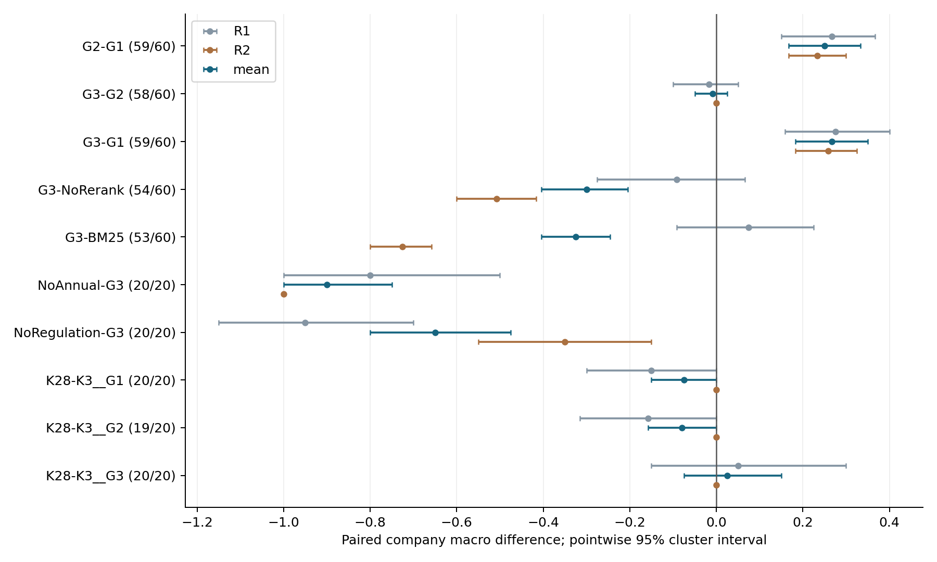
Figure 2. Primary paired-effect estimates from the preserved analysis. Intervals summarize observed company clusters, not missing-output uncertainty.
The gain is concentrated. For G2 versus G1, the fact dimension changes by −0.017, regulatory evidence by +0.267, and citation support and uncertainty handling by zero. The audit-committee topic has a mean paired difference of approximately 0.684 over nineteen observed pairs, compared with 0.100 for dividend disclosure and zero for internal control. These post hoc strata identify where the observed difference occurs. They do not establish an interaction across all possible topics or prove that source allocation is the sole mechanism.
The full configuration does not dominate simplified retrieval. On observed pairs, G3 is lower than the no-reranker configuration by 0.300 and lower than BM25-only by 0.325. Reviewer directions differ for the BM25 comparison, and full-inventory missingness bounds cross zero for both simplified configurations. The appropriate conclusion is that additional retrieval complexity lacks a demonstrated universal benefit here. The results do not establish that neural retrieval or reranking is generally harmful.
Deleting annual evidence lowers the paired mean by 0.900 on the selected twenty questions; deleting regulatory evidence lowers it by 0.650. These differences are consistent with complementary evidence roles, subject to simultaneous changes in information and length. Same-family hosted-service differences are small, with reported intervals including or touching zero. Since default reasoning policies and underlying checkpoints are not matched, neither version comparison constitutes a cross-family generalization result.
Leave-one-company-out analysis preserves a positive G2–G1 difference, ranging from 0.237 to 0.263, whereas the G3–G2 range crosses zero. The full sixty-question algebraic bound for G2–G1 is [0.133, 0.267]; for G3–G2 it is [−0.133, 0.133]. The positive direction of the first comparison is therefore not explained solely by one omitted company or its single missing treatment output. Nevertheless, these checks do not address population sampling, repeated-generation variance, shared rules, or every potential annotation bias.
Table 5. Sensitivity analyses use distinct estimands and are not interchangeable.
Analysis | G2 − G1 | G3 − G2 | Scope
Leave one company out | +0.237 to +0.263 | −0.018 to +0.009 | Observed company-macro differences
Sharp missing-output bound | [+0.133, +0.267] | [−0.133, +0.133] | Full 60-question weighted mean; not a CI
49 complete five-method questions | +0.213 | −0.038 | Execution-selected question subset
12 complete companies / 36 questions | +0.208 | 0.000 | Execution-selected company subset
Reviewer agreement reveals measurement limitations. Across 1,544 paired dimension ratings, exact agreement is 84.97%. Regulatory evidence has only 55.96% exact agreement and a quadratic weighted kappa of approximately 0.201. The second reviewer's regulatory ratings are lower by 0.435 points on average. Citation and uncertainty agreement approach 100%, but one reviewer assigns a constant maximum on those dimensions, giving kappa values of zero. High agreement under a ceiling should not be advertised as strong discrimination of subtle grounding errors.
Table 6. Reviewer agreement and directional differences. Ceiling agreement does not imply discrimination.
Dimension | Exact agreement | Weighted κ | Reviewer 2 − 1
Company facts | 86.5% | 0.405 | +0.117
Regulatory evidence | 55.96% | 0.201 | −0.435
Citation support | 97.67% | 0.000 | Ceiling affected
Uncertainty | 99.74% | 0.000 | Ceiling affected
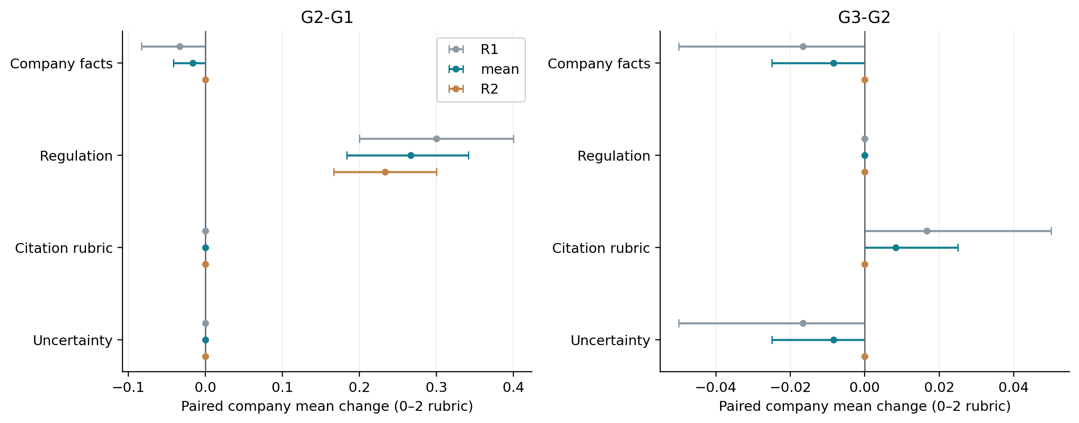
Figure 3. Score-dimension diagnostics. The observed source-allocation benefit is concentrated in regulatory-evidence ratings.
The context diagnostics clarify why source presence and relevance must remain separate. At the default budget, G1 contains an average of 8.183 annual and 1.183 regulatory chunks, with both source roles present in 68.3% of questions. G2 contains five of each and achieves 100% two-role presence. Its actual reference length is shorter, approximately 4,032 rather than 4,945 tokens. Yet average role-balanced reference-location coverage is 39.11% for G2 and 39.83% for G1. Better source balance does not automatically improve coverage of the designated evidence locations.
Table 7. Default source allocation and reference-location diagnostics. PDF and text-only reference units must be distinguished.
Metric | G1 merged | G2 dual
Annual / regulation chunks | 8.183 / 1.183 | 5.000 / 5.000
Both source types present | 68.3% | 100.0%
Actual reference tokens | 4,945 | 4,032
Annual page coverage | 79.67% | 74.33%
Regulatory location coverage | 0.00% | 3.89%
Role-balanced location coverage | 39.83% | 39.11%

Figure 4. Context allocation for the sixty matched questions at the default budget. Candidate supply and packed-token usage are recorded independently.
Default G2 packs all ten candidates, while designated regulatory locations are still absent in 53 of sixty questions. Increasing the packing ceiling cannot recover evidence missing from this candidate list. Fresh BM25 appears to improve aggregate regulatory location coverage to 30.00% or 33.33%, but the difference comes entirely from matching the text-only regulatory source reused by the internal-control questions. On the forty PDF-reference questions, its page coverage remains zero; cached dual retrieval reaches 5.83%. An aggregate mixing whole-source and page units would overstate the precision of the sparse retriever.
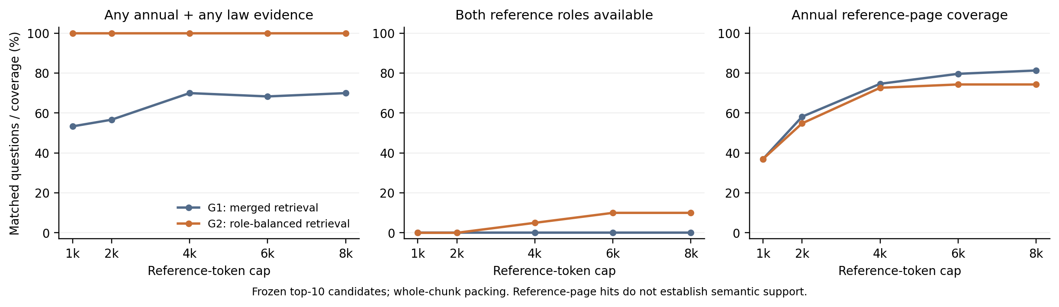
Figure 5. Budget replay. Raising a packing ceiling cannot recover relevant passages absent from the candidate list; the curves are context diagnostics without regenerated answers.
Role prompting increases the number of model-reported claims and the proportion carrying both A and R identifiers, while all three main conditions have zero unresolvable source IDs. These are structural observations. They neither establish that the additional claims are correct nor explain away the absence of a quality gain. Selected successful-call token use and request latency are also reported separately from end-to-end cost: prior failures, recovery, indexing, service load, and retrieval time are not fully included. No monetary efficiency claim follows from these logs.

6 New company and cross year validation
The new-company test fixes four companies outside the original twenty: Haitian Flavouring and Food, China Resources Sanjiu, Gree Electric, and China Merchants Bank. Each contributes its 2023 and 2024 annual report, giving eight company–year questions. Selection is purposive rather than random. The protocol, task fields, candidate budgets, method set, and failure policy were written before new generation. Search snippets for the first two companies had already been visible to the investigator; model calls receive only the saved question and retrieved evidence. The study therefore offers a fresh-company test of a selected implementation, not a previously untouched research process or an independent laboratory replication.
All eight original PDFs were downloaded from company or exchange disclosure sources and hashed. Initial pypdf extraction corrupted much of the Chinese text in both bank reports. Before any test generation, PDFium was selected and applied to every page of all eight reports. Earlier extraction outputs are preserved. The final corpus uses 1,200-character windows with a 1,000-character stride uniformly across both years, and retains the fixed regulatory pool. This removes the earlier extension's parser and chunking mismatch between years. It does not make report year a randomized treatment or establish historical regulatory applicability.
Each question requests three explicitly disclosed fields: the union of named audit-committee members evidenced in that report during the year, the total meeting count, and the set of reported meeting dates. The prompt distinguishes meeting count from the number of distinct dates. It requests structured citations and a limitations list, with empty sets or null for unavailable information. A regulation may not be used to invent a company fact. This narrower task is designed to expose extraction omissions that a broad narrative score can overlook; it does not replace the original dual-source evaluation.
Reference fields were extracted by the current AI assistant and checked against thirteen rendered PDF pages before generation outputs were inspected. They are locked by SHA256 and are not independently produced human labels. Important cases require more than a single line: both Gree reports list four meetings on only three distinct dates, and the bank's 2024 attendance table establishes former committee members absent from its four-name year-end roster. For Haitian 2024, the reference is limited to explicitly linked members in the current report rather than inferring the earlier committee from a previous year's report. This qualification is retained in the reference file and sensitivity analysis.
Hosted conditions use the same initial question, context, temperature 1, and 8,192-token per-call output limit. The three-call revision and three-call agent share a maximum number of generation calls, while fixed expansion uses one generation after its predetermined retrieval actions. No automatic retries are permitted. A rate-limit response stops new dispatch. The planned local cross-family condition fixes the saved single-call prompt and initial context, with model and decoding details recorded separately. It produced no answer and is excluded from performance comparisons.
Names are scored as normalized sets, meeting counts by exact integer match, and dates as normalized ISO sets. Set precision, recall, and F1 expose both invented items and omissions. Three-field exact match requires both sets and the count to be correct. Empty or failed outputs receive zero on these extraction outcomes; response and schema validity are reported separately. This denominator differs deliberately from the primary human-quality analysis, which conditions on valid outputs. Identifier resolution remains a syntactic check, not citation entailment.
We report every company–year result and paired agent differences against each control. Four company clusters are insufficient for persuasive population inference. The analysis does not attach a conventional significance claim to eight correlated cases, treat the two years as independent company samples, or select the better year after observation. The results below are descriptive checks of execution, extraction, and the selected controller on new documents. They remain distinct from the original reviewer scores and from the earlier same-family model-judge ratings.
Table 8. New-company source inventory. Physical page references include the later erratum.
Company | Stock | 2023 pages | 2024 pages | Reference pages 2023 / 2024
Haitian | 603288 | 206 | 208 | 38–39 / 42–43
CR Sanjiu | 000999 | 255 | 273 | 55 / 44, 53–54
Gree | 000651 | 249 | 248 | 51 / 57
CMB | 600036 | 362 | 362 | 93, 97 / 93, 97
Table 9. Supplementary conditions. Maximum calls are matched only between revision and agent; realized compute differs.
Condition | Generation calls | Additional retrieval | Final evidence
K3 single / K2.8 single | 1 | None | Initial context
K3 revision | 3 | None | Initial context plus previous answer in prompt
K3 agent | 3 | 2 planning rounds; at most 4 queries | New hits precede old hits; repacked
K3 fixed expansion | 1 | 4 predetermined queries in 2 rounds | New hits precede old hits; repacked
Qwen3-0.6B | No completed inference | None planned | No answer; not scored
For a predicted set P and reference set G, precision = |P ∩ G| / |P|, recall = |P ∩ G| / |G|, and F1 = 2TP / (2TP + FP + FN). An empty prediction with a nonempty reference scores zero. Exact match requires both sets and the integer meeting count to agree. Duplicate dates are removed for date scoring but are not used to infer meeting count.

6.1 Execution accounting and reference correction
The five hosted conditions account for forty planned answer units. Thirty-eight units have a completed final service response, but one is empty, leaving thirty-seven nonempty schema-valid answers. The saved inventory contains seventy-one call records out of a maximum of seventy-two: seventy HTTP-success responses and one HTTP 502 response. A third revision request for CR Sanjiu 2024 was written but the runner raised an OSError before a response record was saved during local memory pressure. Its remote execution cannot be confirmed. It is recorded as a failed unit, with no retry or substitution of the preceding revision. The K2.8 response for the same question reached its output limit without visible answer text. The Gree 2024 agent final call failed with HTTP 502. These three absent answers remain in the denominator.
Post-output source review identified an error in the frozen reference: the CR Sanjiu 2024 committee union omitted Liu Junyong. Physical page 44 explicitly identifies him as audit-committee chair and member departing on 2 February 2024, and page 94 corroborates the resignation. The committee-meeting table on pages 53–54 starts after that departure. The fixed-expansion answer had correctly included him, but the original scorer treated his name as a false positive. We preserve the original labels and their pre-generation hash, publish a separate source-grounded erratum, and recompute all conditions without generating any new answers. The corrected scores are a post-output analysis and have not received independent human adjudication.
The correction reduces agent three-field exact match from 5/8 to 4/8, because its otherwise complete CR Sanjiu 2024 extraction also omitted the former member. The fixed-expansion member F1 increases from 0.836 to 0.850. Neither label version produces an overall agent advantage over the single-call baseline. This error illustrates why a frozen reference is not necessarily a correct reference and why deterministic scoring alone is not independent validation.
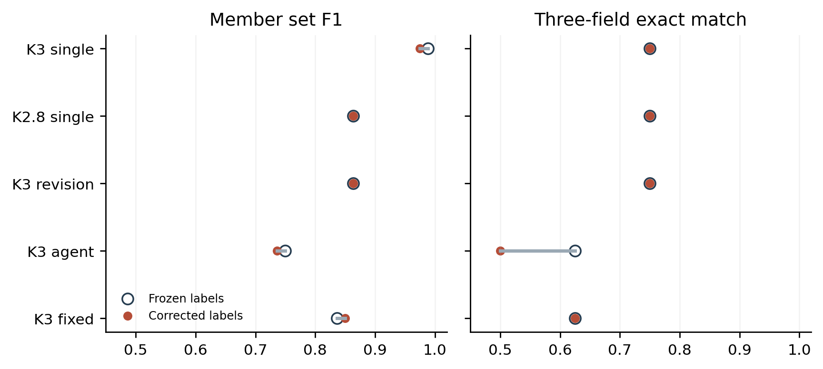
Figure 6. Effect of correcting one omitted former committee member. Frozen and corrected labels are both retained; the corrected analysis was conducted after output inspection.

6.2 Extraction outcomes and cross year contrasts
Table 10 reports corrected outcomes for every planned question. Single-call K3 has the highest member F1 (0.975), count accuracy (1.000), and a date F1 of 0.953. The agent obtains 0.736, 0.750, and 0.714, respectively. Its exact-match count is four, compared with six for single-call K3 and revision and five for fixed expansion. These results describe one sampled output per condition and eight questions; they are not estimates of general model or agent rankings.
Against single-call K3, the agent has no wins, six ties, and two losses on corrected three-field exact match. Its member-F1 mean difference is −0.239, with one win, five ties, and two losses. Against revision it has no exact-match wins, six ties, and two losses; against fixed expansion it has no wins, seven ties, and one loss. Equal maximum generation calls therefore do not reveal an adaptive retrieval benefit in this sample. Fixed expansion is also imperfect and cannot be interpreted as an optimal query policy.
Year-stratified results are descriptive. Single-call K3 has 4/4 exact answers for 2023 and 2/4 for 2024; the agent has 3/4 and 1/4. These four-company pairs do not support a statistical claim about temporal robustness. The 2024 bank report combines a changing roster with dates spread across a chunk boundary, whereas several 2023 questions have complete information in their initial evidence. Differences in task content and evidence availability remain plausible explanations.
Conditioning on nonempty completed outputs raises the agent exact-match fraction to 4/7, but this removes a failed request and changes the estimand. The primary supplementary table retains all eight units. Excluding Haitian 2024 from the member analysis addresses its limited membership scope; the agent member F1 remains below single-call K3. Neither sensitivity repairs the lack of independent reference annotation or the small number of company clusters.
Table 10. Corrected new-company results. All conditions have eight planned units; failed and empty answers score zero.
Condition | Member F1 | Count acc. | Date F1 | Exact / 8 | Visible / 8
K3 single | 0.975 | 1.000 | 0.953 | 6 | 8
K2.8 single | 0.864 | 0.875 | 0.839 | 6 | 7
K3 revision | 0.864 | 0.875 | 0.839 | 6 | 7
K3 agent | 0.736 | 0.750 | 0.714 | 4 | 7
K3 fixed expansion | 0.850 | 0.875 | 0.953 | 5 | 8
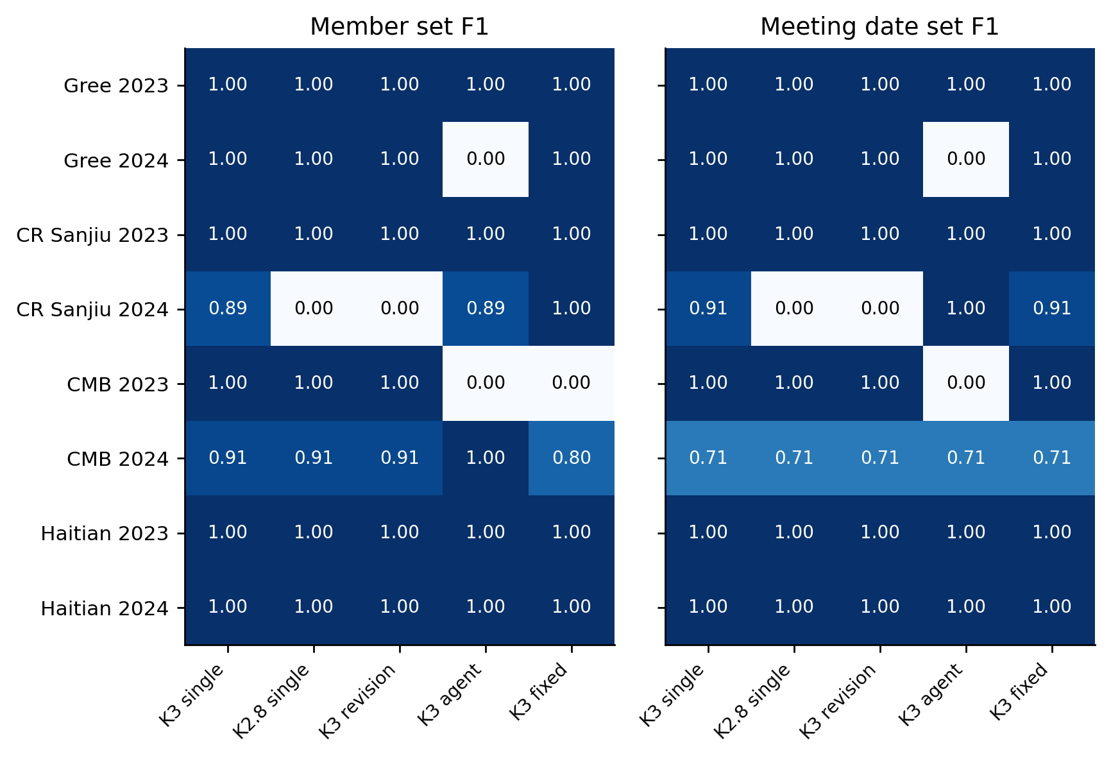
Figure 7. All eight company–year cases under corrected references. Rows are paired across methods; zero includes both missing output and a completed empty extraction. Cases are not independent across years.
Table 11. Corrected exact matches by report year. Four cases per year are descriptive, with no significance claim.
Condition | 2023 exact / 4 | 2024 exact / 4 | Both years / 8
K3 single | 4 | 2 | 6
K2.8 single | 4 | 2 | 6
K3 revision | 4 | 2 | 6
K3 agent | 3 | 1 | 4
K3 fixed expansion | 3 | 2 | 5
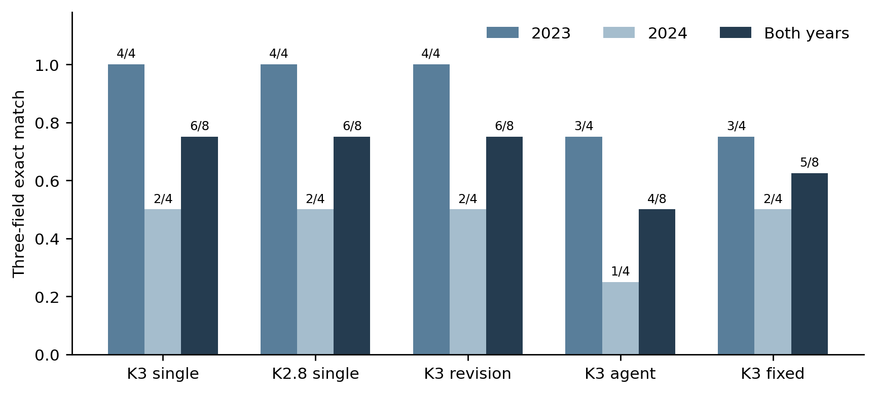
Figure 8. Year-stratified exact extraction. The denominator includes the three absent final answers and both years from each of four companies.

6.3 Evidence displacement and extraction omissions
The CMB 2023 trace provides a concrete failure mechanism. The initial context includes the attendance and committee pages at physical pages 93 and 97, and single-call K3 extracts all three fields correctly. The agent makes two schema-valid planning calls with four queries. Because newly retrieved hits precede prior hits under the unchanged packing ceiling, both useful pages disappear from the final context. The final answer returns empty member and date lists and a null meeting count, explicitly saying the supplied material is insufficient. This is a well-formed abstention after evidence loss, not a malformed answer or proof that the company lacks an audit committee.
CMB 2024 exposes a different limitation. Its selected page-97 chunk ends in the middle of the 14 May meeting entry. The report lists nine meetings, but the later dates are absent from that supplied passage. All five conditions omit the same four later meeting dates. The agent recovers a former member that single-call K3 misses, yet still lacks a complete date set. A page hit therefore does not establish that every required field from the page survives chunking and selection.
Reference-page coverage is only a location diagnostic. Under the original frozen page list, initial coverage is 100% across all questions; final coverage falls to 87.5% for the agent and 81.25% for fixed expansion. Adding the erratum page changes this denominator, so both versions remain available in the analysis files. These traces motivate evidence-retention and table-aware extraction improvements, but no unexecuted repair is assigned a score or described as validated.
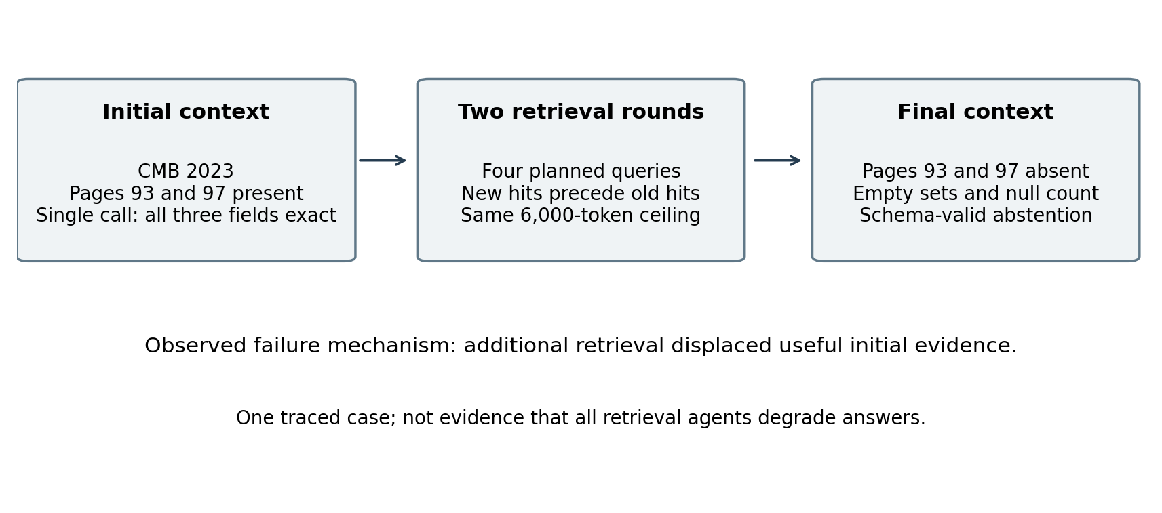
Figure 9. A saved CMB 2023 trace shows useful initial evidence being displaced. The final abstention is consistent with the reduced evidence, while end-to-end extraction worsens.
Table 12. Failure and reference-error taxonomy grounded in saved traces.
Case | Observed issue | Implication
CMB 2023 agent | Pages 93 and 97 removed after new retrieval | A valid planning schema does not preserve evidence
CMB 2024 all conditions | Required dates extend beyond selected page-97 chunk | Page presence does not guarantee field coverage
CR Sanjiu 2024 reference | Departed chair omitted by meeting-table-only labeling | Reference completeness requires personnel-change pages
Gree 2024 agent | Final service call returns HTTP 502 | Execution failure is distinct from answer quality
CR Sanjiu 2024 K2.8 / revision | Output-limit empty answer / unrecorded final response | Failures retained; no selective retry

6.4 Resource use and the cross family execution boundary
The agent uses a mean of 16,334 recorded tokens per planned answer unit, compared with 5,741 for single-call K3, approximately 2.85 times as many. Fixed-context revision uses 16,536 and fixed expansion 6,544. These sums include saved intermediate calls and exclude any consumption from the unrecorded request. Average saved-request durations are not end-to-end latency, local retrieval time, or provider billing. Different reasoning defaults and realized context sizes also prevent a compute-matched interpretation.
The official Qwen3-0.6B checkpoint was downloaded at a pinned revision and verified against its published weight digest [26]. Float32 loading failed with Windows error 1455 before inference. A lower-memory BF16 attempt terminated before a model-loaded receipt or any output. An official quantized derivative was also downloaded and verified, but the tested llama.cpp CPU runtimes failed during startup before loading that model. The processes were stopped or exited, and failed runtimes were not reused for scoring. No cross-family answer exists for this test, and the paper reports no Qwen quality number. The earlier two in-chat GPT cases remain exposed exploratory examples, not replacements for a controlled cross-family run.
Table 13. Saved request resources per planned answer unit. Totals exclude an unrecorded request and local retrieval overhead.
Condition | Mean tokens | Mean request s | Mean new chunks | Queries
K3 single | 5,741 | 45.4 | 0.00 | 0.0
K2.8 single | 5,982 | 34.9 | 0.00 | 0.0
K3 revision | 16,536 | 104.3 | 0.00 | 0.0
K3 agent | 16,334 | 75.2 | 8.75 | 4.0
K3 fixed expansion | 6,544 | 38.5 | 11.12 | 4.0

7 Discussion
The principal distinction is between supplying evidence of each role and locating the evidence needed for a particular claim. Separate retrieval ensures more balanced source availability in the primary evaluation, and the corresponding observed quality gain is concentrated in the regulatory dimension. At the same time, exact target-location coverage does not improve overall. These findings can coexist: a retrieved alternative source may help an answer without matching the designated reference, and an irrelevant regulatory chunk can satisfy a source-presence indicator. The current data do not identify these pathways exhaustively.
A second distinction is between changing an answer and improving it. Role prompting creates more model-reported claims and more mixed-source citation structures, but the primary quality contrast remains close to zero. The initial tool-agent extension similarly introduces genuinely new passages without a stable aggregate advantage under its automatic judge. The new field task provides a sharper test of particular omissions, while its fixed-expansion control checks whether topic-specific retrieval is sufficient. This is a more defensible basis for interpreting controller value than counting tool calls or labeling a longer prompt an agent.
The earlier exploratory extension is retained because its failures informed the later protocol. Across twelve questions from two already exposed companies, forty-eight outputs were scored by a K2.8 model judge; thirty-nine received full marks. A planner-only prompt repair improved schema compliance but one of twelve repaired runs exhausted its output allowance and returned no visible answer. Controlled corruptions were judged more harshly for false facts than for invalid citations, with inconsistent penalties across two cases. Those observations justify replacing the aggregate judge in the new test. They do not validate the new reference labels independently.
Cross-year claims must remain modest. Applying one parser, chunking rule, and retrieval configuration to both years improves comparability, but annual reports differ in content, length, table layout, and disclosure practices. The legal pool is fixed and has not been aligned to every event date. Consequently, the experiment tests operation on documents from two years, not resistance to all temporal distribution shifts, the effect of a regulatory change, or the correctness of historical compliance decisions.
Cross-family performance remains unverified because local Qwen inference did not complete. Verified checkpoint provenance and identical saved prompts improve the design of a future comparison, but neither constitutes an experimental answer. Even a successful small CPU model would differ from the hosted service in capacity, decoding and resource allowance. The present results therefore concern hosted aliases within one model family and cannot establish transfer to other strong generators.
Annotation remains a substantive limitation. The original reviewers disagree most on regulatory evidence and show ceiling effects elsewhere. The new reference fields are AI-assisted and visually checked by the same assistant responsible for the experiment. Deterministic scoring removes the need for a model judge at scoring time, but not uncertainty in the reference. Independent human extraction, blind adjudication of ambiguous membership scope, and claim-level citation checks are still required before treating this supplement as an independent validation of semantic correctness. A ready-made blinded review package is supplied to make that remaining work concrete.
Reproducibility has several levels. File and context hashes make the recorded inputs auditable. Saved requests and raw outputs make reported scores recalculable. A pinned local model makes one generator more precisely identifiable. Hosted aliases, provider reasoning defaults, network conditions, and stochastic generation remain incompletely reproducible. The main study also contains recovery attempts, while the holdout preserves a no-retry rule. These distinctions are material to interpretation and should remain visible in any revised publication version.
The practical implication is to prefer the least complex configuration that meets a clearly specified evidence requirement. On this dataset, source-aware allocation is a useful candidate, while extra prompt structure and retrieval complexity require their own demonstrated benefit. For deployment, abstention when evidence is missing is different from a correct complete extraction, and a successful request is different from a supported answer. The manuscript reports these layers separately so that a reader can judge the trade-off relevant to a particular application.

8 Conclusions
This study evaluates source organization and retrieval control for question answering over company annual reports and regulatory documents. In the original twenty-company human-reviewed study, separate source retrieval shows a small positive observed difference, while source-role prompting on identical evidence shows no stable additional benefit. Source balance improves, but designated evidence-location coverage does not improve overall, and simplified retrieval remains competitive under the available measurements.
The added new-company test standardizes document processing across two years, includes fixed-context revision and deterministic query expansion as agent controls, and evaluates explicit disclosure fields with transparent scoring. The corrected test shows no agent advantage: exact match is 4/8 for the agent and 6/8 for single-call K3. A preserved reference erratum and the failed local model execution make the remaining evidence gaps explicit. The resulting evidence supports a bounded empirical account of when source organization helps and where retrieval, extraction, and evaluation remain unreliable. It does not establish general superiority or fully independent semantic validation.

Data and code availability
The accompanying local research archive contains the new source-document hashes, fixed execution protocol, initial prompts, saved call records, original and corrected reference labels, scoring scripts, aggregate tables, figure sources, and forty randomized review cases. The original-study release is retained separately and included as a nested archive for provenance. No public repository identifier is asserted. Redistribution of third-party source documents and final public deposit remain the authors’ responsibility.

Use of AI assistance
AI assistance was used for code development, document processing, supplementary reference extraction, source-page inspection, analysis, and English drafting. The supplementary labels were not independently annotated by humans. One omission discovered after output inspection is explicitly corrected with source-page evidence. The separate original human ratings retain their recorded provenance.

References
[1] Lewis P, et al. Retrieval-Augmented Generation for Knowledge-Intensive NLP Tasks. NeurIPS 33, 2020: 9459–9474. https://arxiv.org/abs/2005.11401
[2] Chen Z, et al. FinQA: A Dataset of Numerical Reasoning over Financial Data. EMNLP, 2021: 3697–3711. https://doi.org/10.18653/v1/2021.emnlp-main.300
[3] Zhu F, et al. TAT-QA: A Question Answering Benchmark on a Hybrid of Tabular and Textual Content in Finance. ACL-IJCNLP, 2021: 3277–3287. https://doi.org/10.18653/v1/2021.acl-long.254
[4] Choe J, Kim J, Jung W. Hierarchical Retrieval with Evidence Curation for Open-Domain Financial Question Answering on Standardized Documents. Findings of ACL, 2025: 16663–16681. https://doi.org/10.18653/v1/2025.findings-acl.855
[5] Siddharth L, Luo J. Retrieval augmented generation using engineering design knowledge. Knowledge-Based Systems 303, 2024: 112410. https://doi.org/10.1016/j.knosys.2024.112410
[6] Yang W, Some L, Bain M, Kang B. A comprehensive survey on integrating large language models with knowledge-based methods. Knowledge-Based Systems 318, 2025: 113503. https://doi.org/10.1016/j.knosys.2025.113503
[7] Robertson S, Zaragoza H. The Probabilistic Relevance Framework: BM25 and Beyond. Foundations and Trends in Information Retrieval 3(4), 2009: 333–389. https://doi.org/10.1561/1500000019
[8] Karpukhin V, et al. Dense Passage Retrieval for Open-Domain Question Answering. EMNLP, 2020: 6769–6781. https://doi.org/10.18653/v1/2020.emnlp-main.550
[9] Zhang Y, et al. Qwen3 Embedding: Advancing Text Embedding and Reranking Through Foundation Models. arXiv, 2025. https://arxiv.org/abs/2506.05176
[10] Cormack G V, Clarke C L A, Buettcher S. Reciprocal rank fusion outperforms condorcet and individual rank learning methods. SIGIR, 2009: 758–759. https://doi.org/10.1145/1571941.1572114
[11] Alier M, García-Peñalvo F J, Casañ M J, Pereira J, Granados A. Closing the acronym gap in educational retrieval with ontology-guided augmentation. Information Sciences 740, 2026: 123181. https://doi.org/10.1016/j.ins.2026.123181
[12] Asai A, Wu Z, Wang Y, Sil A, Hajishirzi H. Self-RAG: Learning to Retrieve, Generate, and Critique through Self-Reflection. ICLR, 2024. https://arxiv.org/abs/2310.11511
[13] Yan S Q, Gu J C, Zhu Y, Ling Z H. Corrective Retrieval Augmented Generation. arXiv, 2024. https://arxiv.org/abs/2401.15884
[14] Jeong S, Baek J, Cho S, Hwang S J, Park J. Adaptive-RAG: Learning to Adapt Retrieval-Augmented Large Language Models through Question Complexity. NAACL, 2024: 7036–7050. https://doi.org/10.18653/v1/2024.naacl-long.389
[15] Han W, Xiao X, Li Y, Wang J, Pechenizkiy M, Fang M. Adaptive iterative retrieval for enhanced retrieval-augmented generation. Neurocomputing 666, 2026: 132272. https://doi.org/10.1016/j.neucom.2025.132272
[16] Yao S, et al. ReAct: Synergizing Reasoning and Acting in Language Models. ICLR, 2023. https://arxiv.org/abs/2210.03629
[17] Li B, Fan S, Zhu S, Wen L. CoLE: A collaborative legal expert prompting framework for large language models in law. Knowledge-Based Systems 311, 2025: 113052. https://doi.org/10.1016/j.knosys.2025.113052
[18] Wang H, et al. Learning to break: Knowledge-enhanced reasoning in multi-agent debate system. Neurocomputing 618, 2025: 129063. https://doi.org/10.1016/j.neucom.2024.129063
[19] Gao T, Yen H, Yu J, Chen D. Enabling Large Language Models to Generate Text with Citations. EMNLP, 2023: 6465–6488. https://doi.org/10.18653/v1/2023.emnlp-main.398
[20] Es S, James J, Espinosa Anke L, Schockaert S. RAGAs: Automated Evaluation of Retrieval Augmented Generation. EACL System Demonstrations, 2024: 150–158. https://doi.org/10.18653/v1/2024.eacl-demo.16
[21] Ru D, et al. RAGChecker: A Fine-grained Framework for Diagnosing Retrieval-Augmented Generation. NeurIPS Datasets and Benchmarks, 2024. https://arxiv.org/abs/2408.08067
[22] Pipitone N, Alami G H. LegalBench-RAG: A Benchmark for Retrieval-Augmented Generation in the Legal Domain. arXiv, 2024. https://arxiv.org/abs/2408.10343
[23] Liu N F, et al. Lost in the Middle: How Language Models Use Long Contexts. TACL 12, 2024: 157–173. https://doi.org/10.1162/tacl_a_00638
[24] Kimi. Model configuration. Service alias documentation; underlying checkpoint revision unverified. https://www.kimi.com/help/kimi-code/models (accessed 2026-10-23).
[25] SQLite. FTS5 Extension: The bm25() function. https://www.sqlite.org/fts5.html#the_bm25_function (accessed 2026-10-23).
[26] Qwen Team. Qwen3-0.6B model card and official checkpoint. Revision c1899de289a04d12100db370d81485cdf75e47ca. https://huggingface.co/Qwen/Qwen3-0.6B/tree/c1899de289a04d12100db370d81485cdf75e47ca (accessed 2026-10-23).

Appendix A Reproduction and review
Run score_heldout_validation_20261023.py to reproduce the frozen-label analysis and pass --corrected for the explicit erratum version. Run audit_heldout_validation_20261023.py for source, context, inventory, scope, and scoring-contract checks. Recalculation does not require a generation API key. Re-executing hosted generation requires a compatible service and is expected to produce stochastic differences. Generation must not be rerun merely to replace failures in the released inventory.
The blinded-review directory contains forty shuffled HTML cases, the eight original annual reports, and an unfilled reviewer form. The condition mapping and reference answers are kept outside that directory. Output style and retrieved context may reveal the method, so complete blinding is not guaranteed. No completed independent review is claimed. The label erratum is a concrete reason to independently re-extract every reference field, including personnel changes, before publication.

