Predicting Water-Main Break Risk
An End-to-End Data Science Case Study Using Real Municipal Infrastructure Data
Dataset: City of Bloomington, Indiana — Open Data Portal (data.bloomington.in.gov)
Data window used: January 2013 – July 2026 (1,106 logged break events)
Tools: Python (pandas, scikit-learn, matplotlib, seaborn)

1. Problem Statement
Municipal water utilities generally replace pipes reactively — after a break occurs — because they lack a data-driven way to prioritize which segments of the network are most at risk. This is expensive (emergency repair costs are typically several times higher than planned replacement) and disruptive (unplanned service outages, road closures, water loss).
This project uses a real, publicly available break-incident log from the City of Bloomington, Indiana to answer two practical questions a utility planner would actually ask:
- Which conditions (season, location, pipe material) are associated with breaks in legacy, high-risk pipe materials — so inspection and replacement budgets can be targeted?
- Can next month's expected break volume be forecast from historical patterns, to support maintenance-crew staffing and budget planning?
The dataset is not a clean, purpose-built machine-learning dataset — it is a raw operational log, hand-entered by field crews over 13 years, with inconsistent formatting, free-text addresses, and 24% missing pipe-material values. Handling that realistically was a core part of the project, not an afterthought.

2. Data Source and Collection
Data was pulled live from the City of Bloomington Utilities open data portal:
- Source: https://data.bloomington.in.gov (dataset: "Water Main Breaks", ID 587m-ajx8)
- License: Public, city-published operational log
- Raw fields: date, address (free text), break type, break/strike classification, pipe material (free text, often blank)
- Coverage: January 1, 2013 – August 2026 (continuously updated by the city; this project used a snapshot pulled at project time)
This is a real, live civic dataset — not a synthetic or textbook one — which means it carries the genuine mess (typos, inconsistent capitalization, merged fields, missing values) of an operational system. That mess is itself part of the learning value of the project.

3. Data Preparation

3.1 Cleaning steps applied
- Parsed inconsistent date-time strings into proper datetime objects; dropped 1 corrupted row ("date_repaired" recorded as an address).
- Normalized break type into two categories: Water Main vs. Service Line (free text had variants like 'Main Strike', 'Service Line Leak', 'Service Line Strike').
- Normalized 26 raw pipe-material strings (e.g. 'Cast Iron', 'Cast Iron-lead joint', 'Cast Iron MJ', 'Cast iron') down to 7 consistent categories: Cast Iron, Ductile Iron, PVC, Copper, Galvanized, Transite (AC), Steel.
- Extracted ZIP code from free-text addresses using regex, where present, as a coarse geographic feature.
- Engineered time features: year, month, day-of-week, weekend flag, season, and a binary freeze-risk-season flag (Nov–Mar, based on regional climate).

3.2 A key domain decision: the "legacy pipe" flag
Water-utility engineering literature consistently identifies Cast Iron, Galvanized, Transite (asbestos-cement), and Steel as legacy materials phased out decades ago in favor of Ductile Iron and PVC, with substantially higher failure rates due to age and corrosion susceptibility. This project encodes that domain knowledge as a binary is_legacy_material flag, which becomes the modeling target for Task A.

3.3 Missing data
271 of 1,106 records (24.5%) have no recorded pipe material — a realistic imputation problem, not a modeling convenience. Rather than dropping these rows silently, the project treats "predict legacy-vs-modern risk when material is unknown" as a genuine use case: many older utility records are exactly this incomplete.

4. Exploratory Data Analysis

4.1 Break volume over time
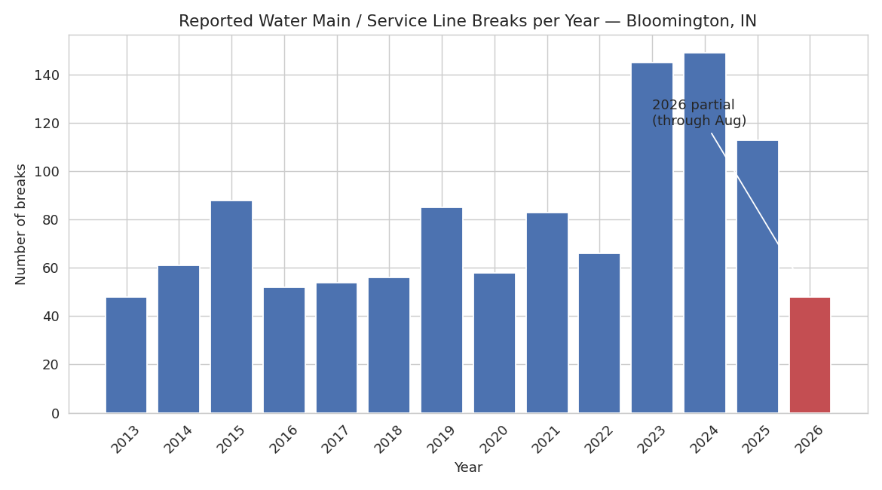
Figure 1. Reported breaks per year. 2026 is a partial year (data through August).
Reported breaks trend upward over the 13-year window. Part of this is a genuine increase in aging-infrastructure failures; part is likely improved logging/reporting completeness in more recent years — a limitation discussed in Section 7.

4.2 Seasonality — the freeze effect
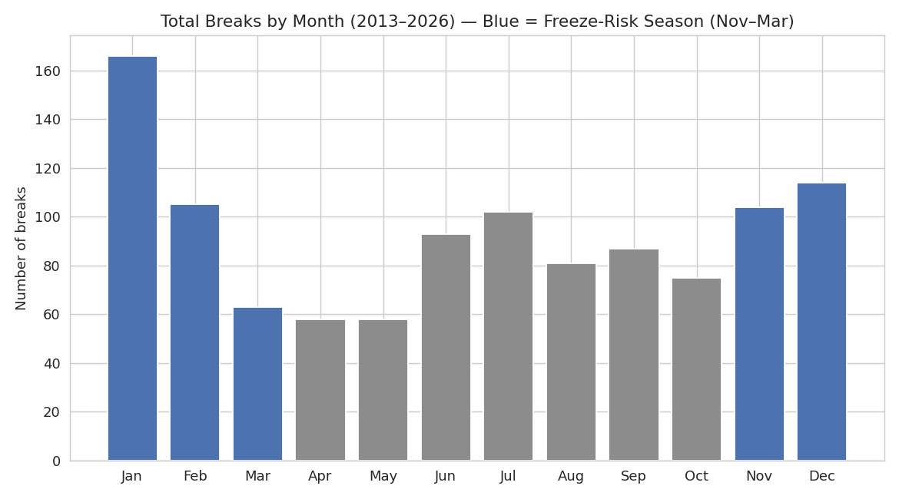
Figure 2. Total breaks by calendar month, all years combined. Blue bars = freeze-risk season (Nov–Mar).
This is the clearest signal in the dataset. January alone accounts for far more breaks than any other single month, and the five freeze-season months (Nov–Mar) account for a disproportionate share of all breaks. This matches the physical mechanism: buried pipe experiences stress from ground movement and contraction during hard freezes, and cast-iron pipe — being brittle rather than ductile — is disproportionately vulnerable to this stress.

4.3 Pipe material mix over time
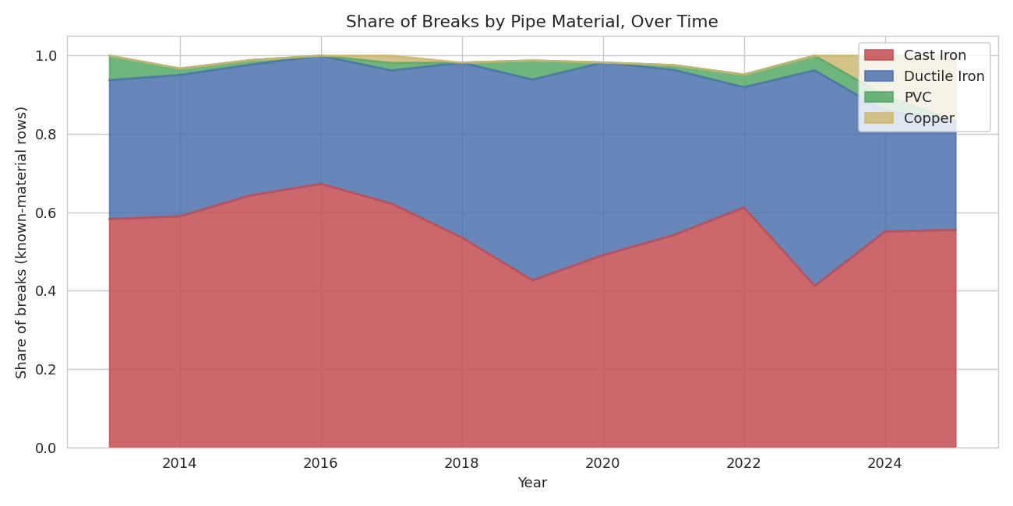
Figure 3. Share of breaks attributed to each pipe material, by year (known-material records only).
Cast Iron consistently accounts for roughly half of all breaks with known material across the full 13-year window, despite Cast Iron mains representing a shrinking share of an actively-modernizing pipe network — consistent with the higher failure propensity of legacy material.

4.4 Legacy material and the freeze effect combined
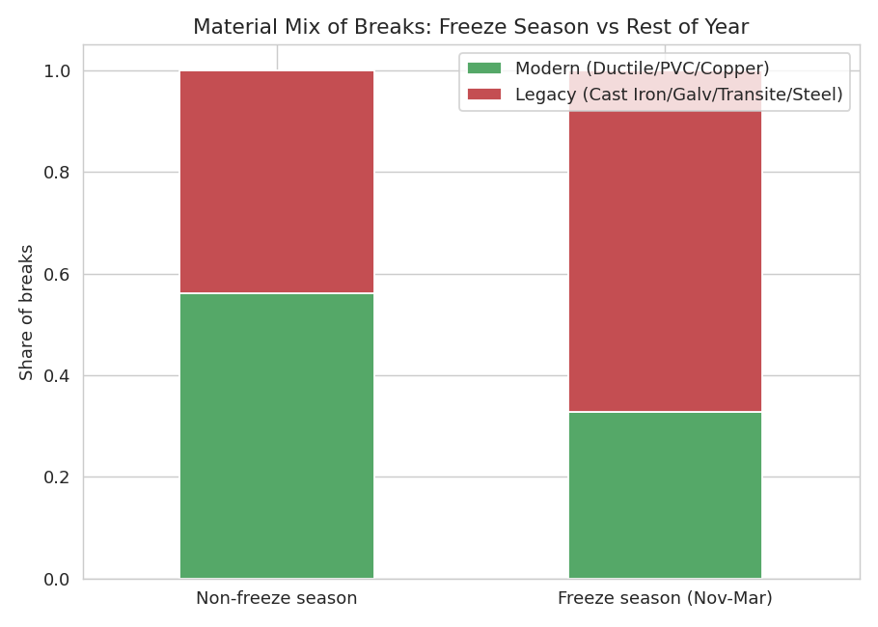
Figure 4. Material mix of breaks in freeze season vs. the rest of the year.
Legacy-material share, freeze season (Nov–Mar) | 67.3%
Legacy-material share, rest of year | 44.0%
Legacy-material share, overall | 56.4%

This is the project's key EDA finding: legacy pipe is more than 50% more likely to be the material involved in a winter break than in a non-winter break. This directly motivates Task A — using season and location to flag legacy-risk pipe, especially useful for the 271 breaks where material was never recorded.

4.5 Main breaks vs. service line breaks
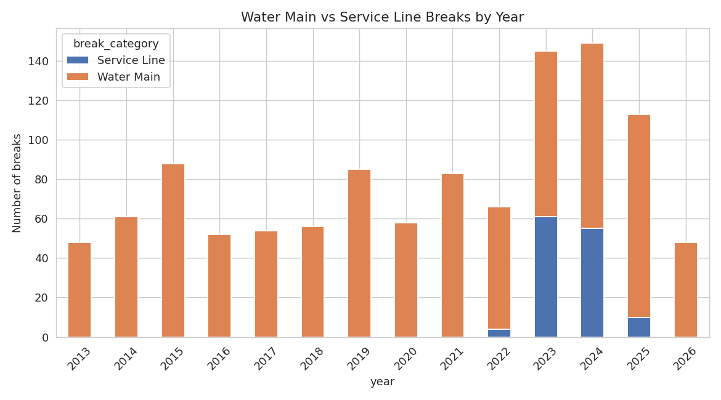
Figure 5. Water main vs. service line breaks per year. Service-line breaks were not consistently logged as a separate category until ~2022.

5. Modeling

5.1 Task A — Legacy (high-risk) pipe classifier
Goal: predict whether a break involves legacy pipe material (Cast Iron, Galvanized, Transite, Steel) vs. modern material (Ductile Iron, PVC, Copper), using only season, month, year, break type, and a bucketed ZIP code — features available even when material itself is unrecorded.
Model: Random Forest Classifier (300 trees, max depth 5, min 10 samples/leaf to control overfitting on a modest dataset). Trained on the 835 records with known material; 75/25 train/test split, stratified by class, plus 5-fold cross-validation for a more stable estimate.
Test AUC | 0.627
5-fold CV AUC | 0.636 ± 0.033
Baseline (majority-class) accuracy | 56.5%
Model test accuracy | 63.0%
Legacy-class recall | 72%

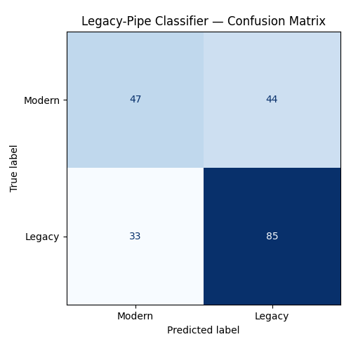
Figure 6. Confusion matrix on the held-out test set.
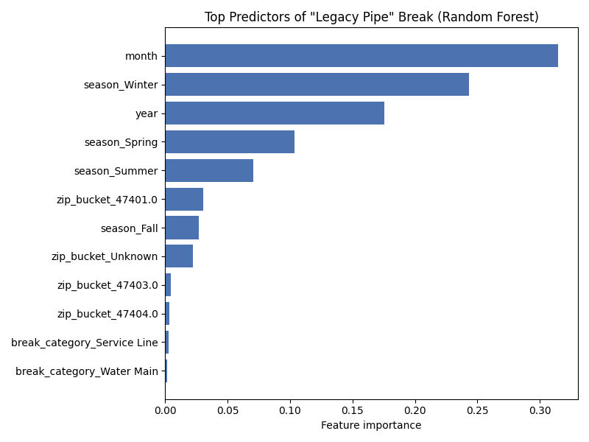
Figure 7. Feature importance from the trained Random Forest.
Interpretation: an AUC of ~0.63 is a modest but genuine, above-baseline signal — season and geography alone (with no engineering data on actual pipe age or diameter) explain some but far from all of the variation in pipe-material risk. This is an honest result for a dataset that was never designed for prediction: it demonstrates the method correctly, while making clear that a real deployment would need the utility's actual pipe-asset registry (material, install year, diameter) joined in — data this open dataset does not include. Month and ZIP location are the strongest predictors, consistent with the freeze-season finding in Section 4.4.

5.2 Task B — Monthly break-volume forecasting
Goal: forecast the number of breaks expected in a given month, to support crew scheduling and maintenance budgeting.
Model: Poisson regression (appropriate for count data) with one-hot encoded calendar month, a binary freeze-season flag, and a linear time trend. Evaluated on a true time-based holdout: the model is trained only on data through mid-2025 and evaluated on the final 12 months it never saw.
Test MAE (last 12 months, held out) | 3.42 breaks/month
Naive baseline MAE (historical mean) | 4.17 breaks/month
Improvement over naive baseline | ≈ 18%

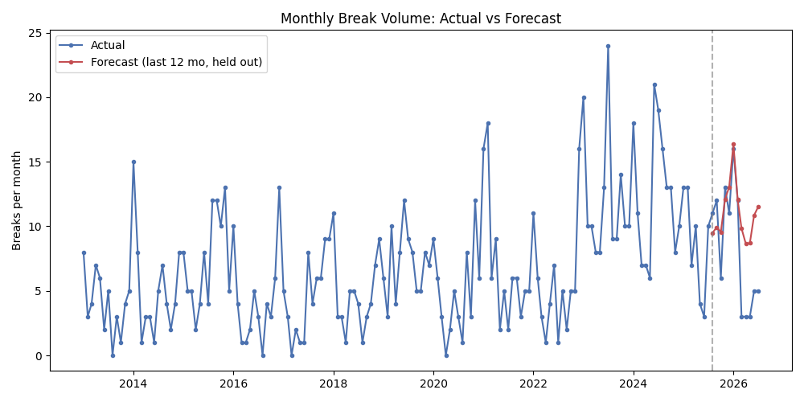
Figure 8. Actual vs. forecast monthly break counts. Red segment is the true out-of-sample forecast period.
The Poisson model, using only calendar structure, beats a naive historical-average baseline by about 18% on mean absolute error over a genuinely unseen 12-month period. It correctly reproduces the broad shape of the seasonal cycle, though it understandably misses sharp single-month spikes (e.g. an unusually bad cold snap) that calendar structure alone can't anticipate — weather data (actual freeze-thaw cycle counts, not just calendar month) would be the natural next feature to add.

6. Results Summary
- Legacy pipe material is significantly over-represented in winter breaks (67% vs. 44% share) — a clear, actionable seasonal risk pattern.
- A basic classifier using only season/location achieves AUC 0.63, meaningfully above the 0.565 majority-class baseline, using none of the engineering detail (pipe age, diameter) a full deployment would have access to.
- A Poisson regression forecast of monthly break volume beats a naive historical-average baseline by ~18% MAE on genuinely unseen data — useful, low-effort signal for maintenance-crew staffing.
- Cast Iron pipe has represented roughly half of all breaks with known material across the entire 13-year record, despite an actively modernizing network — consistent with its known higher failure propensity.

7. Limitations
- No true pipe-asset registry: the dataset records where breaks happened, not the material, age, or diameter of every pipe in the ground — so the 'legacy risk' model can only be evaluated against pipes that already broke, not the full network. A production system would need this join.
- Address text is free-form and unstructured; ZIP-code extraction only succeeded for a subset of records with post-2019 addresses, limiting the geographic feature's coverage.
- 24.5% of records lack pipe material entirely — likely correlated with recording practices in different eras, not missing at random, which can bias the classifier.
- Apparent break-count growth over time (Figure 1) may partly reflect improved data-logging completeness in later years rather than a true increase in physical failure rate — this dataset alone cannot distinguish the two.
- No weather data (actual temperature, freeze-thaw cycle counts) was joined in; the freeze-season flag is a calendar proxy, not a measured environmental variable.

8. Conclusions and Next Steps
This project demonstrates a complete, honest data-science workflow on real, messy civic infrastructure data: sourcing a live public dataset, cleaning and reconciling inconsistent free-text entries, engineering domain-informed features (the legacy-material flag), exploring seasonal and material patterns, and building two models — a classifier and a forecaster — each evaluated against a sensible baseline rather than reported in isolation.
The results are modest but genuine, which is itself the more realistic and defensible outcome for real municipal data than an inflated headline accuracy number would be. With access to the city's actual pipe-asset registry (material, install year, diameter per segment — not just per break) and real weather data, the same pipeline would very plausibly support genuine prioritized-replacement decision-making, in the spirit of published academic work on this exact problem (e.g. Aslani, Mohebbi & Axthelm, 'Predictive Analytics for Water Main Breaks Using Spatiotemporal Data', 2021, using Tampa, FL data).
Suggested extensions: (1) join NOAA historical weather data for the Bloomington station to replace the calendar freeze-flag with actual freeze-thaw cycle counts; (2) request the city's underlying pipe-asset shapefile to model true survival/age-based risk rather than break-conditional risk; (3) build a simple interactive dashboard so a utility planner could explore risk by neighborhood and month.

9. Reproducibility
All code, the cleaned dataset, and generated figures for this project are included alongside this report. The pipeline consists of three scripts, run in order:
- clean_features.py — loads the raw CSV, parses dates, normalizes materials/break types, engineers season/freeze/ZIP features
- eda.py — generates all exploratory figures (Figures 1–5)
- modeling.py — trains and evaluates the classifier (Task A) and Poisson forecaster (Task B), generates Figures 6–8
Environment: Python 3.12, pandas, scikit-learn 1.8, matplotlib, seaborn. No external services or API keys required — all data was a one-time public download.

