PINNACLE LABS

Fake News Detection
Project Report: Data Science with Python, NLP and Machine Learning
Project: Project 1 of Data Science (NOV26P2)
Goal: Identify and classify news articles as real or fake to promote information accuracy.
Language: Python 3
Date: 4 November 2026

1. Introduction
Misinformation spreads quickly on social media and news sites. Manually checking every article is not practical, so this project builds an automated system that reads the text of a news article or headline and predicts whether it is REAL or FAKE.
The system uses Natural Language Processing (NLP) to turn text into numbers and classical machine learning models to learn the difference between reliable and misleading writing. It is built entirely in Python, and includes a training script, a prediction script and an evaluation report.

2. Objectives
- Clean raw news text so that models can learn from it.
- Convert text into numerical features using TF-IDF.
- Train and compare three classification algorithms.
- Evaluate the models with accuracy, precision, recall, F1-score and a confusion matrix.
- Save the best model and use it to classify new articles from the command line.

3. Technologies and Languages Used
The whole project is written in Python. The following libraries are used:
Tool / Library | Purpose
Python 3 | Main programming language for all scripts
pandas | Loading CSV data, cleaning, merging and de-duplicating records
NumPy | Numerical operations and ranking of important words
scikit-learn | TF-IDF vectorizer, ML models (Naive Bayes, Logistic Regression, Linear SVM), pipeline, train/test split and metrics
Regular expressions (re) | Removing URLs, HTML tags, digits and punctuation
joblib | Saving and loading the trained model
matplotlib | Drawing the confusion matrix chart
Jupyter / VS Code | Recommended environments for running and exploring the code

4. System Architecture
The project follows a standard machine learning pipeline. Each stage feeds the next:
- Data loading: news text and labels are read from CSV files (0 = fake, 1 = real).
- Preprocessing: text is lower-cased and cleaned of URLs, HTML, numbers and punctuation.
- Feature extraction: TF-IDF converts each article into a numeric vector.
- Model training: Naive Bayes, Logistic Regression and Linear SVM are trained on 80% of the data.
- Evaluation: each model is tested on the remaining 20% and scored.
- Deployment: the best model is saved and used by predict.py to classify new text.

4.1 Folder structure
fake_news_detection/
data/ sample_news.csv (or Fake.csv and True.csv)
models/ fake_news_model.joblib
reports/ metrics.json, confusion_matrix.png, top_features.json
src/
preprocess.py text cleaning
make_sample_data.py creates a demo dataset
train.py training and evaluation
predict.py classify new text
requirements.txt
README.md

5. How It Works

5.1 Text preprocessing
Raw text contains noise that does not help classification. The function clean_text() in preprocess.py converts text to lower case, removes links and HTML tags, removes everything except letters, and collapses extra spaces. This makes "BREAKING!!!" and "breaking" the same token.
def clean_text(text):
text = text.lower()
text = _URL.sub(' ', text) # remove links
text = _HTML.sub(' ', text) # remove HTML tags
text = _NON_ALPHA.sub(' ', text) # keep letters only
return _SPACES.sub(' ', text).strip()

5.2 TF-IDF feature extraction
Machine learning models cannot read words, so each article is converted into a vector using TF-IDF (Term Frequency, Inverse Document Frequency). A word scores high if it appears often in one article but rarely across all articles, which makes it a useful clue. This project also uses bigrams (two-word phrases such as "mysterious illness"), removes English stop words, and applies sublinear term-frequency scaling.

5.3 Classification models
Model | How it works
Multinomial Naive Bayes | Uses word-frequency probabilities and Bayes' theorem. Very fast and a strong baseline for text.
Logistic Regression | Learns a weight for every word and combines them into a probability of the article being real.
Linear SVM | Finds the best separating boundary between fake and real articles in the TF-IDF space.

Each model is wrapped in a scikit-learn Pipeline together with the TF-IDF step. This guarantees that exactly the same transformation is applied during training and prediction.
Pipeline([
('tfidf', TfidfVectorizer(stop_words='english', ngram_range=(1, 2),
max_df=0.9, min_df=2, sublinear_tf=True)),
('clf', model),
])

5.4 Training, evaluation and selection
The data is split 80/20 with stratification, so both sets keep the same fake/real balance. Every model is trained on the training set and evaluated on the unseen test set. The model with the highest F1-score is saved to models/fake_news_model.joblib.

5.5 Prediction
predict.py loads the saved pipeline, cleans the input text, and returns the label (REAL or FAKE) with an approximate confidence value.
$ python src/predict.py "BREAKING!!! Secret memo LEAKED: miracle cure hidden"
Prediction: FAKE (confidence ~81%)

6. Results
Important: the figures below come from a small synthetic demo dataset (3,000 template-generated headlines, 2,831 after removing duplicates) used only to verify that the pipeline works offline. Scores on real news will be different, and are usually lower. Re-run train.py with the Kaggle Fake and Real News dataset to obtain genuine results.

Model | Accuracy | Precision | Recall | F1-score
Naive Bayes | 97.88% | 97.98% | 97.98% | 97.98%
Logistic Regression | 97.71% | 97.65% | 97.98% | 97.82%
Linear SVM (best) | 98.41% | 98.32% | 98.65% | 98.49%

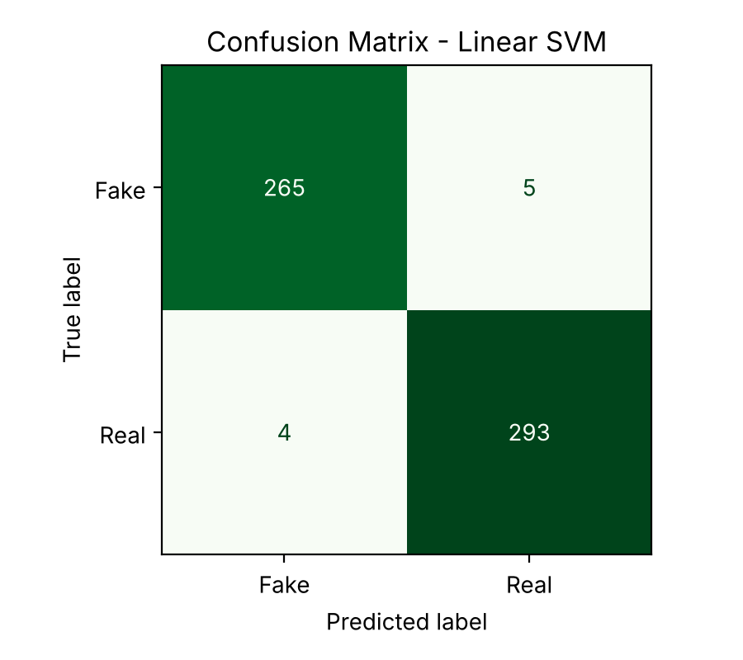
Figure 1: Confusion matrix of the best model on the demo test set

Reading the metrics: accuracy is the share of all predictions that were correct; precision is how many articles predicted REAL were actually real; recall is how many real articles were found; F1 balances precision and recall.

7. How to Run the Project
- Install Python 3.9 or newer.
- Install the libraries: pip install -r requirements.txt
- (Optional) Create demo data: python src/make_sample_data.py
- Train the models: python src/train.py
- Classify a news item: python src/predict.py "your text here"

Using real data: download Fake.csv and True.csv (Fake and Real News Dataset, Kaggle) into the data folder and run:
python src/train.py --fake data/Fake.csv --true data/True.csv

8. Limitations
- The model learns writing style and vocabulary, not facts. It cannot verify whether a claim is actually true.
- A model trained on one dataset may perform worse on news from other sources, topics or time periods.
- Well-written misinformation, or sensational but true headlines, may be misclassified.
- Results on the synthetic demo data are not representative of real-world performance.

9. Future Improvements
- Train on larger real datasets such as ISOT, LIAR or FakeNewsNet and use cross-validation.
- Add deep learning models such as LSTM or transformer models (BERT) for better context understanding.
- Include extra features: source reputation, author, publication date and metadata.
- Build a web app with Streamlit or Flask so users can paste an article and get a result instantly.
- Add explainability (for example LIME or SHAP) to show which words influenced each prediction.

10. Conclusion
This project demonstrates a complete, reproducible machine learning workflow for fake news detection: data preparation, NLP feature engineering, model comparison, evaluation and deployment through a simple prediction script. It provides a solid baseline that can be extended with real datasets and more advanced models.

