Sustainable Packaging Recommendation System
System Documentation
1. Introduction
The packaging industry plays a critical role in environmental sustainability due to its impact on carbon emissions, material waste, and resource consumption.
This project proposes a data-driven Sustainable Packaging Recommendation System that ranks and recommends the most suitable packaging materials for a given product
while explicitly considering sustainability metrics.
2. Problem Statement
Recommend and rank the top-K sustainable packaging materials for a product based on material properties, environmental impact, cost efficiency,
regional availability, and market constraints.
3. Objectives
• Build a unified dataset
• Engineer sustainability-focused features
• Train ranking-based recommendation models
• Ensure data validation and reproducibility
• Provide explainable recommendations
4. System Architecture & Decision Factors
The figure below illustrates the multi-dimensional factors influencing sustainable packaging decisions, including ecological impact, cost efficiency,
regulatory frameworks, consumer appeal, technological innovation, and market demand.
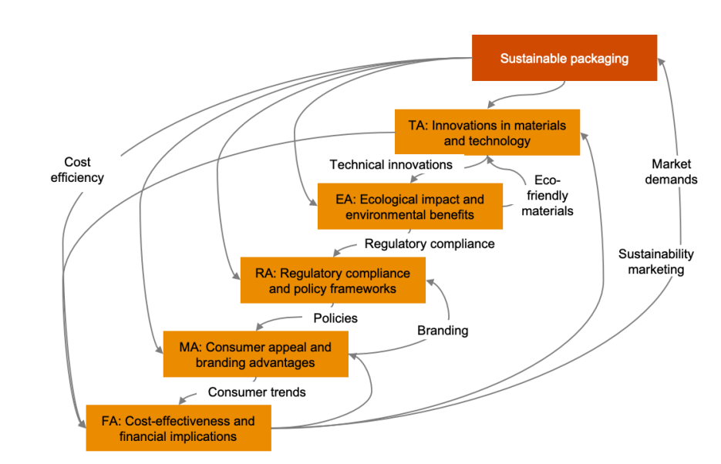
5. Data Sources
• Structured data stored in PostgreSQL (materials, products, regions, market factors)
• Synthetic data for sparsity handling
• Unstructured textual data extracted using NLP from PDFs and reports
6. Data Validation & Cleaning
Schema validation ensures data consistency. Missing values are handled using imputation techniques, and normalization is applied to numerical attributes.
7. Feature Engineering
Key engineered features include:
• CO₂ Impact Index
• Cost Efficiency Index
• Material Suitability Score
• Carbon–Cost Ratio
• Regional Pressure Score
• Material Complexity Score
8. Model Approach
The problem is modeled as a ranking task using tree-based and score-based models to generate Top-K material recommendations.
9. Experiment Tracking
MLflow is used to track experiments, parameters, metrics, and artifacts for reproducibility.
10. Explainability
Each recommendation is accompanied by reasoning based on feature contributions and sustainability trade-offs.
11. Conclusion
This system provides a scalable, explainable, and sustainability-driven approach to packaging material selection.

Explainability and Decision Factor Computation
A core objective of the Sustainable Packaging Recommendation System is transparency.
Rather than functioning as a black-box model, the system explicitly computes and exposes
the contribution of each decision factor involved in recommending packaging materials.

1. Decision Factor Computation
Each recommendation score is derived from a weighted aggregation of engineered features.
These features are computed from validated raw attributes stored in the PostgreSQL database.

a. Ecological Impact (EA)
Ecological impact measures the environmental footprint of a packaging material.
It is computed using:
• CO₂ emission per unit material
• Decomposition or recyclability rate
• Toxicity indicators (if available)
EA Score = Normalized inverse of CO₂ emissions × Recyclability factor
Lower emissions and higher recyclability yield better scores.

b. Financial Implications (FA)
The financial implication factor evaluates the economic feasibility of a material.
It considers:
• Cost per unit
• Availability-related transport cost
• Durability and reuse potential
FA Score = Normalized (Cost efficiency × Durability)
This ensures low-cost but short-lived materials are penalized.

c. Technical & Material Innovation (TA)
This factor captures advancements in packaging technology.
Attributes include:
• Barrier strength
• Mechanical suitability for product type
• Innovation level (bio-based, mono-material, etc.)
TA Score reflects compatibility between product requirements and material performance.

d. Regulatory Compliance (RA)
Regulatory compliance ensures materials adhere to sustainability and safety standards.
It is derived from:
• Regional policy compliance flags
• Certification indicators
• Ban/restriction indicators
Non-compliant materials receive strong penalties or exclusion.

e. Market & Consumer Appeal (MA)
Market acceptance evaluates consumer preference and branding advantages.
It considers:
• Sustainability marketing value
• Consumer trend alignment
• Brand perception scores
This factor enables adoption-oriented recommendations.

2. Aggregated Scoring & Ranking Logic
The final recommendation score is computed as:
Final Score = w1·EA + w2·FA + w3·TA + w4·RA + w5·MA
Weights are configurable and can be tuned based on sustainability priorities.
The ranking model learns optimal weighting patterns from historical data.

3. Model Explainability Output
For every Top-K recommendation, the system outputs:
• Individual factor scores
• Dominant contributing features
• Sustainability vs cost trade-off explanation
This enables stakeholders to understand why a material was recommended.

4. Modular Class Design
To ensure maintainability, explainability logic is implemented using modular classes:
• DataValidator (schema and constraint checks)
• FeatureEngineer (engineered feature computation)
• SustainabilityScorer (EA, FA, TA, RA, MA computation)
• RankingModel (Top-K ranking logic)
• ExplanationEngine (human-readable justification)
Each class resides in a dedicated module aligned with system architecture.
This modular design ensures scalability, transparency, and ease of debugging while
supporting future extensions such as real-time scoring and user-defined weighting.

