Case Study Submission – Design-Led Digital Banking Web App

This document outlines a comprehensive case study project titled “Design-Led Development and Deployment of a Scalable Digital Banking Web App using Azure and Design Thinking.” It demonstrates a modern, innovative approach to building enterprise-grade software with a user-centered mindset combined with robust, scalable cloud infrastructure.

# Project Objectives

• Apply Design Thinking methodology to deeply understand user needs.  
• Develop a modern digital banking application with seamless onboarding.  
• Deploy the application using Microsoft Azure services ensuring scalability, security, and real-time monitoring.  
• Implement end-to-end CI/CD using Azure DevOps to streamline release cycles.

# Technology Stack

Frontend: React.js (responsive user interface)  
Backend: Node.js (RESTful API), Express.js  
Database: Azure Cosmos DB (NoSQL)  
Authentication: Azure Active Directory B2C  
File Storage: Azure Blob Storage  
DevOps: Azure DevOps, GitHub Actions (CI/CD)  
Monitoring: Azure Monitor, App Insights  
Design: Figma (UI/UX prototyping)

# Architecture Flow & Uniqueness

The user interacts with the web app, authenticates via Azure AD B2C, uploads KYC and profile data which is processed and stored in Azure Blob Storage and Cosmos DB respectively.   
A backend system built on Node.js handles data routing and logic. The app is deployed on Azure App Service and monitored via Azure Monitor for reliability.

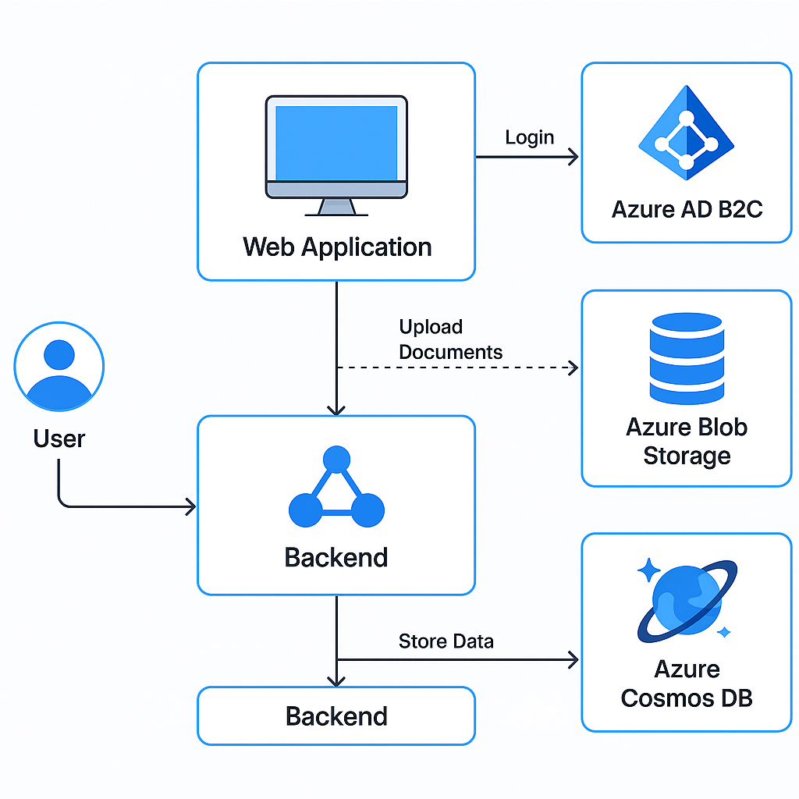

# Innovation & Uniqueness

• Seamless fusion of design thinking with DevOps – solving real user problems while keeping engineering excellence.  
• End-to-end Azure integration for production-readiness.  
• Secure, scalable, cloud-native architecture.  
• CI/CD pipelines mirror real-world enterprise deployment strategies.

# Conclusion

This project showcases a strong understanding of both user empathy and technical implementation. It's a live demonstration of how engineering students can bridge design innovation with cloud technology to create meaningful, production-ready applications.