

Experiment 6

Student Name: Subhradip Majumder
Branch: BE-AIT-CSE
Semester: 5th
Subject Name: ADBMS
UID: 23BAI70059
Section/Group: 23AML_KRG-1 Date of Performance: 24 Sep 2025 Subject Code: 23CSP-333
MEDIUM - LEVEL
- Problem Title: Employee count based on dynamic gender passing.
- Problem Description:TechSphere Solutions, a growing IT services company with offices across India, wants to track and monitor gender diversity within its workforce. The HR department frequently needs to know the total number of employees by gender (Male or Female) . To solve this problem, the company needs an automated database-driven solution that can instantly return the count of employees by gender through a stored procedure that:
1. Create a PostgreSQL stored procedure that:
2. Takes a gender (e.g., 'Male' or 'Female') as input.
3. Calculates the total count of employees for that gender.
4. Returns the result as an output parameter.
5. Displays the result clearly for HR reporting purposes.
- SQL Commands:

CREATE TABLE employee_info (
id SERIAL PRIMARY KEY,
name VARCHAR(50) NOT NULL,
gender VARCHAR(10) NOT NULL,
salary NUMERIC(10,2) NOT NULL,
city VARCHAR(50) NOT NULL
);

INSERT INTO employee_info (id, name, gender, salary, city)
VALUES
(1, 'Alok', 'Male', 50000.00, 'Delhi'),
(2, 'Priya', 'Male', 60000.00, 'Mumbai'),
(3, 'Rajesh', 'Female', 45000.00, 'Bangalore'),
(4, 'Sneha', 'Male', 55000.00, 'Chennai'),
(5, 'Anil', 'Male', 52000.00, 'Hyderabad'),
(6, 'Sunita', 'Female', 48000.00, 'Kolkata'),
(7, 'Vijay', 'Male', 47000.00, 'Pune'),
(8, 'Ritu', 'Male', 62000.00, 'Ahmedabad'),
(9, 'Amit', 'Female', 51000.00, 'Jaipur');

CREATE OR REPLACE PROCEDURE sp_get_employees_by_gender(
IN p_gender VARCHAR(50),
OUT p_employee_count INT
)
LANGUAGE plpgsql
AS $$
BEGIN
-- Count total employees by gender
SELECT COUNT(id)
INTO p_employee_count
FROM employee_info
WHERE gender = p_gender;

-- Display the result
RAISE NOTICE 'Total employees with gender %: %', p_gender, p_employee_count;
END;
$$;

CALL sp_get_employees_by_gender('Male', NULL);

Output:
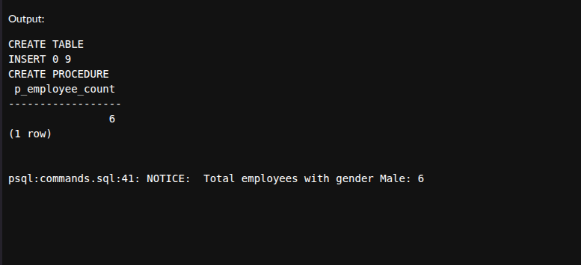
Fig1: View OUTPUT

Learning Outcomes:
  - I learned how to create new procedures.
  - I learned how to perform random values within the table.
  - I learned how to create Stored procedures with specific types.

HARD - LEVEL
- Problem Title: SmartStore Automated Purchase System
- Problem Description:
SmartShop is a modern retail company that sells electronic gadgets like smartphones, tablets, and laptops. The company wants to automate its ordering and inventory management process. Whenever a customer places an order, the system must:
1. Verify stock availability for the requested product and quantity.
2. If sufficient stock is available:
- Log the order in the sales table with the ordered quantity and total price.
- Update the inventory in the products table by reducing quantity_remaining and increasing quantity_sold.
- Display a real-time confirmation message: "Product sold successfully!“
3. If there is insufficient stock, the system must:
- Reject the transaction and display: Insufficient Quantity Available!"

- SQL Commands:

CREATE TABLE products (
product_code VARCHAR(10) PRIMARY KEY,
product_name VARCHAR(100) NOT NULL,
price NUMERIC(10,2) NOT NULL,
quantity_remaining INT NOT NULL,
quantity_sold INT DEFAULT 0
);

CREATE TABLE sales (
order_id SERIAL PRIMARY KEY,
order_date DATE NOT NULL,
product_code VARCHAR(10) NOT NULL,
quantity_ordered INT NOT NULL,
sale_price NUMERIC(10,2) NOT NULL,
FOREIGN KEY (product_code) REFERENCES products(product_code)
);

INSERT INTO products (product_code, product_name, price, quantity_remaining, quantity_sold)
VALUES
('P001', 'iPHONE 13 PRO MAX', 109999.00, 10, 0),
('P002', 'Samsung Galaxy S23 Ultra', 99999.00, 8, 0),
('P003', 'iPAD AIR', 55999.00, 5, 0),
('P004', 'MacBook Pro 14"', 189999.00, 3, 0),
('P005', 'Sony WH-1000XM5 Headphones', 29999.00, 15, 0);

INSERT INTO sales (order_date, product_code, quantity_ordered, sale_price)
VALUES
('2025-09-15', 'P001', 1, 109999.00),
('2025-09-16', 'P002', 2, 199998.00),
('2025-09-17', 'P003', 1, 55999.00),
('2025-09-18', 'P005', 2, 59998.00),
('2025-09-19', 'P001', 1, 109999.00);

SELECT * FROM PRODUCTS;
SELECT * FROM SALES;

---SOLUTION:
CREATE OR REPLACE PROCEDURE pr_buy_products(
IN p_product_name VARCHAR,
IN p_quantity INT
)
LANGUAGE plpgsql
AS $$
DECLARE
v_product_code VARCHAR(20);
v_price FLOAT;
v_count INT;
BEGIN

-- Step 1: Check if product exists and has enough quantity
SELECT COUNT(*)
INTO v_count
FROM products
WHERE product_name = p_product_name
AND quantity_remaining >= p_quantity;

-- Step 2: If sufficient stock
IF v_count > 0 THEN

-- Fetch product code and price
SELECT product_code, price
INTO v_product_code, v_price
FROM products
WHERE product_name = p_product_name;

-- Insert a new record into the sales table
INSERT INTO sales (order_date, product_code, quantity_ordered, sale_price)
VALUES (CURRENT_DATE, v_product_code, p_quantity, (v_price * p_quantity));

-- Update stock details
UPDATE products
SET quantity_remaining = quantity_remaining - p_quantity,
quantity_sold = quantity_sold + p_quantity
WHERE product_code = v_product_code;

-- Confirmation message
RAISE NOTICE 'PRODUCT SOLD..! Order placed successfully for % unit(s) of %.', p_quantity, p_product_name;

ELSE
-- Step 3: If stock is insufficient
RAISE NOTICE 'INSUFFICIENT QUANTITY..! Order cannot be processed for % unit(s) of %.', p_quantity, p_product_name;
END IF;
END;
$$;

CALL pr_buy_products ('MacBook Pro 14"', 1);

Output:

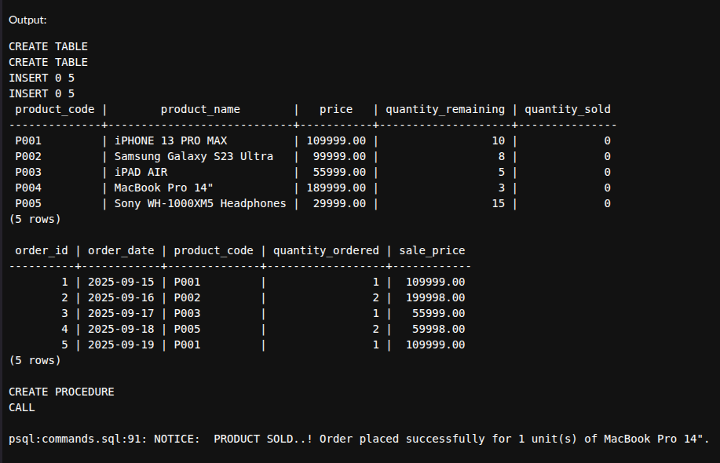
Fig1: View OUTPUT

9. Learning Outcomes:
  - I learned how to create stored procedures.
  - I learned how to perform random values within the table.
  - I learned how to create stored procedures with specific types.

