

Experiment 7

Student Name: Subhradip Majumder
Branch: BE-AIT-CSE
Semester: 5th
Subject Name: ADBMS
UID: 23BAI70059
Section/Group: 23AML_KRG-1
Date of Performance: 22 Nov 2025 Subject Code: 23CSP-333

HARD - LEVEL
- Problem Title: Transactions
- Problem Description: Design a robust PostgreSQL transaction system for the students table where multiple student records are inserted in a single transaction. If any insert fails due to invalid data, only that insert should be rolled back while preserving the previous successful inserts using savepoints. The system should provide clear messages for both successful and failed insertions, ensuring data integrity and controlled error handling.

- SQL Commands:

DROP TABLE IF EXISTS students;

CREATE TABLE students (
id SERIAL PRIMARY KEY,
name VARCHAR(50) UNIQUE,
age INT,
class INT
);

-- EXCEPTION HANDLING

DO $$
BEGIN TRANSACTION
-- Start a transaction
BEGIN
-- Insert multiple students
INSERT INTO students(name, age, class) VALUES ('Anisha',16,8);
INSERT INTO students(name, age, class) VALUES ('Neha',17,8);
INSERT INTO students(name, age, class) VALUES ('Mayank',19,9);

-- If all succeed
RAISE NOTICE ' Transaction Successfully Done';

EXCEPTION WHEN OTHERS THEN
-- If any insert fails
RAISE NOTICE 'Transaction Failed..! Rolling back changes.';
RAISE; -- this will rollback the entire transaction
END;
END;
$$;

SELECT * FROM students;

--VIOLATED SCENARIO
DO $$
BEGIN TRANSACTION
-- Start a transaction
BEGIN
-- Insert multiple students
INSERT INTO students(name, age, class) VALUES ('Anisha',16,8);
INSERT INTO students(name, age, class) VALUES ('Mayank',19,9);
INSERT INTO students(name, age, class) VALUES ('Anisha',17,8); --ERROR
INSERT INTO students(name, age, class) VALUES ('Mayank',19,9);

-- If all succeed
RAISE NOTICE ' Transaction Successfully Done';

EXCEPTION WHEN OTHERS THEN
-- If any insert fails
RAISE NOTICE 'Transaction Failed..! Rolling back changes.';
RAISE; -- this will rollback the entire transaction
END;
END;
$$;

Output:

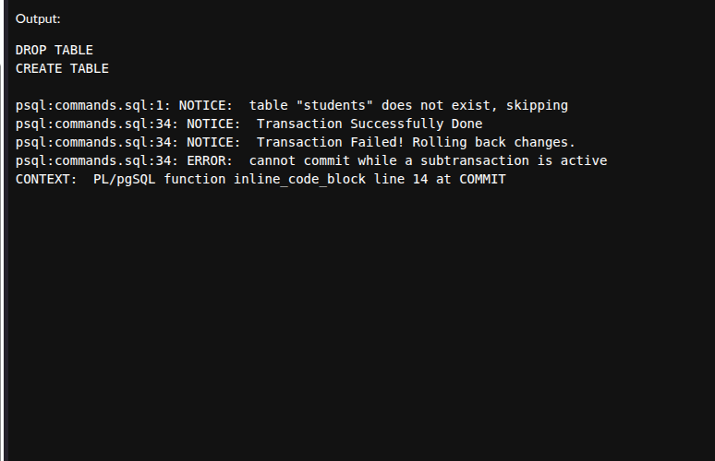
Fig1: View OUTPUT

9. Learning Outcomes:
  - I learned how to create triggers.
  - I learned how to perform types of triggers.

