LAB-2 AGILE MODEL
Agri Supply Chain – Blockchain Enabled Supply Chain Platform

Pushkar Kumar
23BCE1634

Project Overview
The Agri Supply Chain – Blockchain Platform is a decentralized web application designed to bring transparency, traceability, and fair trade practices into agricultural supply chains.
The system integrates blockchain smart contracts, backend APIs, and a React-based frontend to enable decentralized crop auctions, real-time shipment tracking, and QR-based product provenance.
Because the project involves rapidly evolving technologies like blockchain and smart contracts, an Agile development model was chosen to allow continuous refinement, testing, and integration of components throughout development.

Why Agile for This Project
Traditional development models are not flexible enough for blockchain-based systems where smart contracts, APIs, and user interfaces must evolve together.
Agile enables:
• Incremental smart contract development
• Continuous integration between blockchain and web services
• Early user feedback on UI and workflows
• Progressive security and performance optimization

Agile Sprint Planning
The entire development process is divided into three iterative sprints, each delivering a working and testable system increment.

Sprint 1 – Core Infrastructure & Decentralized Auctions
Objectives
• Define overall system architecture
• Set up local blockchain network using Hardhat
• Design database for user management
• Implement user registration and login
• Develop Auction smart contract for crop trading
• Deploy smart contract on local blockchain
• Create backend APIs to interact with auction contract
• Build frontend pages for creating and bidding on auctions
• Integrate MetaMask wallet connection
Deliverable
A functional decentralized auction module where farmers can create auctions and buyers can place bids through a web interface connected to blockchain.

Sprint 2 – Supply Chain Tracking & Product Provenance
Objectives
• Develop smart contract for GPS-based shipment tracking
• Develop smart contract for storing product lifecycle records
• Write and execute unit tests for both contracts
• Implement backend APIs for updating and fetching tracking data
• Generate and validate QR codes linked to blockchain records
• Build frontend interface to display real-time shipment locations
• Create QR scanner to retrieve product history
Deliverable
A transparent supply chain tracking system where each product’s journey from farm to retailer is recorded on blockchain and accessible through QR scanning.

Sprint 3 – System Integration, Testing & Deployment
Objectives
• Integrate auction, tracking, and provenance modules
• Perform end-to-end blockchain to UI data flow testing
• Optimize smart contracts for gas efficiency
• Conduct backend validation and API testing
• Test frontend usability and responsiveness
• Implement security checks and access controls
• Configure environment variables for production
• Deploy smart contracts and host web application
Deliverable
A fully integrated, secure, and deployable blockchain-based agricultural supply chain platform.

Agile Development Flow
The Agile workflow follows a continuous loop:
Product Backlog → Sprint Planning → Sprint Backlog → Sprint Execution → Daily Stand-up → Sprint Review → Sprint Retrospective → Back to Product Backlog
Each sprint produces a working increment that is reviewed, tested, and refined based on feedback.

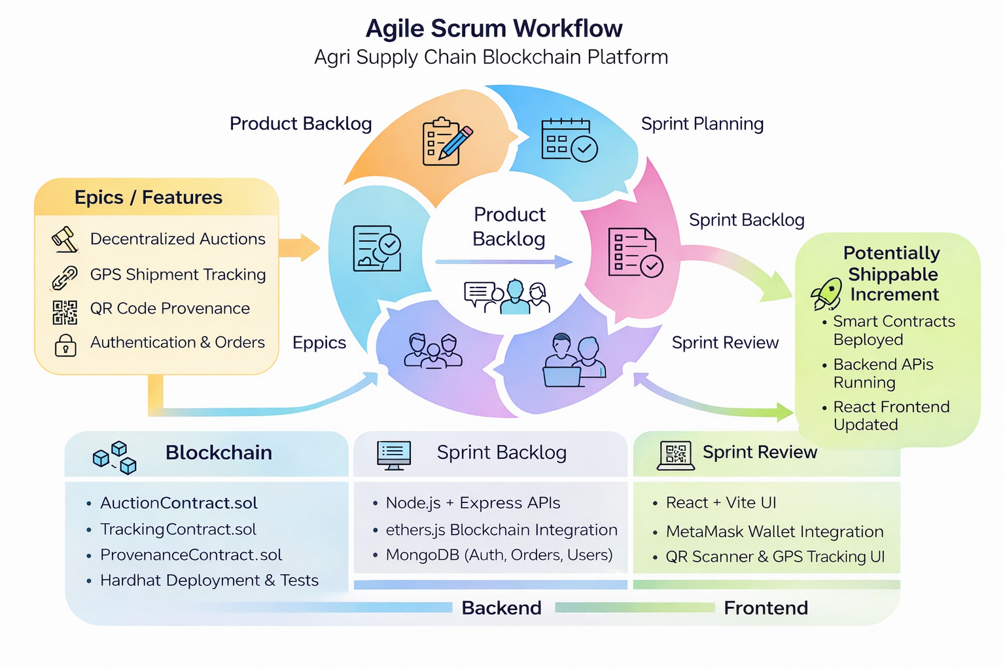

Agile Team Structure
• Product Owner: Defines features and priorities
• Scrum Master: Manages sprint activities and removes blockers
• Blockchain Developer: Builds and tests smart contracts
• Backend Developer: Develops APIs and database logic
• Frontend Developer: Builds user interfaces and wallet integration

Continuous Feedback and Improvement
After every sprint review:
• Smart contract logic is refined
• User interface improvements are added
• Backend performance is optimized
• Security vulnerabilities are addressed
• New features from the roadmap are added to backlog
This ensures continuous enhancement of functionality, security, and user experience.

Benefits of Agile in This Project
• Supports rapid blockchain prototyping
• Allows parallel development of contracts, APIs, and UI
• Encourages continuous testing and integration
• Reduces risk of late-stage failures
• Adapts quickly to new requirements
• Ensures a stable and scalable final product

