Name : Pushkar Kumar
Reg_no: 23BCE1634
SOFTWARE LAB WEEK – 4
( SEQUENCE DIAGRAM AND ACTIVITY DIAGRAM)

1.SEQUENCE DIAGRAM:
A Sequence Diagram is a type of UML diagram that represents how different components of a system interact with each other in a specific order over time. It shows the sequence of messages exchanged between objects or system modules to perform a particular functionality.

In this project, the sequence diagram represents the process of a buyer placing a bid in an auction within the Agri Supply Chain Blockchain Platform.
The interaction flow is as follows:
- The Buyer initiates the process by placing a bid.
- The request is sent to the Frontend interface.
- The Frontend forwards the bid details to the Backend server.
- The Backend validates the bid through the Auction module.
- The Auction module records the transaction on the Blockchain.
- The Blockchain confirms the transaction.
- A success response is sent back through Backend → Frontend → Buyer.
- The Buyer receives confirmation that the bid has been successfully placed.

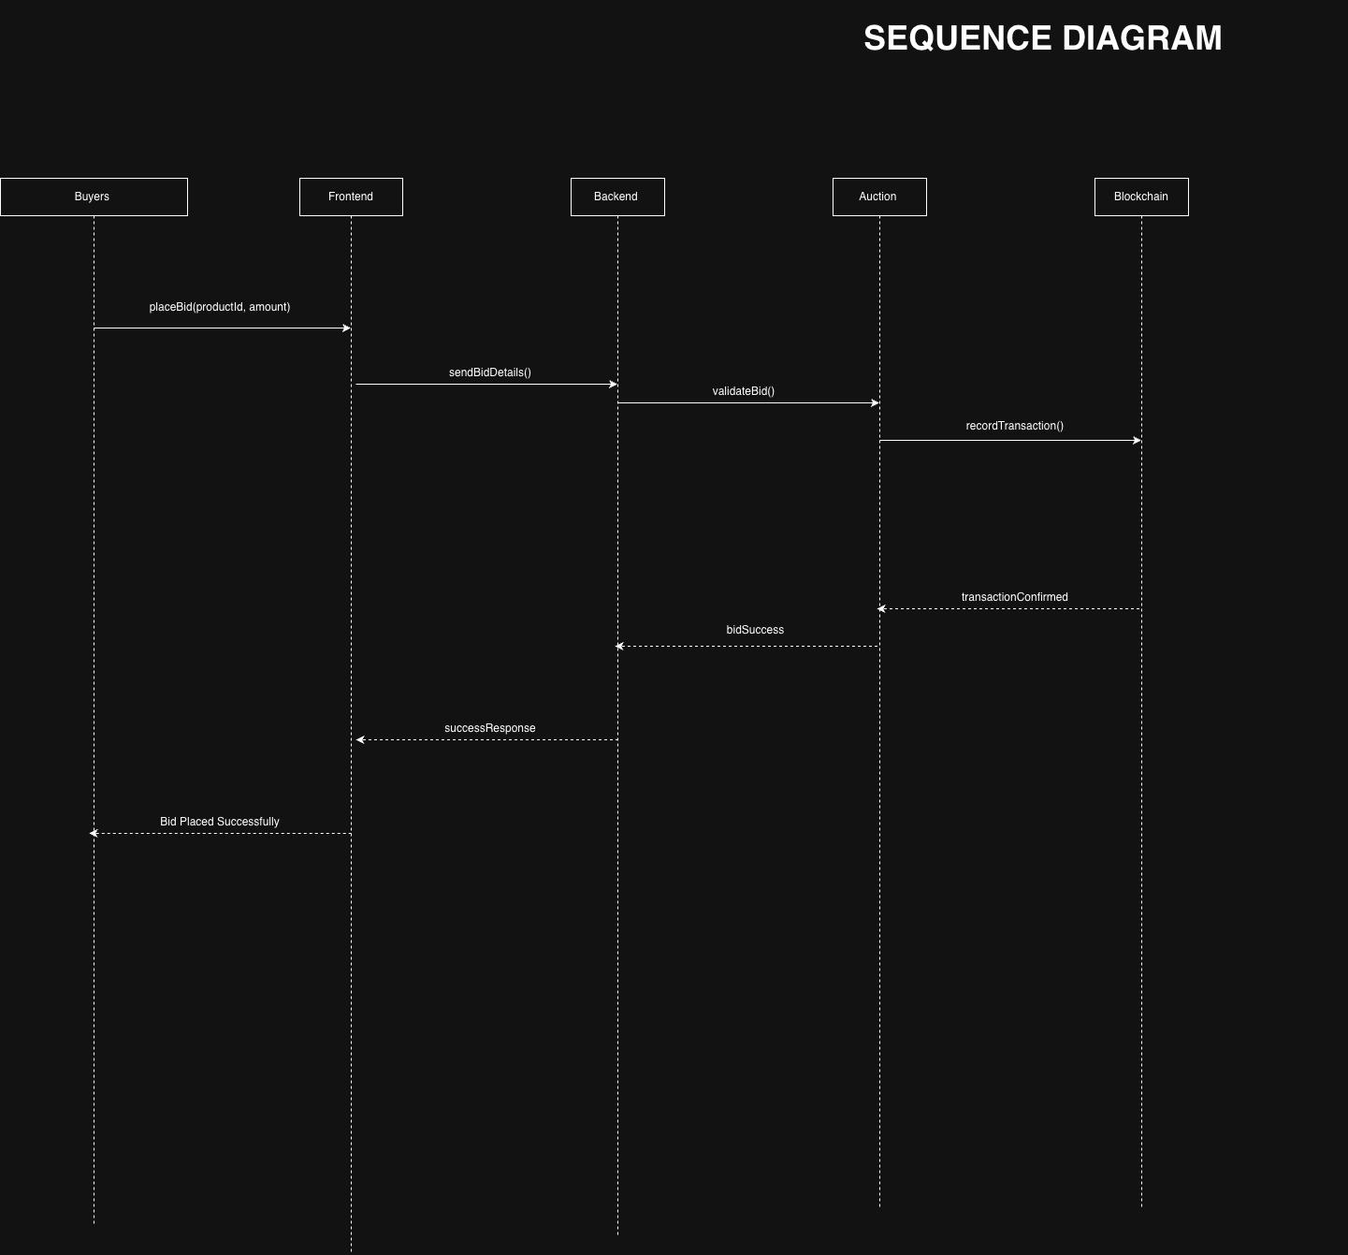
Procedural Flow of Sequence Diagram:
The Buyer initiates the process by selecting a product and entering the bid amount.
- The Buyer sends a placeBid(productId, amount) request to the Frontend.
- The Frontend forwards the bid details to the Backend server using sendBidDetails().
- The Backend validates the request and forwards it to the Auction module using validateBid().
- The Auction module checks whether the bid is valid and higher than the current highest bid.
- If valid, the Auction module sends the transaction details to the Blockchain using recordTransaction().
- The Blockchain records the transaction and sends a confirmation message back to the Auction module (transactionConfirmed).
- The Auction module sends a success response to the Backend (bidSuccess).
- The Backend forwards the response to the Frontend (successResponse).
- Finally, the Frontend displays the message “Bid Placed Successfully” to the Buyer.
2. ACTIVITY DIAGRAM :
An Activity Diagram is a type of UML diagram that represents the workflow or process flow of a system. It shows the sequence of activities, decision points, and the overall control flow from start to end.

In this project, the activity diagram represents the workflow of the auction process in the Agri Supply Chain Blockchain Platform.
The process flow is as follows:
- The process starts when the user logs into the system.
- The user selects a product available for auction.
- The user places a bid on the selected product.
- The system checks whether the bid is the highest bid.
- If the bid is not the highest:
  - The system displays “Bid Failed”.
  - The process ends.
- If the bid is the highest:
  - The transaction is recorded on the Blockchain.
  - The auction ends.
  - Payment processing is initiated.
  - The process ends successfully.

In an activity diagram:
- A filled circle (●) represents the Start node.
- A rounded rectangle represents an Activity.
- A diamond shape represents a Decision point.
- A double circle (◎) represents the End node.
- Arrows show the direction of flow.

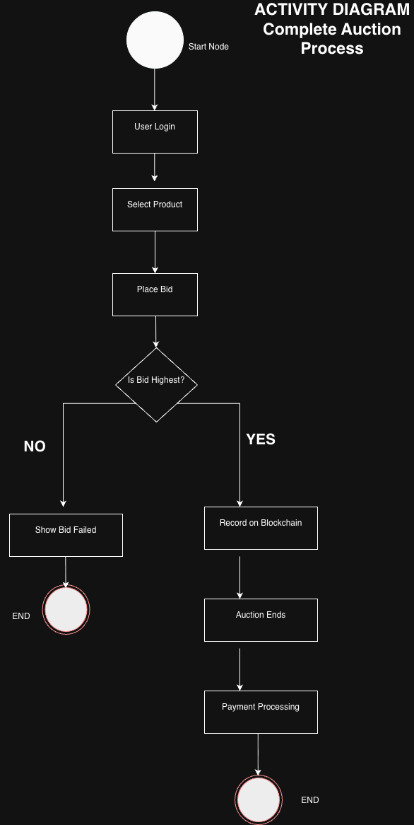
Thank You

