Name : Pushkar Kumar
reg_no: 23BCE1634
WEEK – 03
Use Case and Class Diagram:

- Use Case :

This use case diagram illustrates how various stakeholders interact with the Agri Supply Chain Blockchain Platform. Farmers can add products, accept bids, and track shipments. Buyers can view products, place bids, make payments, and track provenance. The Admin manages users and monitors transactions, while the Logistics Provider updates shipment status. Blockchain Network executes smart contracts to ensure transparency and security.
Source: Implemented Using Draw.io.
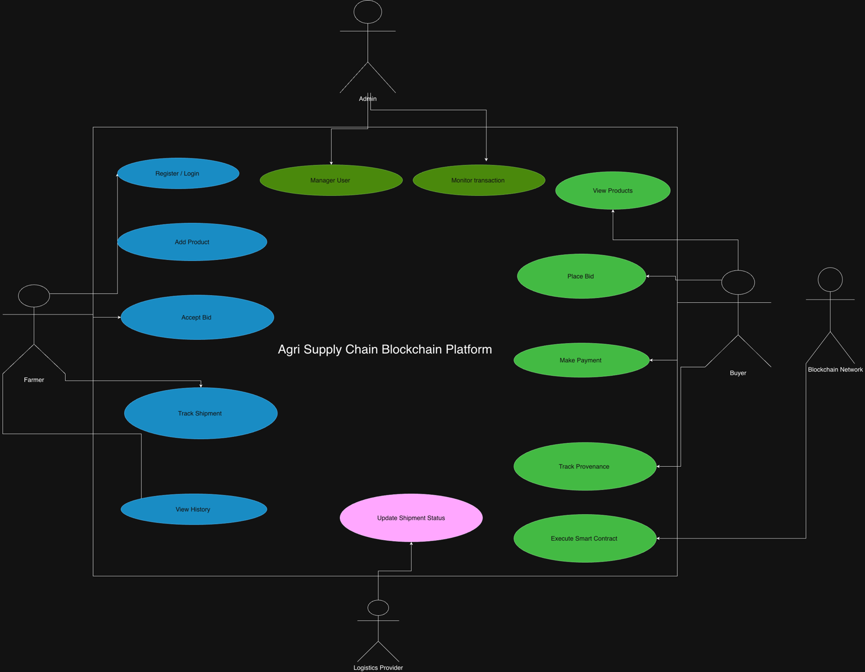

1. Farmer(Actor):
The Farmer is responsible for registering into the system and adding agricultural products for sale. Farmers can view auction results, accept the highest bid, and track the shipment status of their products. This ensures transparency and better pricing for agricultural produce.

2. Buyer(Actor):
The Buyer views available products listed by farmers and participates in auctions by placing bids. After winning an auction, the buyer makes payments and can track the provenance of the product through blockchain records to ensure authenticity.

3.Admin(Actor):
The Admin manages the overall system operations. The admin verifies users, monitors transactions, and ensures the smooth functioning of the platform. Admin also helps in resolving disputes and maintaining system integrity.

4. Logistics Provider(Actor)
The Logistics Provider is responsible for transporting agricultural products from farmers to buyers. They update shipment status and confirm product delivery, enabling real-time tracking of goods.

5. Product(Actor)
The Product component represents agricultural goods listed by farmers. It contains details such as product name, quantity, base price, and farmer information. Products are associated with auctions for bidding.

6. Auction(Actor)
The Auction component manages the bidding process. It starts the auction for a product, accepts bids from buyers, determines the highest bid, and closes the auction once bidding ends.

7. Blockchain Transaction
This component stores transaction details on the blockchain. It records transactions securely and verifies them, ensuring data immutability, transparency, and trust in the supply chain.

8. Blockchain Network
The Blockchain Network executes smart contracts and maintains an immutable ledger of transactions. It ensures secure, transparent, and tamper-proof storage of auction and payment data.

9. User
The User component is a base class representing common properties of all system users such as Farmer, Buyer, and Admin. It includes basic functionalities like login, registration, and logout.

CLASS DIAGRAM :

The class diagram represents the static structure of the Agri Supply Chain Blockchain Platform. It shows the different classes involved in the system, their attributes, methods, and the relationships between them. The diagram helps in understanding how data and functionalities are organized within the system.

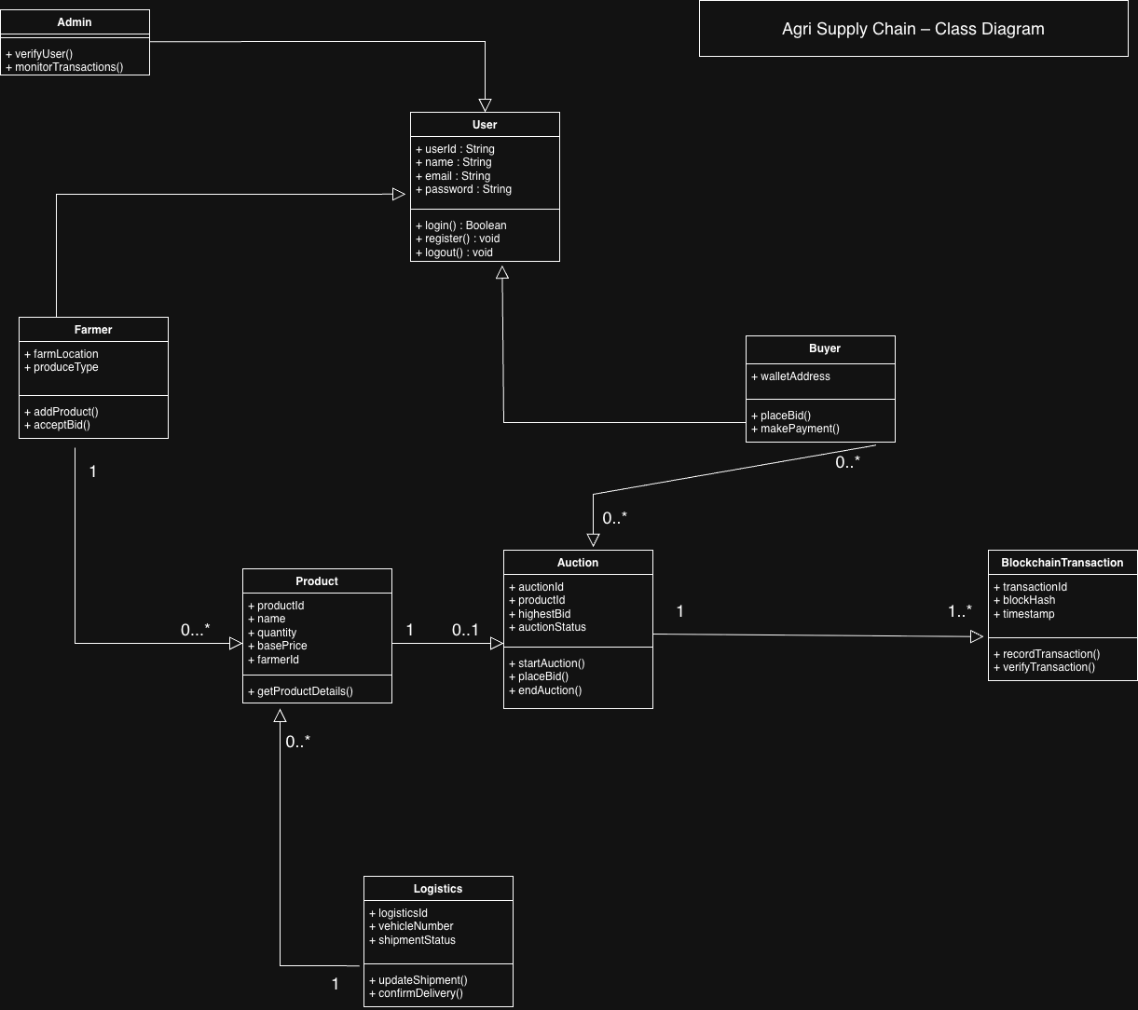
The User class acts as a base class containing common attributes such as userId, name, email, and password, along with basic operations like login, registration, and logout. The Farmer, Buyer, and Admin classes inherit from the User class, demonstrating an is-a relationship and promoting code reusability.
The Product class represents agricultural products added by farmers and stores information such as product ID, quantity, and base price. The Auction class manages the bidding process for each product and maintains auction-related details like highest bid and auction status. The BlockchainTransaction class records and verifies transactions on the blockchain to ensure transparency and security.
The Logistics class handles shipment-related activities, including updating shipment status and confirming delivery. Associations between classes represent interactions such as product creation, auction handling, logistics management, and blockchain transaction recording.
Overall, the class diagram provides a clear view of the system architecture and defines how different components interact to support a transparent and secure agri supply chain.

