Real-Time Public Transport Tracking System
Project Documentation — 50% Implementation

1. The Problem We Are Trying to Solve
Anyone who has waited at a bus stop without knowing when the next bus will arrive understands the frustration this project tries to solve. Passengers often end up guessing. They look down the road repeatedly, check the time, and hope the bus appears soon. This uncertainty wastes time and makes public transport feel unreliable, even when the service itself may actually be functioning well.
The issue is not limited to passengers alone. Drivers usually do not have a simple digital method to share their current location with passengers or the transport system. Transport administrators also struggle to monitor buses efficiently because information is often scattered, manually tracked, or based on rough assumptions.
This project attempts to address these issues by building a centralized and easy-to-use system. Passengers can check the location of buses and see an estimated arrival time. Drivers can update their current position. Administrators can manage the buses in service from a single place without unnecessary complications.

2. What This Project Set Out to Do
The goal of this project is practical and focused. Instead of trying to build a very complex system immediately, the idea was to first develop a working prototype that clearly demonstrates the main concept and can be expanded later.
The system is designed around three main types of users. Passengers should be able to view available buses and see approximately when a bus will reach their stop. Drivers need a simple interface to report their current GPS coordinates. Administrators require tools to add buses to the system or remove buses that are no longer operating.
From a technical perspective, the project also aims to create a clean REST API layer that allows the frontend and backend to communicate smoothly. The final objective for this stage was to deliver a functional prototype that shows the idea working in practice, even though not every advanced feature is implemented yet.

3. How It Was Built
The system architecture was intentionally kept simple to make development and testing easier.
The backend is built using Node.js with Express, which handles all incoming API requests. The frontend uses React with Vite to create the user interface. Communication between the frontend and backend happens through Axios, which manages HTTP requests in a simple and efficient way.
For now, the project stores data in memory. Bus records are stored in a JavaScript array on the server instead of a database. This approach was chosen for the prototype phase because it keeps the setup simple and avoids the extra work of configuring a database. The downside is that the data resets whenever the server restarts.
The backend currently provides four REST API endpoints:
- One endpoint to retrieve all buses
- One endpoint to add a new bus
- One endpoint to update a bus location
- One endpoint to delete a bus
The Express server runs on port 5000, and CORS is enabled so the frontend can communicate with the backend during development.
On the frontend side, React's useState and useEffect hooks manage state and data fetching. The interface is divided into three separate pages, each designed for one specific type of user. This separation keeps the interface simple and prevents unnecessary clutter.

4. What Is Working So Far
At this stage, the backend is fully functional. The Express server runs correctly, and all four API endpoints operate as expected. The system can perform basic create, read, update, and delete operations on bus records stored in memory.
A simulated estimated arrival time is also displayed. It does not yet calculate real travel distance, but it helps demonstrate what the final passenger interface will eventually show.
The Passenger Page displays all available buses along with their bus number, route, latitude, longitude, and estimated arrival time. It serves as a simple read-only interface where passengers can quickly view important information.
The Driver Page allows drivers to select their bus from a dropdown menu and enter their current latitude and longitude. When they submit the form, the PUT API request updates the location of that bus in the system.
The Admin Page gives administrators control over the list of buses. From this page they can add new buses, remove existing ones, and view the current fleet registered in the system. The design focuses on clarity and functionality rather than unnecessary complexity.

5. Known Limitations for Now
It is important to clearly state what this prototype does not include yet. These limitations are expected at this stage because the project is intentionally only halfway complete.
There is currently no authentication system, which means any user can access any of the three pages. Real GPS tracking is also not integrated. Drivers manually enter their location instead of the system capturing coordinates automatically.
The estimated arrival time shown to passengers is simulated rather than calculated using actual distance or traffic information.
Another limitation is that the system does not yet use WebSockets, which means updates are not truly real time. Passengers need to refresh the page to see the most recent bus location.
Finally, because there is no database yet, all stored data disappears when the server restarts. This is acceptable during the prototype stage but will need to change in the next phase.

6. Project Links
GitHub Repository:
https://github.com/23BCE1956/D2_23BCE1956_Archishman/tree/main/Week_5
Screenshots:

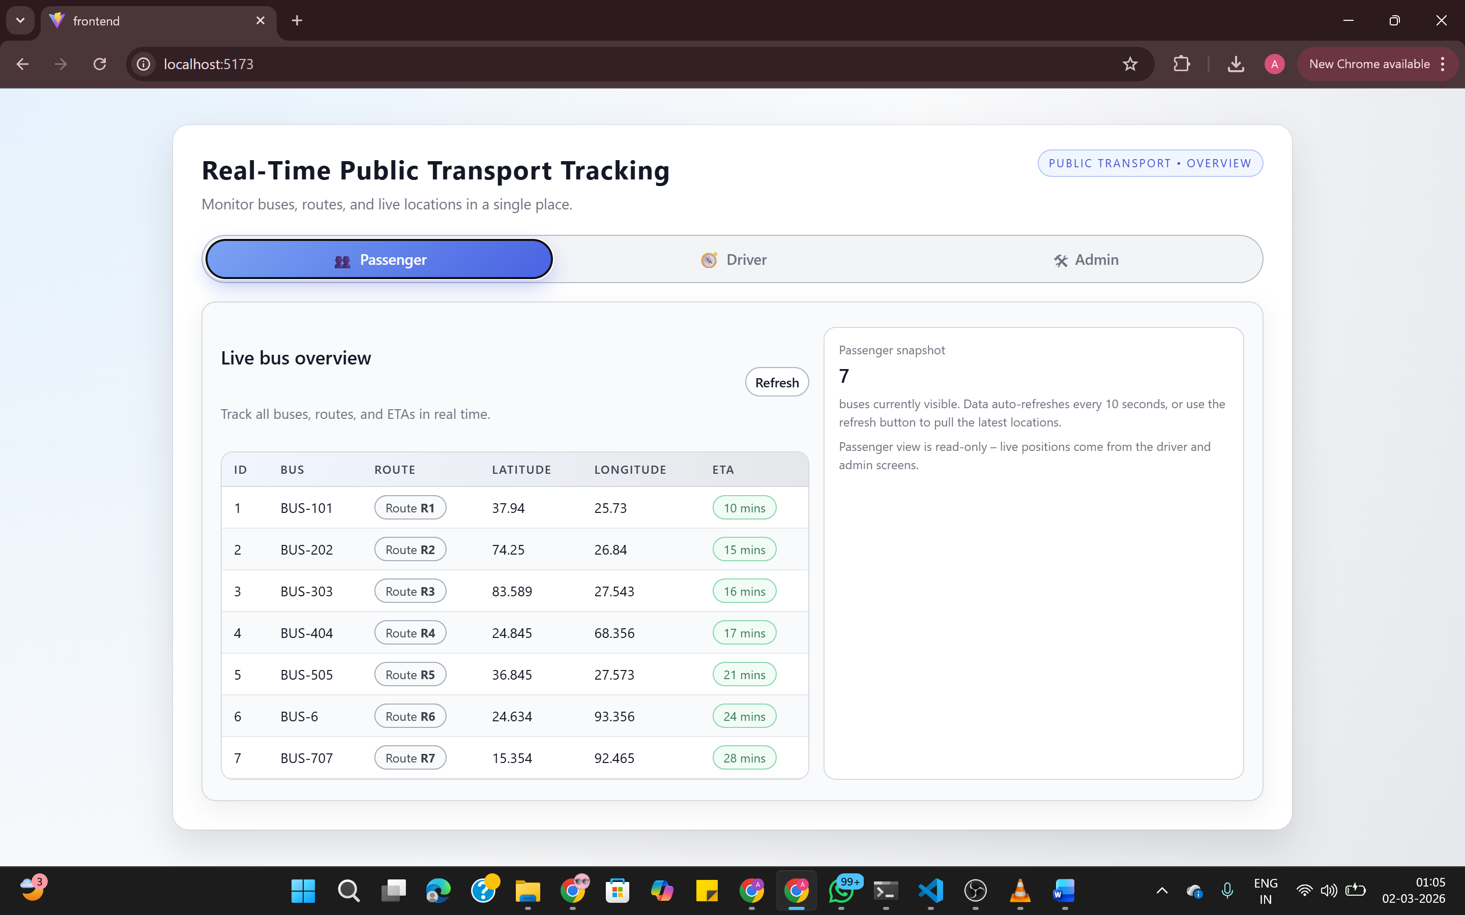

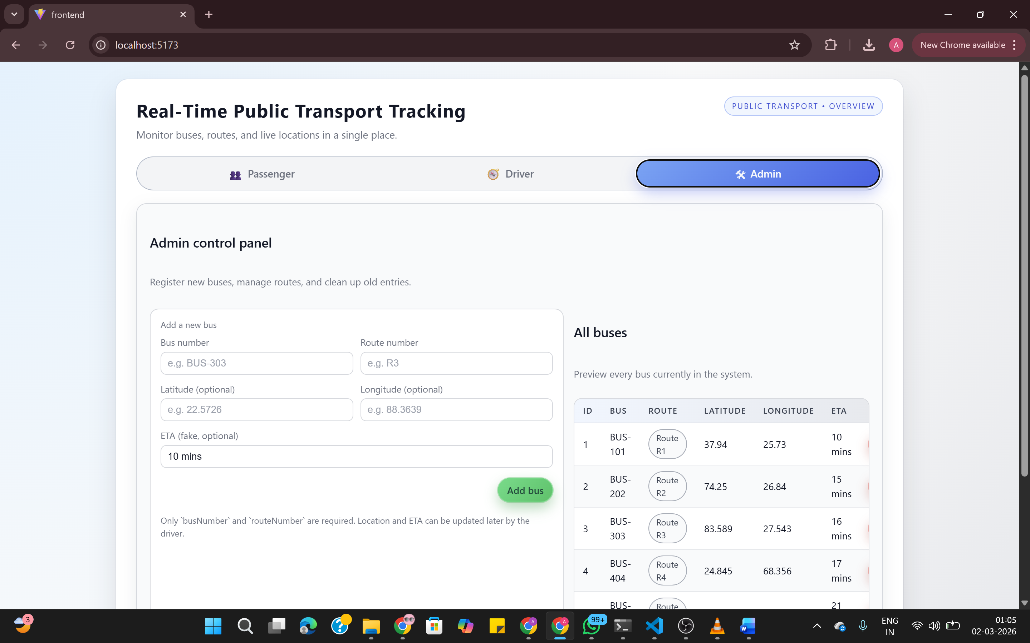

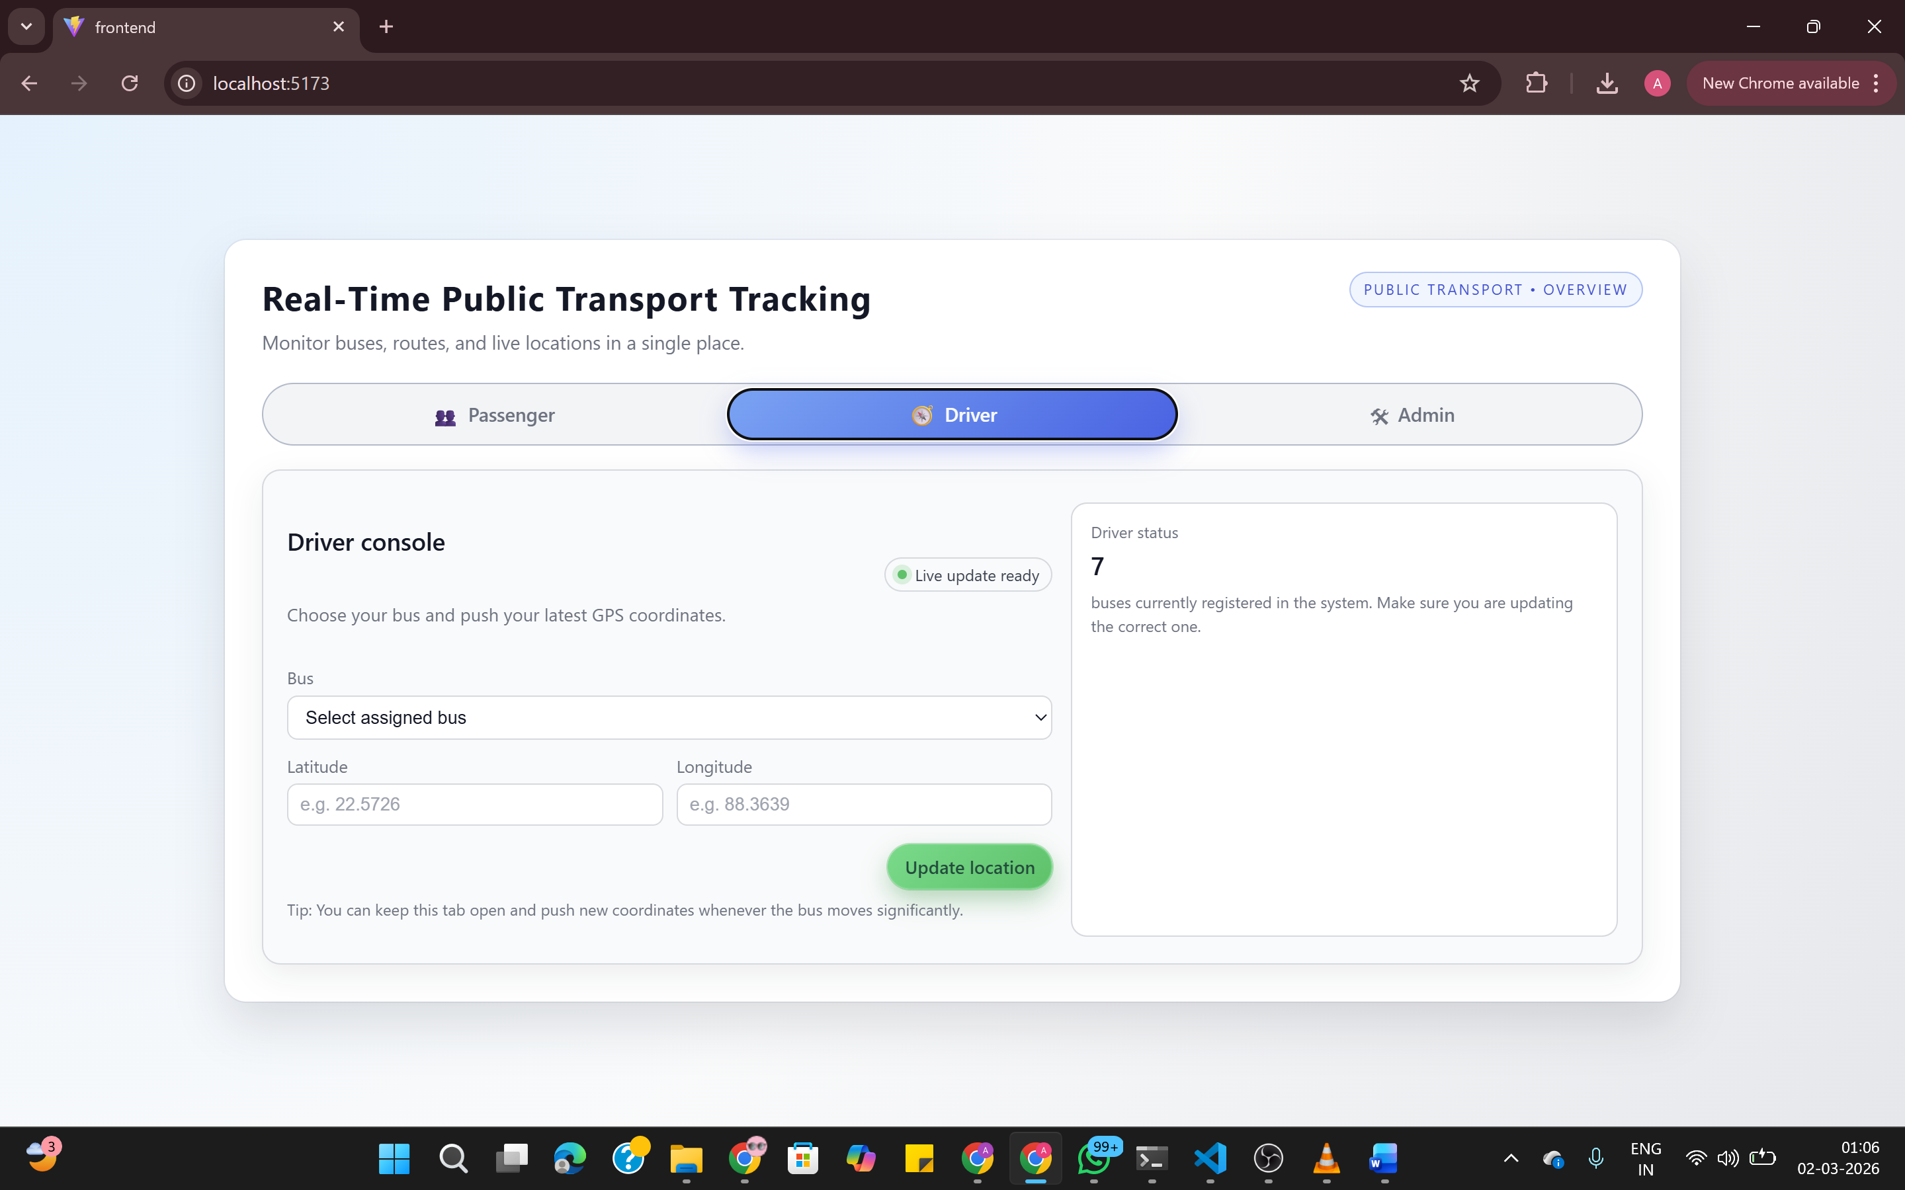

Conclusion
The current system represents a genuine working prototype. It is not just a design or a concept. The application runs, accepts real input, and responds to user interactions.
Buses can be added to the system, their locations can be updated, and passengers can view the available information. This creates a solid foundation for the next stage of development.
The remaining work is already planned. A MongoDB database will replace the temporary in-memory storage. An authentication system will ensure that passengers, drivers, and administrators can only access the features intended for them. WebSockets will allow real time updates so that passengers see location changes instantly without refreshing the page.
Later improvements may also include Google Maps integration to visually display bus movement and calculate accurate arrival times based on distance and road conditions.
The core idea is already working. The next phase will focus on making the system more realistic, reliable, and scalable.

