Real-Time Public Transport Tracking System
Software Engineering Lab
Archishman Debnath
23BCE1956

1. Introduction
Public transportation remains a vital part of urban mobility, yet many systems still rely on static schedules and printed timetables. Passengers waiting at bus stops often face uncertainty, as they have no real-time information about delays, traffic conditions, or whether a bus has already passed. This project addresses that gap by developing a simple and accessible real-time tracking system using modern web technologies. The goal is to create a solution that is easy to deploy, cost-effective, and usable without requiring dedicated hardware or mobile applications.

2. System Overview
The proposed system is a web-based platform designed to provide real-time location updates of public transport vehicles. It supports three types of users: passengers, drivers, and administrators. Each role interacts with the system through a browser interface, eliminating the need for app installation.
Drivers initiate tracking by opening a webpage on their smartphone, selecting their assigned bus, and enabling location tracking. The system uses the browser’s built-in GPS capabilities to continuously capture location data and transmit it to the server. Passengers, on the other hand, can view live bus movements on an interactive map without refreshing the page. Administrators manage the system by adding or removing buses through a secure interface.
The backend is implemented using Node.js and Express, with data stored in a simple in-memory array. Real-time communication is handled using Socket.io, ensuring instant updates across all connected clients.

3. Background
Traditional vehicle tracking systems often rely on specialized GPS hardware or dedicated mobile applications. While effective, these solutions involve higher costs, installation complexity, and maintenance overhead. Such requirements make them unsuitable for smaller transport networks, educational institutions, or budget-constrained environments.
This project adopts a more practical approach by leveraging the capabilities of modern web browsers. The Geolocation API allows smartphones to act as GPS transmitters, removing the need for additional hardware. Unlike earlier browser-based solutions that use periodic polling, this system uses an event-driven method through watchPosition, which improves both efficiency and accuracy.
Additionally, instead of repeatedly requesting updates from the server, the system uses a real-time communication model. This significantly reduces latency and ensures that passengers receive updates almost instantly, improving the overall user experience.

4. Proposed System and Features
The system improves upon typical academic tracking projects by automating location capture and enabling real-time updates. Drivers are not required to manually enter coordinates, as the system automatically retrieves GPS data from the device. This reduces human error and simplifies operation.
Passengers can view live bus locations on an interactive map, where markers update dynamically as new data is received. A status table complements the map by displaying route information, estimated arrival times, and whether each bus is currently active. The system determines bus status based on recent updates, marking a bus as offline if no data is received within a specified time.
The administrative module provides essential management functions, allowing authorized users to add or remove buses. Security is maintained through password-protected access for both drivers and administrators.

5. System Architecture

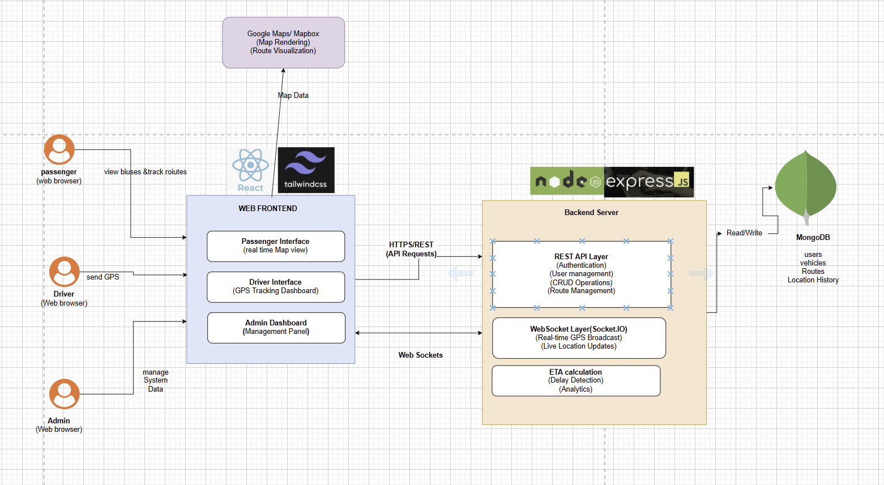
The system follows a client-server architecture with three main client interfaces: passenger, driver, and admin. All communication is routed through a centralized Node.js server.
When a driver’s device detects a change in location, the browser triggers a callback function that extracts latitude and longitude values. These coordinates are sent to the server using a WebSocket connection. The server updates the corresponding bus information and immediately broadcasts the updated data to all connected clients.
Passenger interfaces receive these updates in real time and re-render the map and data table accordingly. This continuous flow of information ensures that users always have access to the latest bus locations.
The backend also provides REST APIs for operations such as fetching bus data, adding new buses, and verifying user credentials. All data is temporarily stored in memory, simplifying the system while meeting the requirements of the project.

6. Communication Protocols
The system uses two primary communication methods: HTTP/REST and WebSocket. REST APIs handle operations such as data retrieval and authentication, while WebSocket connections enable real-time updates.
Socket.io is used to manage WebSocket communication, providing features such as automatic reconnection and event-based messaging. Data is transmitted in JSON format at the application layer, ensuring simplicity and compatibility.
For secure deployment, HTTPS and WSS protocols are required, as modern browsers enforce security for location-based services. The underlying network stack ensures reliable and ordered data transmission, making the system robust and efficient.

7. Experimental Setup
The system was tested using a standard development environment consisting of a laptop with Node.js and a smartphone for driver simulation. All devices were connected over a local Wi-Fi network.
The frontend was developed using React, while the backend used Node.js with Express. Additional libraries such as Socket.io and Leaflet were used for real-time communication and map visualization respectively.
Testing involved multiple scenarios, including simultaneous tracking of multiple buses, delayed updates, and administrative operations. The system demonstrated consistent performance, with location updates reflected in under 100 milliseconds on a local network.

8. Results and Observations
The system successfully achieved real-time tracking functionality. When a driver enabled tracking, the bus marker appeared on the passenger interface and moved smoothly as the vehicle changed position. Multiple drivers could be tracked simultaneously without interference.
The offline detection mechanism worked as expected, accurately identifying inactive buses based on the absence of updates. Administrative actions such as adding or deleting buses were reflected across the system with minimal delay.
Overall, the system provided a responsive and user-friendly experience, meeting the primary objectives of the project.

9. Limitations
Despite its effectiveness, the system has certain limitations. GPS accuracy can be reduced in indoor or densely built environments, leading to less precise location updates. Since data is stored in memory, all information is lost when the server restarts. A production-level system would require a persistent database.
Additionally, the estimated arrival times are based on simple calculations and do not account for real-time traffic conditions or route optimization.

10. Conclusion
This project demonstrates a practical and efficient approach to real-time public transport tracking using web technologies. By eliminating the need for dedicated hardware and mobile applications, the system significantly reduces deployment complexity and cost.
The use of browser-based GPS, real-time communication, and interactive mapping creates a seamless experience for both drivers and passengers. While there are areas for improvement, the system provides a strong foundation for future enhancements and real-world implementation.
In conclusion, the project successfully fulfills its objective of delivering a simple, scalable, and accessible transport tracking solution.

