Development of a Mobile-Based Travel Data Collection System for Transportation Planning
Anubhav Jha
School of Computer Science and Engineering Vellore Institute of Technology, Chennai Email: anubhav.jha2023@vitstudent.ac.in

Abstract—Transportation planning requires accurate and large-scale travel data, which is traditionally collected using manual household surveys. These methods are time-consuming, expensive, and limited in coverage. This project proposes a mobile-based application that automatically captures travel-related information using sensor data and user input. The system integrates GPS tracking, user interaction, and AI-driven insights to generate comprehensive trip chains. The collected data is stored in a centralized database accessible to NATPAC scientists for effective transportation planning and decision-making.
- Background
Accurate transportation data is essential for infrastructure development and urban planning. However, current approaches rely heavily on manual surveys, which cover only a small portion of the population and are prone to human error. With the widespread use of smartphones, there is an opportunity to automate data collection using mobile applications that can capture real-time travel behavior.
- Proposed System
The proposed system is a mobile-based travel tracking platform that collects detailed trip information with minimal user effort.
- Workflow
  - The user installs and registers in the mobile application.
  - With user consent, the app continuously tracks location using GPS.
  - The system automatically detects trip start and end points.
  - Google Maps API is used for reverse geocoding to convert coordinates into readable locations.
  - The app nudges users to fill missing details such as trip purpose, cost, and companions.
  - All trip data is sent to a Flask-based backend server.
  - Data is stored in a PostgreSQL database.
  - Scientists access the data through a web portal.
  - Gemini API analyzes travel patterns and generates insights.
- Novelty
- Automated trip detection using GPS
- Minimal user input through smart nudging
- Integration of AI for pattern analysis
- Scalable real-time data collection
- System Architecture
The system consists of four major components:
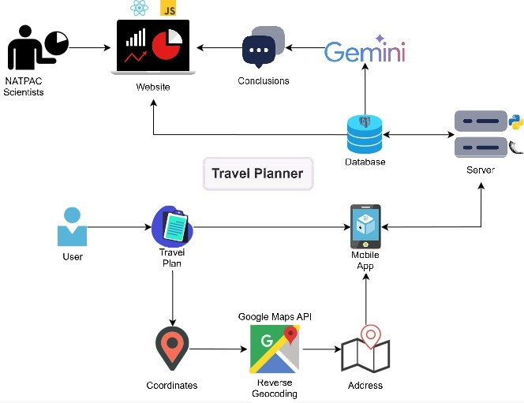

Fig. 1. Architecture diagram

- Mobile Application: Built using React Native Expo, responsible for data collection.
- Backend Server: Developed using Flask to handle API requests.
- Database: PostgreSQL for storing structured trip data.
- Web Portal: React-based interface for scientists to analyze data.
- Protocol Stack
The system follows a layered architecture:
- Application Layer: User interface and web portal interactions.
- Transport Layer: HTTP/HTTPS communication between client and server.
- Network Layer: Internet-based data transmission.
- Data Layer: PostgreSQL database for structured storage.
- AI Layer: Gemini API for analytics and insights.
- Testbed / Experimental Setup
- Tools Used
  - Mobile App: React Native (Expo)
  - Backend: Flask
  - Database: PostgreSQL
  - Web Portal: React
  - APIs: Google Maps API, Gemini API

- Dataset
  - Real-time trip data generated from user movement
  - Includes origin, destination, distance, and trip metadata
- Environment
  - Localhost development
  - API testing using Postman
  - Mobile testing using emulator and physical device
- Implementation Results
The system successfully captures and stores travel-related data including:
  - Trip origin and destination
  - Travel time and distance
  - Mode of transport
  - Trip purpose and cost
The mobile application effectively detects trips and reduces manual effort through intelligent prompts. The web portal allows visualization and analysis of travel patterns. AI-based insights help identify trends and support decision-making.
- Results and Conclusion
This project presents a scalable and efficient solution for travel data collection using mobile technology. By automating trip detection and integrating AI-based analytics, the system overcomes limitations of traditional survey methods. The proposed approach enhances data accuracy, increases coverage, and provides valuable insights for transportation planning. Future enhancements include real-time analytics, predictive modeling, and large-scale deployment.

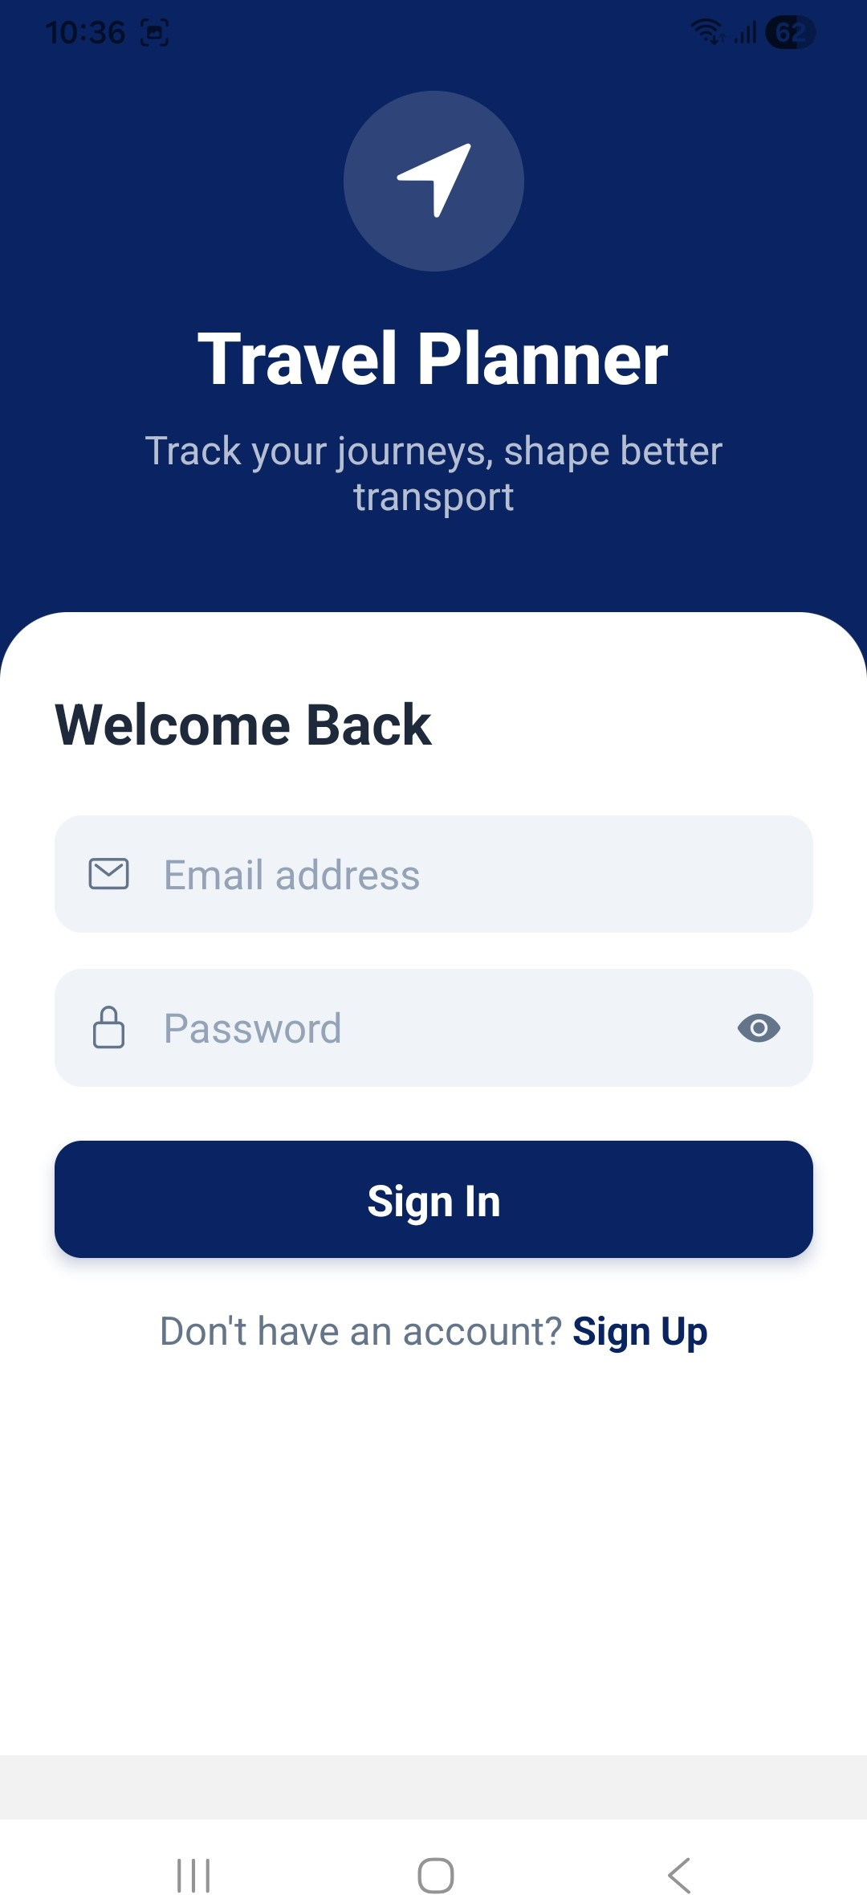

Fig. 2. Login Screen of Mobile Application

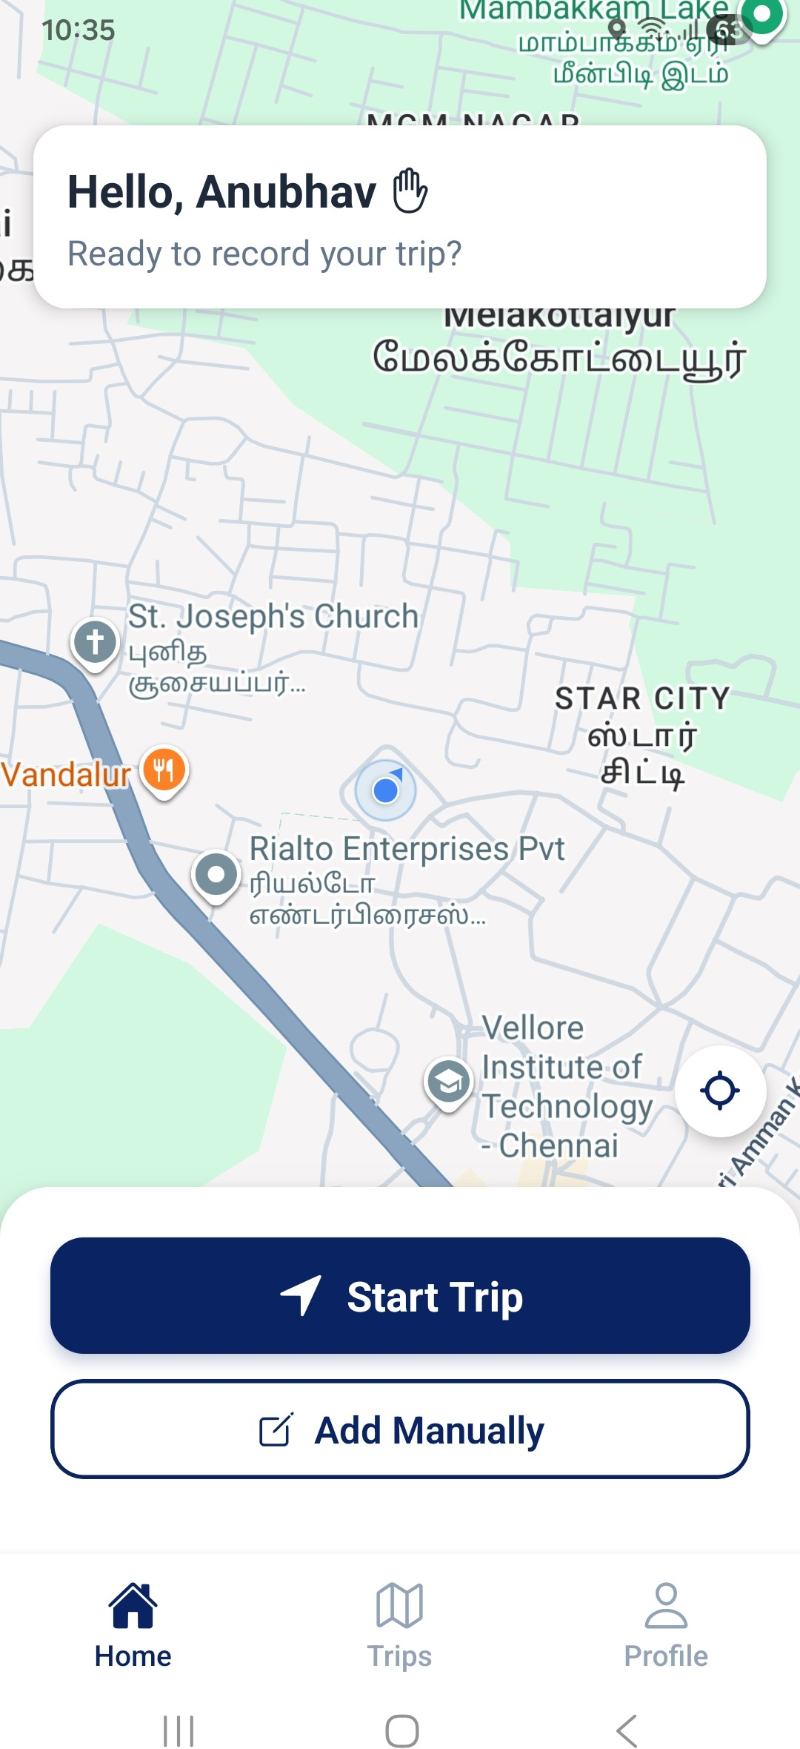

Fig. 3.Home Screen of Mobile Application

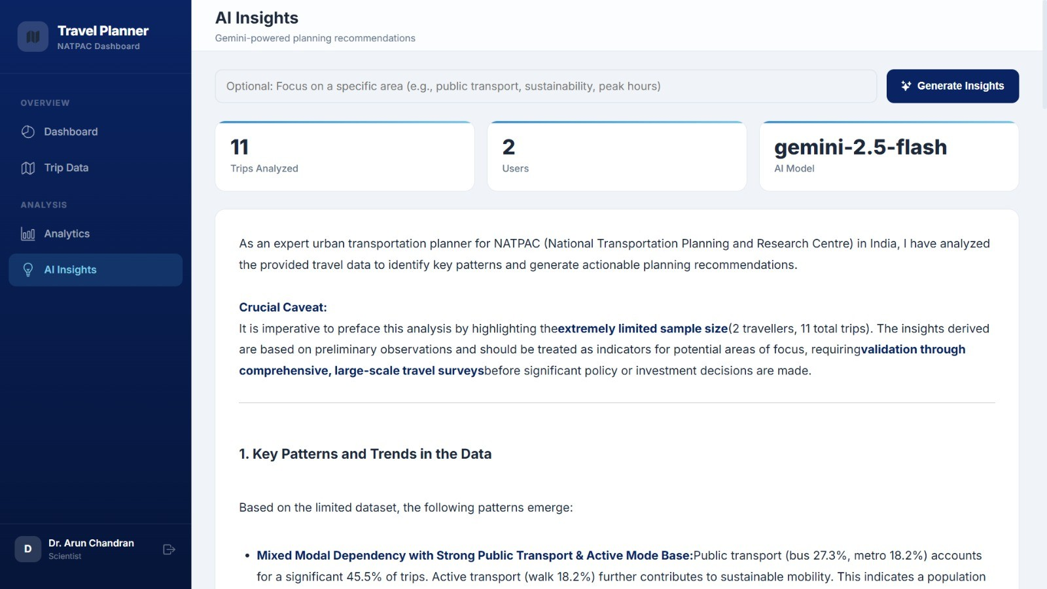

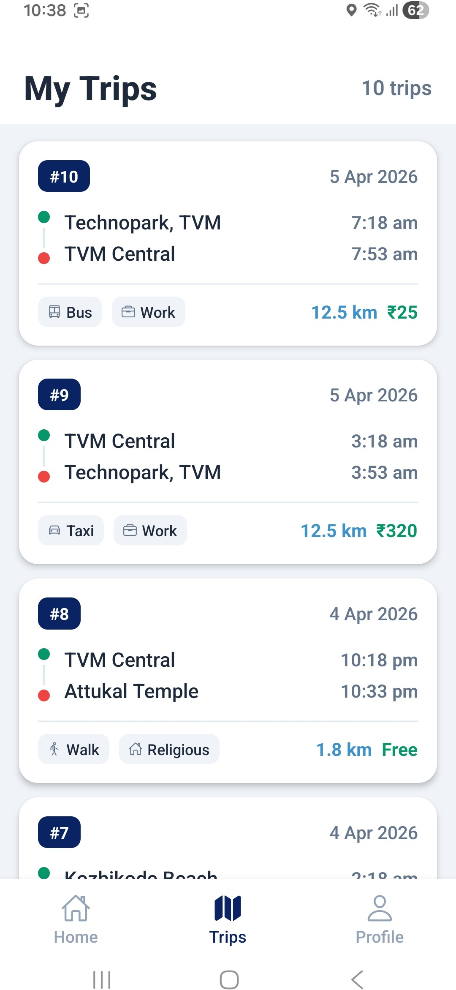
Fig. 4.My Trips Screen of Mobile Application

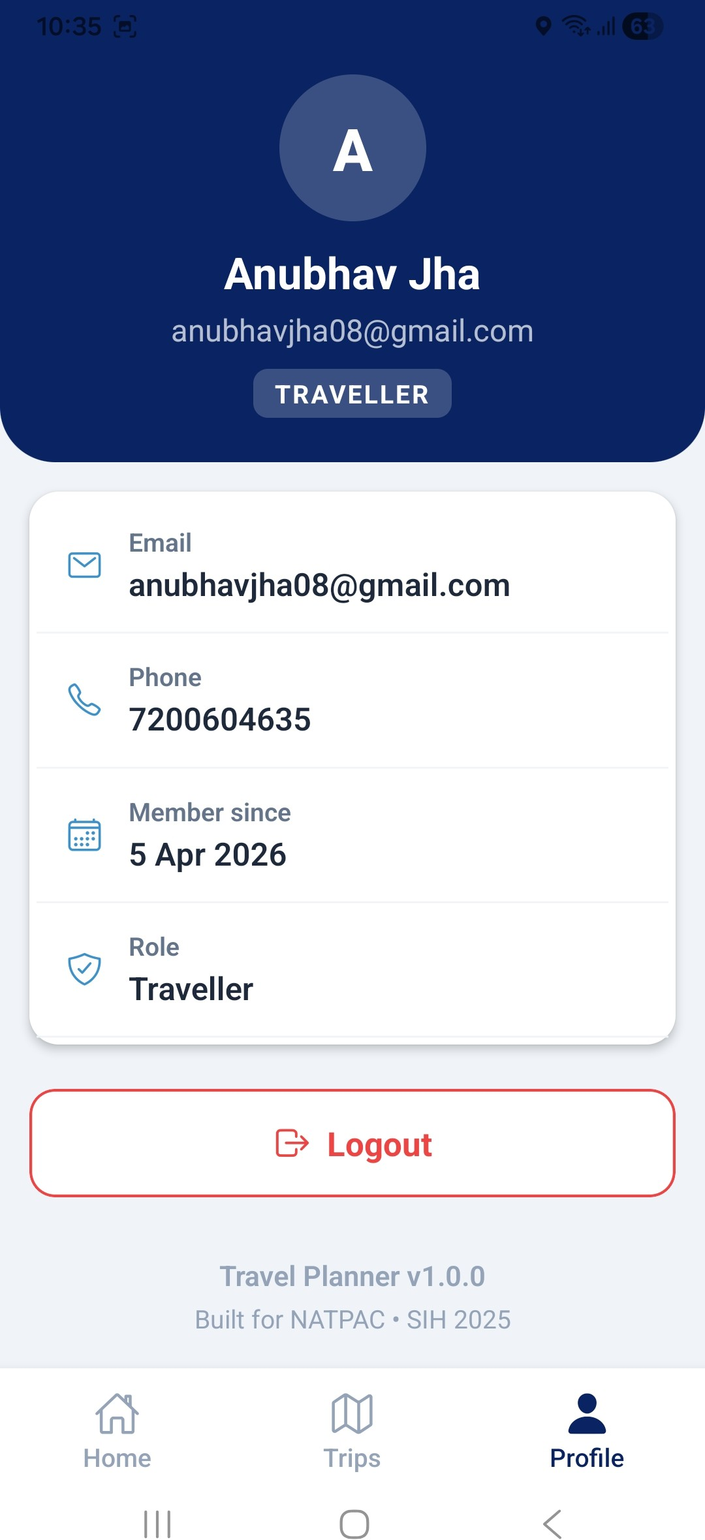

Fig. 5. Login Screen of Mobile Application
Fig. 6. AI Insights of Web Application

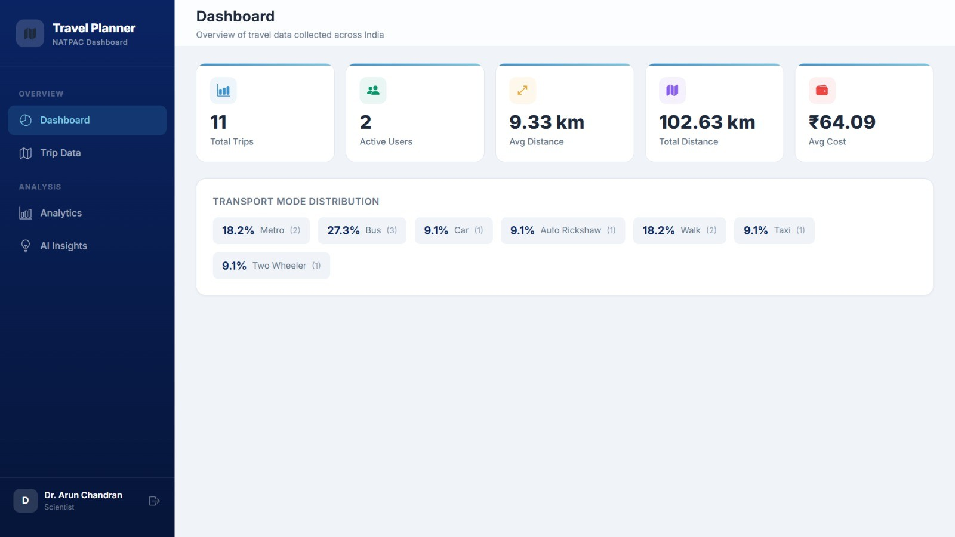

Fig. 7. Dashboard Screen of Web Application

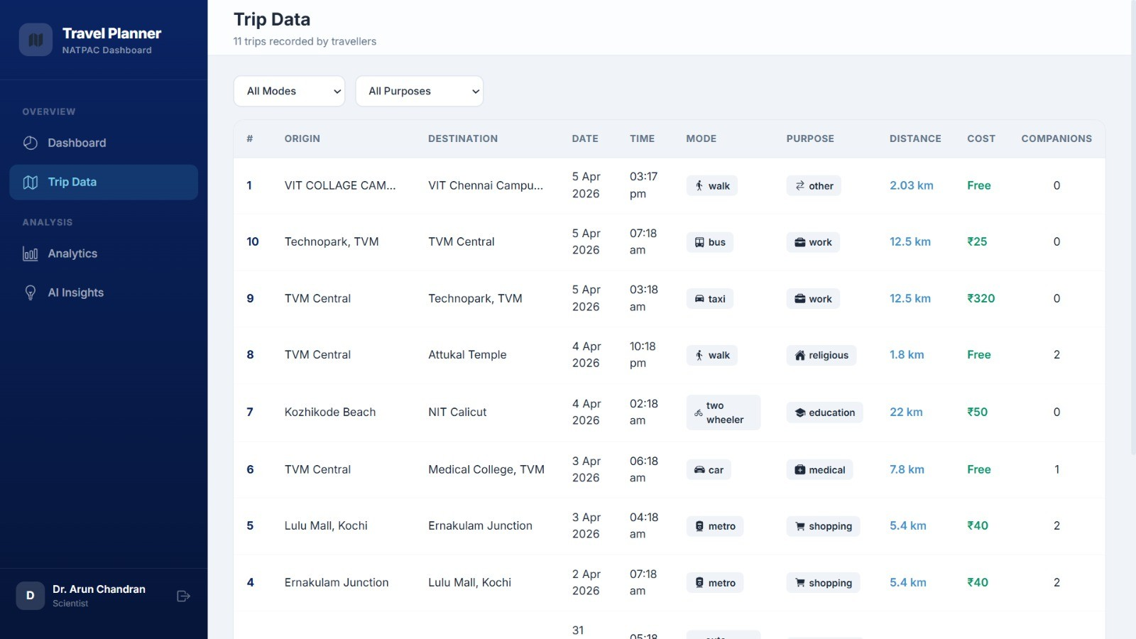

Fig. 8. Trip Data of Web Application

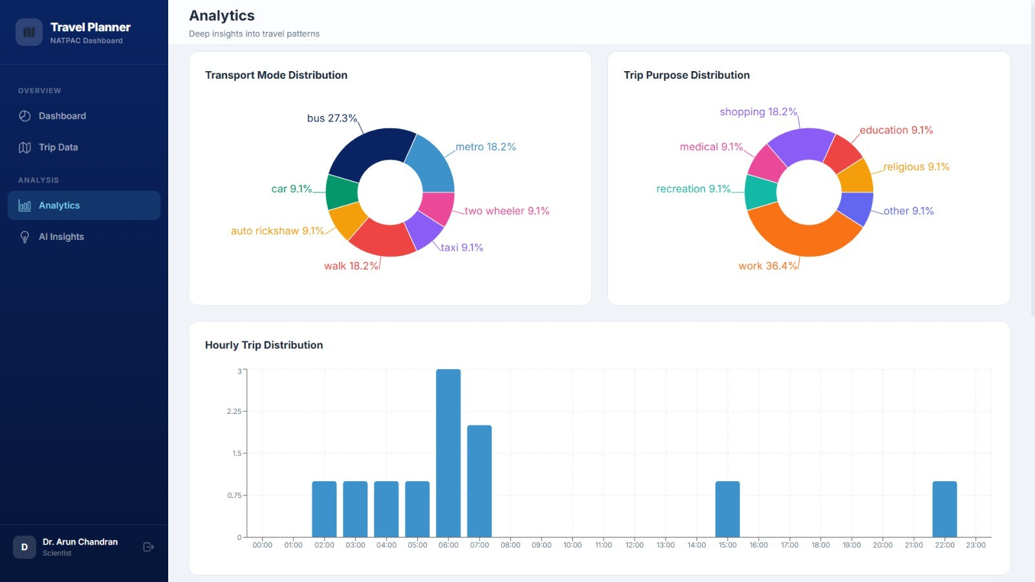

Fig. 9. Analytics of Web Application

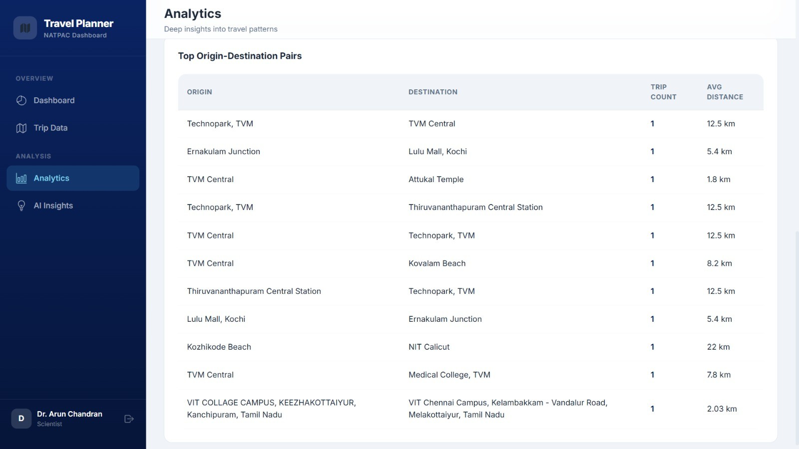

Fig. 10. Analytics of Web Application

