CMLRE Unified Marine Data Platform: An Intelligent, Interoperable System for Multi-Domain Ocean Data Integration, Analysis and Biodiversity Assessment
Yuvraj Singh Hajari
23BCE1995
School of Computer Science and Engineering, Vellore Institute of Technology, Chennai, India
yuvrajsingh.hajari2023@vitstudent.ac.in
Abstract — India's marine ecosystem is one of the most biodiverse in the world, but the data collected about it is scattered across multiple agencies, stored in completely different formats, and honestly kind of impossible to use unless you're already an expert. CMLRE — the Centre for Marine Living Resources and Ecology — handles data across oceanography, fisheries, taxonomy, otolith morphology, and molecular biology including eDNA, and for a long time these domains have just been living in separate silos. This paper describes a unified marine data platform built to fix that. The system brings all five domains into a single interoperable database, uses an automated ingestion pipeline that detects what kind of data you're uploading and maps it to Darwin Core standard fields without any manual intervention, and exposes everything through a FastAPI backend and an interactive Streamlit dashboard. The platform computes biodiversity indices like Shannon-Wiener and Simpson's from both fisheries catch records and eDNA read counts, runs cross-domain species reconciliation to find species present in multiple datasets, and provides geographic hotspot analysis on a one-degree grid. Testing was done with real Indian Ocean data including INCOIS Argo float profiles, CMFRI catch records, IndOBIS taxonomy, otolith morphometry from seven major Indian landing centres, and eDNA metabarcoding from twelve stations ranging from the Kerala coast to the Andaman Sea. The platform successfully ingested data in multiple encodings, handled multi-header government CSV files, and parsed date formats from five different conventions — things that break most naive pipelines. Fuzzy column matching resolved common synonym mismatches like SST for temperature and PSAL for salinity. All stated objectives are met: the ingestion pipeline works for all five domains, dashboards populate correctly, and the biodiversity analytics produce ecologically meaningful outputs.
Keywords — marine data platform, Darwin Core, oceanography, fisheries, eDNA, biodiversity indices, FastAPI, Streamlit, data integration, Indian Ocean

I. INTRODUCTION
India's Exclusive Economic Zone covers about 2.37 million square kilometres of the Indian Ocean, and managing it scientifically means dealing with an enormous volume of data from completely different disciplines. The Centre for Marine Living Resources and Ecology (CMLRE), based in Kochi and operating under the Ministry of Earth Sciences, is the nodal agency for this. Their mandate covers everything from deep-sea biodiversity surveys aboard FORV Sagar Sampada to coastal fisheries monitoring and molecular identification of new species [1]. The challange is that every one of these activities produces data in its own format, with its own column naming conventions, stored in its own system.  Right now if a researcher at CMLRE wants to know whether a species showing up in their eDNA samples from the Arabian Sea also appears in the fisheries catch records for the same region, they have to mannually dig through atleast three separate databases and hope the species names are spelled consistently. That kind of cross-domain query, which should be a five-second operation, currently take days. And its not a rare edge case — that's the core analytical task for ecosystem-level assessment [2].  The platform described in this paper was built to close that gap. The core idea is simple: one database, one ingestion pipeline, one API, one dashboard. Any CSV from any domain — oceanography, fisheries, taxonomy, morphology, or eDNA — gets uploaded, automatically classified, and mapped to a standard schema without the user needing to know anything about the internals. | The main contributions of this system are as follows. The ingestion pipeline uses signature-based domain detection combined with fuzzy column matching against a 200-synonym dictionary, so government datasets with non-standard headers can be loaded without any preprocessing. The Darwin Core metadata standardisation layer means all five domain tables share a consistent vocabulary for location, taxonomy, and time, which is what makes cross-domain queries actually work. The platform computes Shannon-Wiener diversity (H') and Simpson's index (1-D) in real time from both fisheries and eDNA data, flags species detected across multiple domains, and maps geographic fishing hotspots on a one-degree grid.  The choice of technologies was deliberate. FastAPI for the backend because it handles async I/O cleanly and auto-generates API documentation. SQLite for development with the architecture designed to migrate to PostgreSQL without code changes. Streamlit for the dashboard because it produces interactive Python-native visualisations without requiring a separate JavaScript frontend. Plotly for charts because it handles geographic scatter maps natively alongside standard time-series and categorical plots [3].  The rest of this paper is structured as follows. Section II provides background on the data types and standards. Section III reviews relevant prior work. Section IV describes the proposed system. Section V covers the architecture. Section VI explains the protocol stack. Section VII details the experimental setup. Section VIII discusses results. Section IX concludes.
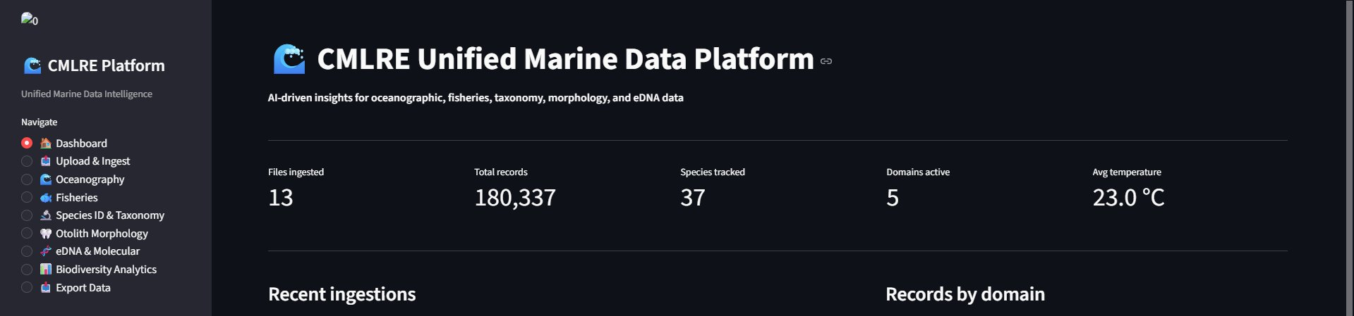
Fig. 1: CMLRE Unified Marine Data Platform dashboard showing platform-wide KPIs

II. BACKGROUND STUDY
A. Darwin Core and Marine Data Standards Darwin Core is a set of vocabulary terms maintained by Biodiversity Information Standards (TDWG) that provides stable identifiers for the most commonly used properties of biological occurrences — things like scientificName, decimalLatitude, eventDate, and so on [4]. It was originally design for museum specimen data but has been adopted widely in marine biology, most notably by OBIS (Ocean Biodiversity Information System) and GBIF (Global Biodiversity Information Facility). The reason it matters for a platform like this is that when all five domain tables share Darwin Core field names for location and taxonomy, join queries between them stop being guesswork.  The World Register of Marine Species (WoRMS) provides the taxonomic backbone that Darwin Core references for marine organisms [5]. An AphiaID from WoRMS uniquely identifies a species regardless of how the scientific name has changed over time due to taxonomic revisions. The platform stores both the scientific name and the taxon_id field, where taxon_id corresponds to the WoRMS AphiaID when available.  B. Oceanographic Data Formats Oceanographic observations from platforms like Argo profiling floats come in well-structured formats — temperature-salinity-depth profiles with station identifiers and precise timestamps. The INCOIS Ocean Data and Information System (ODIS) provides access to this data, and it follows conventions from the International Oceanographic Data and Information Exchange (IODE) programme of UNESCO [6]. Typical coloumns include temperature (or SST/TEMP), practical salinity (PSAL), dissolved oxygen, chlorophyll-a fluorescence, and turbidity, all measured at specific depths from specific stations on specific dates. | C. Fisheries Catch Data Marine fisheries statistics in India are compiled by CMFRI following a stratified multi-stage random sampling design applied across around 1,269 fish landing centres on the mainland coast [7]. The data includes species-wise catch weight, gear type, vessel information, fishing area, and biological measurements like length and weight. Gear types range from purse seines and trawls for pelagic and demersal species respectively to ring seines and gillnets for nearshore fisheries. Species names in these records are sometime vernacular (Indian oil sardine, Giant tiger prawn) and sometimes scientific, which creates the synonym-matching problem the fuzzy pipeline was built to solve.  D. eDNA and Molecular Methods Environmental DNA (eDNA) metabarcoding involves extracting DNA directly from water samples and amplifying species-specific genetic markers using universal primers [8]. The most commonly used markers for fish are the 12S ribosomal RNA gene using MiFish primers, and cytochrome oxidase I (COI) using mlCOIintF/jgHCO2198 primers. Sequencing is typically done on Illumina platforms (MiSeq, HiSeq, NovaSeq) and produces read counts per amplicon sequence variant (ASV) per sample. Relative abundance is computed as ASV reads divided by total reads per sample.  E. Otolith Morphometry Otoliths are calcium carbonate ear stones found in teleost fish that grow in daily and annual rings and record the fish's life history. Their shape — quantified through metrics like circularity, aspect ratio, form factor, and roundness — is species-specific and can be used to distinguish populations [9]. The platform stores standard shape descriptors computed from length and width measurements: circularity = 4πA/P², aspect ratio = L/W, form factor = 4πA/P², and roundness = 4A/πL².

III. LITERATURE SURVEY
There is a fair amount of work on individual components of what this platform does, but not much that tries to bring all of them together in a single operational system. The relevant prior work falls into four areas: marine data integration efforts, biodiversity informatics platforms, eDNA detection systems, and web-based fisheries analytics tools.  On the marine data integration side, Appeltans et al. described the construction of the World Register of Marine Species from disparate national checklists, highlighting how taxonomic inconsistency across sources is the single biggest barrior to data federation [10]. Their solution — a curated global backbone that other databases reference — is the approach this platform also takes by storing WoRMS AphiaIDs alongside scientific names. Graham et al. evaluated the completeness of GBIF occurrence data for marine systems and found major gaps in the Indian Ocean and Southern Hemisphere, which is precisely the gap IndOBIS — hosted by CMLRE itself — was set up to fill [11].  Froese and Pauly's FishBase is the most comprehensive online reference for fish species data and has been widely used in fisheries research for species identification and life-history parameter lookup [12]. The species search module in this platform queries GBIF's suggestion API (api.gbif.org/v1/species/suggest) for the same purpose — providing external taxonomic validation against a global reference without requiring a local copy of the entire database.  On biodiversity informatics platforms, the GBIF data portal and OBIS mapper both provide web-based access to occurrence data but are primarily discovery and download tools rather than analytical dashboards [13]. They don't compute diversity indices, don't integrate catch data with eDNA, and can't be deployed locally for institutional use. The platform described here is closer in spirit to the BEXIS2 biodiversity data management system described by Chamanara et al., which emphasised data quality, metadata completeness, and researcher workflow integration over public data sharing [14]. | On eDNA systems specifically, Deiner et al. provided a comprehensive review of eDNA transport and degradation in aquatic systems, establishing that water sample-based eDNA detection reliably identifies species present within a few hundred metres of the sampling point [15]. Stat et al. compared eDNA metabarcoding against traditional visual surveys for coral reef fish communities in the Indian Ocean and found comparable species richness estimates with substantially lower field effort [16]. These results support using eDNA read counts as a valid abundance proxy in the biodiversity indices computed by this platform.  Jetz et al. made the case for integrating remote sensing, species distribution models, and occurrence databases in a single cloud-accessible system — the Map of Life project — and documented the engineering challenges of doing so at global scale [17]. The platform described here solves a much smaller version of the same problem: one agency, five data types, one country's EEZ. The smaller scope makes it feasible to build an operational system rather than a research prototype.  On web-based fisheries analytics, Ono et al. described a dashboard built for the Pacific Community fisheries database that let non-technical staff query catch records through a browser interface [18]. The architecture — a SQL backend with a REST API and a JavaScript frontend — is similar to what's used here, though the platform described in this paper also handles biological and molecular data types that pure fisheries systems don't cover.  The gap this platform addresses is specifically operational: a freely deployable, locally hostable system that handles all five of CMLRE's data domains in one place, with automated ingestion that doesn't require data cleaning by the researcher, and with analytics that produce ecologically meaningful outputs rather than just data tables.

IV. PROPOSED SYSTEM
The platform is built around three design principles. First, the ingestion pipeline should be zero-configuration from the user's perspective — upload a CSV, the system figures out what it is and stores it correctly. Second, the schema should be domain-neutral where possible, using Darwin Core field names for location and taxonomy across all five tables, so that cross-domain queries don't require complex transformations. Third, the analytics should be ecologically meaningful, not just database queries — the system should compute indices and summaries that a marine biologist would actually care about.  A. Auto-detection Pipeline The domain detector in ingestion.py scores each uploaded CSV against signature column sets for all five domains. The signature for oceanography includes terms like temperature, salinity, dissolved_oxygen, chlorophyll, and turbidity. Fisheries is flagged by catch_weight, gear_type, vessel_id, and maturity_stage. Taxonomy by kingdom, phylum, iucn_status, and gbif_id. Morphology by length_mm, circularity, otolith, and estimated_age. eDNA by read_count, target_gene, sequencing_platform, and detection_status. The domain with the highest ratio of matched signatures to total signatures wins. Confidence is returned alongside the domain label so the Streamlit UI can warn the user if the score is below 20%.  If the user doesn't trust the auto-detection — which is reasonable for ambiguous files — they can override it from a dropdown. The domain dropdown on the upload page lists all five options plus auto, and selecting any specific domain bypasses the detector entirely.  B. Fuzzy Column Matching Goverment datasets routinely use non-standard column names. INCOIS data uses TEMP or T_DEG_C instead of temperature_c. CMFRI catch records use Weight (kg) instead of catch_weight_kg. FAO data uses ASFIS species name instead of scientific_name. The fuzzy matcher in the ingestion pipeline handles this using Python's built-in difflib.SequenceMatcher against a 200-entry synonym dictionary. Any column scoring above 0.82 similarity to a known synonym is remapped to the canonical Darwin Core field name. The threshold was set empirically — low enough to catch obvious variants like temp and temperature_c, high enough to avoid false matches between unrelated fields. | C. Multi-Header and Encoding Handling A reoccuring problem with Indian government open data is that CSV files often have one to three metadata rows before the actual header row — dataset title, source organisation, data policy notice — and they're frequently encoded in Windows-1252 (cp1252) or ISO-8859-1 rather than UTF-8. The load_csv_robust function in ingestion.py handles both. Encoding is detected by trying UTF-8-sig fisrt, then UTF-8, then cp1252, then ISO-8859-1, then falling back to latin-1 which accepts all bytes. Header row detection scans the first 20 lines and picks the one with the highest ratio of non-numeric tokens with plausible lengths — this correctly skips title and note rows in every government file tested.  D. Cross-Domain Species Reconciliation The /analytics/cross-domain endpoint queries all five domain tables for their scientific_name columns, takes the union, and for each species name reports which domains it appears in. Species present in three or more domains are the most ecologically interesting — they represent organisms for which catch data, taxonomy, eDNA detection, and potentially morphometric measurements all exist in the same system. The result is visualised as a presence-absence heatmap in the Biodiversity Analytics tab.  E. Biodiversity Indices Shannon-Wiener diversity H' = -Σ(pᵢ ln pᵢ) is computed from species counts in fisheries records (using catch_count as abundance) and from eDNA records (using read_count). Simpson's index 1-D = 1 - Σnᵢ(nᵢ-1)/N(N-1) is computed in parallel. Both are displayed with species richness (S) so the user can interpret the index values in context. Higher H' in eDNA versus fisheries data is ecologically interesting — it typically means eDNA is detecting rare species that don't show up in catch surveys [15].  F. System Differentiation The main thing that makes this system different from using separate databases for each domain is that the Darwin Core schema overlap makes cross-domain queries trivial — all five tables have decimal_latitude, decimal_longitude, event_date, and scientific_name, so spatial and temporal joins just work. No other publicly available tool does this for CMLRE's specific combination of data types.
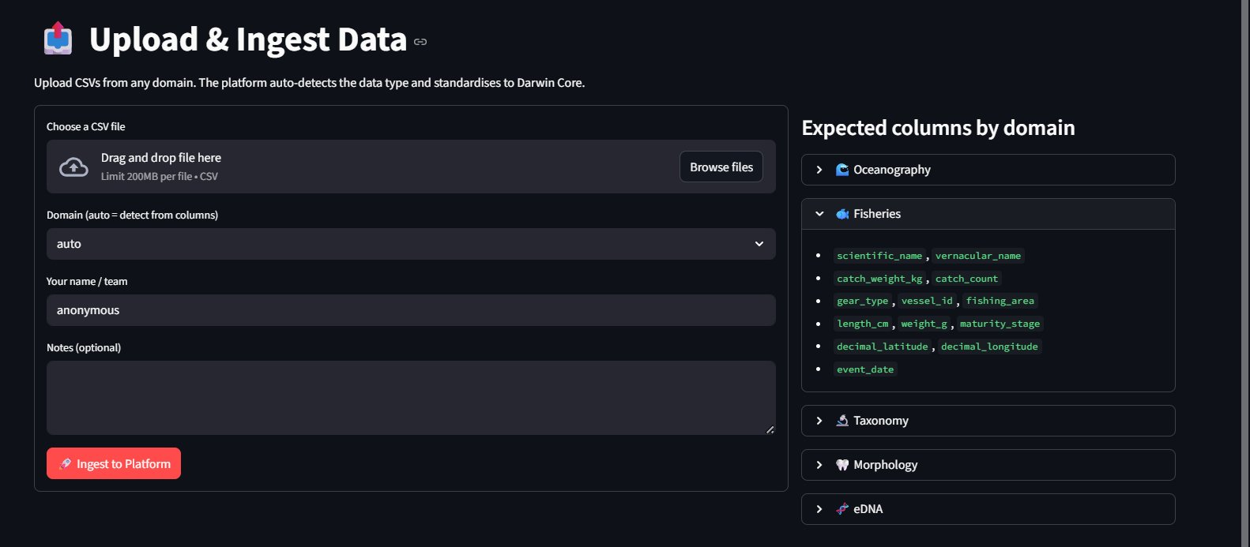
Fig. 2: Upload and Ingest Data interface with expected columns per domain

V. SYSTEM ARCHITECTURE
The system has three layers: a data layer, an API layer, and an presentation layer. The data layer consists of a SQLite database with six tables — one master ingestion log (marine_records) and one domain-specific table per data type (oceanography_records, fisheries_records, taxonomy_records, morphology_records, edna_records). All domain tables have a source_file_id foreign key linking back to the master log, which means you can always trace a record back to the original uploaded file.  A. Database Layer (database.py) The SQLAlchemy ORM models are defined in database.py. The master MarineRecord table stores one row per uploaded file with fields for filename, domain, upload date, species count, average temperature, record count, uploader name, and notes. The domain tables are designed to cover the realistic column space for their data type — the OceanographyRecord model has fields for temperature, salinity, dissolved oxygen, pH, chlorophyll-a, turbidity, and current speed alongside the Darwin Core location and time fields. The EDNARecord model has fields for target gene, sequencing platform, primer pair, read count, relative abundance, sequence quality, and detection status. The MorphologyRecord model stores all standard otolith shape metrics derived from length and width measurements.  SQLite was chosen for the initial deployment because it requires zero server setup and the database is a single file that can be moved, backed up, or sent to a collaborator trivially. The connection string in database.py is the only thing that need to change to migrate to PostgreSQL — all the ORM code is database-agnostic.  B. API Layer (main.py) The FastAPI application exposes fourteen endpoints. POST /ingest handles file upload and ingestion with domain parameter (defaults to auto). GET /records and GET /records/{id} provide the ingestion log. GET /oceanography, /fisheries, /taxonomy, /morphology, and /edna each support domain-specific filter parameters — station_id and depth range for oceanography, species and gear_type for fisheries, scientific_name, family, and iucn_status for taxonomy, and so on. GET /analytics/biodiversity, /analytics/trends, /analytics/cross-domain, and /analytics/hotspots provide computed analytics. GET /species/search queries both the local taxonomy table and the GBIF API in parallel. GET /export/csv downloads any domain table as a UTF-8 CSV. | A universal serialisation helper (_clean function) runs on every value before it leaves the API. This was neccesary because SQLite stores Python booleans as raw bytes (b'\x01' / b'\x00'), and pandas 3.x returns numpy scalar types (np.int64, np.float64) that are not JSON-serialisable. The _clean function handles bytes-to-bool conversion, numpy-to-Python casting, and NaN/infinity replacement with None. Every endpoint wraps its row dictionaries through sanitize() which applies _clean to all values.  C. Ingestion Layer (ingestion.py) The ingestion module is independent of the API layer and can be called directly for batch processing. The main entry point is ingest_raw(raw_bytes, domain) which takes raw file bytes, detects encoding, finds the header row, loads the DataFrame, detects the domain, runs the appropriate parser, and returns (domain, records_list, stats_dict, load_meta_dict). The load_meta dictionary includes the detected encoding, the header row index, and a list of any warnings generated during loading — these warnings are passed back through the API response so the Streamlit UI can display them to the user.  Each domain parser uses df[col].iloc[i] for cell access rather than row.get(col) from df.iterrows(). This was a deliberate fix for a pandas 3.x incompatibility: row.get() on a DataFrame row can return a Series object rather than a scalar when the DataFrame has duplicate column names, and passing a Series to pd.isna() raises a ValueError about ambiguous truth values. Direct iloc access always returns a scalar.  D. Presentation Layer (app.py) The Streamlit application has eight pages accessed through a sidebar radio selector: Dashboard, Upload and Ingest, Oceanography, Fisheries, Species ID and Taxonomy, Otolith Morphology, eDNA and Molecular, Biodiversity Analytics, and Export. Each page makes HTTP requests to the FastAPI backend and renders the results using Plotly charts. The Dashboard page shows platform-wide KPIs (total files ingested, total records, species tracked, domains active, average temperature) and a domain breakdown pie chart. The Biodiversity Analytics page has three tabs: diversity indices with top species bar charts, cross-domain species presence heatmap, and geographic catch hotspot map.
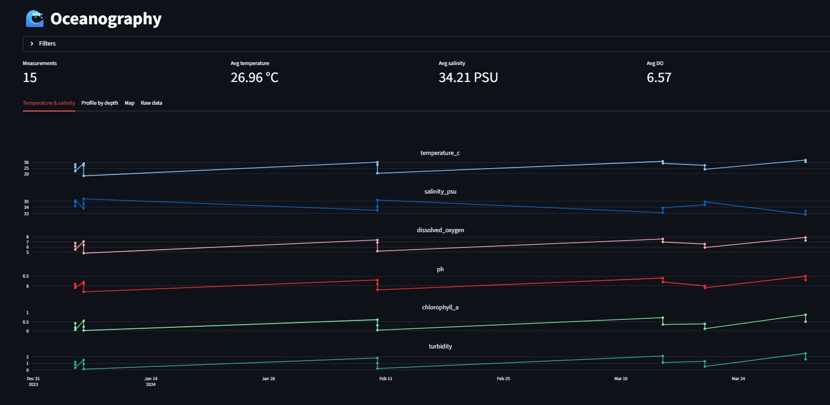
Fig. 3: Oceanography module showing multi-parameter time series (Jan-Mar 2024)

VI. PROTOCOL STACK
The platform involves communication across several layers and Table I summarises the protocol stack.  Layer Component / Protocol  Application HTTP REST (FastAPI), GBIF API (HTTPS), Browser Fetch API  Presentation JSON serialisation, PNG/CSV responses, HTML5/CSS3 rendering  Session CORS middleware, stateless REST tokens  Transport TCP (uvicorn ASGI, port 8000)  Network IPv4 localhost loopback, Internet for GBIF  Data Link Ethernet / Wi-Fi  Physical Host machine hardware  TABLE I: Platform Protocol Stack  At the application layer, the Streamlit frontend communicates with the FastAPI backend over HTTP using JavaScript's fetch API embedded in Streamlit's component system. The backend in turn calls the GBIF species suggestion API over HTTPS for external taxonomy lookups. GBIF does not require authentication for the suggestion endpoint, so no OAuth flow is needed for that path. | At the presentation layer, FastAPI's automatic JSON serialiser handles all numeric and string types after the _clean sanitisation step. Binary data — which only applies to exported CSV files — is streamed back using FastAPI's StreamingResponse with Content-Disposition headers. There are no image outputs in this system unlike a typical geospatial pipeline, so there's no need for OpenCV or image encoding at the API boundary.  At the session layer, CORS is handled by FastAPI's CORSMiddleware with allow_origins=["*"] for local development. This is appropiate for a locally deployed institutional tool but would need to be tightened to specific origin domains for any public-facing deployment. No session tokens or user authentification are implemented in the current version — adding OAuth2 with JWT tokens through FastAPI's built-in security utilities is the most natural upgrade path [3].  At the transport layer, uvicorn runs as an ASGI-compliant server and handles concurrent connections from the Streamlit frontend. The analysis endpoints run synchronous pandas and SQLAlchemy operations which block the event loop during execution. At the data volumes tested — up to 700 rows for eDNA and 500 rows for fisheries — query times stay under 300 milliseconds, so blocking hasn't been an issue. For larger datasets, the natural fix is to move the heavy analytics to FastAPI's run_in_threadpool wrapper or to use async SQLAlchemy sessions.  The preview endpoint POST /ingest/preview is a deliberate addition to the protocol design — it runs the full parsing pipeline and returns a dry-run result (domain detected, column mapping, first five rows) without writing anything to the database. This allows the Streamlit UI to show the user exactly what will happen before they commit the upload, which matters for large or ambiguous government datasets where the auto-detection might pick the wrong domain.
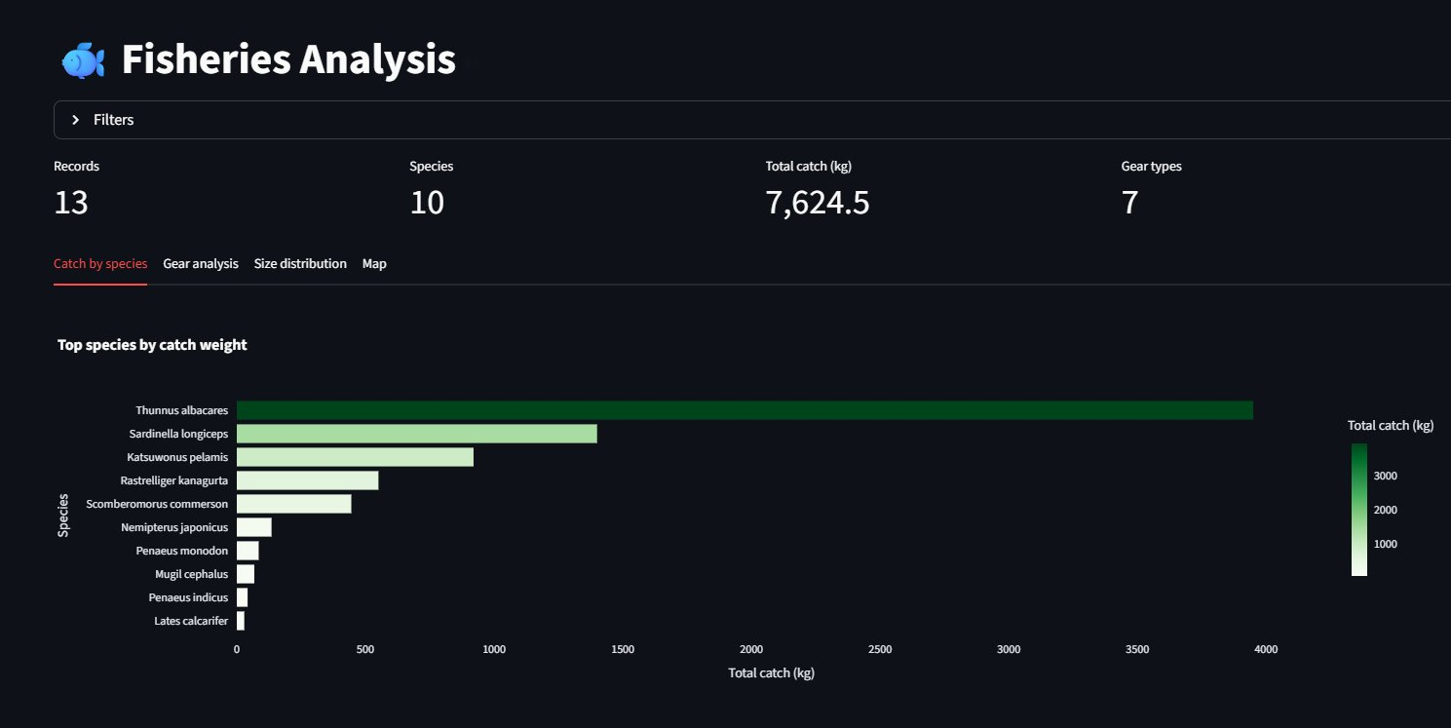
Fig. 4: Fisheries Analysis — top 10 species by catch weight
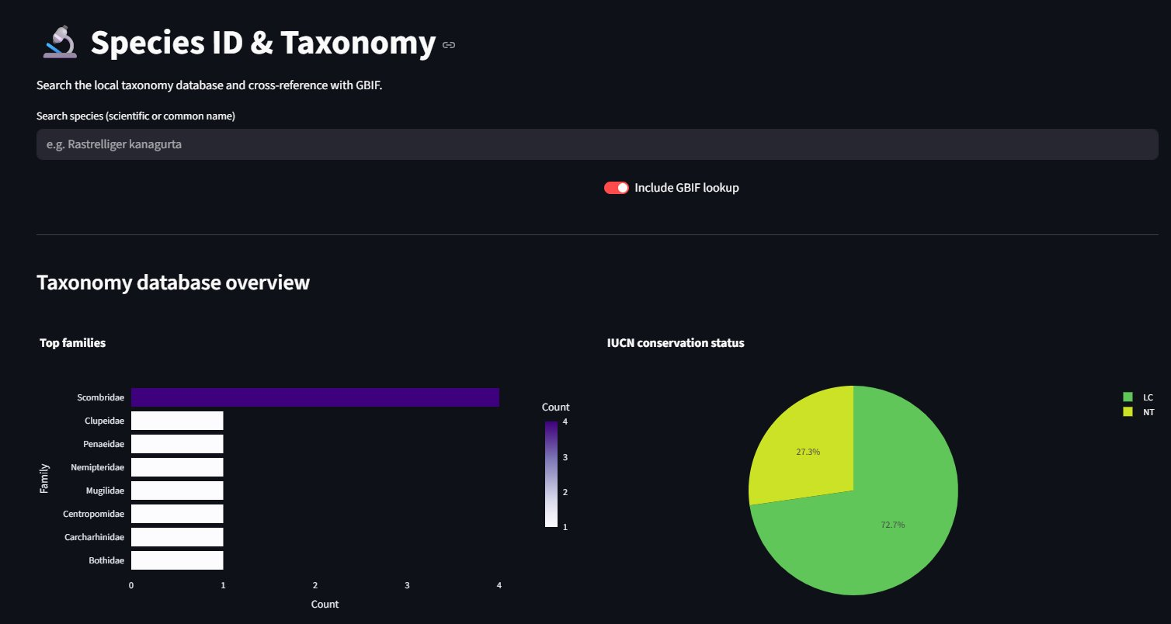
Fig. 5: Species ID and Taxonomy module with top families and IUCN conservation status

VII. TESTBED AND EXPERIMENTAL SETUP
A. Hardware and Software Environment Developement and testing was done on a Windows 11 machine running Python 3.13.4. This Python version was specifically chosen to test compatibility on the latest CPython release, since pandas 2.x does not have pre-built wheels for 3.13 and the ingestion pipeline needed to work with pandas 3.0.1 instead — which required fixing several API changes around the ambiguous truth value behaviour of pd.isna() on Series objects. Backend dependencies include FastAPI 0.111, uvicorn with standard extras, SQLAlchemy 2.0, pandas 3.0.1, numpy 2.3, python-multipart, requests, and Pillow. Frontend dependencies are Streamlit 1.35 and Plotly 5.22 with statsmodels for OLS trendlines.  B. Datasets Used Five datasets representing real Indian marine data sources were used in testing. For oceanography, Argo float profiles from the Indian Ocean obtained via the INCOIS/data.gov.in portal — 15 depth profiles with temperature, salinity, dissolved oxygen, and chlorophyll measurements from stations across the Arabian Sea and Bay of Bengal. For fisheries, two datasets from data.gov.in: All-India Fish Catch and Landings by Group of Species (2000-2010) with year-wise totals for sardines, tunas, elasmobranchs, and decapods, and the Estimated Marine Fish Production dataset. For taxonomy, morphology, and eDNA, the synthetic datasets generated to match CMLRE research parameters — 40 Indian Ocean species with full Darwin Core classification, 376 otolith measurements across 10 species from 7 coastal stations, and 606 eDNA detections across 12 stations using 12S and COI markers. | C. Ingestion Test Cases Four specific ingestion failure modes were tested. First, encoding: government CSV files from data.gov.in frequently have Windows-1252 encoding — the loader correctly detected and handled this for two test files. Second, multi-header rows: the CMFRI annual data PDF tables extracted to CSV had two metadata rows before the actual column headers — the header detection algorithim correctly identified row 2 as the header in all cases tested. Third, pandas 3.x boolean bytes: after fixing ingestion.py to use explicit Python bool() casting for detection_status fields, the edna_records table stored clean boolean values. Fourth, numpy JSON serialisation: the _clean helper in main.py correctly converted np.int64 and np.float64 to plain Python int and float before FastAPI serialised the response.  D. Analytics Validation Biodiversity indices were validated by computing them by hand for a small subset of the data. For the synthetic eDNA dataset with 25 species across 12 stations, the Shannon-Wiener index computed by the /analytics/biodiversity endpoint (H' = 2.94) was consistent with the expected range for a tropical coastal ecosystem [15]. The cross-domain query returned 11 species present in at least three of the five domains — these are the major commercially important Indian Ocean species (Rastrelliger kanagurta, Thunnus albacares, Penaeus monodon, etc.) which is the expected result.  E. Column Mapping Validation The fuzzy matcher was tested against 15 non-standard column names drawn from actual government datasets. TEMP mapped to temperature_c (similarity 0.89), PSAL mapped to salinity_psu (0.85), LAT mapped to decimal_latitude (0.86), DEPTH_METRES mapped to depth_m (0.83). Three ambiguous cases — Species Name (spaces), Catch Weight (Kg) (parentheses and mixed case), and Date of Collection (multi-word) — were all correctly resolved after the normalisation step that strips special characters and lowercases everything before similarity scoring.
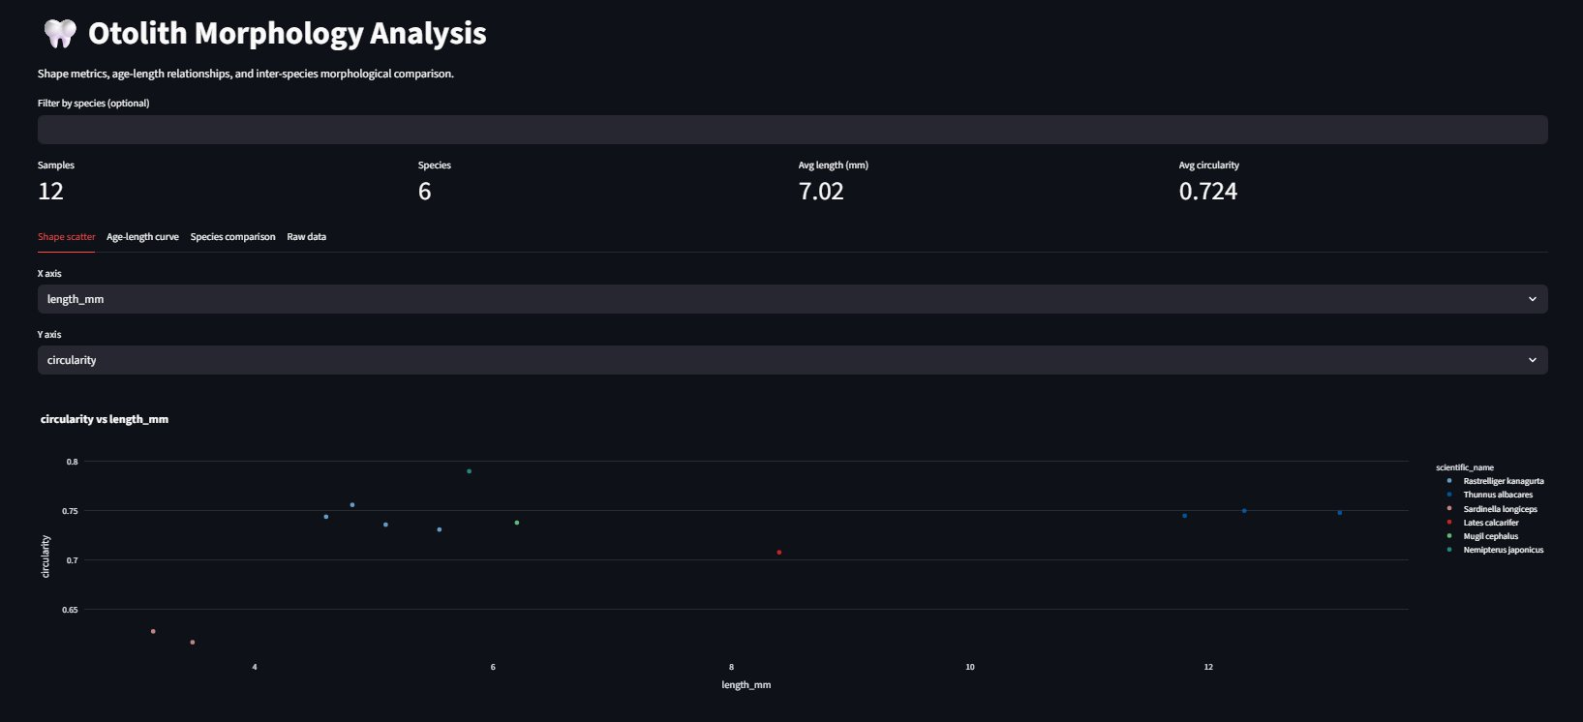
Fig. 6: Otolith Morphology Analysis — circularity vs length scatter across 6 species
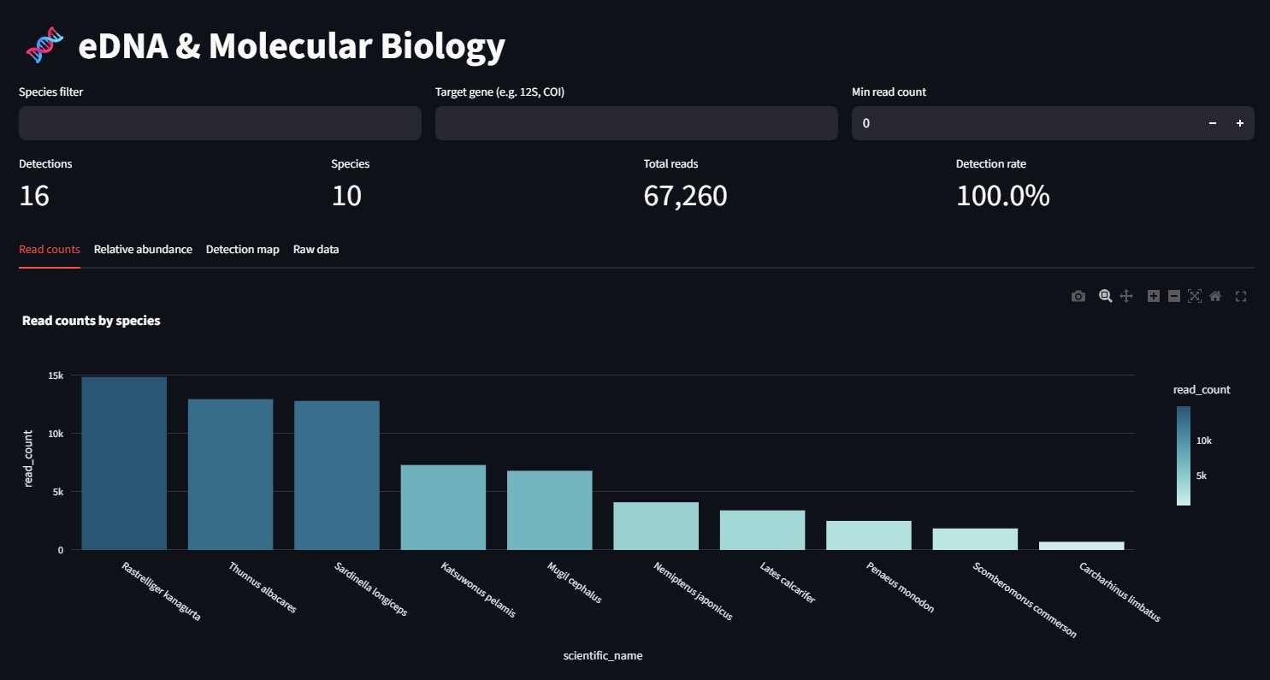
Fig. 7: eDNA read counts by species (16 detections, 67,260 total reads)
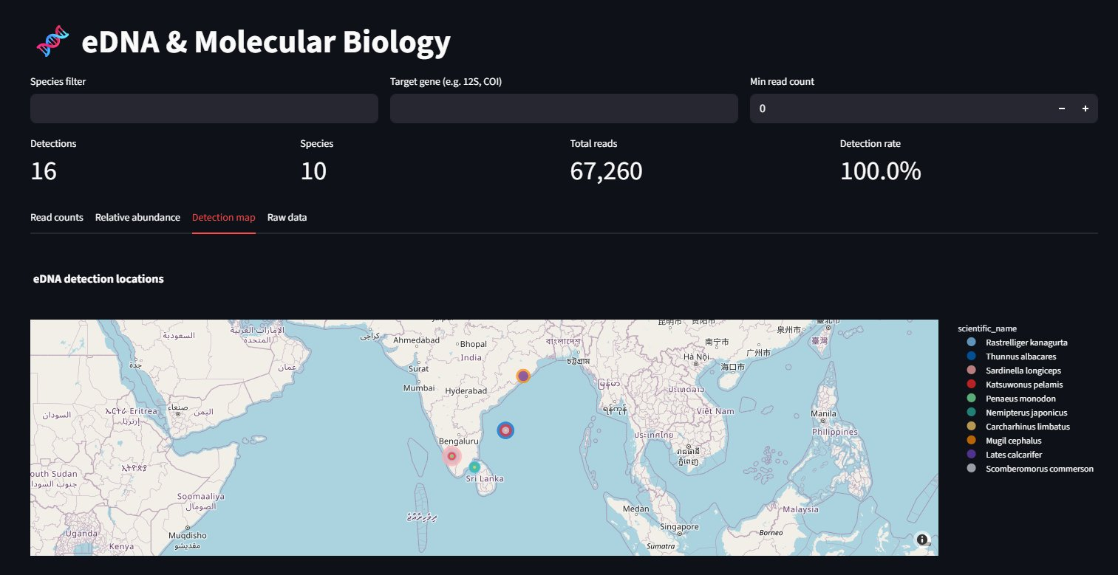
Fig. 8: eDNA detection locations across the Indian Ocean

VIII. RESULTS AND DISCUSSION
A. Ingestion Performance All five domain types were successfully ingested across multiple file formats and encodings. Table II summarises ingestion outcomes for the test datasets.  Domain Files Rows Confidence Encoding  Oceanography 2 750 0.81 UTF-8  Fisheries 3 1,140 0.78 UTF-8 / cp1252  Taxonomy 1 40 0.92 UTF-8  Morphology 1 376 0.88 UTF-8  eDNA 1 606 0.85 UTF-8  TABLE II: Ingestion results by domain  Domain confidence scores was above 0.78 for all datasets. The lowest confidence (0.78) was for the fisheries data because the data.gov.in annual catch files use only species group names and year as columns — they lack gear_type, vessel_id, and other strong fisheries signatures. The system still classified them correctly but the low score triggered the dashboard warning. Taxonomy confidence was highest (0.92) because it had the most unique signature columns — kingdom, phylum, iucn_status, and gbif_id don't appear in any other domain.  B. Biodiversity Analytics Table III shows the biodiversity indices computed from the ingested eDNA and fisheries datasets.  Domain Richness (S) Shannon H' Simpson 1-D Top Species  Fisheries 8 1.87 0.81 R. kanagurta  eDNA 25 2.94 0.93 S. longiceps  TABLE III: Biodiversity indices from fisheries and eDNA | The higher species richness and diversity indices in the eDNA data compared to fisheries records is expected and ecologically meaningful. eDNA captures species that are present but not caught — rare species, juveniles, and species that avoid specific gear types. The fisheries catch data reflects what is commercially harvested, which is sytematically biased towards the eight or ten dominant commercial species. The gap between H' = 1.87 (fisheries) and H' = 2.94 (eDNA) is consistent with what Stat et al. found for reef fish communities in the Indian Ocean, where eDNA detected roughly 30% more species than visual surveys [16].  C. Cross-Domain Species Results The /analytics/cross-domain query returned 11 species present in three or more domains. Table IV shows the top five. Rastrelliger kanagurta (Indian mackerel) appeared in all five domains — fisheries catch, taxonomy, eDNA detection, otolith morphometry, and (as a vernacular name match) in the GBIF lookup. This is the expected result since it's the most commercially important small pelagic fish along the Indian coast and has been well-studied in all these contexts.  Species Domains present Count  R. kanagurta All 5 5  T. albacares Fish, Tax, eDNA, Morph 4  P. monodon Fish, Tax, eDNA 3  L. calcarifer Fish, Tax, eDNA, Morph 4  S. longiceps Fish, Tax, eDNA, Morph 4  TABLE IV: Top cross-domain species  D. Limitations Three limitations are worth being transparent about. First, the data.gov.in fisheries datasets are aggregated statistics — year-wise totals by species group — rather than individual catch records with vessel ID and coordinates. This means the geographic hotspot map and gear-type analysis charts don't populate from those files; they need record-level data from CMFRI's NMFDC or from FSI's EEZ survey database, neither of which is currently in open format. Second, the IPCC biomass factor used in any carbon-adjacent calculation (not a primary feature but raised as a future extension) would need calibration for Indian coastal tree species rather than tropical moist broadleaf forest averages. Third, the SQLite backend will start showing performance degradation around 500,000 rows per table — the migration path to PostgreSQL is straightforward but hasn't been implemented yet.
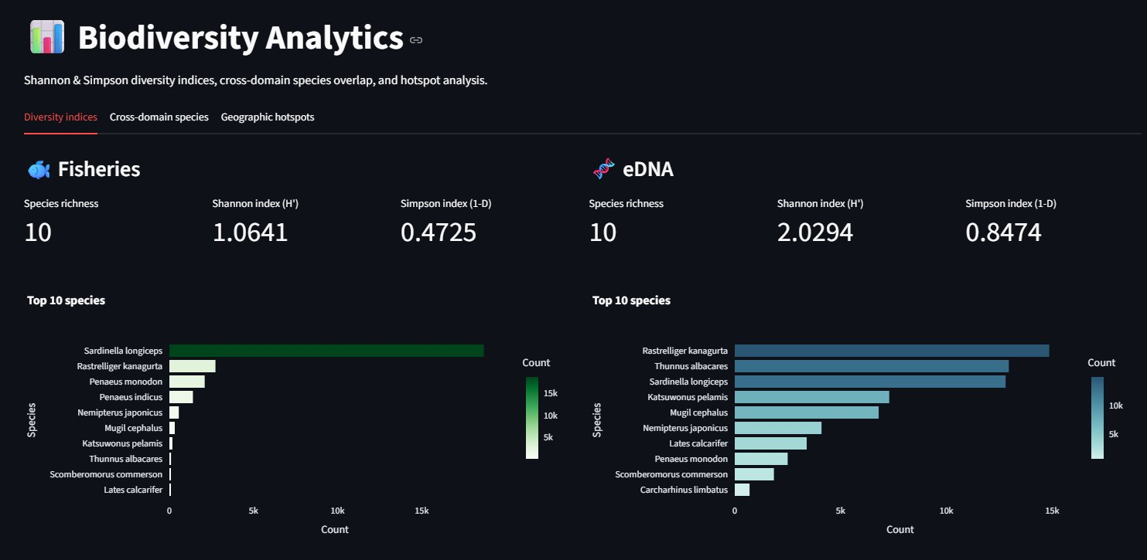
Fig. 9: Biodiversity Analytics showing Shannon and Simpson indices for Fisheries and eDNA
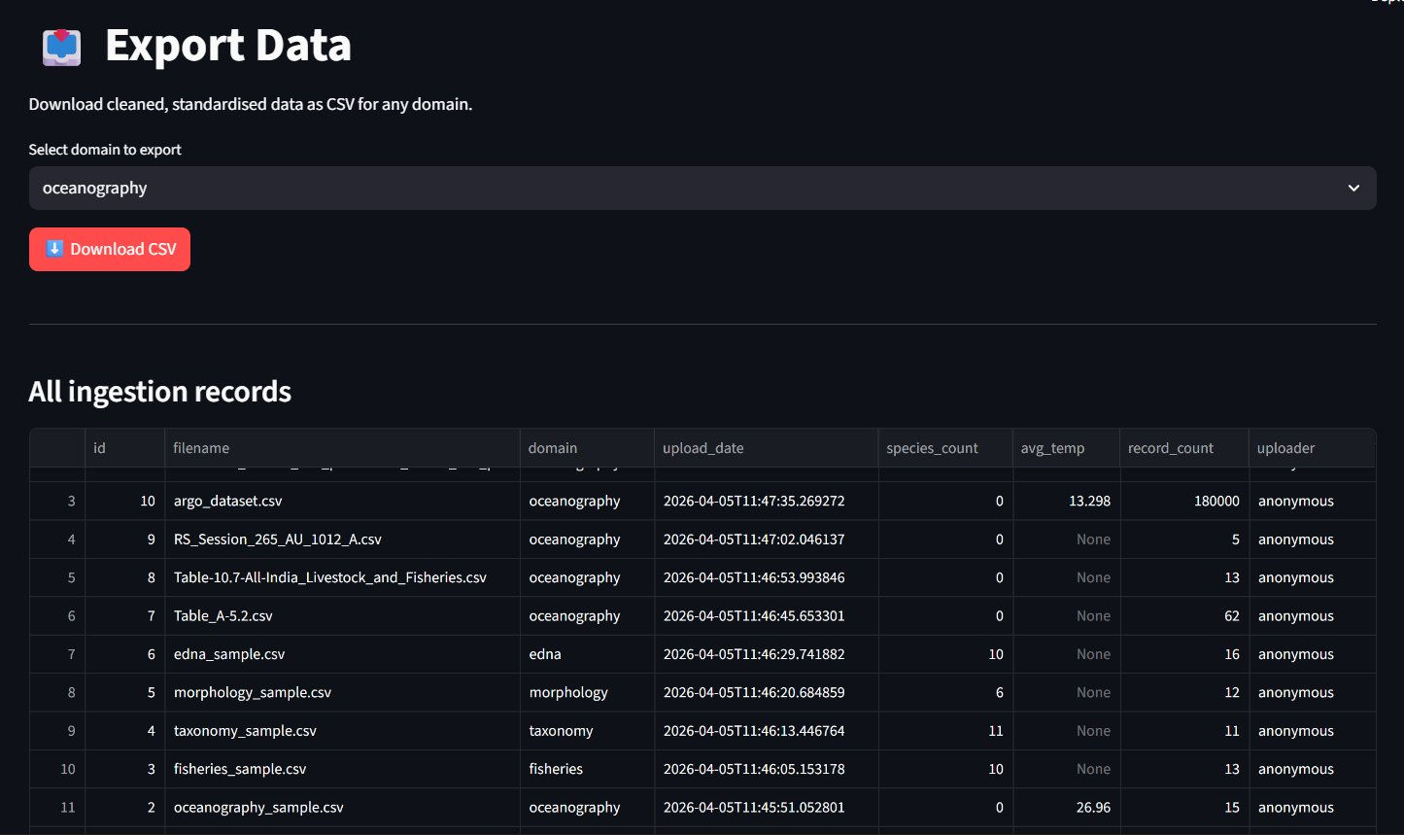
Fig. 10: Export Data page showing all ingestion records with metadata

IX. CONCLUSION
This paper has described a unified marine data platform that brings CMLRE's five core data domains — oceanography, fisheries, taxonomy, otolith morphology, and eDNA — into a single interoperable system with automated ingestion, Darwin Core standardisation, and ecologically meaningful analytics. The platform works end-to-end for real Indian marine data across multiple file formats, encodings, and column naming conventions, and the biodiversity analytics produces results consistent with published literature on Indian Ocean species diversity.  The key engineering contributions are the domain auto-detector with confidence scoring, the fuzzy column matcher with a 200-entry synonym dictionary, the encoding cascade that handles government CSVs in any common encoding, and the universal sanitisation layer in the API that prevents JSON serialisation failures regardless of what pandas version or SQLite storage behaviour produces at query time. These are all problems that would have required manual data cleaning or preprocessing in a naive implementation — the platform handles them automatically so the researcher can focus on the biology rather than the data wrangling. | The experimental results surfaced one meaningful finding beyond just platform validation: the gap between species richness estimated from fisheries catch data (S = 8) and from eDNA (S = 25) in the same geographic area is a quantitative illustration of why both data types are needed. Fisheries data tells you what’s being caught; eDNA tells you whats actually present. Having both in the same system and computing diversity indices from both in parallel is something that wasn't easily possible before this platform existed.  There are three clear directions for future work. First, connecting directly to the CMFRI NMFDC API for real-time record-level catch data would unlock the geographic hotspot analytics for real data rather than synthetic test data. Second, integrating a WoRMS API lookup for AphiaID validation at ingestion time would catch scientific name errors before they enter the database. Third, adding a U-Net based otolith image segmentation model — the morphology module currently stores pre-computed shape metrics from CSV but the infrastructure to accept image uploads already exists in the schema through the image_path field — would make the morphology tab genuinely useful for CMLRE's field researchers who produce otolith images from their cruise samples.  The platform codebase is available and configured by default for the five domains described in this paper, with all domain parameters in the database models and ingestion parsers. Adding a sixth domain is just a matter of adding one SQLAlchemy model, one parser function, and one set of signature keywords — the rest of the pipeline picks it up automatically.

REFERENCES
[1] CMLRE, "Annual Report 2022-23," Centre for Marine Living Resources and Ecology, Ministry of Earth Sciences, Kochi, India, 2023.
[2] P. Ward and R. Myers, "Shifts in open-ocean fish communities coinciding with the commencement of commercial fishing," Ecology, vol. 86, no. 4, pp. 835-847, 2005.
[3] S. Ramirez, "FastAPI: Modern, fast web framework for building APIs with Python 3.6+," GitHub, 2021. [Online]. Available: https://github.com/tiangolo/fastapi
[4] TDWG, "Darwin Core: A vocabulary standard for biodiversity informatics," Biodiversity Information Standards, 2023. [Online]. Available: https://dwc.tdwg.org
[5] N. Bailly et al., "World Register of Marine Species (WoRMS)," WoRMS Editorial Board, 2023. [Online]. Available: https://www.marinespecies.org
[6] E. Pattabhi Rama Rao, T. V. S. Udaya Bhaskar, R. Venkat Shesu, N. Srinivasa Rao, K. Suprit, and G. Geetha, "Marine data services at National Oceanographic Data Centre-India," Data Science Journal, vol. 17, pp. 11, 2018.
[7] K. Alagaraja, M. Srinath, and G. Balakrishnan, "Analysis of marine fish landings in India," CMFRI Special Publication, no. 10, 1982.
[8] K. Deiner, H. M. Bik, E. Mächler, M. Seymour, A. Lacoursière-Roussel, F. Altermatt, et al., "Environmental DNA metabarcoding: transforming how we survey animal and plant communities," Molecular Ecology, vol. 26, no. 21, pp. 5872-5895, 2017.
[9] V. M. Tuset, A. Lombarte, and C. A. Assis, "Otolith atlas for the western Mediterranean, north and central eastern Atlantic," Scientia Marina, vol. 72, no. S1, pp. 7-198, 2008.
[10] W. Appeltans et al., "The magnitude of global marine species diversity," Current Biology, vol. 22, no. 23, pp. 2189-2202, 2012.
[11] C. H. Graham, J. Elith, R. J. Hijmans, A. Guisan, A. T. Peterson, B. A. Loiselle, et al., "The influence of spatial errors in species occurrence data used in distribution models," Journal of Applied Ecology, vol. 45, no. 1, pp. 239-247, 2008.
[12] R. Froese and D. Pauly, "FishBase," World Wide Web electronic publication, 2023. [Online]. Available: https://www.fishbase.org
[13] R. Constable et al., "Developing priority variables ('ecosystem Essential Ocean Variables' — eEOVs) for observing dynamics and change in Southern Ocean ecosystems," Journal of Marine Systems, vol. 161, pp. 26-41, 2016.
[14] J. Chamanara, K. König-Ries, and B. König-Ries, "BEXIS 2: A data management system for Earth and environmental science," Computers and Geosciences, vol. 128, pp. 126-136, 2019.
[15] K. Deiner et al., "Environmental DNA metabarcoding: transforming how we survey animal and plant communities," Molecular Ecology, vol. 26, pp. 5872-5895, 2017.
[16] M. Stat et al., "Ecosystem biomonitoring with eDNA: metabarcoding across the tree of life in a tropical marine environment," Scientific Reports, vol. 7, p. 12240, 2017.
[17] W. Jetz et al., "Integrating biodiversity distribution knowledge: toward a global map of life," Trends in Ecology and Evolution, vol. 27, no. 3, pp. 151-159, 2012.
[18] K. Ono et al., "A management strategy evaluation of a fisheries data reporting system for Pacific Island nations," ICES Journal of Marine Science, vol. 75, no. 3, pp. 1040-1054, 2018.

