
DEPARTMENT OF

COMPUTER SCIENCE & ENGINEERING

WORKSHEET 1
Student Name: Khushi Khemka UID: 23BCS10652
Branch: BE-CSE Section/Group: Krg_3A
Semester: 6th Subject Name: System Design Subject Code: 23CSH-314

Aim: To design a URL Shortner System

Steps:

- Functional Requirements:
Create a short URL from a Long URL.
--Optional: Support custom URL
--Support expiration date: Default+ custom expiration

User should get redirected to the original URL from short URL.

- Non-Functional Requirements:
Low Latency: response in least amount of time: ( On URL-creation, on URL Redirect) - 200 ms.
Scalability: 100M daily active user & application should be able to short 1B URL.
Unique: Shorten URL should be Unique.
Availability: 24 x 7 available.
CAP: Tradeoff btw Consistency & Availability: We need high availability here as per req.
Availability >> Consistency
We will achieve consistency having some delay - This system is called Eventual system.

- API Design:
- POST Endpoint: /v1/url -> short-URL
Since this is POST request, we have to pass the body
{
longURL,
customURL ? (optional),
expirationDate}
Now we have retrive the longURL also, we neet GET Request
- GET: /v1/url/{short-url} -> will redirect me to longURL.

- High-Level Design:

Now According to the functional requirement of the system, we can identify
that :
There will be a client who is requesting, then there will a server upon which
computation will be going on, and lastly there will be an database in which
storage will be done.

- Low-Level Design:

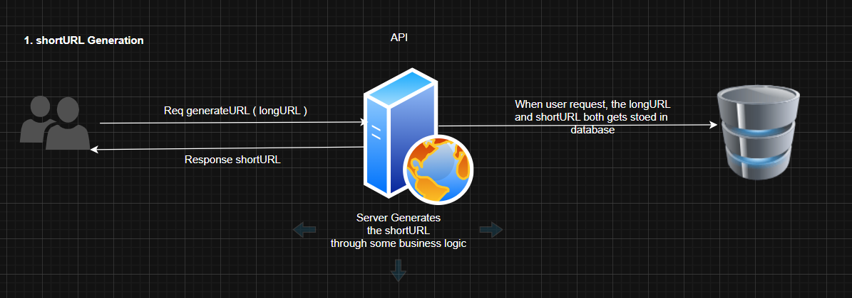

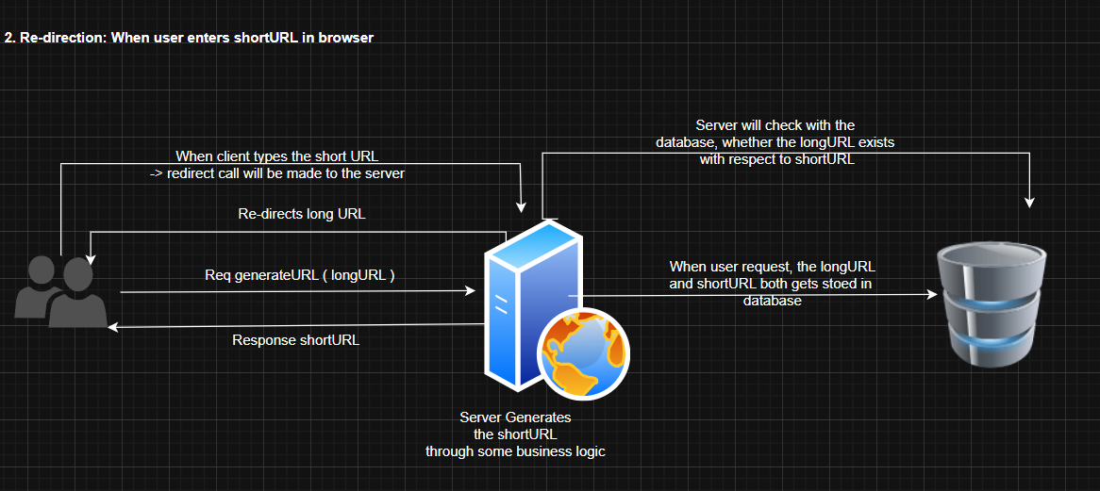

Approach 01: Encryption

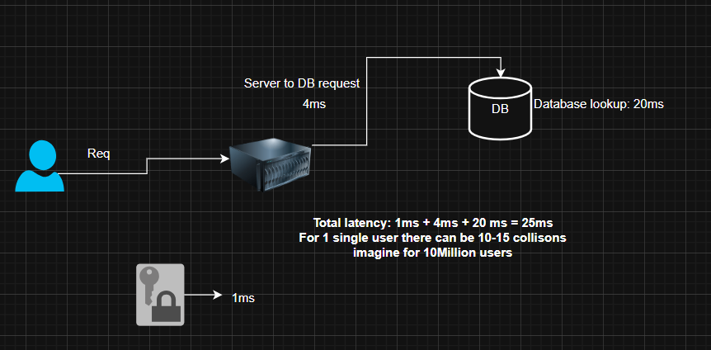

Approach 02: Counter Approach

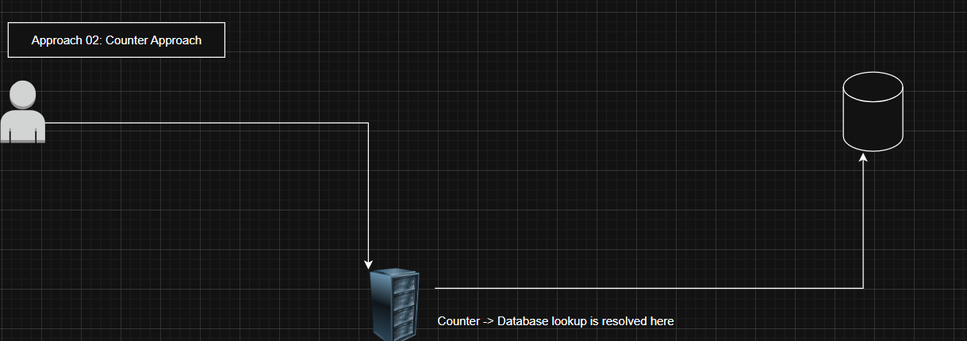

Scaling:

