6488217 Pattaradnai Kaeodumkoeng Sec.2

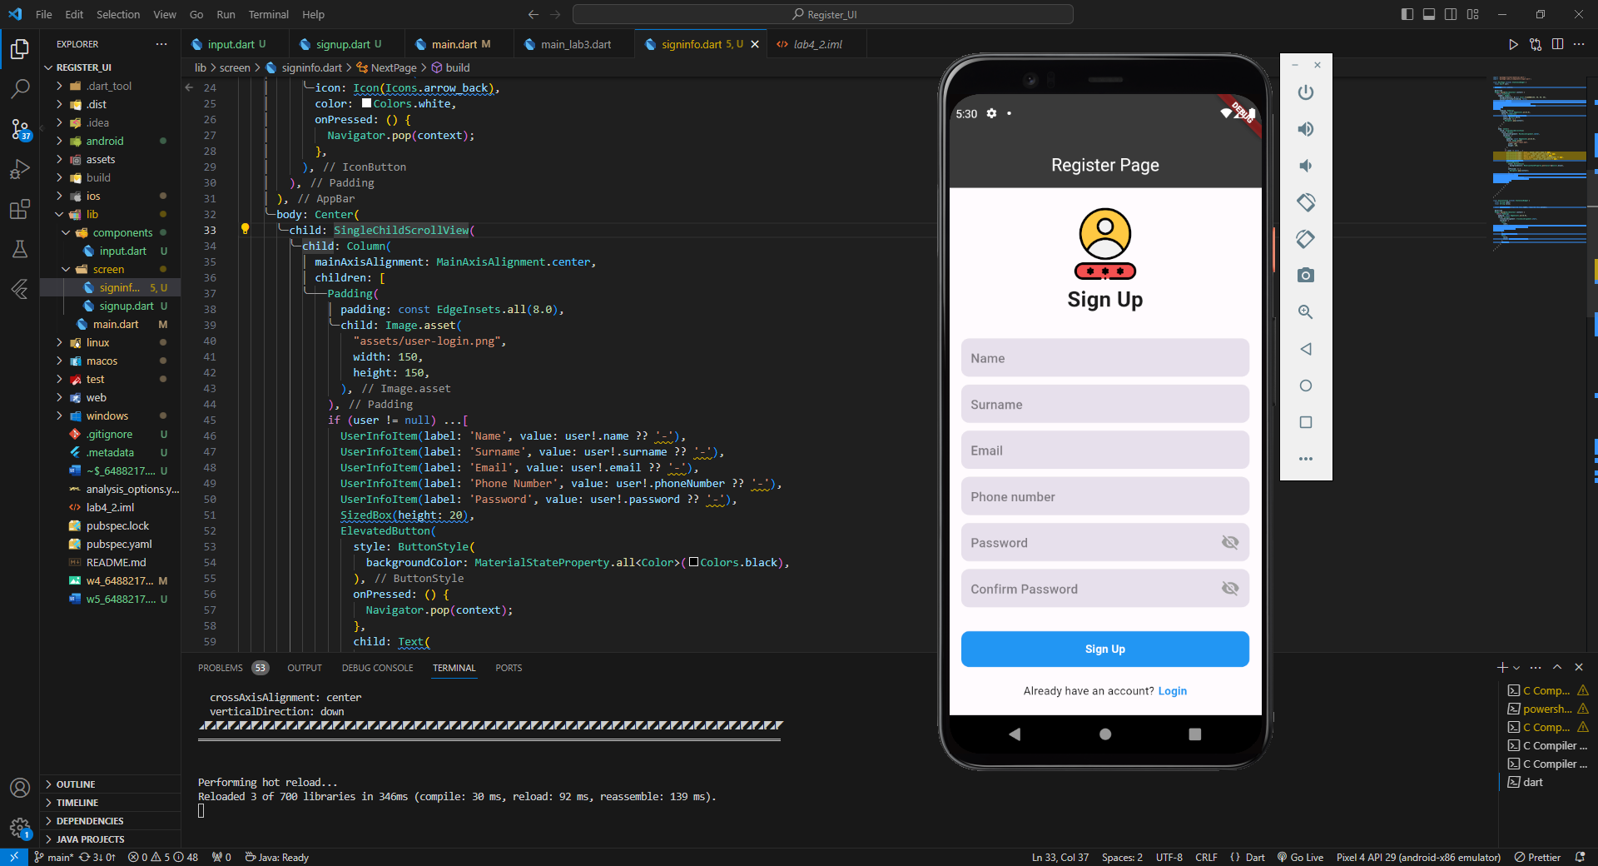

First Page – Sign up

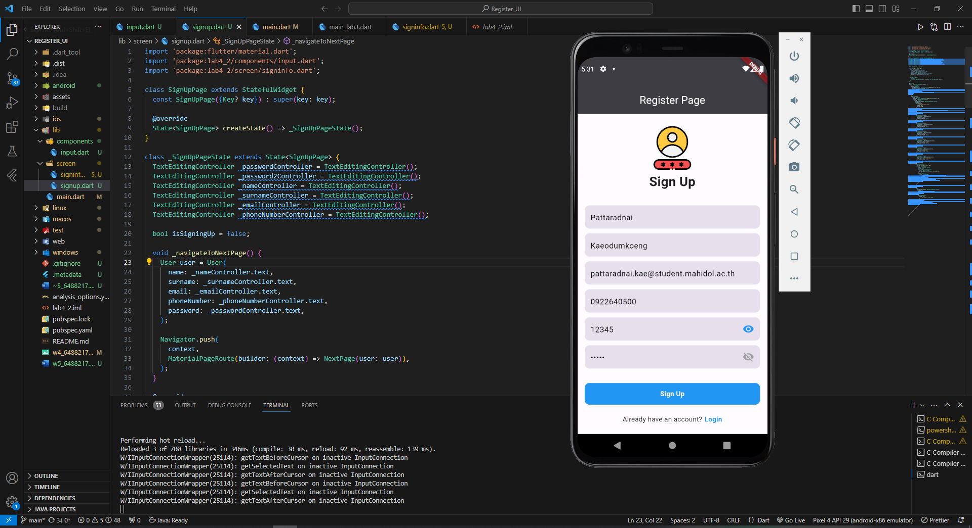

First Page – Sign up after input some data

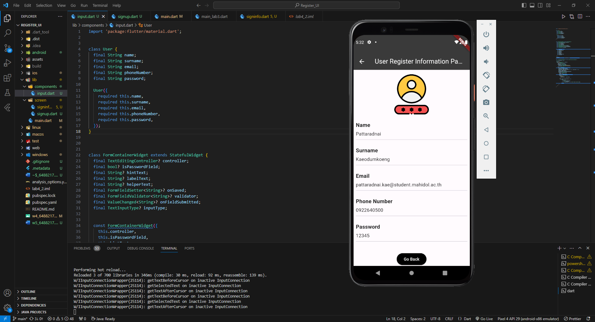

Second Page – User register information page

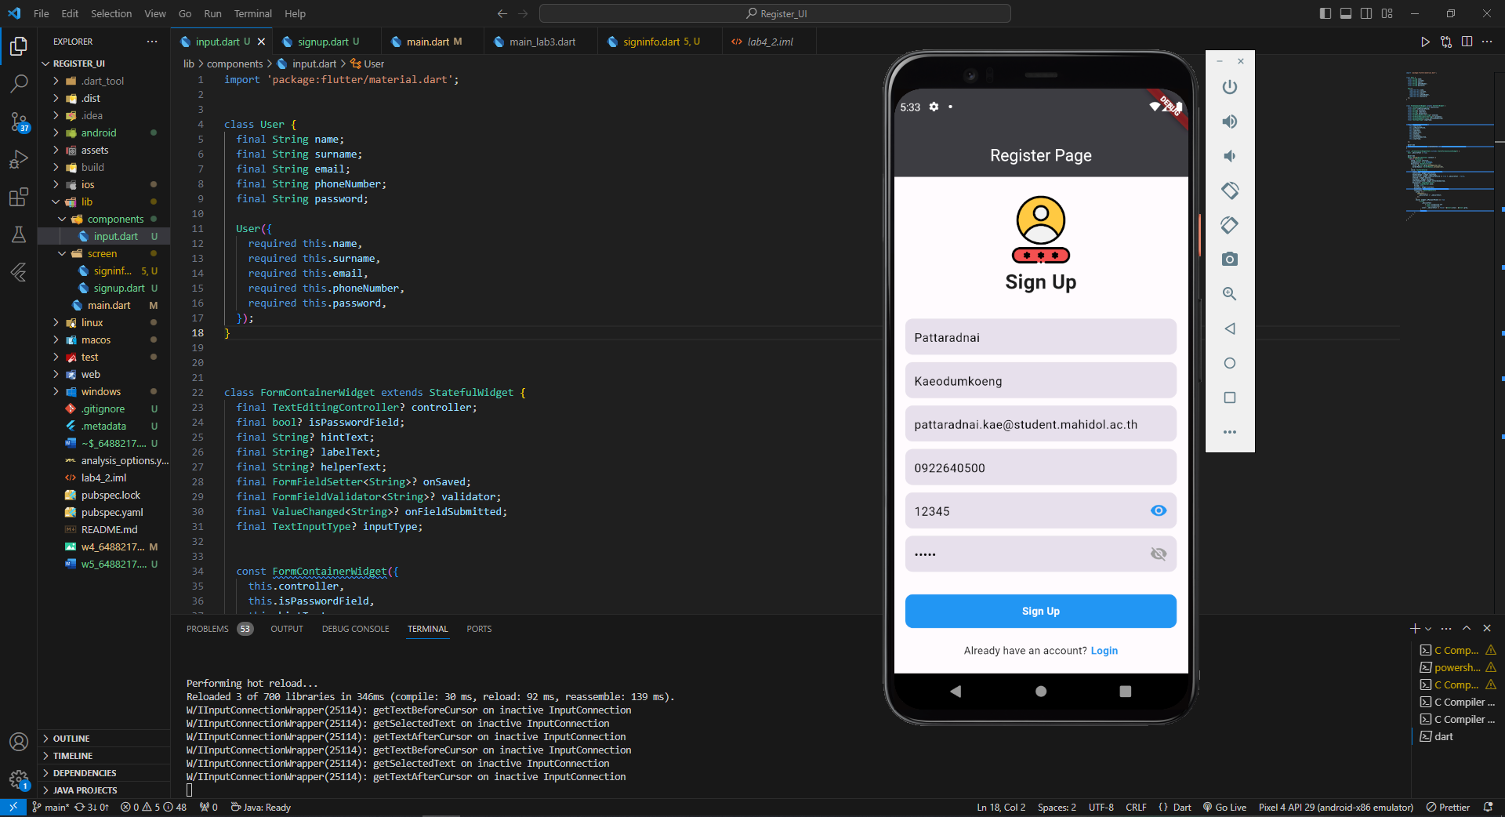

Go back to first page by go back button/ back arrow