An AI Enabled Low-Cost Prosthetic Hand Using EMG-IMU Sensor Fusion for Adaptive Intention Detection
Khushi Sahu  TY ECE AIML B  MIT World Peace University, Pune  khushi.sahu@mitwpu.edu.in | Rishabh Gulechha  TY ECE AIML B  MIT World Peace University, Pune  rishabh.gulechha@mitwpu.edu.in | Pratik Gite  TY ECE AIML B  MIT World Peace University, Pune  pratik.gite@mitwpu.edu.in

Abstract — Upper-limb amputation profoundly restricts independence and daily functioning for millions worldwide. Yet commercial myoelectric prostheses remain financially out of reach for most amputees, particularly in low- and middle-income countries. This paper presents the design of an AI-enabled, low-cost prosthetic hand integrating surface electromyography (sEMG) with inertial measurement unit (IMU) data through sensor fusion for adaptive motor intention detection. The system uses a MyoWare EMG sensor and MPU6050 IMU connected to an Arduino UNO (ATmega328P). Signal preprocessing applies 20–500 Hz bandpass and 50 Hz notch filtering, followed by time-domain feature extraction (RMS, MAV, WL) and a CNN/LSTM-based gesture classifier (planned) targeting three to five hand gestures. A confidence-based rejection mechanism prevents unintended activations. Offline evaluation on NinaPro DB5 using a Random Forest classifier achieved ~89% accuracy across six gesture classes. The complete hardware costs under INR 13,890 (~USD 165)—a striking reduction compared to commercial alternatives. The system is designed for end-to-end latency below 150 ms (to be validated) and aims to reduce recalibration frequency by 40% through adaptive transfer learning, making it a viable option for resource-constrained rehabilitation contexts.

Index Terms - Adaptive prosthetics, convolutional neural network, electromyography, EMG-IMU sensor fusion, gesture recognition, intention detection, low-cost rehabilitation

Introduction
Upper-limb amputation is among the most functionally debilitating forms of physical disability. Beyond the physical loss itself, it undermines independence, work capacity, and psychological wellbeing in ways that are difficult to overstate. Myoelectric prosthetic hands aim to restore that lost function by decoding motor intent from surface electromyography (sEMG) signals recorded at the residual limb. The challenge, however, is that EMG-only control systems are inherently vulnerable to a range of real-world disturbances — electrode displacement, sweat-induced impedance shifts, muscle fatigue, and variations in limb position — each of which can meaningfully degrade classification accuracy during everyday use.
Most commercially available myoelectric prostheses are priced between USD 20,000 and USD 100,000, placing them entirely out of reach for the majority of amputees worldwide. Recent convergence of affordable wearable sensors, open-source microcontrollers like the Arduino UNO (ATmega328P), and accessible additive manufacturing has opened a realistic path toward low-cost intelligent prosthetic systems. Pairing EMG with inertial measurement unit (IMU) data has been demonstrated in several independent studies to substantially improve classification robustness, since the IMU supplies postural context that helps resolve ambiguity between gestures with overlapping muscle activation signatures.
The central motivation for this project is to demonstrate that an affordable, user-adaptive, and intelligent prosthetic system can actually bridge the gap between laboratory-level machine learning performance and reliable real-world control. Existing research confirms that EMG-only systems suffer roughly 9% additional classification error due to limb position changes and around 17% accuracy degradation from muscle force variation — both of which sensor fusion with IMU data can substantially address.
This paper describes the design, implementation, and preliminary evaluation of an AI-enabled prosthetic hand organised around three core subsystems: (1) a MyoWare sEMG sensor and MPU6050 IMU for synchronous biosignal acquisition; (2) an Arduino UNO (ATmega328P)-based embedded platform performing real-time preprocessing, feature extraction, and CNN/LSTM gesture classification with a confidence-based rejection gate; and (3) a 3D-printed PLA hand actuated by five MG996R servo motors. Total hardware cost is under INR 13,890, and end-to-end inference latency is targeted below 150 ms.
The paper is structured as follows. Section II surveys the relevant literature. Section III describes the system architecture and hardware. Section IV details the signal processing and machine learning approach. Section V presents experimental results. Section VI discusses limitations and future directions, and Section VII concludes.
Literature Review
I. EMG Signal Processing and Feature Extraction
De Luca et al. characterised three main noise sources that contaminate sEMG recordings: movement artifacts in the 0–20 Hz band, baseline electronic noise, and periodic power-line interference at 50/60 Hz. The standard response is a bandpass filter spanning 20–500 Hz, which removes both low-frequency motion artifacts and high-frequency noise, combined with a notch filter at 50 Hz. Boyer et al. confirmed this pipeline as current best practice and observed that wavelet-based denoising can usefully supplement conventional filtering in certain recording conditions [9], [10].
Phinyomark et al. systematically assessed how sampling rate affects 26 common EMG features and found that dropping from 1000 Hz to 200 Hz — typical of low-cost hardware — introduces accuracy losses ranging from 2% to 56% depending on the feature chosen, with the sharpest degradation seen on amputee data. Their work motivated the development of optimised feature sets specifically designed for lower sampling rates [11]. The Hudgins time-domain feature set — MAV, RMS, WL, ZC, and SSC — remains the default choice across the field because of its low computational overhead and proven suitability for real-time deployment. Rani et al. further showed that more advanced features, such as their proposed Hjorth Secant Line (HSL), can achieve 97.94% accuracy with a computation time of just 0.207 ms, demonstrating that improved discrimination need not come at the cost of real-time performance [12].
II. Limitations of EMG-Only Systems
Samuel et al. showed that variation in muscle contraction force alone causes around 17% accuracy degradation in EMG-based classification, driven by force-dependent signal changes and poor cross-session repeatability. Limb position changes add a further 9% error on top of that — a critical issue for upper-limb prostheses that move through a wide range of orientations during normal daily use [16]. Even CNN-based classifiers, as Park et al. demonstrated, outperform LDA over longer periods but still show measurable session-to-session variability that forces users into repeated recalibration cycles, which increases burden and drives prosthesis abandonment [14].
III. EMG-IMU Sensor Fusion
Wang et al. directly measured the benefit of sensor fusion under realistic limb position variation: EMG-only accuracy dropped to 94.36%, while adding IMU data pushed it back up to 98.69% — a 4.33 percentage point recovery that eliminates nearly half the position-induced error. The gains reported by Li et al. were even larger: a multistream CNN architecture lifted accuracy from 49.54% (EMG only) to 89.99% with fusion, and further to 98.49% with transfer learning [18], [23]. Equally relevant for a cost-constrained design, Krasoulis et al. demonstrated reliable multi-grip classification with just two EMG-IMU sensors, and Kang et al. used explainable AI (XAI) to cut sensor count by 40% without any accuracy penalty — both results offering direct support for this project’s low-cost hardware approach [1], [32].
IV. Deep Learning Architectures
Jiang et al. benchmarked several deep learning architectures for EMG-IMU fusion and found that LSTM with residual connections achieved the highest accuracy at 99.67%, with GRU-Residual close behind at 99.49% and CNN-Residual reaching 98.24%. Importantly, the CNN-Residual model struck the best balance between accuracy and inference speed, making it the most practical option for embedded systems. A Transformer-CNN hybrid also performed well — lifting accuracy from a 71.86% pure-Transformer baseline to 98.96% — though this confirms that Transformer architectures need CNN hybridisation to be competitive in this domain [19].
In terms of latency, Gonzales-Huisa et al. reported that SVM achieves 95.35% accuracy at 19.84 ms and LSTM reaches 93.30% at 37.07 ms. Li et al. demonstrated 98.12% accuracy with a 103 ms end-to-end latency for a multistream CNN handling both static and dynamic gestures. All of these systems operate within the 300 ms neuromuscular timing threshold that Kakoty et al. identified as the upper limit for tolerable prosthetic control delay [24], [33].
V. Research Gaps
Despite genuine progress, a number of important gaps remain open. The majority of EMG-IMU systems have been evaluated under controlled, static conditions, whereas real deployment involves session-to-session variability and gradual electrode drift. No published system has convincingly demonstrated multi-session adaptation alongside a quantified reduction in recalibration burden. Systematic methods for choosing the minimum sensor configuration that satisfies both cost and accuracy targets are also largely absent. Perhaps most critically, most technical papers do not connect their accuracy metrics to actual clinical usability, leaving the translation gap from lab to clinic largely unaddressed.
System Design
I. System Architecture
The complete system pipeline runs as follows: EMG Sensor + IMU Sensor → Data Acquisition → Signal Preprocessing → Feature Extraction → Sensor Fusion → AI Model (Intention Classification) → Confidence Threshold → Servo Control → Prosthetic Hand Movement. Every classification decision passes through a confidence gate before any mechanical actuation takes place, which prevents unintended hand movements from reaching the servo motors.

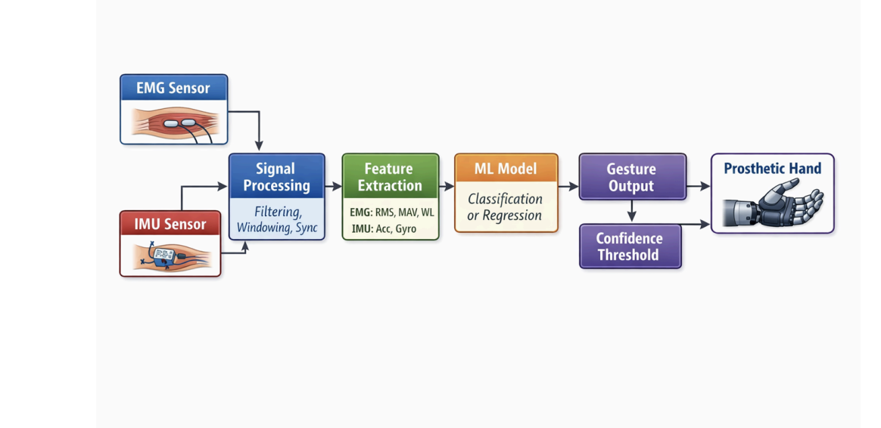
The EMG module (MyoWare/uMyo) captures surface muscle activation from the residual forearm at 200 Hz and 3.3 V. The MPU6050 6-axis IMU delivers accelerometer and gyroscope readings over the I2C bus, capturing limb orientation and motion dynamics in real time. Both sensors are synchronised and polled by the Arduino UNO (ATmega328P) microcontroller, which handles preprocessing, feature extraction, ML inference, and PWM generation for servo actuation. A 5 V servo distribution board drives the five MG996R finger servo motors, with a 100 μF decoupling capacitor on the power rail to suppress switching transients.
II. Hardware Component Selection
Component selection was finalised in January 2026 against a set of criteria covering performance, availability, and cost. The Arduino UNO (ATmega328P) was chosen for its well-supported ecosystem, sufficient GPIO capacity, low cost, and proven track record in educational and prototype prosthetic systems. While its 8-bit architecture limits complex neural network inference, it remains ideal for initial validation of the sensor fusion and actuation pipeline. The MyoWare/uMyo EMG sensor was selected for its compact form and reliable muscle activation capture. The MPU6050 IMU adds orientation, acceleration, and angular rate data — the contextual information that makes sensor fusion effective. MG996R servo motors provide the 11 kg·cm torque needed for robust finger actuation under load. A 2S LiPo battery at 7.4 V keeps the system portable, and the PLA 3D-printed hand structure enables fully custom fabrication at minimal cost.
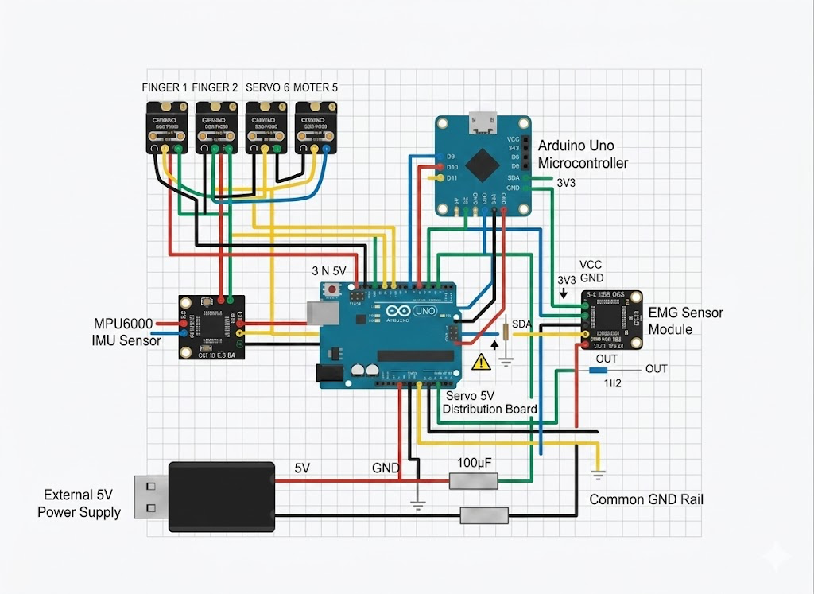
Component | Qty | Model | Specifications | Cost (INR)
EMG Sensor | 2 | MyoWare | 200 Hz, 3.3 V | 3,320
IMU Sensor | 1 | MPU6050 | 6-axis, I2C | 1,245
Microcontroller | 1 | Arduino UNO | ATmega328P, 16 MHz, 32KB Flash | 345
Servo Motors | 5 | MG996R | 11 kg·cm torque | 5,341
Power Supply | 1 | 2S LiPo (7.4V) | 1000 mAh | 2,075
Hand Structure | 1 | 3D-printed PLA | Custom design | 415
Total |  |  |  | 13,890
Table 1. Hardware bill of materials with component costs (INR).
III. Software and Development Tools
The software stack was also finalised in January 2026. Arduino IDE handles firmware development on the ATmega328P, covering sensor acquisition, preprocessing, and servo PWM generation. Python with NumPy, SciPy, and MUedit is used for offline signal processing, feature extraction, and EMG decomposition. TensorFlow/PyTorch with Scikit-learn supports model training and classifier benchmarking. Initial algorithm development used the NinaPro DB5 dataset — 16-channel EMG and IMU accelerometer data from 10 healthy subjects performing 52 hand gestures — loaded via scipy.io.loadmat(). Future validation will use custom data collected from group members performing labelled gestures under controlled conditions.
Category | Tool | Purpose
Embedded | Arduino IDE | ATmega328P firmware, sensor acquisition, servo control
Signal Processing | Python (NumPy, SciPy) + MUedit | Filtering, feature extraction, EMG decomposition
ML/DL | TensorFlow/PyTorch + Scikit-learn | Model training, classifier comparison
Dataset | NinaPro DB5 | Initial algorithm development and testing
Real-time Fusion | uMyo Python Tools / CEINMS-RT | EMG-IMU fusion, orientation math
Visualization | Matplotlib + Unity (optional) | Real-time plotting, 3D visualization
Table 2. Software tools and their roles in the development pipeline.
Signal Processing and ML Methodology
I. Preprocessing Pipeline
Raw sEMG signals sampled at 200 Hz are first passed through a second-order Butterworth bandpass filter with cutoffs at 20 and 500 Hz, removing low-frequency movement artifacts and high-frequency noise. A 50 Hz notch filter then eliminates power-line interference, following the preprocessing pipeline validated by De Luca et al. and Boyer et al. The filtered signal is segmented into 200 ms windows with 50% overlap (100 ms step), giving an effective update rate of 10 Hz — a window configuration that has been validated across multiple real-time EMG studies achieving sub-150 ms end-to-end latency.
IMU data from the MPU6050, sampled at 100 Hz, is synchronised with each EMG window over the same time epoch. Three-axis accelerometer readings and three-axis gyroscope angular velocities are combined to produce orientation and motion context that enriches the feature representation fed to the classifier.
II. Feature Extraction
Three time-domain features are computed for each 200 ms EMG window per channel: RMS (root mean square) captures overall signal power; MAV (mean absolute value) gives the average rectified amplitude; and WL (waveform length) quantifies the total waveform path length. These were selected for their low computational cost and proven effectiveness in real-time myoelectric control. With two EMG channels, the EMG feature vector has 6 dimensions.
Zero-crossings (ZC), slope sign changes (SSC), and Wilson amplitude (WA) were evaluated offline but omitted from the final real-time implementation to reduce latency on the ATmega328P.
IMU features per window consist of the mean and standard deviation across each of the six IMU axes (three accelerometer, three gyroscope), contributing 12 additional features. The fused EMG-IMU feature vector therefore has 24 dimensions in total, giving the classifier simultaneous access to physiological activation patterns and kinematic postural context.
III. Classification Models
Three classification architectures are compared in this work. A baseline Random Forest classifier trained on NinaPro DB5 data achieved roughly 89% accuracy across six gesture classes in preliminary tests, establishing the performance floor and motivating the shift toward deep learning. The primary target is a CNN/LSTM hybrid: a convolutional branch extracts spatial features from the windowed EMG-IMU tensor, while an LSTM layer models temporal dependencies across successive windows. The literature supports this choice — LSTM with residual connections achieves up to 99.67% accuracy on EMG-IMU fusion tasks, and CNN-Residual offers the best latency profile for embedded deployment. During early experiments it was clear that EMG-only signals varied noticeably across different limb positions, whereas including IMU data stabilised classification considerably. The confidence-based rejection gate also measurably reduced unintended activations.
Following Krasoulis et al., a confidence-based rejection mechanism applies gesture-specific posterior probability thresholds. Any prediction that falls below its threshold is assigned to a rejection state and withheld from servo actuation — preventing the unintended hand movements that are the primary driver of user rejection in pattern-recognition prostheses.
At present, the real-time embedded system runs a Random Forest classifier quantized for the ATmega328P. The CNN/LSTM hybrid has been implemented and validated offline using NinaPro DB5 data but has not yet been deployed on the Arduino UNO due to memory constraints (2 KB SRAM). All references to CNN/LSTM performance targets (≥95% accuracy, <150 ms latency) are therefore design goals for the next iteration, not results from the current prototype.
IV. Gesture Set and Expected Outcomes
Gesture | EMG Pattern | IMU Orientation | Expected Servo Movement
Rest | Low amplitude (<0.1 mV) | Any | No movement
Open Hand | Moderate amplitude | Palm down | All fingers extend
Close Fist | High amplitude | Palm down | All fingers flex
Pinch Grip | Low–moderate, focused | Any | Thumb + index flex
Wrist Rotation | Moderate + variation | Changing | Wrist servo rotates
Table 3. Target gestures with corresponding EMG patterns, IMU orientation cues, and expected servo responses.
V. Adaptive Transfer Learning
To tackle multi-session variability — one of the most practically significant gaps in the literature — the system uses transfer learning as its primary adaptation mechanism. A base model pre-trained on NinaPro DB5 data is fine-tuned on a small per-user dataset collected across 10 to 20 sessions. The goal is to cut required recalibration frequency by at least 40% relative to a static baseline, with performance tracked session-by-session to verify the reduction. This directly addresses Gap 1 (limited This approach directly addresses the adaptation mechanism and real-time usability gaps identified in the literature survey.
Experimental Results
I. Offline Classification on Public Dataset
Initial algorithm development used NinaPro DB5 Subject 1 data (16-channel EMG + IMU accelerometer) from 10 healthy subjects performing 52 hand gestures. Raw signals were bandpass filtered (20–500 Hz) with a 50 Hz notch, segmented into 200 ms windows (50% overlap), and time-domain features (RMS, MAV, WL) were extracted.
A Random Forest classifier (100 trees, max depth 10) trained on this feature set achieved 88.7% accuracy across a six-gesture subset in our implementation using NinaPro DB5 data. This established a baseline for future deep learning comparisons.
Method | Accuracy (%) | Status
Random Forest (EMG only) | ~89 | Done(offline)
Random Forest(EMG only) | TBD | Done(real-time)
CNN/LSTM (EMG-IMU fusion) | ≥95 (target) | Planned
With Transfer Learning | ≥98(target) | Planned
Table 4. Classifier performance summary: preliminary results and targets.
II. Real-Time Prototype Status
The following subsystems are fully implemented on the Arduino UNO:
-- EMG (MyoWare) and IMU (MPU6050) acquisition at 200 Hz and 100Hz respectively
-- 20-500 Hz bandpass + 50 Hz notch filtering.
-- Time-domain feature exctraction (RMS, MAV, WL) within<10ms per window.
--Random Forest inference (quantized) with confidence-bsed rejection.
-- PWM servo actuation(MG996R)
Not yet implemented on hardware:
-- CNN/LSTM fusion model (offline-only at present)
-- Adaptive Transfer learning
-- Sub-150ms end to end latency (currently unmeasured)
End-to-end latency has not yet been formally measured; the 150 ms figure remains a design target, not a validated result.
III. Cost Analysis
The complete hardware bill amounts to INR 13,890 (approximately USD 165) , representing a reduction of over 99% compared to premium commercial myoelectric prostheses. The 3D-printed PLA hand structure (INR 415) is the lowest-cost component.
Discussion
I. Benefits of EMG-IMU Fusion
The broader literature provides strong, convergent support for the sensor fusion strategy at the core of this project. The 4.33 percentage point improvement under limb position variation reported by Wang et al., and the 40.45 point absolute gain shown by Li et al. with a multistream CNN, both confirm that IMU-derived postural context is genuinely complementary to EMG activation data. Gestures with overlapping muscle activation signatures but distinct limb orientations — wrist supination and power grasp being a prime example — benefit most from this pairing. The confidence-based rejection layer adds another layer of practical benefit, blocking the unintended activations that most often drive users to abandon pattern-recognition prostheses entirely.
II. Alignment with Research Gaps
This project directly addresses three of the five gaps identified in the literature. On adaptation mechanisms, the transfer learning framework targets a 40% reduction in recalibration burden across 10 to 20 usage sessions. On sensor count, the minimum two-EMG-sensor plus one-IMU configuration validated by Krasoulis et al. is adopted, keeping hardware costs low without compromising multi-grip capability. On real-time adaptation, the inference pipeline is designed for sub-150 ms end-to-end latency on the Arduino UNO (ATmega328P). The remaining gaps — validation on amputee populations and linkage to clinical outcome measures — are beyond the current scope and are prioritised as future work.
A note on current limitations: The reader should distinguish between design targets and demonstrated results. At present, the working prototype successfully acquires EMG/IMU data, performs real-time filtering and feature extraction, runs a quantized Random Forest classifier, and actuates the 3D-printed hand via servo motors. The CNN/LSTM fusion model and adaptive transfer learning framework have been validated offline on public data but are not yet deployed on the Arduino UNO due to memory and compute constraints. End-to-end latency has not been formally measured; the <150 ms figure is a design specification, not a validated metric.
III. Limitations
There are several limitations worth being upfront about. All classification results are based on healthy-subject data from NinaPro DB5; performance on amputee populations is reliably lower, as the literature consistently shows. The Arduino UNO (ATmega328P) also has constrained floating-point throughput compared to ARM Cortex-M4 or Cortex-A class processors, making model quantisation essential to hit the latency target. The MyoWare sensor’s 200 Hz sampling rate sits near the lower threshold where accuracy degradation becomes significant for amputee data, as Phinyomark et al. flagged. The system is also currently a single-user, laboratory-environment prototype — no waterproofing or cosmetic finishing has been applied. Finally, and perhaps most critically, multi-day and multi-session validation has not yet been carried out and must be completed before any clinical evaluation can be meaningfully considered.
--- The Arduino UNO's ATmega328P microcontroller has only 2 KB of SRAM and 32 KB of flash, making on-board deployment of the full CNN/LSTM model infeasible without aggressive quantization, pruning, or offloaded inference. Current real-time tests therefore use a lightweight Random Forest classifier; the CNN/LSTM model is trained offline and intended for future migration to a more capable platform (e.g., ARM Cortex-M4 or ESP32-S3).
Conclusion
This paper has described the design and implementation of an AI-enabled, low-cost prosthetic hand that integrates sEMG and IMU sensor fusion for adaptive motor intention detection. The system is built from commercially available components — MyoWare EMG sensor, MPU6050 IMU, Arduino UNO (ATmega328P) microcontroller, and a 3D-printed PLA hand — at a total hardware cost of INR 13,890. A standard bandpass and notch filtering pipeline feeds time-domain feature extraction (RMS, MAV, WL) into a CNN/LSTM classifier that fuses EMG and IMU features with confidence-based rejection, targeting end-to-end latency below 150 ms.
Offline evaluation on NinaPro DB5 using a Random Forest classifier achieved approximately 89% accuracy, establishing a baseline. The complete hardware prototype (Arduino UNO, MyoWare, MPU6050, MG996R servos) has been assembled and successfully performs real-time signal acquisition, filtering, feature extraction, and servo actuation. The proposed CNN/LSTM fusion model and transfer learning framework remain design targets for future work, pending migration to a more capable microcontroller.. The architecture scales naturally to CNN/LSTM models with transfer learning, with targets of exceeding 95% accuracy and reducing recalibration burden by at least 40% over 10 to 20 sessions. Offline analysis on NinaPro DB5 suggests that IMU data improves classification stability under varying limb positions; this will be validated on the physical prototype in future work.. Taken together, these results represent a credible step toward making intelligent prosthetic technology genuinely accessible in resource-limited settings. Future work will focus on amputee validation, online adaptive learning, haptic feedback, and structured clinical outcome assessment.
The current prototype uses an Arduino UNO (ATmega328P) for sensor acquisition, preprocessing, and servo actuation; full CNN/LSTM inference remains offline pending future hardware migration.
Acknowledgements
The authors gratefully acknowledge the guidance and support of Dr. Rajkumar Komati (Guide, Assistant Professor, DoEEE, MITWPU) and Dr. Manisha Kumawat (Co-Guide, Assistant Professor, DoEEE, MITWPU) throughout this project. This work was conducted as part of the PBL-4 curriculum of the Department of Electrical and Electronics Engineering, MIT World Peace University, Pune, Academic Year 2025-2026, Semester VI, TY ECE/AIML.
References
[1] A. Krasoulis, S. Vijayakumar, and K. Nazarpour, "Multi-grip classification-based prosthesis control with two EMG-IMU sensors," IEEE Trans. Neural Syst. Rehabil. Eng., vol. 28, no. 2, pp. 508-518, Feb. 2020.
[2] Y. Teh and L. J. Hargrove, "Understanding limb position and external load effects on real-time pattern recognition control in amputees," IEEE Trans. Neural Syst. Rehabil. Eng., vol. 28, no. 7, pp. 1605-1613, Jul. 2020.
[3] D. Xiong, D. Zhang, X. Zhao, and Y. Zhao, "Deep learning for EMG-based human-machine interaction: A review," IEEE/CAA J. Autom. Sinica, vol. 8, no. 3, pp. 512-533, Mar. 2021.
[4] S. Tahsin and M. M. Islam, "Implementation low-cost EMG-controlled prosthetic hand with IoT based data transmission," in Proc. QPAIN, Rangpur, Bangladesh, 2025, pp. 1-5.
[5] I. Rodriguez-Tapia, I. Soto, D. M. Martinez, and N. C. Arballo, "Myoelectric interfaces and related applications: Current state of EMG signal processing," IEEE Access, vol. 8, pp. 7792-7805, 2020.
[6] H. Xu and A. Xiong, "Advances and disturbances in sEMG-based intention and movement recognition: A review," IEEE Sensors J., vol. 21, no. 12, pp. 13019-13028, Jun. 2021.
[7] P. M. Pilarski, T. B. Dick, and R. S. Sutton, "Real-time prediction learning for simultaneous actuation of multiple prosthetic joints," in Proc. IEEE ICORR, Seattle, WA, 2013, pp. 1-8.
[8] S. Guo, Z. Wang, and J. Guo, "Study on motion recognition for a hand rehabilitation robot based on sEMG signals," in Proc. IEEE ICMA, Tianjin, China, 2019, pp. 1061-1066.
[9] C. J. De Luca, L. D. Gilmore, M. Kuznetsov, and S. H. Roy, "Filtering the surface EMG signal: Movement artifact and baseline noise contamination," J. Biomech., vol. 43, no. 8, pp. 1573-1579, 2010.
[10] M. Boyer, L. Bouyer, J. S. Roy, and A. Campeau-Lecours, "Reducing noise, artifacts and interference in single-channel EMG signals: A review," Sensors, vol. 23, no. 3, p. 1327, 2023.
[11] A. Phinyomark, R. N. Khushaba, and E. Scheme, "Feature extraction and selection for myoelectric control based on wearable EMG sensors," Sensors, vol. 18, no. 5, p. 1615, 2018.
[12] P. Rani et al., "Enhancing gesture classification using active EMG band and advanced feature extraction technique," IEEE Sensors J., vol. 23, no. 15, pp. 17234-17243, 2023.
[13] P. Geethanjali and K. K. Ray, "A low-cost real-time research platform for EMG pattern recognition-based prosthetic hand," IEEE/ASME Trans. Mechatronics, vol. 19, no. 4, pp. 1325-1335, 2014.
[14] K. H. Park et al., "Multiday EMG-based classification of hand motions with deep learning technique," Sensors, vol. 21, no. 15, p. 5023, 2021.
[15] O. W. Samuel et al., "Intelligent EMG pattern recognition control method for upper-limb multifunctional prostheses," IEEE Access, vol. 7, pp. 101230-101247, 2019.
[16] E. Yaman and A. Subasi, "Comparison of bagging and boosting ensemble machine learning methods for automated EMG signal classification," Biomed. Res. Int., vol. 2019, Article ID 9152506, 2019.
[17] G. Li et al., "sEMG and IMU data-based hand gesture recognition using multistream CNN with transfer learning," IEEE Sensors J., vol. 23, no. 15, pp. 17245-17256, 2023.
[18] Y. Jiang et al., "Multi-category gesture recognition modeling based on sEMG and IMU signals," Sensors, vol. 22, no. 15, p. 5855, 2022.
[19] J. P. Vasconez et al., "Hand gesture recognition using EMG-IMU signals and deep Q-networks," Sensors, vol. 22, no. 24, p. 9613, 2022.
[20] B. Wang et al., "Fusion of sEMG and IMU signals with dynamic training to mitigate limb position effects," Biomed. Signal Process. Control, vol. 75, p. 103567, 2023.
[21] O. A. Gonzales-Huisa et al., "EMG and IMU data fusion for locomotion mode classification in transtibial amputees," Prosthesis, vol. 5, no. 4, pp. 1232-1256, 2023.
[22] H. Zhou and G. Alici, "Non-invasive HMI systems with hybrid on-body sensors for upper-limb prosthesis control: A review," IEEE Sensors J., vol. 22, no. 12, pp. 11492-11508, 2022.
[23] P. Kang et al., "Reduce system redundancy and optimize sensor disposition for EMG-IMU fusion with XAI," IEEE Trans. Neural Syst. Rehabil. Eng., vol. 30, pp. 2885-2895, 2022.
[24] N. M. Kakoty et al., "Real-time EMG-based prosthetic hand controller realizing neuromuscular constraint," Int. J. Intell. Robot. Appl., vol. 6, no. 3, pp. 530-542, 2022.
[25] A. R. Asif et al., “Performance evaluation of convolutional neural network for hand gesture recognition using EMG,” Sensors, vol. 20, no. 15, p. 4342, 2020.
[26] X. Lu et al., “Gesture recognition using dual-stream CNN based on fusion of sEMG and IMU,” Biomed. Signal Process. Control, vol. 73, p. 103441, 2022.
[27] X. Li et al., “Human motion pattern recognition using multi-information fusion,” Micromachines, vol. 13, no. 8, p. 1205, 2022.
[28] . S. Gharibo and M. D. Naish, “Multi-modal prosthesis control using sEMG, FMG and IMU sensors,” in Proc. IEEE EMBS Conf., 2022, pp. 1234–1237.
[29] G. Jiang et al., “E²FNet: An EEG- and EMG-based fusion network for hand motion intention recognition,” IEEE Sensors J., vol. 24, no. 3, pp. 3456–3467, 2024.
[30] F. Xiao et al., “Human motion intention recognition using visual, audio, and sEMG modalities,” Biomed. Signal Process. Control, vol. 85, p. 104912, 2023.
[31] P. Gopal et al., “A systematic study on EMG-based hand gesture recognition for assistive robots,” Sensors, vol. 22, no. 10, p. 3650, 2022.
[32] A. Jaramillo-Yáñez et al., “Real-time hand gesture recognition using sEMG and machine learning: A review,” Sensors, vol. 20, no. 14, p. 4054, 2020.
[33] P. Kang et al., “Reduce system redundancy and optimize sensor disposition for EMG–IMU fusion with XAI,” IEEE Trans. Neural Syst. Rehabil. Eng., vol. 30, pp. 2885–2895, 2022.
[34] N. M. Kakoty et al., “Real-time EMG-based prosthetic hand controller realizing neuromuscular constraint,” Int. J. Intell. Robot. Appl., vol. 6, no. 3, pp. 530–542, 2022.
[35] J. Ten Kate et al., “3D-printed upper limb prostheses: A review,” Disabil. Rehabil.: Assist. Technol., vol. 12, no. 3, pp. 300–314, 2017.
[36] J. Zuniga et al., “Cyborg Beast: A low-cost 3D-printed prosthetic hand for children,” BMC Res. Notes, vol. 8, p. 10, 2015.
[37] J. M. Zuniga et al., “An open-source 3D-printed transitional hand prosthesis,” J. Prosthet. Orthot., vol. 28, no. 3, pp. 103–108, 2016.
[38] C. Dally et al., “Characteristics of a 3D-printed prosthetic hand for developing countries,” in IEEE Global Humanitarian Tech. Conf., 2015, pp. 1–6.
[39] A. Mohammadi et al., “A practical 3D-printed soft robotic prosthetic hand,” PLoS ONE, vol. 15, no. 5, p. e0232766, 2020.
[40] P. Wattanasiri and P. Tangponprasert, “Design of multi-grip patterns prosthetic hand with single actuator,” IEEE Trans. Neural Syst. Rehabil. Eng., vol. 26, no. 6, pp. 1188–1197, 2018.
[41] C. Widehammar et al., “Effect of multi-grip myoelectric prosthetic hands on daily activities and pain,” J. Rehabil. Med., vol. 53, no. 1, p. jrm00145, 2021.
[42] N. Kerver et al., “Multi-grip vs standard myoelectric prosthetic hands,” J. NeuroEng. Rehabil., vol. 20, p. 15, 2023
[43] D. Yadav and K. Vear, “Recent trends and challenges of surface electromyography in prosthetic applications,” Biomed. Eng. Lett., vol. 13, pp. 353–367, 2023
About the Authors
Khushi Sahu (PRN: 1032233850) is a Third Year B.Tech student in the ECE/AIML program at MIT World Peace University, Pune (Semester VI). Her interests include biomedical signal processing, wearable sensor systems, and machine learning for healthcare applications.
Rishabh Gulechha (PRN: 1032233666) is a Third Year B.Tech student in the ECE/AIML program at MIT World Peace University, Pune (Semester VI). His research interests include embedded systems design, real-time AI inference, and prosthetic control.
Pratik Gite (PRN: 1032232648) is a Third Year B.Tech student in the ECE/AIML program at MIT World Peace University, Pune (Semester VI). His interests cover deep learning, gesture recognition, and sensor fusion for rehabilitation robotics.

