**PROPHETIC ANOMALY NAVIGATING THE JUST-IN-TIME REVERSAL**

**Preface**

**TABLE OF CONTENTS**

**1. SOFTWARE DEVELOPMENT LIFE CYCLE**

**2. PLATFORM KNOWLEDGE**

**3. ABOUT PROJECT**

3.1 ABSTRACT

3.2 SCOPE OF THE PROJECT

3.3 EXISTING SYSTEM

3.3.1 DISADVANTAGES

3.4 PROPOSED SYSTEM

3.4.1 ADVANTAGES

**4. BOTTOM LINE AND FUTURE ENHANCEMENT**

**5. SOFTWARE AND HARDWARE REQUIREMENTS**

**1. SDLC (Software Development Life Cycle)**

The Software Development Life Cycle is a systematic process for building software that ensures the quality and correctness of the software built. SDLC process aims to produce high-quality software which meets customer expectations. The software development should be completed within the pre-defined time frame and cost.

**SDLC Phases**

The entire SDLC process is divided into the following stages:

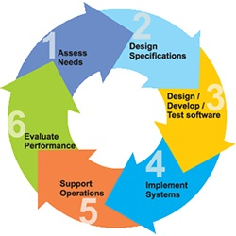

* Phase 1: Requirement collection and analysis
* Phase 2: Feasibility study
* Phase 3: Design
* Phase 4: Coding
* Phase 5: Testing
* Phase 6: Installation/Deployment
* Phase 7: Maintenance

**2. PLATFORM KNOWLEDGE**

**Introduction to java**

Java programming language was originally developed by Sun Microsystems which was initiated by James Gosling and released in 1995 as a core component of Sun Microsystems' Java platform. Initially, the language was called “Oak” but it was renamed as “Java” in 1995. The primary motivation of this language was the need for a platform-independent language. Finally, Java is for Internet Programming where C was to System Programming.

**Java architecture**

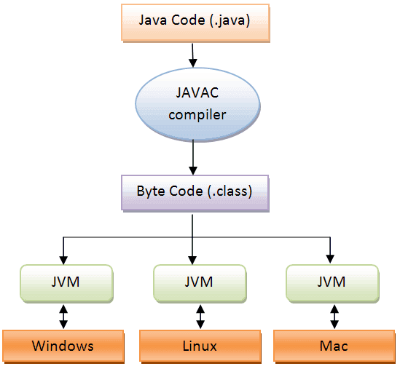Java is a high-level Object-oriented programming language. A program written in high level language cannot be run on any machine directly. First, it needs to be translated into that particular machine language. The javac compiler does this thing, it takes java program (.java file containing source code) and translates it into machine code (referred as byte code or .class file). Java Virtual Machine (JVM) is a virtual machine that resides in the real machine (your computer) and the machine language for JVM is byte code. JVM executes the byte code generated by compiler and produce output. JVM is the one that makes java platform independent.

**PROPHETIC ANOMALY NAVIGATING THE JUST-IN-TIME REVERSAL**

**3. ABOUT THE PROJECT**

**3.1 Abstract**

Warehouse data is more important to deal with stored database, it may checked and store in a warehouse to prevent the security problem. The frequently used data has been make a id for each data to rectify and fetch the record easily from the database. It is one of the important part of handling the required data in fast way to access and to check the stock details based on id and its updates of additional stocks. The scanned QR list may contain all the data about the product it contains all the details about it. It will prevent the attacks from other foreign agents that has been prevented by using this warehouse, The tedious process like data loss, data mismatching, data handling will get recovered when it has been check with the QR id and easy to extract the product counts for each data. The purpose and methodologies which achieves the security prevention and easy retrieving of data from the database. Here, preprocess the data which will calculate the records from the database, this model may update the security enhancement and data handling will also become an efficient with the database.

**3.2 Scope of the project**

Data warehouse may contains the data from the users, it act as a temporary storage a copy of data also contains on database. Paper describing the implementation of development in full-scales, it has mainly encouraged. Regardless the disciplines, data handling in warehouse may involves updating data, revoke, deletion of data may efficient. The project which helps them to understanding the issues related to the data structure based on the QR code registration. It has been handled based on the unique identity may neglect the duplication and data redundancy of data. It may become more useful for upcoming upgrade, so that industrial sectors. In future world, it will play a vital role in many sectors.

**3.3 Existing System**

In this existing applications, the data has not checked while store as temporarily in warehouse and the predictive fashion may not be good while in manipulation of records which are regularly combined in an massive order of data to handle it. Consequent data contamination may have risk factor to maintain data behaviors and manipulation. It will not play an vital role for the user to do manipulation of data in massive way and not an accurate prediction also, which causes the user to have a difficult situations on it.

**3.3.1 Disadvantages**

* Data loss happens which makes trouble to the users and employers, by suffer to revoke the data for data integrity.
* Fetching data become more difficult task which also be redundant, it will cause the lacking of time management.
* Modern technological usage is limited.

**3.4 Proposed System**

The proposed system can determine the data frequently, it may gain excessive performance in the system identification and it may serve a predictive model to manage the data in warehouse. The version accurately determine the dynamics of data, data optimization is also happen by removing a redundancy of data from the database. Efficient usage of massive data which may use for all the user to make cache of data in an needed time, so that it may useful to have a data check and storage using QR code.

**3.4.1 Advantages**

* Management of the time may leads to better usage of massive data by the user.
* Use of QR process may achieve data redundancy of the user.
* Data revoking is also happens smooth way for all the end users
* Usage of the automatic way of data management leads to more advantage

**4. BOTTOM LINE AND FUTURE ENHANCEMENT**

The proposed version combines the benefits of DL and a self- developing structure such that it is able to extract greater powerful features in an efficient manner. Its miles really worth noting that the converting technique of shape size is completed in a growing way. It has no additional operation of deleting neurons in a mastering method, it reduces computational complexity. As an end result, the aggregate and rolling optimization can acquire better tracking control performances. There is no escape from the fact that the need and demand for finite and vulnerable water will continue to expand and so will competition for it. More uncertainty in water availability, higher frequency of extreme weather events, and more rapid return flows of water to the atmosphere are expected in the future.

**5. HARDWARE AND SOFTWARE REQUIREMENTS**

**Hardware requirements:**

* Processor : Intel (R) Pentium (R)
* Speed : 1.6 GHz and Above
* RAM : 4 GB and Above
* Hard Disk : 120 GB
* Monitor : 15’’ LED SVGA
* Input Devices : Keyboard, Mouse

**Software requirements:**

* Operating system : Windows 7 / 8 / 8.1 / 10
* Coding Language : JAVA / J2EE
* Java Version : jdk 8
* IDE : Eclipse Oxygen
* Database : MySQL v5.1
* Database Tool : HeidiSql v11.0
* Application Server : Apache Tomcat 8.X / 9.X