ADITYA COLLEGE OF ENGINEERING AND TECHNOLOGY
Department of Computer Science & Engineering

SHOPEZ
E-Commerce Web Application
Full Stack Project Documentation — MERN Stack
A Project Report Submitted in Partial Fulfillment of the Requirements for the Internship Program

Submitted By
1. Bonda Kavya Sri — 23MH1A05L9
2. Dwarampudi Bhagyasri — 23MH1A05M1
3. Kaki Guna Sai Teja — 23MH1A05M3
4. Kottela Sandeep — 23MH1A05M6
5. Kunisetty Hadassa — 23MH1A05M8

Academic Year: 2026
Submission Date: July 2026

Table of Contents
Submitted By 1
Table of Contents 2
1. Introduction 4
2. Project Overview 4
Purpose 4
Features 4
3. Architecture 5
Frontend 5
Backend 5
Database 6
4. Setup Instructions 6
Prerequisites 6
Installation 6
5. Folder Structure 7
Client Folder Layout 7
Server Folder Layout 7
6. Running the Application 7
Terminal 1 — Backend Server 7
Terminal 2 — Client Application 7
7. API Documentation 8
8. Authentication 9
9. User Interface & Screenshots 9
9.1 Registration Page 9
9.2 Login Page 10
9.3 Home Page / Product Catalog 10
9.4 Product Search & Filter Results 11
9.5 Product Detail Page 11
9.6 Shopping Cart Page 12
9.7 Checkout Page 12
9.8 My Orders Page 13
9.9 Order Detail Page 13
9.10 Admin Dashboard 14
9.11 Admin – Manage Products 14
9.12 Admin – Manage Orders 15
10. Testing 15
11. Known Issues 16
12. Future Enhancements 16

1. Introduction
Project Title: ShopEZ – MERN E-Commerce Platform
Team: This project was developed collaboratively by a 5-member team, covering full-stack development (frontend and backend), REST API design, JWT-based authentication, MongoDB schema design, and admin dashboard implementation. Individual contributions are listed on the cover page.

2. Project Overview

Purpose
ShopEZ is a full-stack e-commerce web application built to provide a complete online shopping experience — from product discovery through checkout and post-purchase order tracking — while also giving store administrators the tools to manage the product catalog and fulfill orders. The project was built to demonstrate practical, production-grade full-stack engineering patterns using the MERN stack: secure authentication, role-based access control, server-side validation of client-submitted data, and a clean separation between the presentation, API, and data layers.

Features
- Authentication: JWT-based authentication. On login/register, the server issues a signed access token (7-day expiry) which the client stores and attaches to subsequent requests via an Authorization header.
- Product Catalog: Searchable and filterable catalog. Search matches product name and description (via a MongoDB text index); category filtering is fully dynamic — the category list is derived live from existing product data rather than hardcoded.
- Shopping Cart: Client-side cart state (React Context, persisted to localStorage), so it survives page refreshes without requiring a database write until checkout.
- Checkout: Cash on Delivery (COD) order flow with server-side re-validation of price and stock for every item — the server never trusts prices submitted by the client. No online payment gateway (credit/debit card, UPI, etc.) is integrated in the current version.
- Order Tracking: Customers can view their order history and track each order's status (Pending → Processing → Shipped → Delivered, or Cancelled).
- Customer Reviews & Ratings: Logged-in users can leave a 1-5 star rating and written comment on any product (one review per user per product); the product's average rating and review count update automatically.
- Admin Dashboard: Full product CRUD, including direct image upload from the admin's computer (stored on the server and served statically); full order visibility with the ability to update order status.

3. Architecture
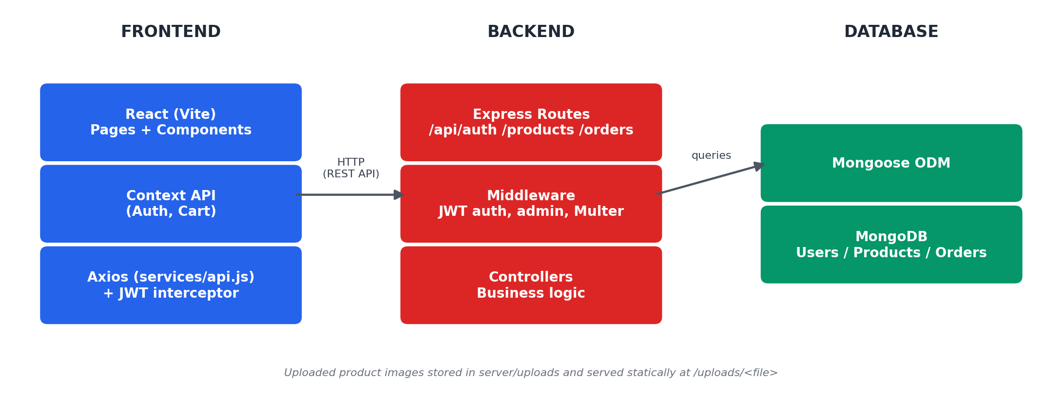
Fig 3.1 – Technical Architecture

Frontend
The client is a Single Page Application built with React 18 and Vite. Routing is handled with React Router. Application-wide state is limited to two concerns — the logged-in user and the shopping cart — both managed with React's built-in Context API rather than a dedicated state-management library, since a heavier solution (e.g. Redux) was not warranted by the app's actual state complexity. All HTTP communication goes through a single shared Axios instance with a request interceptor that automatically attaches the JWT to every call.

Backend
The server is a REST API built with Express.js on Node.js, written in plain JavaScript (CommonJS modules). Routes, controllers, models, and middleware are separated into their own folders by responsibility rather than by business domain. Incoming requests pass through CORS handling, JSON body parsing, and — for protected routes — JWT verification and role-checking middleware, before reaching the relevant controller function.

Database
MongoDB, accessed through Mongoose. A compound text index on the Product collection (name, description, category) supports catalog search. Reviews are embedded directly inside each Product document, and each Order embeds a frozen snapshot of its line items and shipping address at the time of purchase, rather than referencing live, mutable data. There is no separate Cart collection or Mongoose transaction usage — the cart lives only in the browser until checkout, at which point a single Order.create() call converts it into a permanent record.

4. Setup Instructions

Prerequisites
- Node.js (v18 or higher) and npm
- A MongoDB instance (local installation, or a MongoDB Atlas cloud database)
- Git

Installation
- Clone or download the project codebase locally.
- Create a .env file in the server folder based on the provided .env.example (set MONGO_URI, JWT_SECRET, PORT), and a .env file in client based on its .env.example (VITE_API_URL).
- Install dependencies:
# In server root
cd server
npm install

# In client root
cd ../client
npm install

- (Optional) Populate the database with sample data:
cd server
npm run seed

5. Folder Structure

Client Folder Layout
client/
├── src/
│ ├── components/ # Navbar, ProductCard, StarRating,
│ │ # AdminRoute, PrivateRoute
│ ├── pages/ # Home, ProductDetail, Cart, Checkout,
│ │ # Login, Register, Orders, OrderDetail,
│ │ # AdminDashboard, AdminProducts, AdminOrders
│ ├── context/ # AuthContext.jsx, CartContext.jsx
│ ├── services/ # api.js (Axios instance), imageUrl.js
│ ├── utils/ # currency.js
│ ├── App.jsx # Route declarations
│ └── main.jsx # Entry point, provider composition
├── index.html
├── vite.config.js
└── package.json

Server Folder Layout
server/
├── models/ # User.js, Product.js, Order.js (Mongoose schemas)
├── controllers/ # authController.js, productController.js, orderController.js
├── routes/ # authRoutes.js, productRoutes.js, orderRoutes.js, uploadRoutes.js
├── middleware/ # auth.js (JWT + admin check), upload.js (Multer), errorHandler.js
├── config/ # db.js (MongoDB connection)
├── seed/ # seedProducts.js
├── utils/ # generateToken.js
├── uploads/ # uploaded product image files (served statically)
├── .env.example
└── server.js # Application entry point

6. Running the Application

Terminal 1 — Backend Server
cd server
npm run dev
The API listens on http://localhost:5000

Terminal 2 — Client Application
cd client
npm run dev
The client is served on http://localhost:3000
Health check: visit http://localhost:5000/api/health — a successful response returns {"status":"ok","message":"ShopEZ API is running"}.

7. API Documentation
The key endpoints exposed by the server API are listed below. All endpoints are prefixed with the base URL http://localhost:5000.
Method | Endpoint | Description | Auth Required
POST | /api/auth/register | Register a new customer account | No
POST | /api/auth/login | Authenticate and receive a JWT | No
GET | /api/auth/profile | Get the logged-in user's profile | Yes
GET | /api/products | List products (supports keyword, category, page, limit) | No
GET | /api/products/:id | Retrieve a single product's details, including reviews | No
GET | /api/products/categories/all | List all distinct product categories | No
POST | /api/products | Create a new product | Yes (Admin)
PUT | /api/products/:id | Update an existing product | Yes (Admin)
DELETE | /api/products/:id | Delete a product | Yes (Admin)
POST | /api/products/:id/reviews | Submit a star rating and review for a product | Yes
POST | /api/upload | Upload a product image file | Yes (Admin)
POST | /api/orders | Submit a new order (checkout) | Yes
GET | /api/orders/my | Fetch the logged-in user's own order history | Yes
GET | /api/orders | Fetch every order on the platform | Yes (Admin)
GET | /api/orders/:id | Fetch a single order (owner or admin only) | Yes
PUT | /api/orders/:id/status | Update an order's fulfillment status | Yes (Admin)
GET | /api/health | Basic API health check | No

8. Authentication
ShopEZ implements JWT-based authentication with a single access token (no refresh token rotation). On successful login or registration, the server signs a JSON Web Token containing the user's ID and role, with a 7-day expiry, using a server-side secret (JWT_SECRET). The token is returned in the response body and stored client-side in localStorage; an Axios request interceptor automatically attaches it as a Bearer token on every subsequent API call. Protected routes verify this token via the protect middleware, and admin-only routes additionally check the user's role via the admin middleware. When the token expires, the user is required to log in again — there is currently no silent background refresh mechanism.

9. User Interface & Screenshots
The images below are dummy placeholders. Replace each one with an actual screenshot of your running application, in the same order, before submitting. Capture the full browser window (address bar visible) so it is clear the app is running locally on the ports listed in Section 6.

9.1 Registration Page
Signup form showing name, email and password fields.
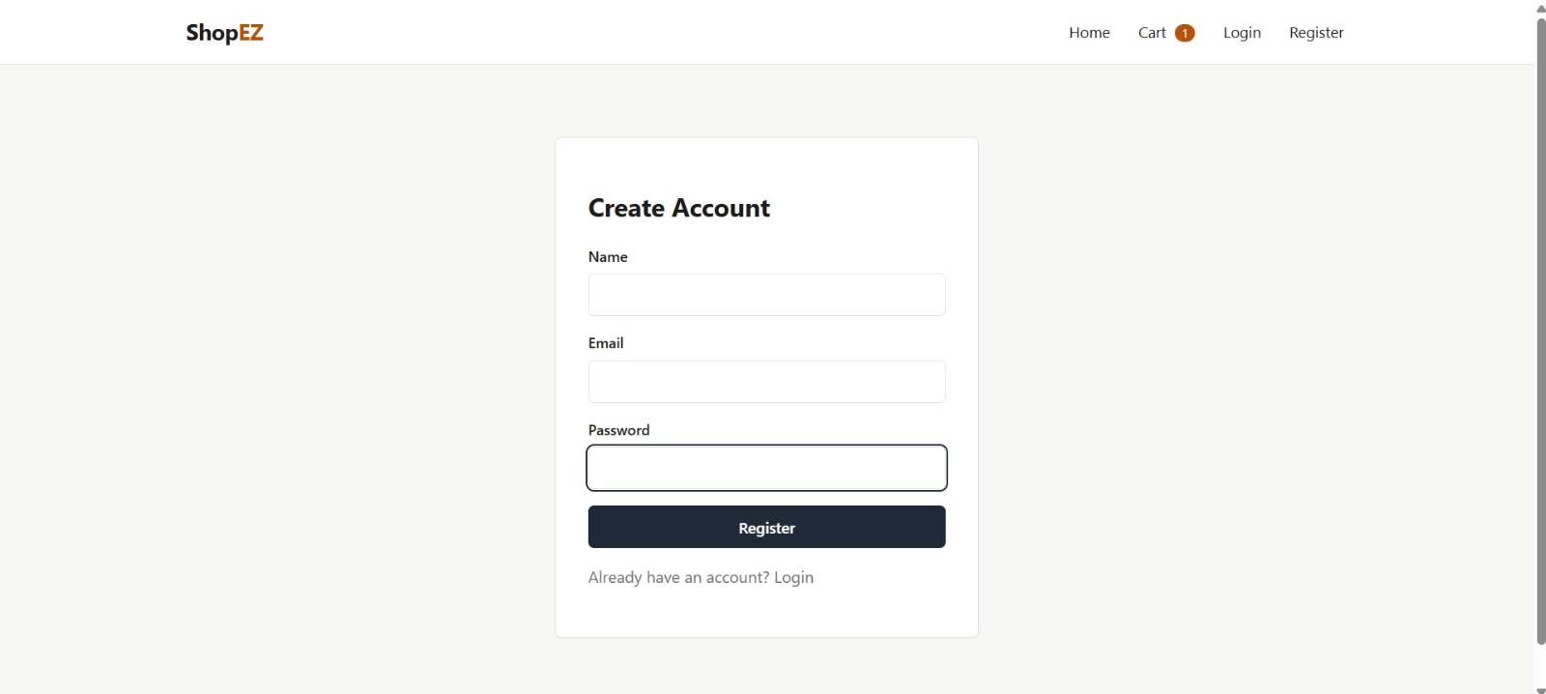

9.2 Login Page
Login form and any validation/error message state.
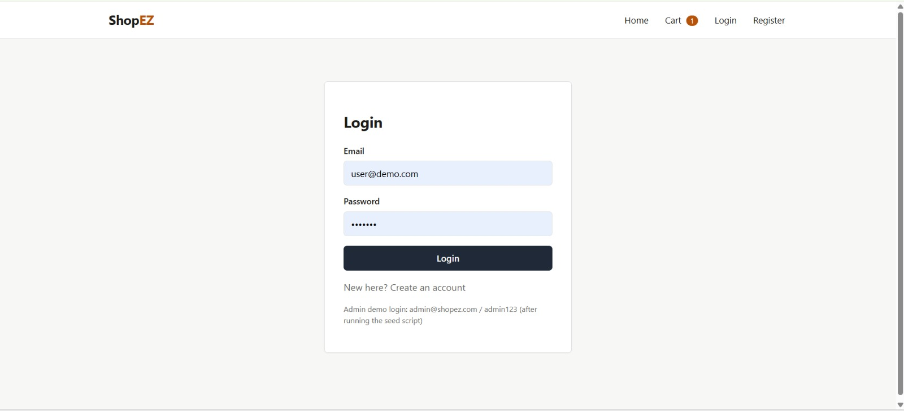

9.3 Home Page / Product Catalog
Full product grid with the category filter dropdown visible.
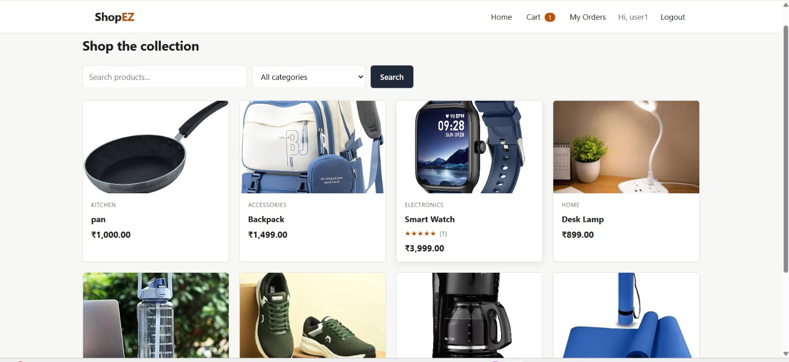

9.4 Product Search & Filter Results
Search box in use with a keyword typed, showing filtered results.
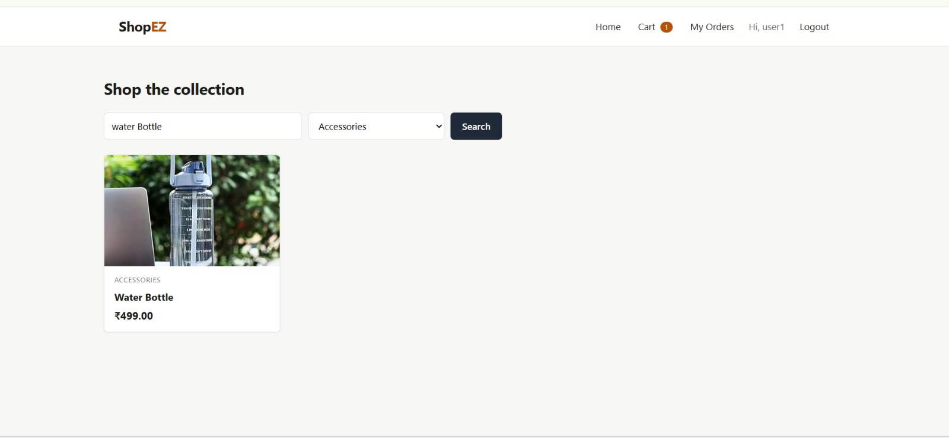

9.5 Product Detail Page
Full product detail view including the reviews & star-rating section at the bottom.
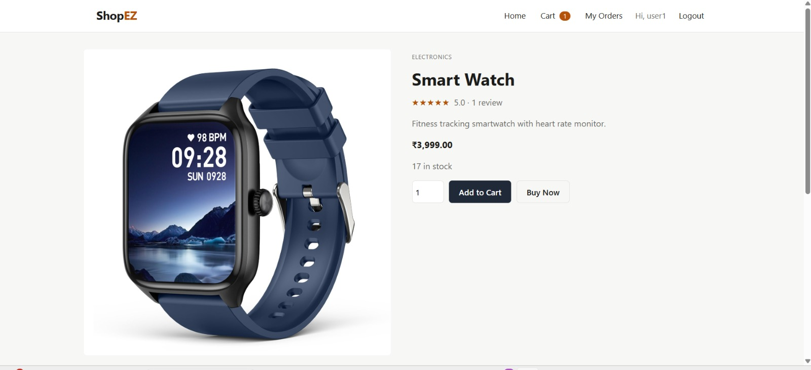

9.6 Shopping Cart Page
Cart with at least 2 items, showing quantity controls and the total price.
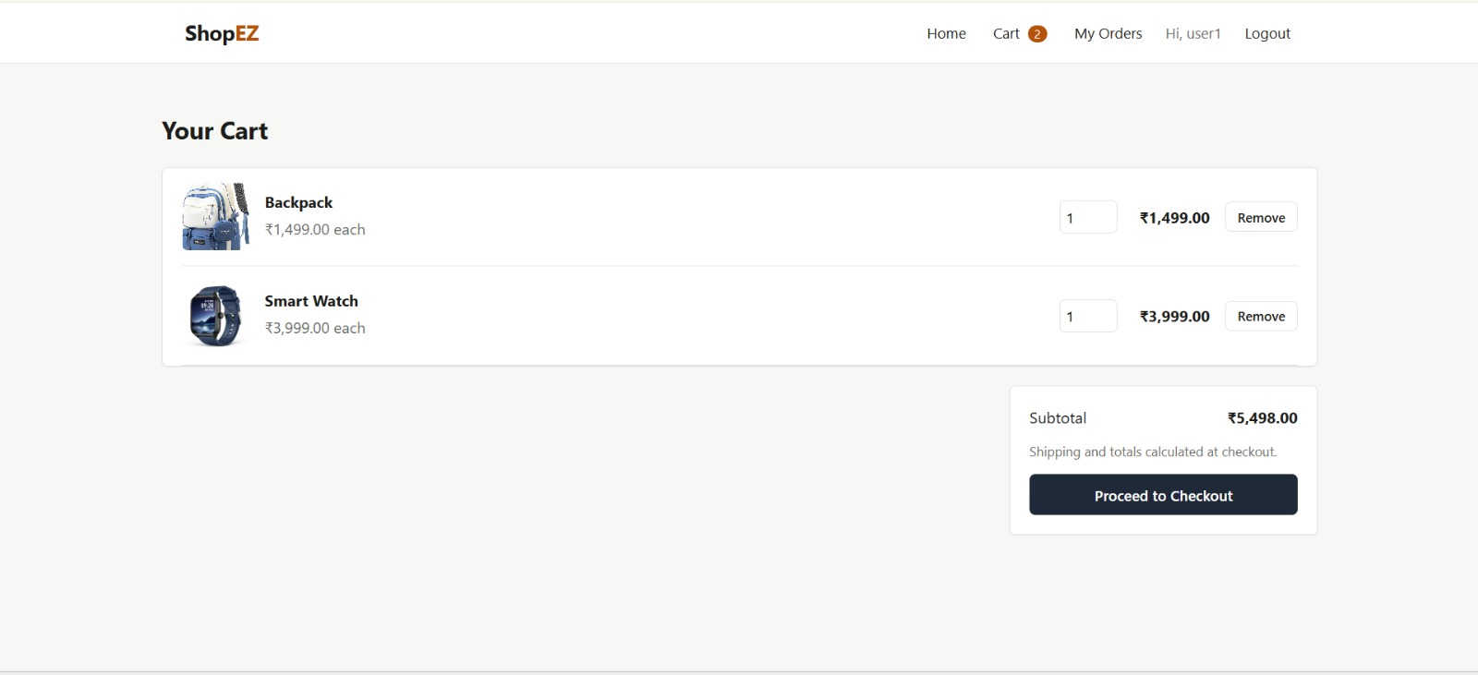

9.7 Checkout Page
Shipping address form with the Cash on Delivery order summary.

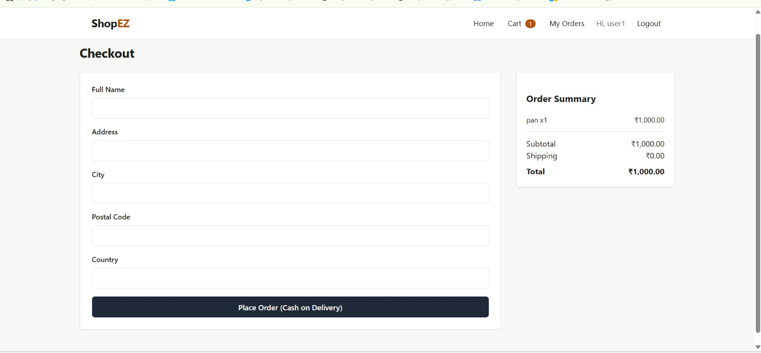

9.8 My Orders Page
Order history list showing at least one order and its status.
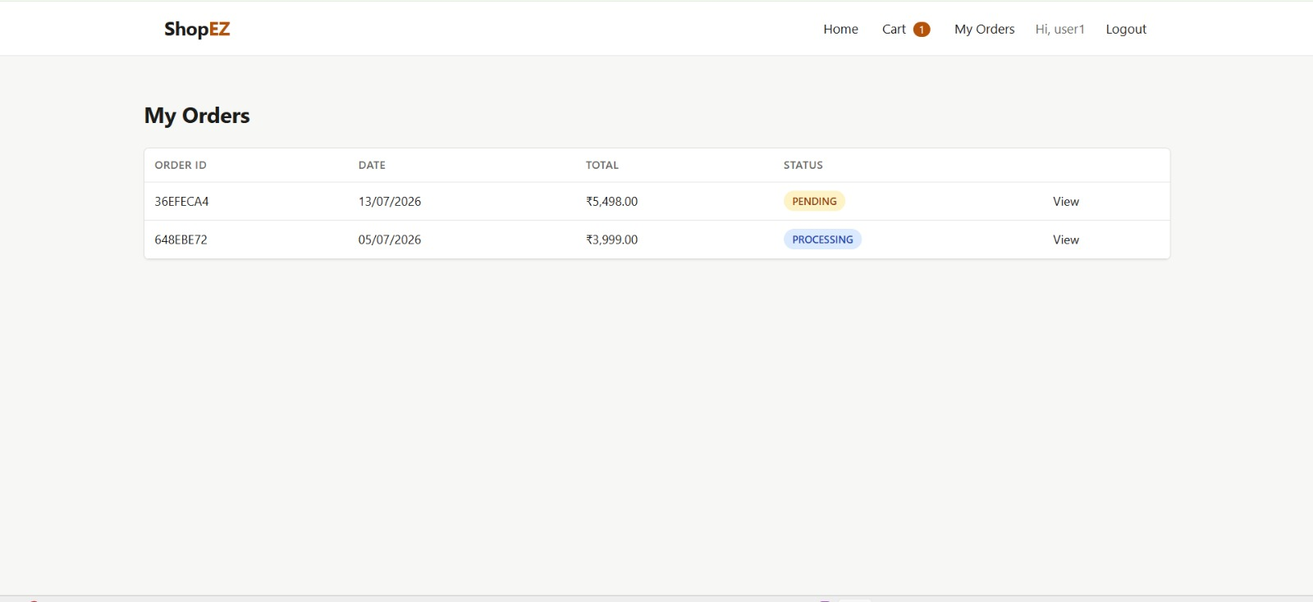

9.9 Order Detail Page
Single order's full detail view, including items and shipping address.
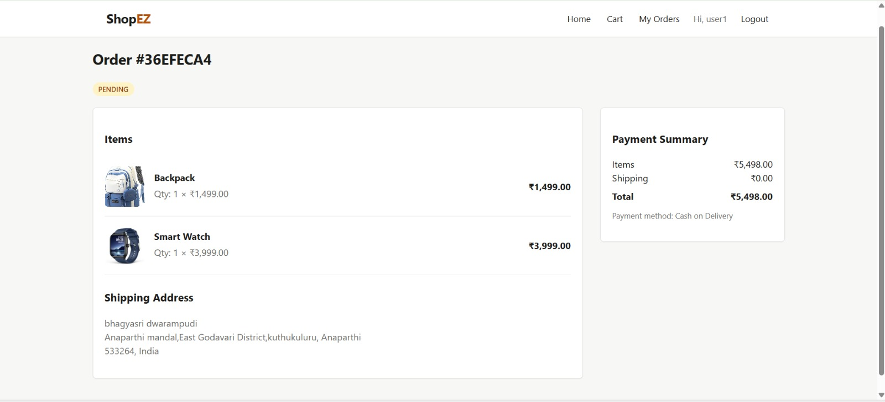

9.10 Admin Dashboard
Admin landing page/overview after logging in as admin@shopez.com.
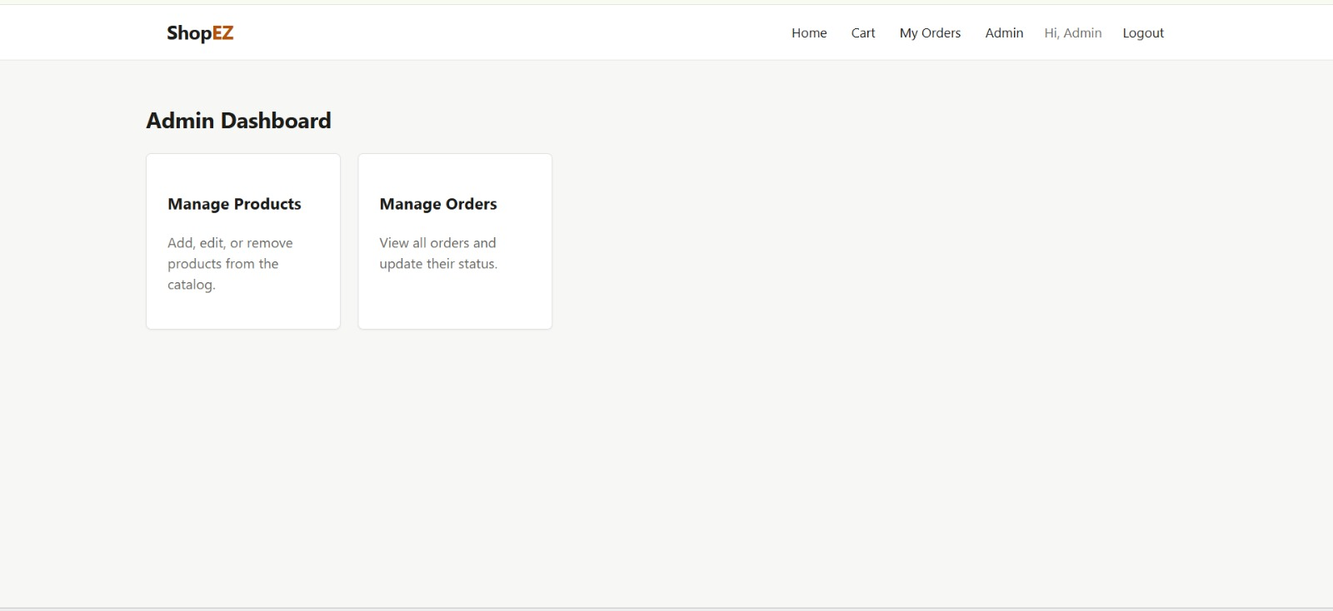

9.11 Admin – Manage Products
Product list with CRUD controls, and the image upload form open.
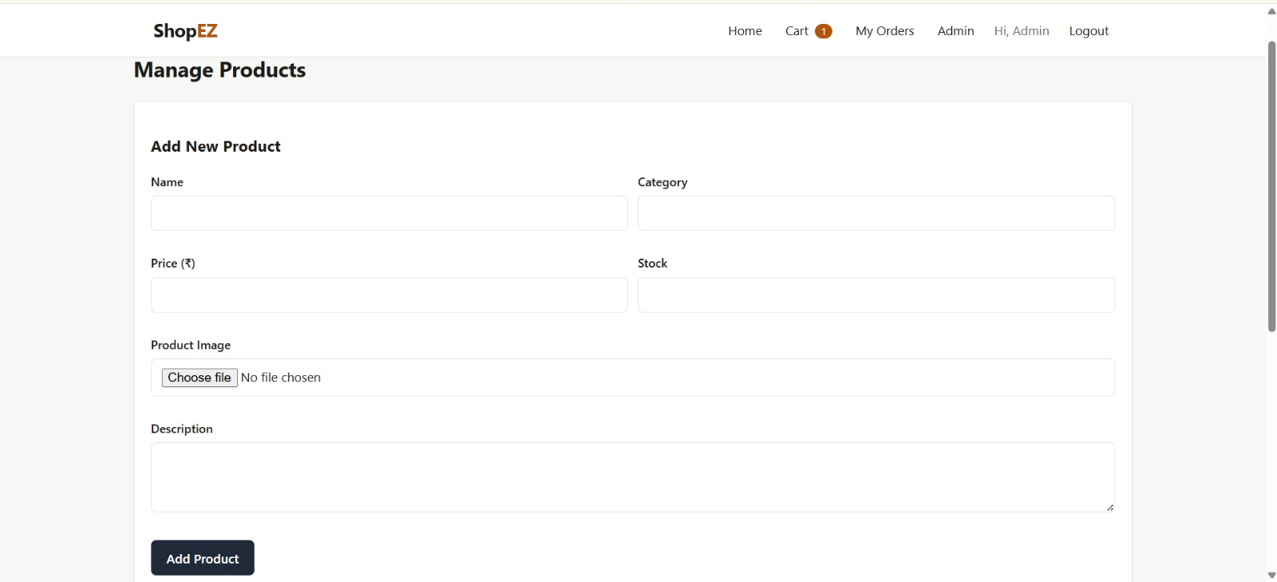

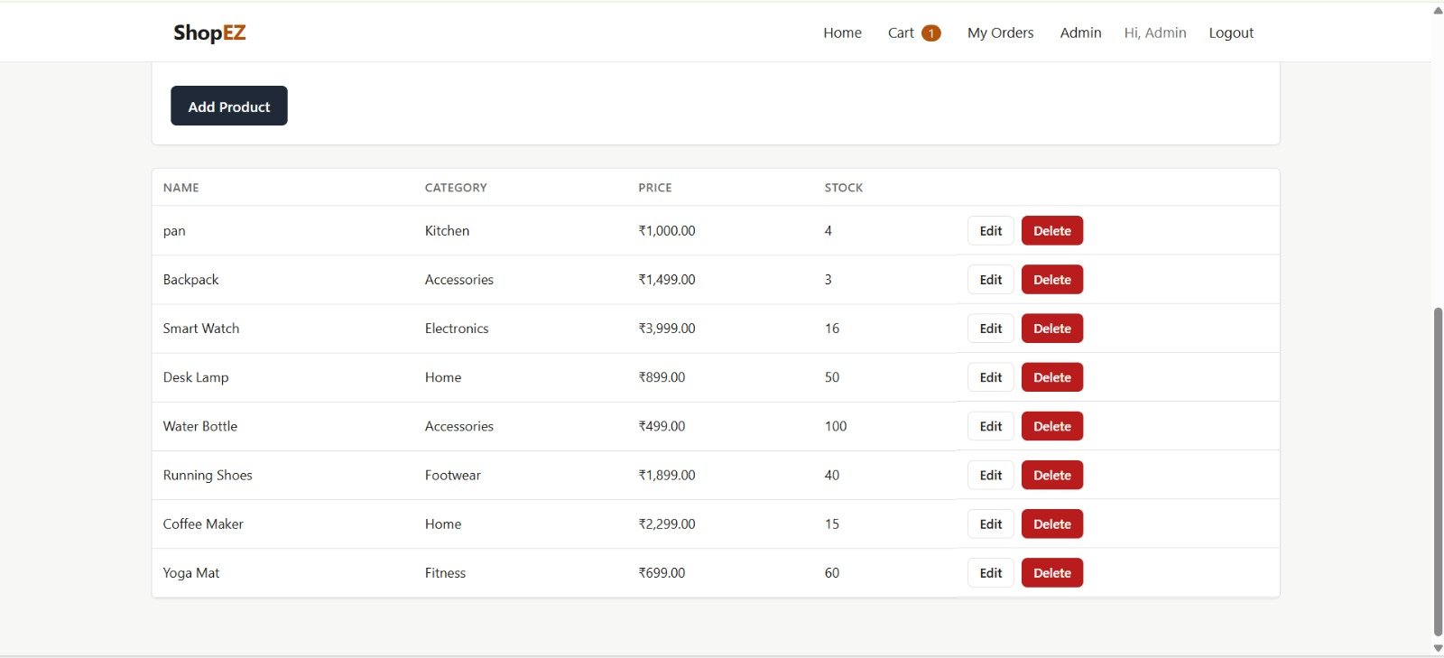

9.12 Admin – Manage Orders
Orders list with the status-update dropdown/button visible.

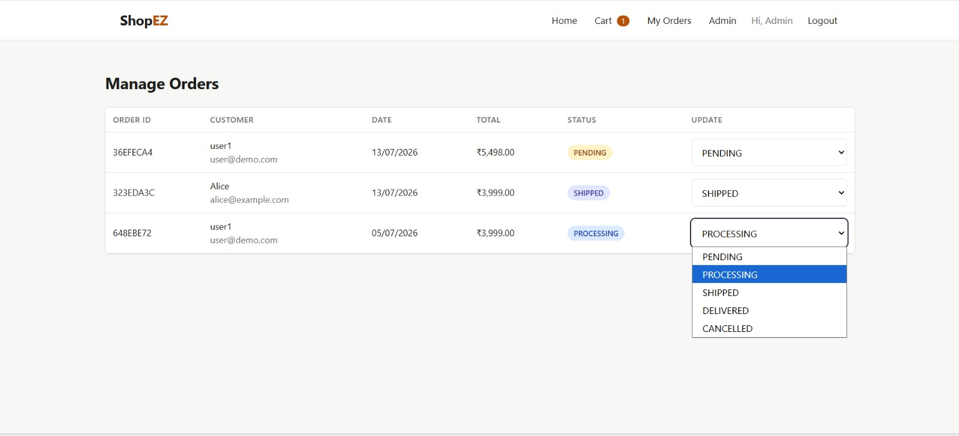

10. Testing
Manual functional testing was performed across the core user flows: registration and login, product browsing/search/filtering, add-to-cart and quantity updates, checkout and order creation, order status updates from the admin dashboard, product image upload, and the review/rating submission flow. Backend module loading and the production frontend build were verified after each change. Automated testing (unit tests for controllers, integration tests for API routes, and component tests for the frontend) is not yet implemented — see Future Enhancements.

11. Known Issues
- Checkout only supports a Cash on Delivery flow; no online payment gateway is integrated.
- Uploaded product images are stored on the server's local disk (server/uploads/), which is not persistent across most cloud redeployments — a cloud storage service would be needed for production use.
- Authentication uses a single long-lived access token rather than a short-lived access token with refresh rotation, which is a simpler but less security-hardened approach.
- The frontend does not yet expose pagination controls in the UI, although the backend's product listing endpoint already supports page and limit parameters.

12. Future Enhancements
- Integrate a real online payment gateway (e.g. Razorpay/UPI for the Indian market) alongside Cash on Delivery.
- Move product image storage to a cloud storage service (e.g. Cloudinary or AWS S3).
- Add short-lived access tokens with refresh token rotation for stronger session security.
- Add a wishlist/favorites feature.
- Add automated testing (unit, integration, and component tests).
- Add pagination controls to the product listing UI.

