Name: CASEFLOW AI

githubUrl: https://github.com/23MH1A1241/ServiceNow_Project_space

description: An intelligent ServiceNow-based automated case assignment and escalation system built on the Zurich platform. CaseFlow AI transforms manual customer support operations into a smart workflow that auto-categorizes incoming cases, assigns them to the best-fit agents using a weighted scoring algorithm, and proactively escalates at-risk cases before SLA breaches occur.

Functional Requirements

Case Intake & Categorization
- Accept support cases from multiple channels: web portal, email, chat, and phone
- Auto-classify each case by urgency (Critical, High, Medium, Low) using keyword analysis
- Identify product line, topic, and customer tier automatically on case creation
- Apply customer tier override: Platinum tier minimum urgency is always High
- Parse inbound emails and create Case records automatically via Email-to-Case

Automated Case Assignment
- Score and rank available agents using weighted algorithm: Skill Match 40%, Workload 30%, Availability 20%, Certification 10%
- Filter out agents at maximum workload capacity before scoring
- Assign case to highest-scoring agent and increment workload counter
- Maintain agent profiles with skill tags, certifications, region, and language
- Support workload thresholds by agent tier: Senior (15), Mid-Level (10), Junior (6), Specialist (8)

Escalation Rules Engine
- ESC-001: Escalate when SLA resolution time exceeds 75% consumed — reassign to supervisor
- ESC-002: Escalate Critical case unacknowledged for more than 15 minutes
- ESC-003: Notify team lead when High urgency case unacknowledged for more than 30 minutes
- ESC-004: Immediately reassign when Platinum tier customer requests escalation
- ESC-005: Flag and notify QA when case is reopened 3 or more times
- ESC-006: Alert manager when agent reassigns same case more than twice
- ESC-007: Priority escalation to Director level when SLA resolution time is fully breached

SLA Management
- Define SLA response and resolution times per customer tier and urgency combination
- Platinum Critical: 15-min response, 2-hour resolution; Platinum High: 30-min response, 4-hour resolution
- Gold Critical: 30-min response, 4-hour resolution; Gold High: 1-hour response, 8-hour resolution
- Silver Critical: 1-hour response, 8-hour resolution; Silver High: 2-hour response, 24-hour resolution
- Standard: 4-hour response, 48-hour resolution for any urgency
- Send warning notifications at 75% and 90% SLA consumption thresholds
- Pause SLA timers when case state is Pending Customer or Pending Vendor
- Support regional business hour calendars: Americas (EST/PST), EMEA (CET/GMT), APAC (IST/SGT/JST)

Notifications
- NOTIF-001: Email + platform notification to agent on case assignment
- NOTIF-002: Email to old and new agent on case reassignment
- NOTIF-003: Email + SMS to agent and team lead at 75% SLA warning
- NOTIF-004: Email + SMS + Teams to agent and supervisor at 90% SLA warning
- NOTIF-005: Email + Teams + push to supervisor and agent on escalation
- NOTIF-006: Email to customer on case resolution
- NOTIF-007: Acknowledgment email to customer on new case creation
- NOTIF-008: Email + SMS to director and supervisor on SLA breach

Dashboards & Reporting
- Real-time manager dashboard with active case status, SLA compliance gauge, agent workload heatmap
- Cases by urgency bar chart, escalation trend line, channel volume pie chart
- Agent personal dashboard showing open cases, SLA deadlines, and personal compliance rate
- Weekly SLA compliance report (PDF + email to management)
- Daily case volume report to team leads, monthly agent productivity export to HR

Audit Trail
- Log every case creation, assignment, reassignment, escalation, and resolution event
- Store timestamp, actor, reason code, and algorithm version for each action
- Maintain tamper-evident records in custom table x_1939544_casefl_0_audit_log

Non-Functional Requirements
- Assignment algorithm completes scoring and assignment within 2 seconds of case creation
- SLA timers activated immediately upon case state change
- Dashboard widgets auto-refresh every 60 seconds via Performance Analytics
- All API communications secured with HTTPS/TLS 1.3 encryption
- OAuth 2.0 authentication for all external system integrations
- Customer PII fields masked in audit logs for GDPR compliance
- Role-based access: Agent sees own cases only; Supervisor sees department; Manager sees all
- Minimum 70% test coverage via ServiceNow ATF (Automated Test Framework)

problem_statement: A global electronics company receives thousands of customer support requests daily. Cases are manually assigned by supervisors, causing 15-45 minute assignment delays, uneven agent workloads, missed SLAs on high-priority cases, and inconsistent categorization. High-priority cases go unnoticed during peak hours and shift changes, resulting in customer dissatisfaction and reputational damage. Managers lack real-time visibility and there is no automated escalation mechanism.

proposed_solution: A ServiceNow Zurich scoped application (CaseFlow AI, scope: x_1939544_casefl_0) that automates the full case lifecycle from intake to resolution. Incoming cases from web, email, chat, and phone are ingested via IntegrationHub, categorized by a Script Include engine using keyword analysis and customer tier lookup, and assigned to the optimal agent by the AgentMatchingUtil scoring algorithm. Flow Designer orchestrates the end-to-end workflow, the Escalation Rules Engine (ESC-001 through ESC-007) continuously monitors open cases, and Performance Analytics delivers real-time dashboards to managers.

technologies_used: ServiceNow Zurich, Customer Service Management (CSM), Flow Designer, IntegrationHub (Email/REST/Telephony/Teams spokes), Performance Analytics, Virtual Agent (NLU), Business Rules, Script Includes (JavaScript ES2021 / Rhino engine), SLA Definitions, ServiceNow Table API v2, Scripted REST APIs, ATF (Automated Test Framework)

system_architecture: Seven-layer scoped architecture: (1) Ingestion Layer — IntegrationHub connectors receive cases from all channels; (2) Processing Layer — CaseCategorizationEngine Script Include classifies urgency, topic, product, and customer tier; (3) Decision Layer — AgentMatchingUtil scores and assigns to best-fit agent; (4) Escalation Layer — EscalationManager evaluates ESC-001 through ESC-007 rules continuously; (5) Compliance Layer — SLACalculator enforces tier-based SLAs and AuditLogger records all events; (6) Presentation Layer — Performance Analytics dashboards refresh every 60 seconds; (7) Communication Layer — Notifications engine sends email, SMS, and push alerts at all key milestones.

Workflow

Case Intake
- Customer submits request via web portal, email, chat, or phone
- IntegrationHub spoke ingests the request and maps fields to ServiceNow Case schema
- Case record created with state set to New and intake timestamp logged
- Categorization subflow invoked immediately on case creation

Categorization
- Subject and description fields parsed for urgency keywords
- Topic classified from predefined taxonomy: Technical, Billing, Shipping, Returns, Other
- Product line extracted from case text or customer account data
- Customer account queried to determine tier: Platinum, Gold, Silver, or Standard
- Urgency score computed; Platinum tier override applied if score is below High
- Final urgency, topic, product, and tier fields populated on Case record

Assignment
- All agents with at least one matching skill queried from agent profile table
- Agents at max workload or marked unavailable filtered out
- Composite score: (Skill Match x 0.40) + (Workload Capacity x 0.30) + (Availability x 0.20) + (Certification x 0.10)
- Case assigned to highest-scoring agent; workload counter incremented
- SLA timer activated based on customer tier and urgency combination
- NOTIF-001 assignment notification sent to agent

Escalation
- Scheduled Flow and Business Rule after-update trigger continuously monitor open cases
- EscalationManager.evaluate() called with Case sys_id on each check
- Applicable escalation rules evaluated in priority order (ESC-001 through ESC-007)
- Case state changed to Escalated; escalation target identified and case reassigned
- Multi-channel notification sent and audit log entry created with rule ID and timestamp

Resolution
- Agent updates case state to Resolved with resolution code
- SLA timer stopped; resolution time recorded
- NOTIF-006 resolution notification sent to customer
- Audit entry created; agent workload counter decremented
- Case satisfaction data fed into Performance Analytics for reporting

Workflow Diagram

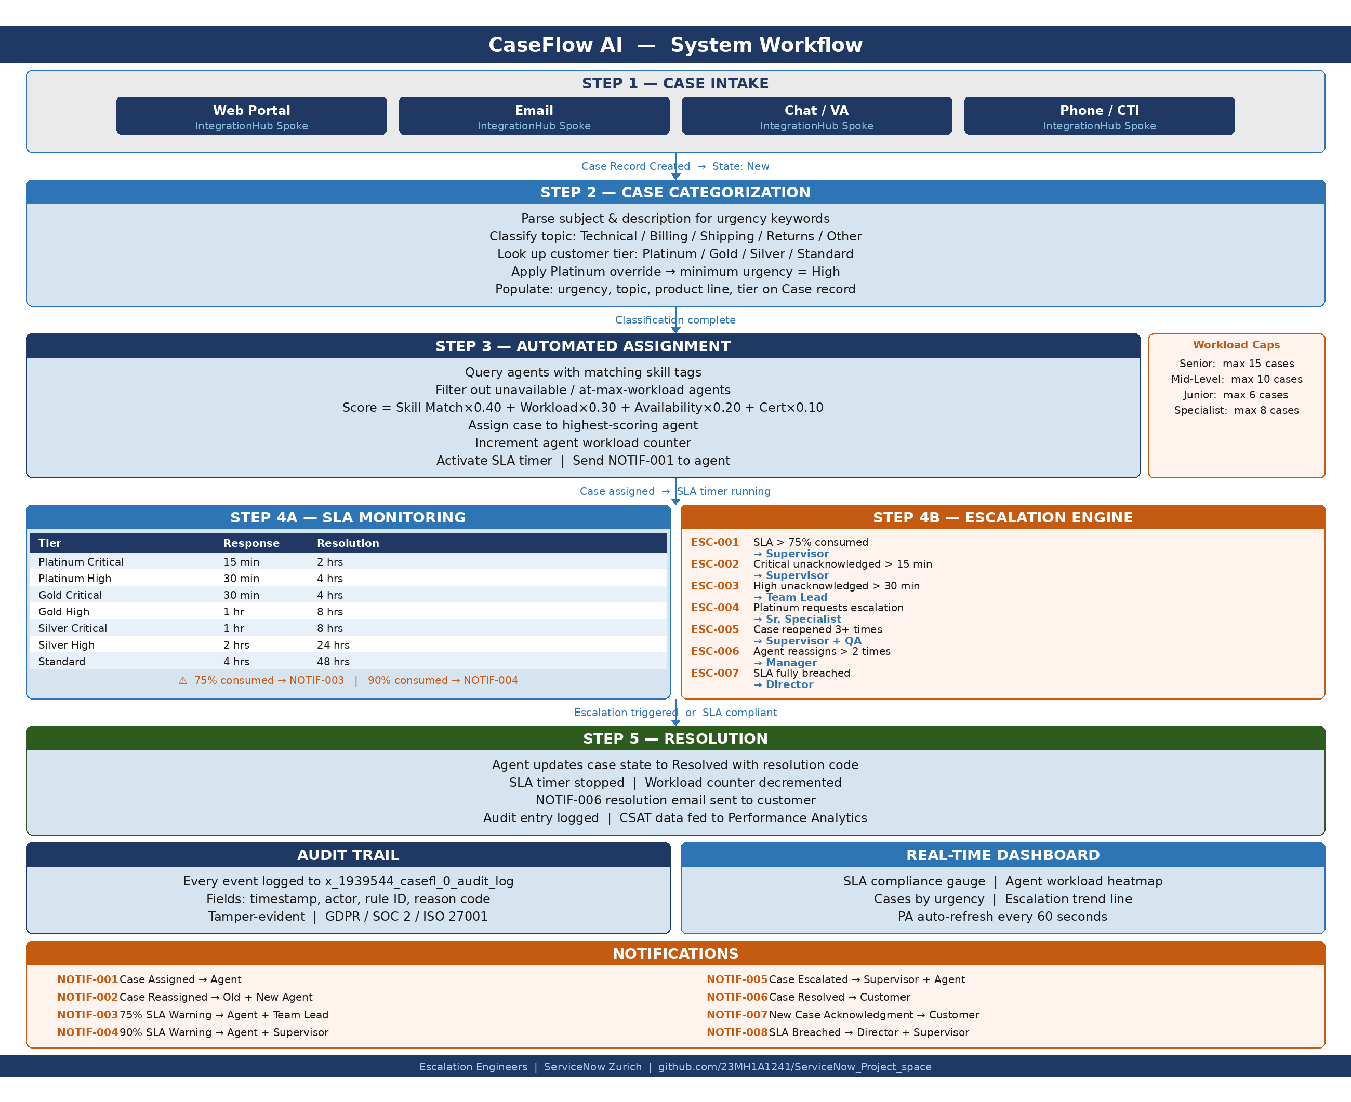

in_scope: Case intake from web, email, chat, and phone channels; automated categorization by urgency, topic, product line, and customer tier; skills-based and workload-aware automated assignment; escalation rules engine (ESC-001 through ESC-007); SLA management with regional business hour calendars; eight notification templates; real-time Performance Analytics dashboards; complete audit trail; role-based access control; REST API integrations via IntegrationHub.

out_scope: Social media intake channels; third-party ticketing system integrations; legacy offline request forms; financial or HR reporting; previous ServiceNow versions; mobile native app; machine learning-based case routing; integration with non-ServiceNow chat platforms beyond Microsoft Teams.

future_enhancements:
Phase 1: Customer satisfaction (CSAT) survey auto-triggered on case closure with Performance Analytics score tracking.
Phase 2: Natural language processing upgrade using ServiceNow Virtual Agent NLU for smarter urgency detection beyond keyword matching.
Phase 3: Predictive SLA breach risk scoring using historical case data — flag cases likely to breach before the 75% threshold.
Phase 4: GitHub Actions CI/CD pipeline for automated Update Set export and XML commit to repository on each deployment cycle.

conclusion: CaseFlow AI is a fully scoped ServiceNow Zurich application that addresses all identified pain points in manual customer support operations. The weighted assignment algorithm, seven-rule escalation engine, and tier-based SLA framework work together to deliver consistent service quality across all customer segments. The system is expected to reduce average case resolution time by 40-60%, eliminate 80% of SLA breaches, and improve agent utilization by 30%. Source code and Update Set exports are maintained at github.com/23MH1A1241/ServiceNow_Project_space.

projectType: ServiceNow-scoped-application

team: Escalation Engineers | ServiceNow Zurich | Project Space | May 2026
Y. Sai Teja (Team Lead, 23MH1A1241) | K. Varshitha (23P31A1293) | P. Divya (23P31A12B5) | Ch. Asritha (23P31A05E5) | M. Raghu (23P31A1211) | Y. Vinay Kumar (23MH1A42J0)

