AGILE DEVELOPMENT PROCESS AND DEVOPS LAB
FINAL ASSESSMENT TEST
M KAARTHIK
23MIS0050

Q1. For the java application automate the continuous integration process using Jenkins. a. To implement the arithmetic operations.

Solutions:

1. Create a Maven-based application adhering to the standard Maven directory structure.

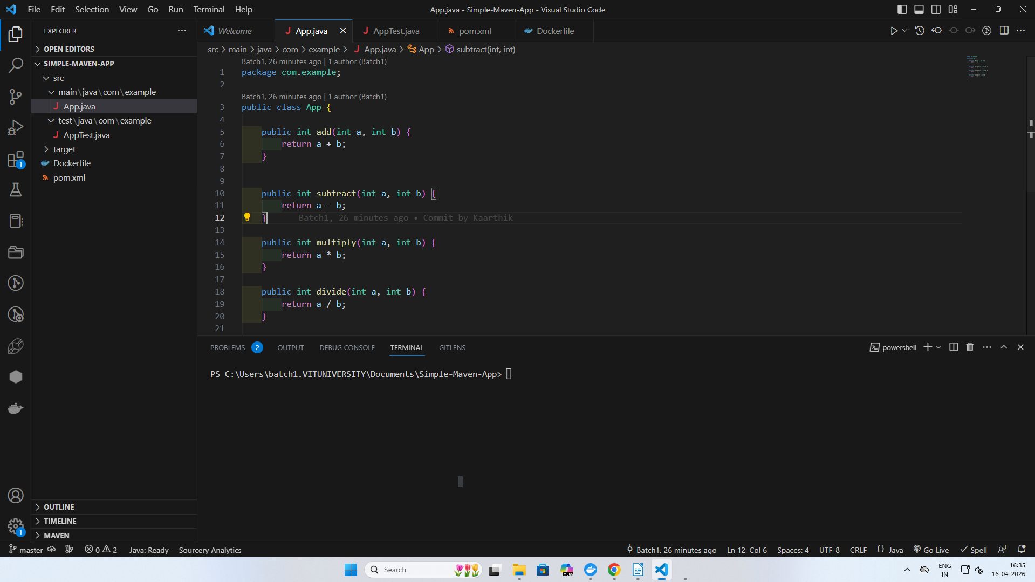

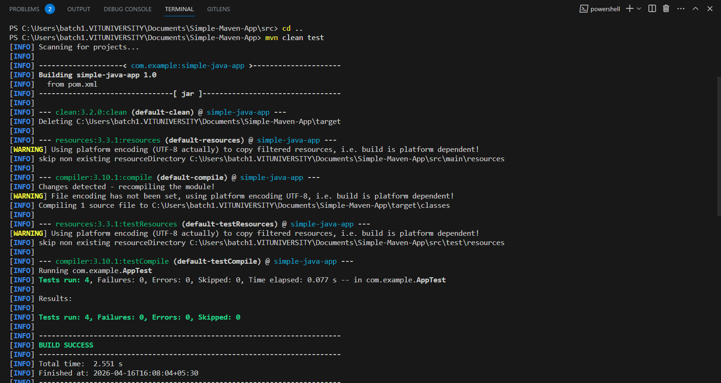
2. Write the code in Visual Studio and push it to your GITHUB repository.
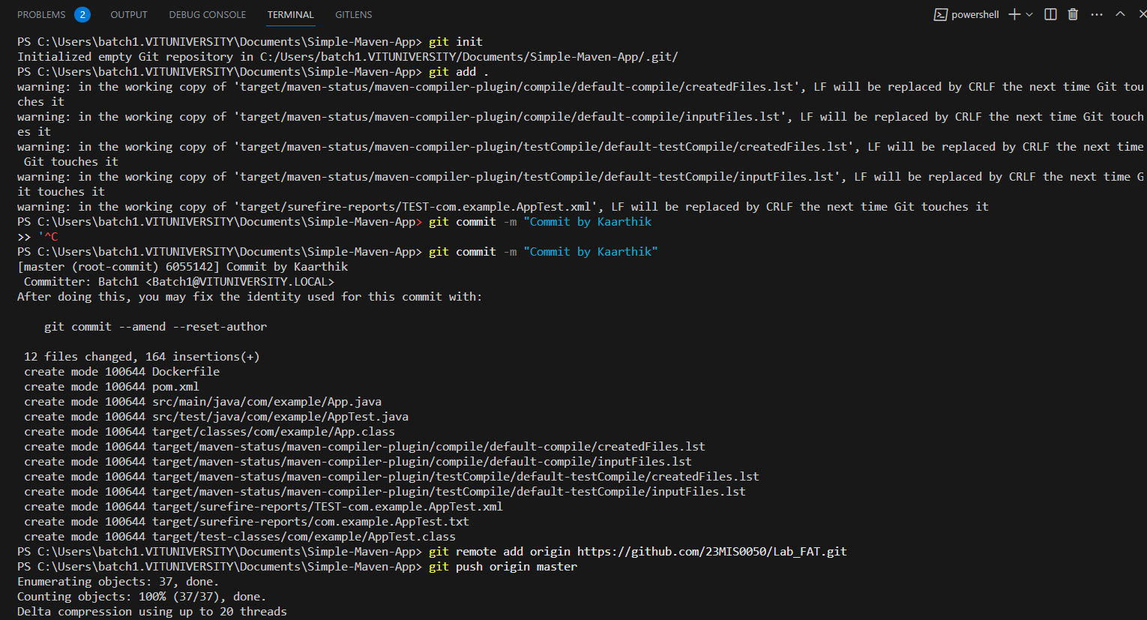

3 . Modify the code and commit the updates back in GITHUB.

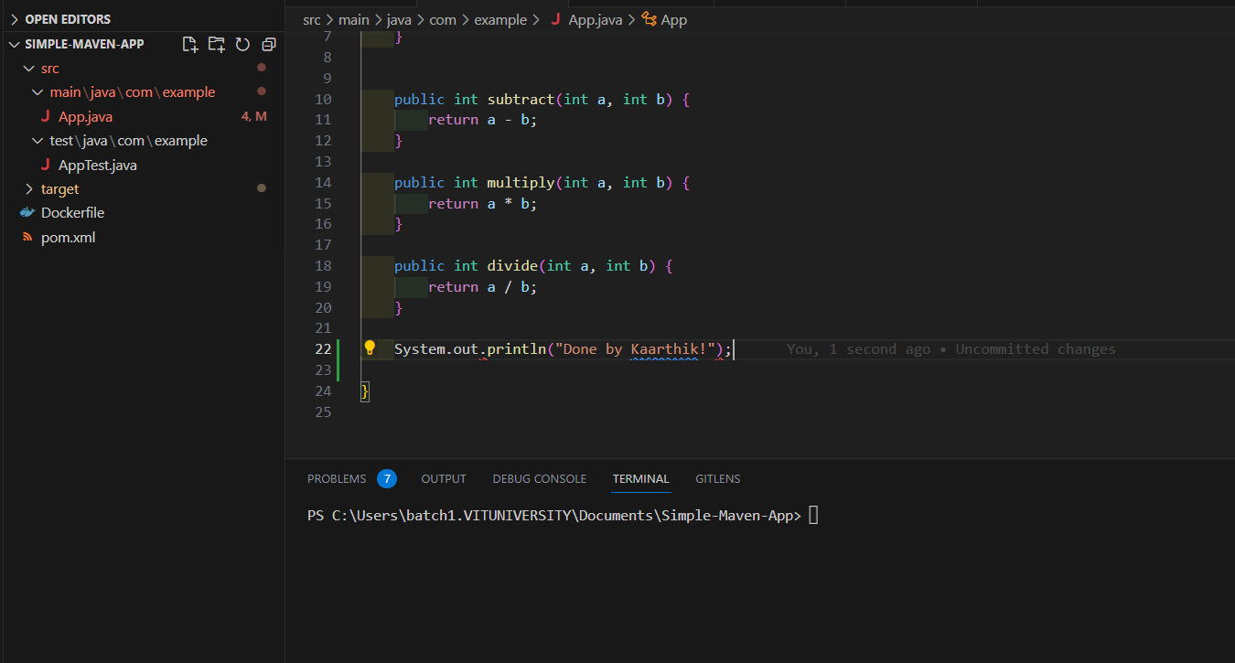
Modified the JavaFile

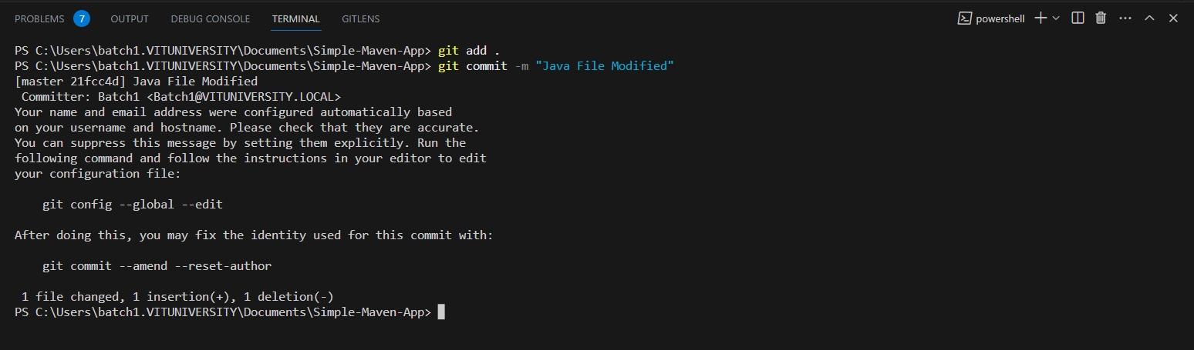
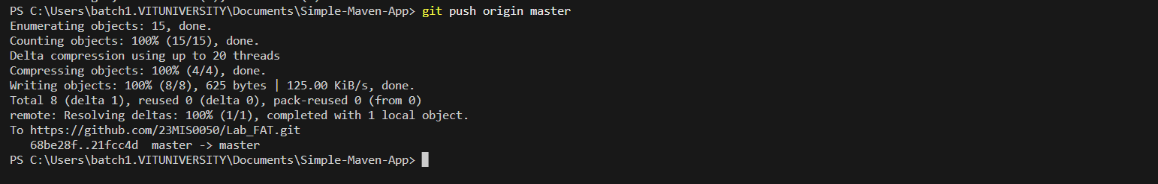

4. Using Jenkins configure the job as pipeline and create the stages for the Continuous Integration process.

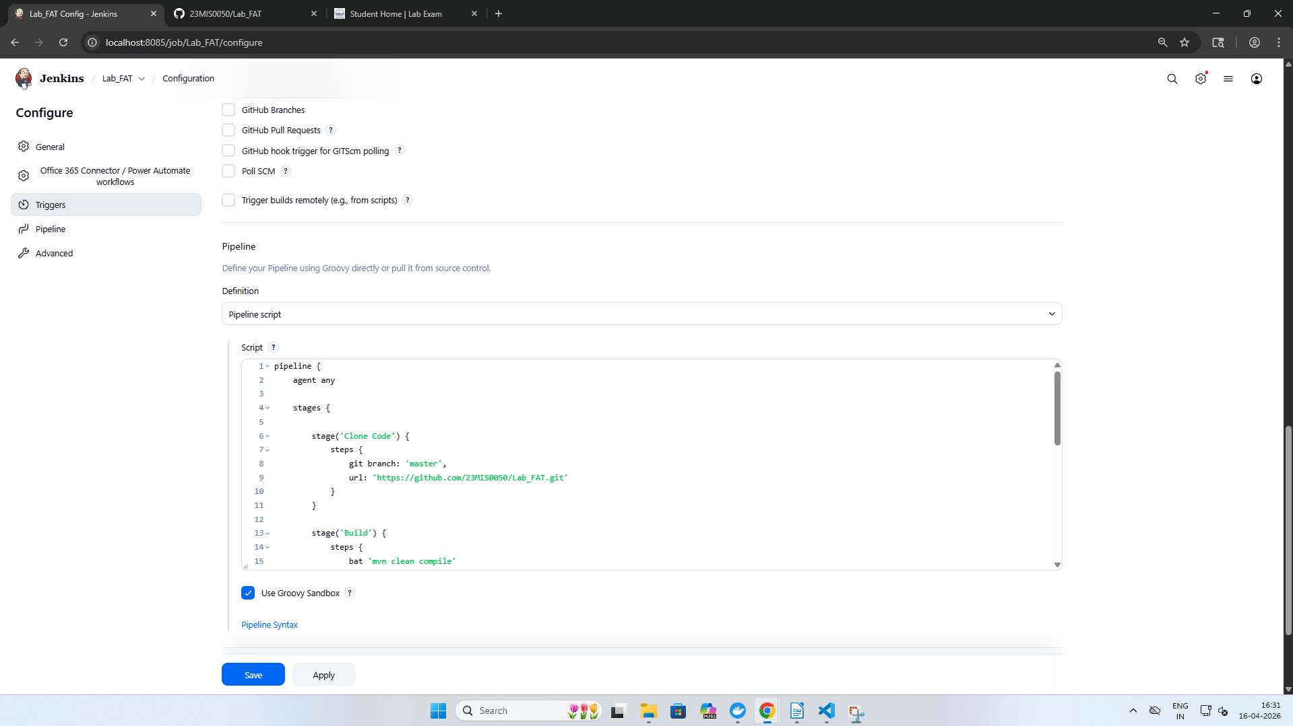

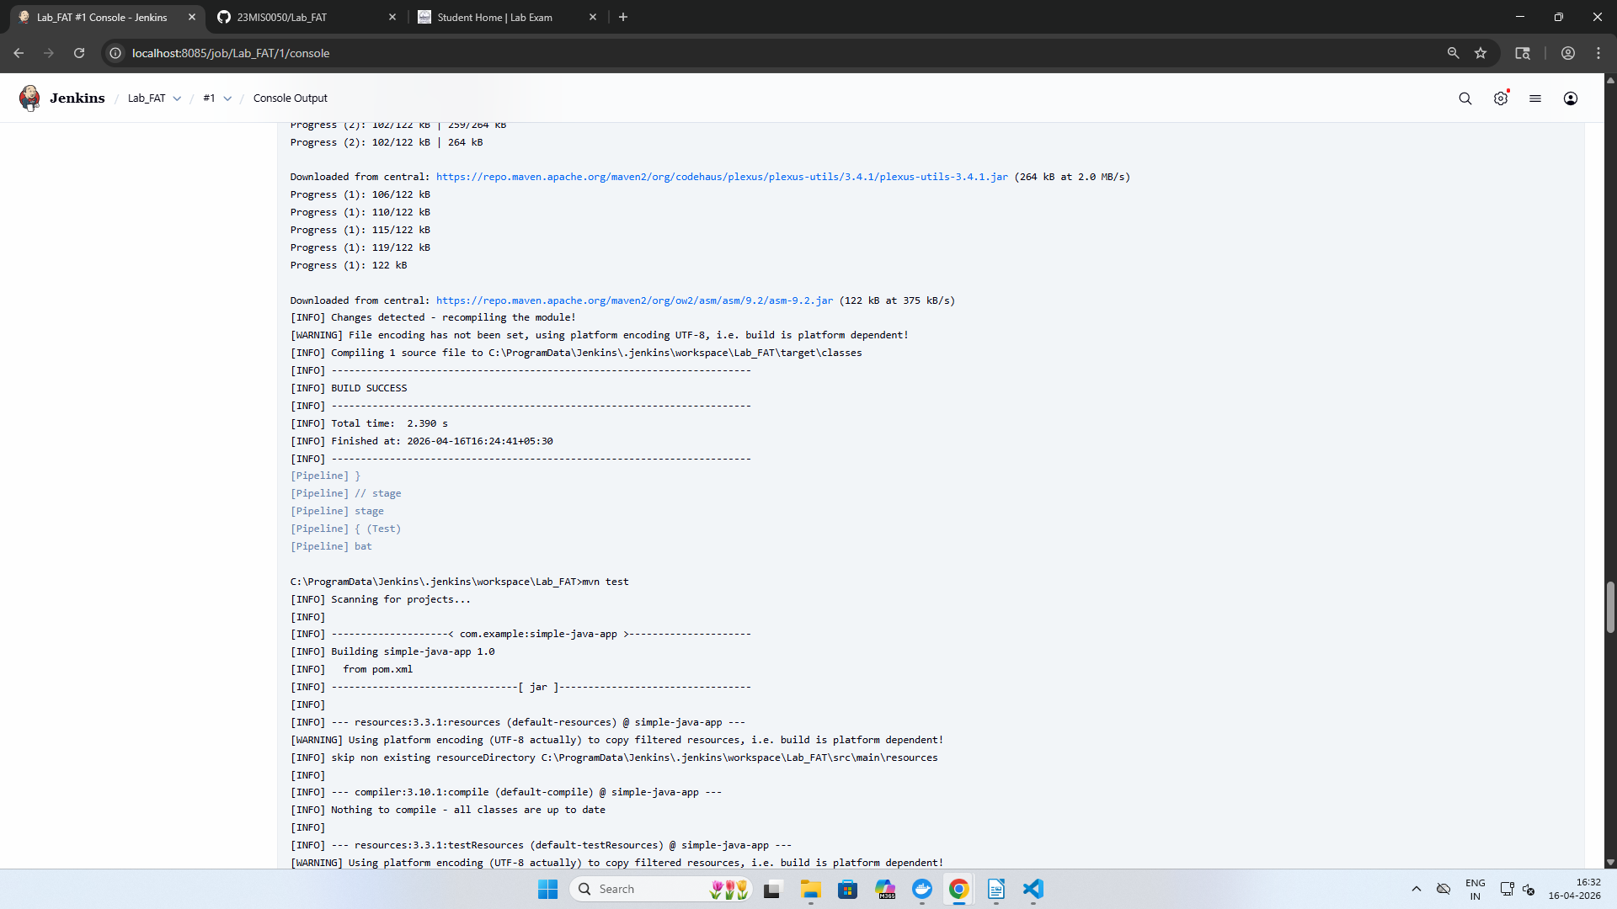

Test using JUNIT testing and building using Maven

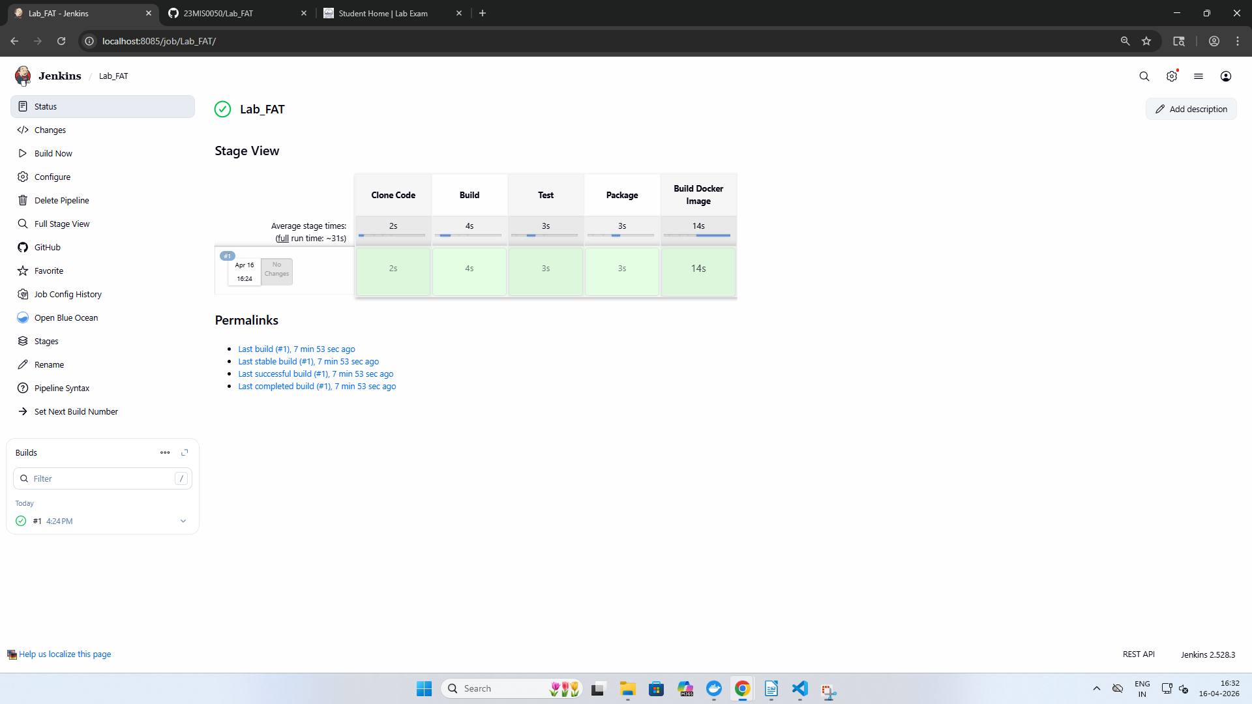

Creation of Docker image
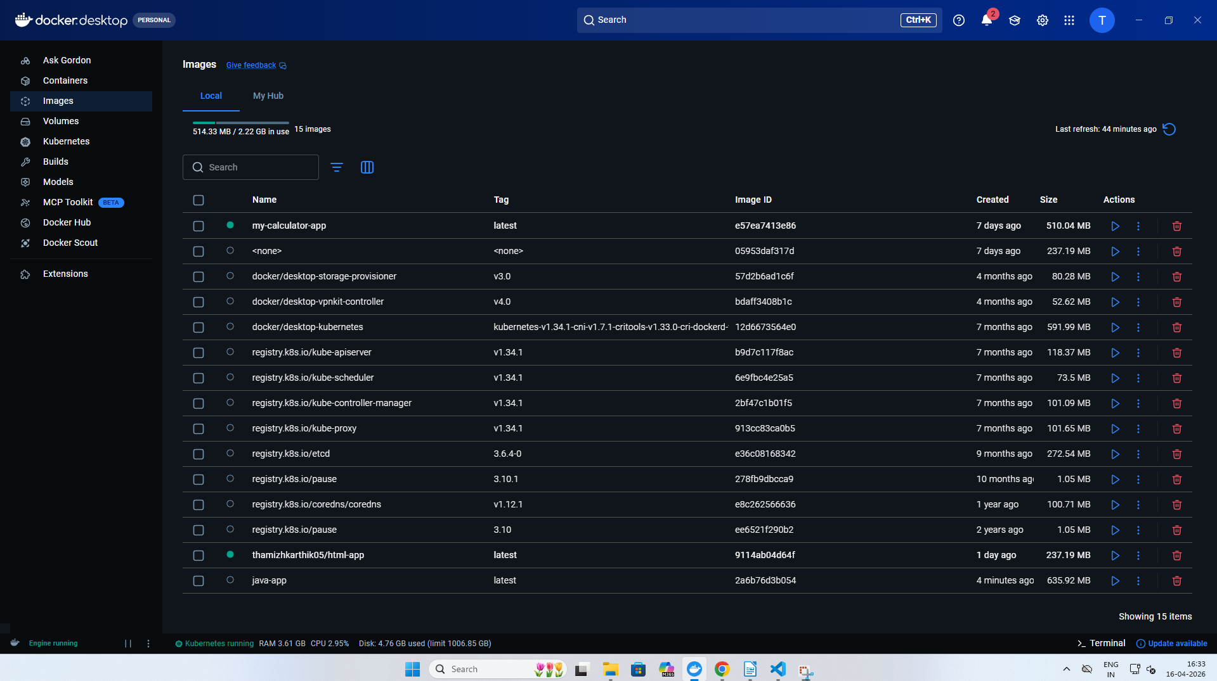

Pipeline Script:

pipeline {
agent any
stages {
stage('Clone Code') {
steps {
git branch: 'master',
url: 'https://github.com/23MIS0050/Lab_FAT.git'
}
}
stage('Build') {
steps {
bat 'mvn clean compile'
}
}
stage('Test') {
steps {
bat 'mvn test'
}
}
stage('Package') {
steps {
bat 'mvn package'
}
}
stage('Build Docker Image') {
steps {
bat 'docker build -t java-app .'
}
}
}
}

GitHub Link : https://github.com/23MIS0050/Lab_FAT.git

