Smart Bridge Internship
Assingment-2

-Abhay
LTVIP2025TMID47387Up
Create below visualization on:
- Donut Chart
- Area Chart
- Text table
- Highlighted table
- WordCloud
- Funnel Chart
- Waterfall

DONUT CHART
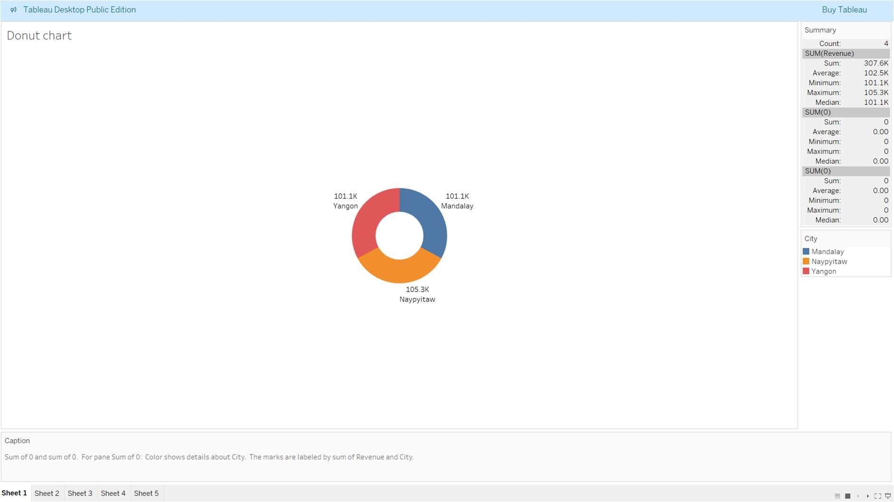

AREA CHART
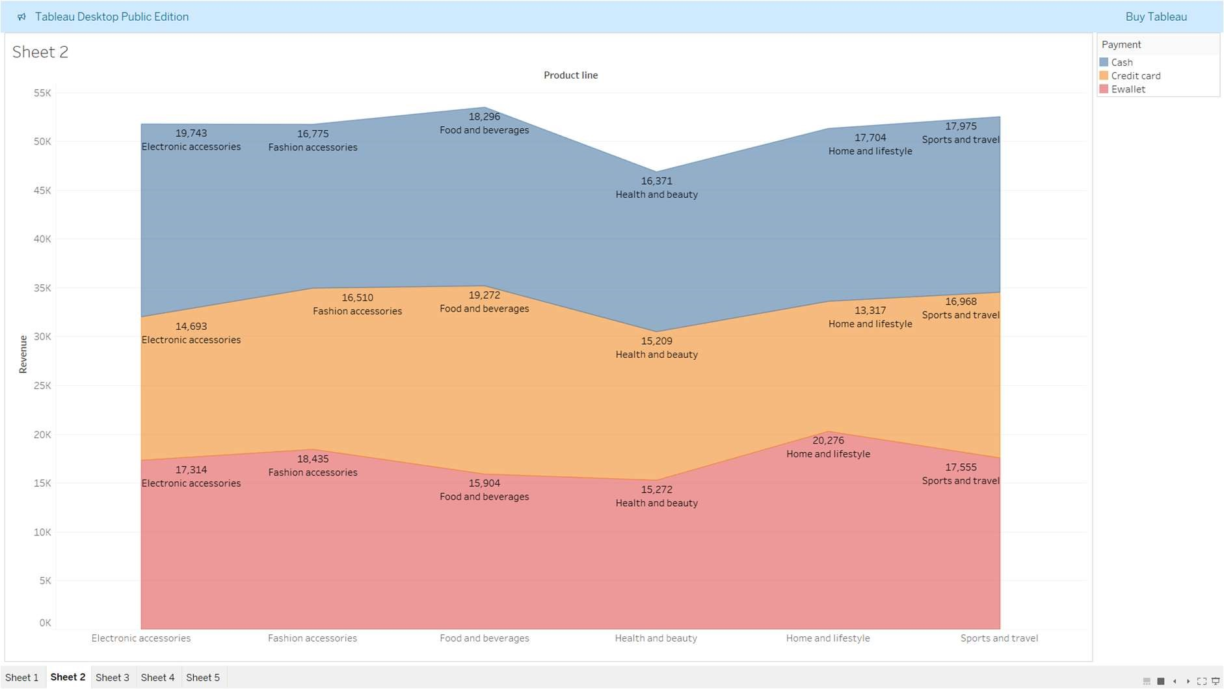

TEXT TABLE
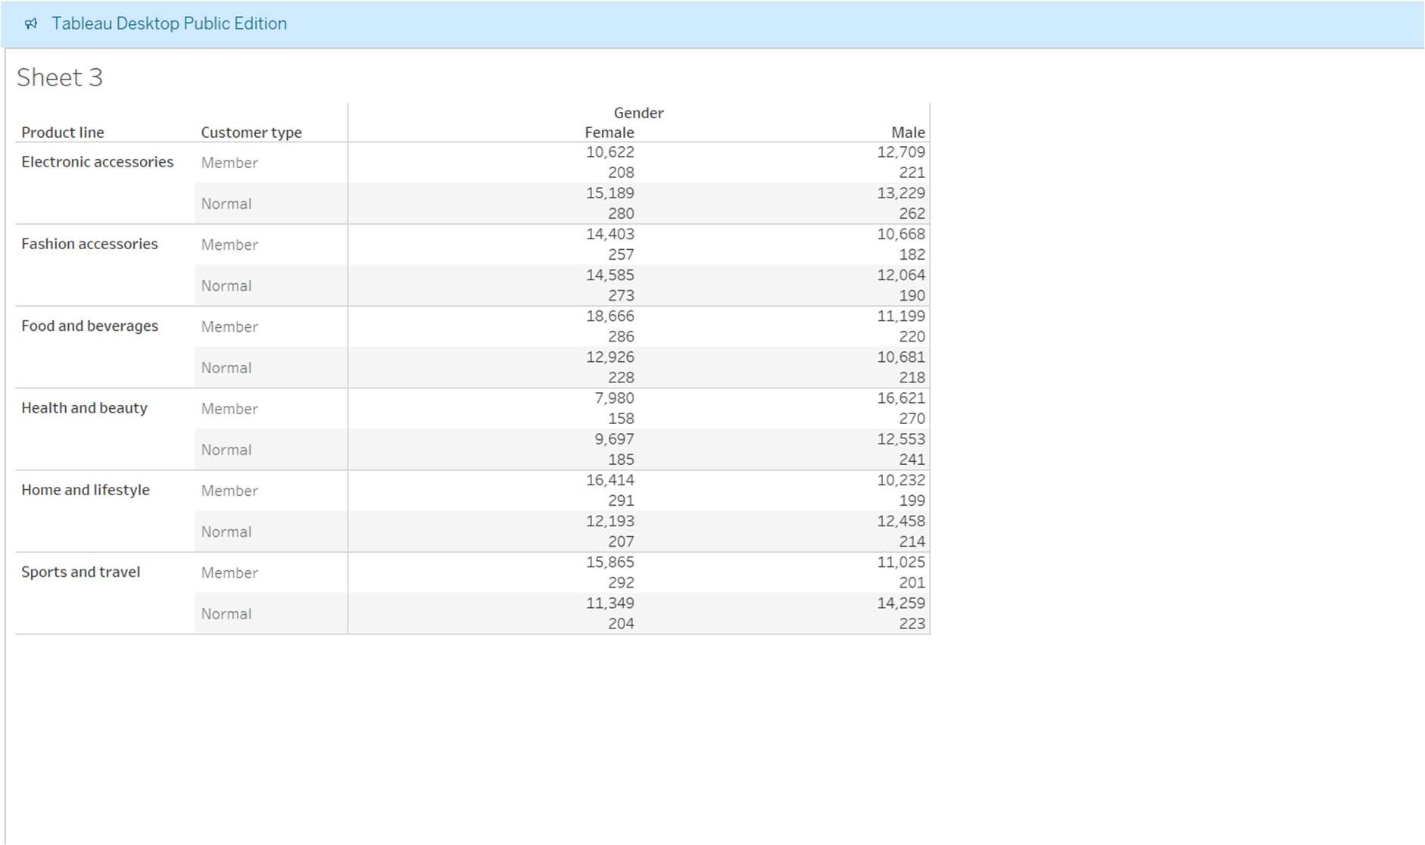

WORD CLOUD
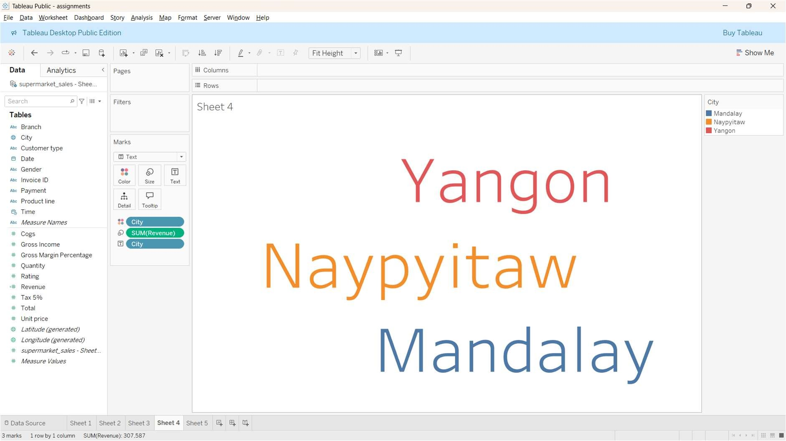

WATERFALL CHART
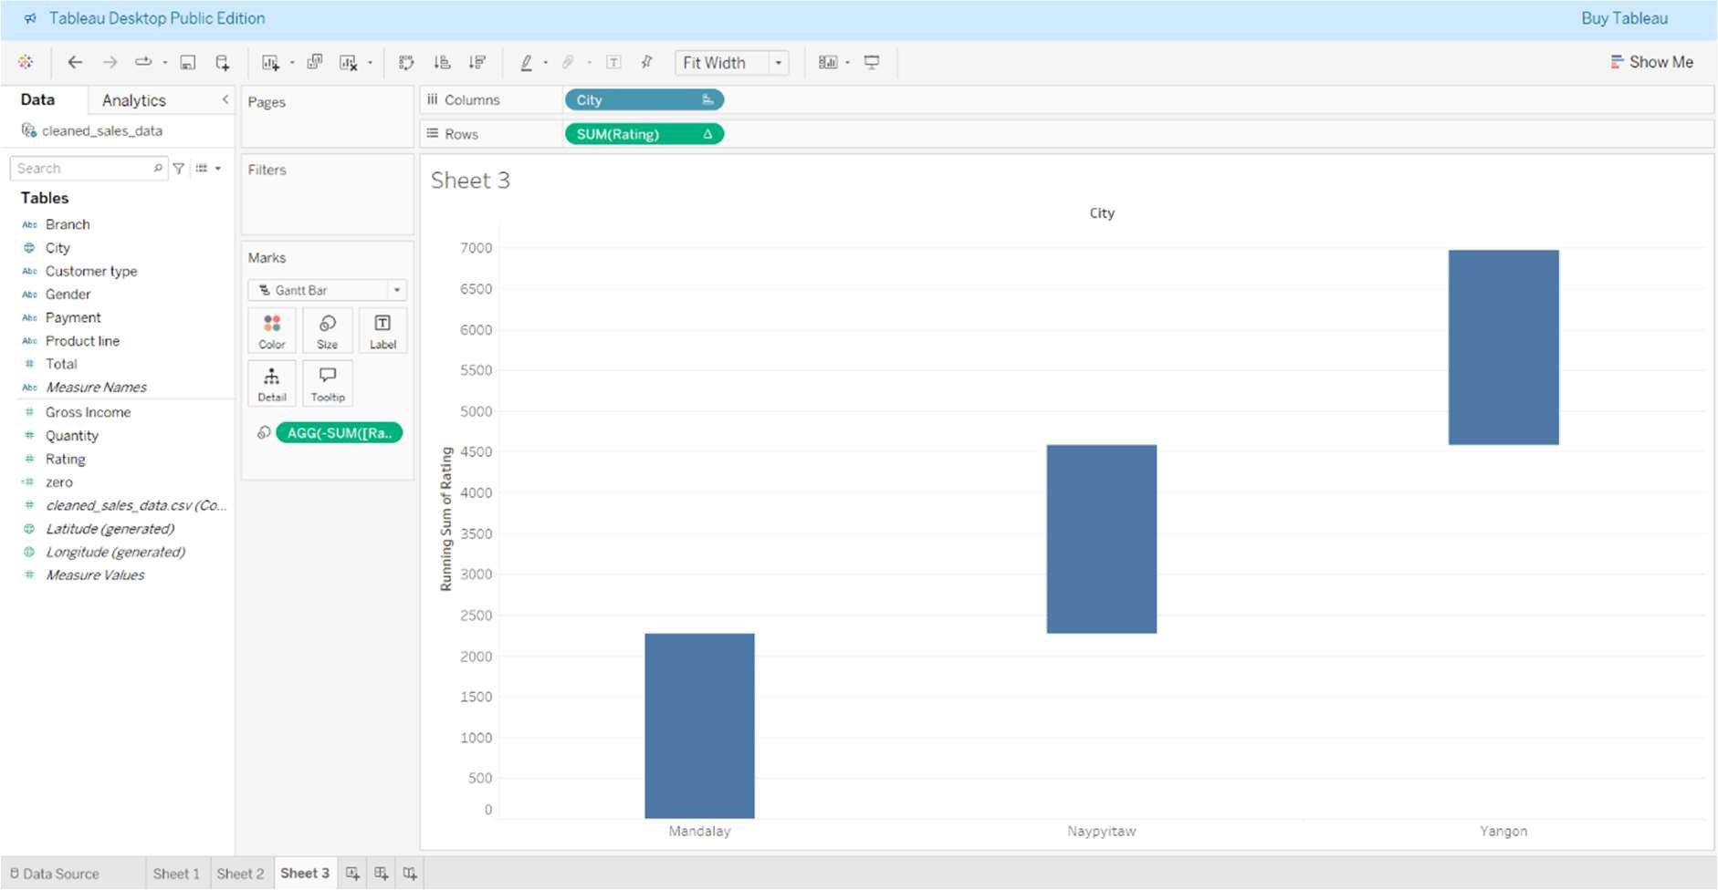

HIGHLIGHTED TABLE
