Smart Bridge Internship
Assignment-3

Abhay
LTVIP2025TMID47387

DASHBOARD:
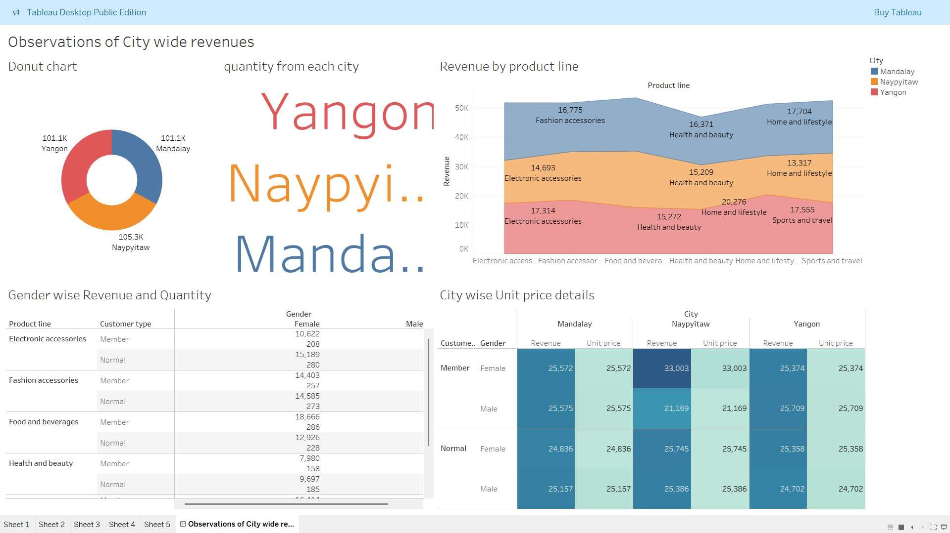
RESULTS BY EACH CITY:
CITY 1 :- YANGON
CITY 2 :- NAYIPITAW

CITY 3 :- MANDALAY
