Deliverable 3
Final Report
INSTRUCTOR: N. Drawel
PREPARED BY: Kian Denzel Ombao, Julien Pelletier-Henley
5/11/2026
Contents
Introduction 2
Conceptual Design of the Database 2
Logical Database Schema 3
Functional Dependencies and Database Normalization 4
SQL Statement Results 4

Introduction

Conceptual Design of the Database
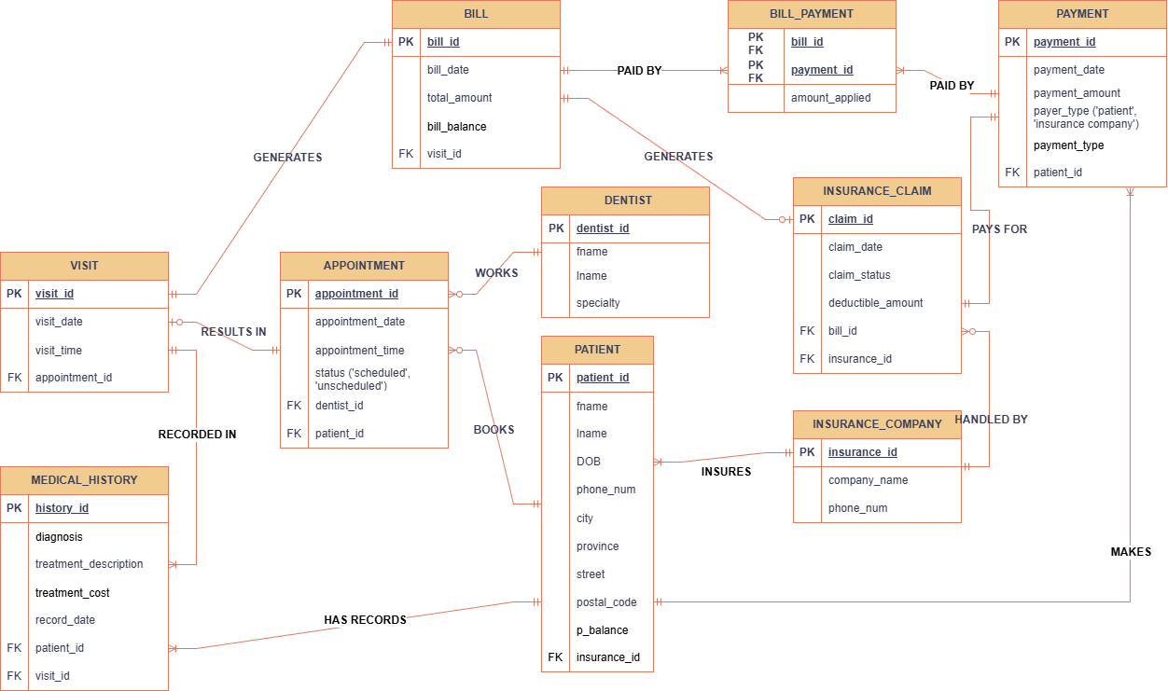

Logical Database Schema
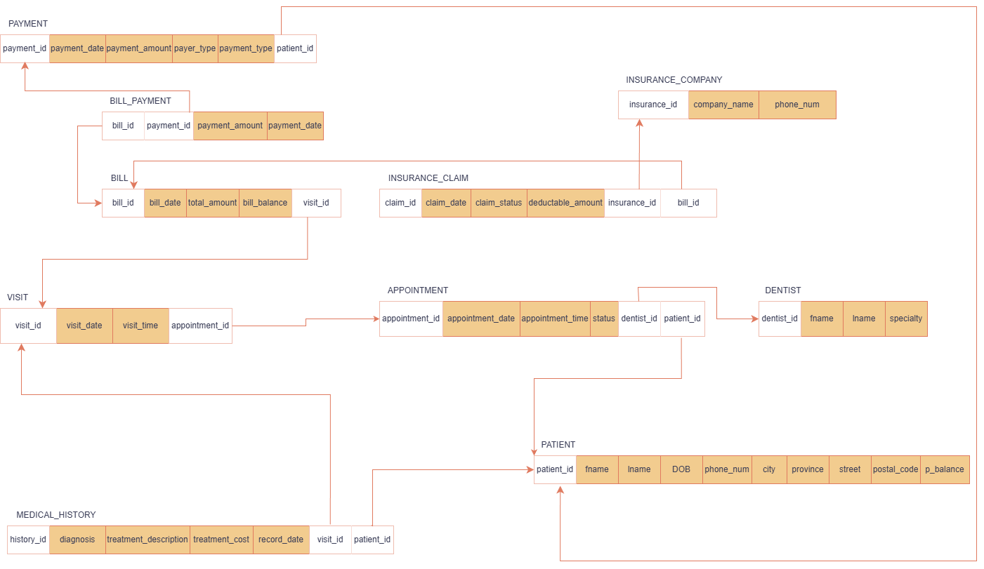
SQL statements used to construct and populate the database:
CREATE DATABASE dental_clinic_DB
USE dental_clinic_DB
-- DROP TABLES IF THEY EXIST
DROP TABLE IF EXISTS BillPayment;
DROP TABLE IF EXISTS Payment;
DROP TABLE IF EXISTS InsuranceClaim;
DROP TABLE IF EXISTS InsuranceCompany;
DROP TABLE IF EXISTS Bill;
DROP TABLE IF EXISTS MedicalHistory;
DROP TABLE IF EXISTS Visit;
DROP TABLE IF EXISTS Appointment;
DROP TABLE IF EXISTS Patient;
DROP TABLE IF EXISTS Dentist;
-- 3.D
CREATE SEQUENCE seq_bill_id
START WITH 1000
INCREMENT BY 1
NO CACHE
NO CYCLE;
-- CREATE ALL TABlES 3.A
CREATE TABLE dentist (
dentist_id INT PRIMARY KEY,
d_fname VARCHAR(20) NOT NULL,
d_lname VARCHAR(20) NOT NULL,
d_specialty VARCHAR(25)
);
CREATE TABLE insurance_company (
insurance_id INT PRIMARY KEY,
company_name VARCHAR(30) UNIQUE,
phone_num VARCHAR(15) UNIQUE
);
CREATE TABLE patient (
patient_id INT IDENTITY(1000,1) PRIMARY KEY,
p_fname VARCHAR(20) NOT NULL,
p_lname VARCHAR(20)NOT NULL,
p_dob DATE,
p_phone_num VARCHAR(15) UNIQUE,
city VARCHAR(20),
province VARCHAR(15),
street VARCHAR(15),
postal_code CHAR(6) NOT NULL,
insurance_id INT,
CONSTRAINT patient_insurance_id_fk FOREIGN KEY (insurance_id) REFERENCES insurance_company(insurance_id)
);
CREATE TABLE appointment (
appointment_id INT PRIMARY KEY,
appointment_date DATE,
appointment_time TIME,
appointment_status VARCHAR(16),
dentist_id INT,
patient_id INT,
CONSTRAINT appointment_dentist_id_fk FOREIGN KEY (dentist_id) REFERENCES dentist(dentist_id),
CONSTRAINT appointment_patient_id_fk FOREIGN KEY (patient_id) REFERENCES patient(patient_id) ON DELETE CASCADE
);
CREATE TABLE visit (
visit_id INT PRIMARY KEY,
visit_date DATE,
visit_time TIME,
appointment_id INT,
CONSTRAINT visit_appointment_id_fk FOREIGN KEY (appointment_id) REFERENCES appointment(appointment_id) ON DELETE CASCADE
);
CREATE TABLE bill (
bill_id INT PRIMARY KEY DEFAULT NEXT VALUE FOR seq_bill_id,
bill_date DATE,
total_amount NUMERIC(10,2) NOT NULL,
bill_balance NUMERIC(10,2),
visit_id INT,
CONSTRAINT bill_visit_id_fk FOREIGN KEY (visit_id) REFERENCES visit(visit_id) ON DELETE CASCADE
);
CREATE TABLE insurance_claim (
claim_id INT PRIMARY KEY,
claim_date DATE,
claim_status VARCHAR(15),
deductible_amount NUMERIC(10,2),
bill_id INT,
insurance_id INT,
CONSTRAINT insuranceclaim_bill_id_fk FOREIGN KEY (bill_id) REFERENCES bill(bill_id) ON DELETE SET NULL,
CONSTRAINT insuranceclaim_insurance_id_fk FOREIGN KEY (insurance_id) REFERENCES insurance_company(insurance_id)
);
CREATE TABLE payment (
payment_id INT PRIMARY KEY,
payment_date DATE NOT NULL,
payment_amount NUMERIC(10,2) NOT NULL,
payer_type VARCHAR(30),
payment_type VARCHAR(30),
patient_id INT,
CONSTRAINT payment_patient_id_fk FOREIGN KEY (patient_id) REFERENCES patient(patient_id) ON DELETE CASCADE
);
CREATE TABLE bill_payment (
bill_id INT,
payment_id INT,
amount_applied NUMERIC(10,2) NOT NULL,
PRIMARY KEY (bill_id, payment_id),
CONSTRAINT billpayment_bill_id_fk FOREIGN KEY (bill_id) REFERENCES bill(bill_id),
CONSTRAINT billpayment_payment_id_fk FOREIGN KEY (payment_id) REFERENCES payment(payment_id) ON DELETE CASCADE
);
CREATE TABLE medical_history (
history_id INT PRIMARY KEY,
diagnosis VARCHAR(20),
treatment_description VARCHAR(60),
treatment_cost NUMERIC(10,2),
record_date DATE,
patient_id INT,
visit_id INT,
CONSTRAINT medicalhistory_patient_id_fk FOREIGN KEY (patient_id) REFERENCES patient(patient_id) ON DELETE CASCADE,
CONSTRAINT medicalhistory_visit_id_fk FOREIGN KEY (visit_id) REFERENCES visit(visit_id)
);
--3.B
-- Cascade set to patient foreign key in appointment because if the patient is deleted so are his/her appointments.
-- Cascade set to appointment foreign key in visit because if an appointment is deleted so is the visit.
-- Same thing for visit fk in bill because if a visit is deleted so is its bill.
-- Set null to bill fk in insurance claim because if a bill is deleted the claim was still made.
-- Cascade set to patient fk in payment because if a patient is deleted so are its payments.
-- Cascade set to payment fk in bill_payment because if the payment is deleted, so is its reference.
-- Cascade set to patient in medical history because if it is deleted so is its history.
-- INSERT DATA 3.C
INSERT INTO dentist
VALUES (1001, 'Cha', 'Kuria', 'Orthodontist'),
(1002, 'Laureat', 'Mush', 'Periodontist'),
(1003, 'Guck', 'Goose', 'Dental Public Health'),
(1004, 'Mary', 'Robins', 'Endodontist');
INSERT INTO insurance_company
VALUES (1100, 'FirstCompany', '514-111-1111'),
(2200, 'SecondCompany', '514-222-2222'),
(3300, 'ThirdCompany', '514-333-3333'),
(4400, 'FourthCompany', '514-444-4444');
INSERT INTO patient (p_fname, p_lname, p_dob, p_phone_num, city, street, province, postal_code, insurance_id)
VALUES ('Sony', 'Jr', '1998-03-23', '514-324-7643', 'Montreal', 'Queen Mary', 'Quebec', 'H1W1Y8', 1100),
('Jones', 'DaSec', '1997-04-16', '514-574-7868', 'Montreal', 'Saint-Luc', 'Quebec', 'H2W5K9', 2200),
('Alice', 'Smith', '1999-08-11', '514-876-9900', 'Laval', 'Main', 'Quebec', 'H3R4T6', 3300),
('Brian', 'Lee', '2000-12-01', '438-345-2233', 'Saint-Jérôme', 'Cedar', 'Quebec', 'J7Z2B1', 4400);
INSERT INTO appointment
VALUES (1001, '2026-05-20', '14:30:00', 'Scheduled', 1003, 1000),
(1002, '2026-07-14', '13:00:00', 'Scheduled', 1001, 1001),
(1003, '2026-08-10', '15:00:00', 'Completed', 1002, 1002),
(1004, '2026-09-02', '10:00:00', 'Scheduled', 1004, 1003);
INSERT INTO visit
VALUES (1010, '2026-03-23', '12:40:00', 1001),
(1020, '2026-02-14', '16:05:00', 1002),
(1030, '2026-06-10', '09:15:00', 1003),
(1040, '2026-07-01', '11:30:00', 1004);
INSERT INTO bill (bill_date, total_amount, bill_balance, visit_id)
VALUES ('2026-04-23', 200.00, 200.00, 1010),
('2026-03-14', 300.00, 250.00, 1020),
('2026-07-10', 150.00, 150.00, 1030),
('2026-08-05', 400.00, 350.00, 1040);
INSERT INTO insurance_claim
VALUES (1001, '2026-03-10', 'Claimed', 100.00, 1000, 1100),
(1002, '2026-04-23', 'Claimed', 200.00, 1001, 2200),
(1003, '2026-06-20', 'Pending', 120.00, 1002, 3300),
(1004, '2026-07-25', 'Claimed', 180.00, 1003, 4400);
INSERT INTO payment
VALUES (1010, '2026-04-20', 200.00, 'Patient', 'Credit', 1000),
(1020, '2026-03-10', 300.00, 'Insurance Company', null, 1001),
(1030, '2026-07-12', 150.00, 'Patient', 'Debit', 1002),
(1040, '2026-08-08', 400.00, 'Insurance Company', null, 1003);
INSERT INTO bill_payment
VALUES (1000, 1010, 200.00),
(1001, 1020, 300.00),
(1002, 1030, 150.00),
(1003, 1040, 400.00);
INSERT INTO medical_history
VALUES (1001, 'Cavity', 'Cavity needs to be removed', 50.00, '2025-09-23', 1000, 1010),
(1002, 'Infection', 'Cure with oral antibiotics', 300.00, '2024-05-07', 1001, 1020),
(1003, 'Gum Issue', 'Deep cleaning required', 120.00, '2025-10-11', 1002, 1030),
(1004, 'Root Canal', 'Requires root canal procedure', 400.00, '2025-12-20', 1003, 1040);
-- 3.E
-- Likely that user will often search appointments by dentist or schedule.
-- For example, a receptionist looking for all of a dentists appointment for a specific day.
CREATE INDEX idx_appointment_dentist_schedule
ON APPOINTMENT (dentist_id, appointment_date, appointment_time);
-- Likely that user will search payments by patient or date.
-- For example, a receptionist finding which patient made a payment on a specific day.
CREATE INDEX idx_payment_patient_date
ON PAYMENT (patient_id, payment_date);
-- 3.F
ALTER TABLE dentist
ADD salary NUMERIC(10,2);
ALTER TABLE dentist
ADD CONSTRAINT d_salary_ck CHECK (salary > 30000);

Functional Dependencies and Database Normalization

SQL Statement Results

