Team Members: Jordan Andradi, Noah Martins, Julian P-H, Brandon Langlois

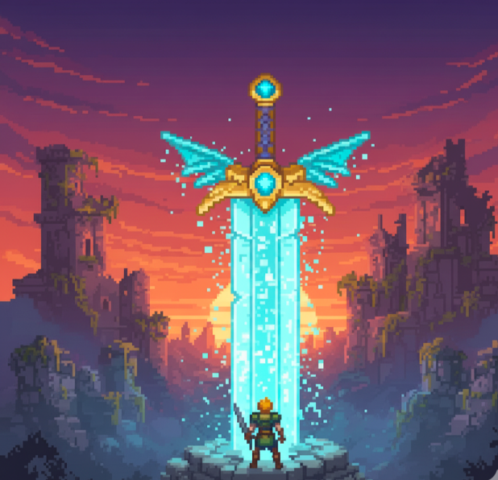
Title Kindred

Tag line “Adventure, Quest, Fight, Survive”

Genre Adventure

Platform PC

Target 2D Game enthusiasts that liked Undertale

Plays like Undertale meets Skill Tree
Draft of Box Art

Goal Reach the end of the worlds and beat all the bosses. Complete skill tree.

Popular Game A Popular Game B or twist
Undertale Twist: Skill Tree

Core Mechanics
Primary:
- Usage of different weapons and abilities unlocked in a skill tree in order to
eliminate enemies and bosses.
- Navigating through complex pathways, puzzles and enemy or boss fights.

Secondary:

- Experience points system/counter for points to be used on the skill tree.
- (Optional) Ally AI characters that follow along and fight with the player.

Game Project Summary
Supporting Screenshot / Drawings / Collage for Worlds / Levels / Characters / Game Items

Story: The player is lured into this world by a trick played by an unknown enemy and he has to navigate through the world believing he is trying to save a friend or family member when in reality it was all a trap to capture him. At the end he must escape and fight this big enemy to escape the world.

Setting: Medieval, starts in forest/nature. Ends with final boss fight in castle dungeon.

Setting references: Rogue Heroes: Ruins of Tasos, Terraria, Stardew Valley(for look not gameplay).

Key Experiences: Kill enemies and bosses while traveling thorough levels, after each kill collect some sort of XP or points to use in the skill tree. Adapt to different weapons and mechanics as you progress through the game. Fight against one final boss to complete the game.

Selling points: Nostalgia (2D games), Skill tree (Grinding aspect), Distinct art style.

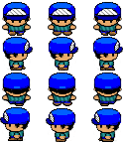
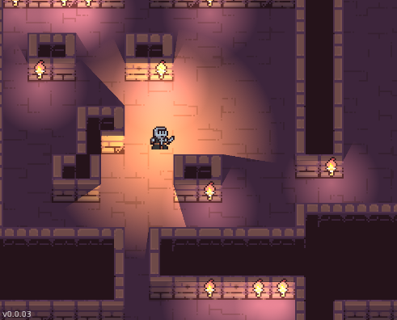
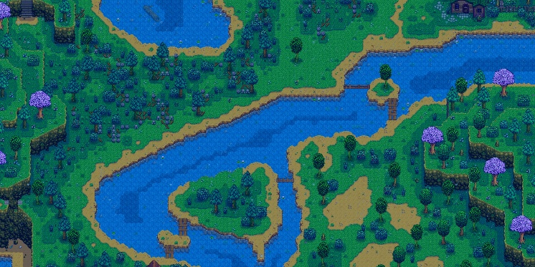
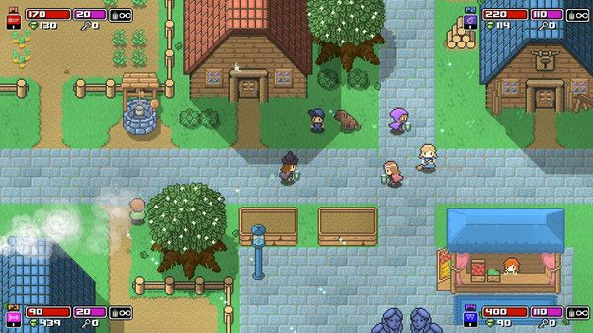
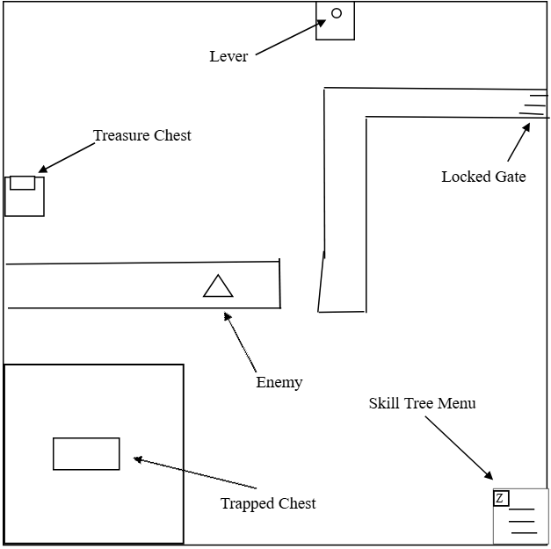
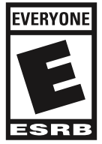
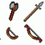
Game Inspiration:
Supporting Screenshot / Drawings / Collage for Worlds / Levels / Characters / Game Items

