MySQL 8.0.28

#Создание таблиц

CREATE TABLE subscriber (

id_subscriber INT PRIMARY KEY AUTO_INCREMENT,

id_surname INT

);

CREATE TABLE subscriber_surname (

id_surname INT PRIMARY KEY,

surname VARCHAR(33)

);

CREATE TABLE type_phone (

id_type_phone INT PRIMARY KEY AUTO_INCREMENT,

name ENUM(

'отдельный телефон',

'таксофон', 'спаренный телефон'

)

);

CREATE TABLE application (

id_application INT PRIMARY KEY AUTO_INCREMENT,

id_phone INT, date DATE

);

CREATE TABLE phone (

id_phone INT PRIMARY KEY AUTO_INCREMENT,

id_subscriber INT,

phone VARCHAR(15),

id_type_phone INT

);

#Заполнение таблиц

INSERT type_phone

VALUES

(

1, 'отдельный телефон'

),

(2, 'таксофон'),

(

3, 'спаренный телефон'

);

INSERT phone

VALUES

(1, 1, '251111111', 1),

(2, 1, '292222222', 2),

(3, 2, '333333333', 3),

(4, 2, '334444444', 1),

(5, 2, '255555555', 2),

(6, 3, '296666666', 3),

(7, 3, '337777777', 1);

INSERT application

VALUES

(1, 2, '2020-03-01'),

(2, 2, '2021-01-11'),

(3, 3, '2022-11-22'),

(4, 3, '2020-08-21'),

(5, 5, '2021-07-09'),

(6, 6, '2022-07-17'),

(7, 2, '2021-12-24'),

(8, 2, '2020-07-07'),

(9, 4, '2020-09-06'),

(10, 3, '2020-08-19'),

(11, 3, '2020-01-03');

INSERT subscriber_surname

VALUES

(1, 'Пушкин'),

(2, 'Иванов'),

(3, 'Петров');

INSERT subscriber

VALUES

(1, 1),

(2, 2),

(3, 3);

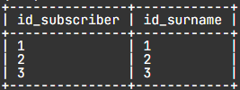 - SUBSCRIBER

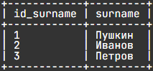 - SUBSCRIBER_SURNAME

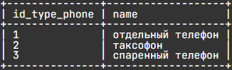 - TYPE_PHONE

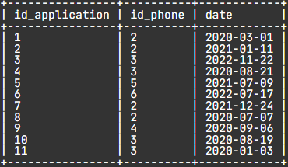 - APPLICATION

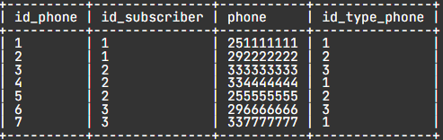 - PHONE

# 1. For August 2020:

SELECT

*

FROM

application

WHERE

MONTH(date) = 8

AND YEAR(date) = 2020;

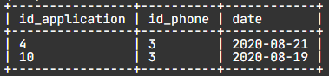

# 2. Number of telephones by line type:

SELECT

name line,

COUNT(*) total_number_with_this_line

FROM

phone

JOIN type_phone USING(id_type_phone)

GROUP BY

id_type_phone;

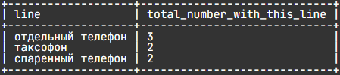

# 3. Phones for which there are applications:

SELECT

DISTINCT phone

FROM

phone

JOIN application USING(id_phone);

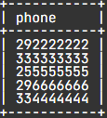

# 4. Sort the first 3 numbers from the table by last name:

SELECT

phone,

surname,

name type_phone

FROM

subscriber_surname

JOIN subscriber USING(id_surname)

JOIN (

SELECT

phone,

id_subscriber,

id_type_phone

FROM

phone

LIMIT

3

) temporary_table USING(id_subscriber)

JOIN type_phone USING(id_type_phone)

ORDER BY

2;

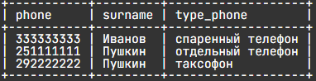

# *5:

CREATE TABLE phone_archive (

id_phone_archive INT PRIMARY KEY AUTO_INCREMENT,

id_subscriber INT,

phone VARCHAR(15),

id_type_phone INT,

deletion_date DATE

);

INSERT phone_archive

VALUES

(1, 1, '251111111', 1, '2022-02-02'),

(2, 2, '251111111', 2, '2021-01-01'),

(3, 3, '296666666', 3, '2022-12-12'),

(4, 1, '296666666', 1, '2021-11-11'),

(5, 2, '290000000', 2, '2022-07-08');

SELECT

*

FROM

phone_archive;

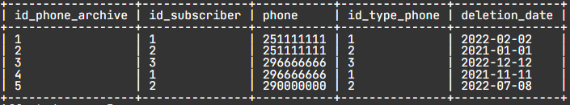

WITH temporary AS (

SELECT

phone

FROM

phone

UNION

SELECT

phone

FROM

phone_archive

)

SELECT

phone

FROM

temporary;

