11. karate api testing
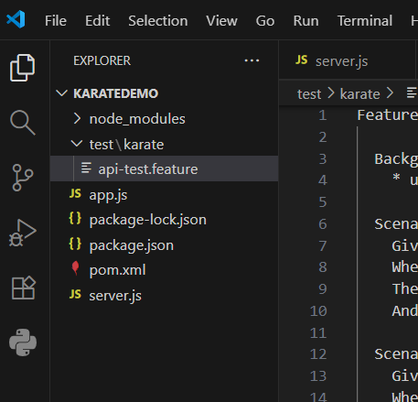
1.server.js
const express = require('express');
const app = express();
app.use(express.json());
let students = [
{ id: 1, name: 'Lara', course: 'Computer Science' },
{ id: 2, name: 'John', course: 'Information Technology' }
];
app.get('/students', (req, res) => {
res.status(200).json(students);
});
app.get('/students/:id', (req, res) => {
const id = parseInt(req.params.id);
const student = students.find(s => s.id === id);
if (student) {
res.status(200).json(student);
} else {
res.status(404).json({ message: 'Student not found' });
}
});
app.post('/students', (req, res) => {
const newStudent = {
id: students.length + 1,
name: req.body.name,
course: req.body.course
};
students.push(newStudent);
res.status(201).json(newStudent);
});

app.listen(3000, () => console.log('Server running on port 3000'));
- npm init -y
npm install express
node server.js
2. pom.xml
<project>
<modelVersion>4.0.0</modelVersion>
<groupId>com.demo</groupId>
<artifactId>karate-test-demo</artifactId>
<version>1.0</version>

<dependencies>
<dependency>
<groupId>com.intuit.karate</groupId>
<artifactId>karate-junit5</artifactId>
<version>1.4.0</version>
<scope>test</scope>
</dependency>
</dependencies>

<build>
<plugins>
<plugin>
<groupId>org.apache.maven.plugins</groupId>
<artifactId>maven-surefire-plugin</artifactId>
<version>2.22.2</version>
</plugin>
</plugins>
</build>
</project>
3. api-test feature
Feature: Testing Student API using Karate

Background:
* url 'http://localhost:3000'

Scenario: Get all students
Given path 'students'
When method get
Then status 200
And match response[0].name == 'Lara'

Scenario: Get student by ID
Given path 'students', 2
When method get
Then status 200
And match response.course == 'Information Technology'

Scenario: Add new student
Given path 'students'
And request { name: 'Alex', course: 'Data Science' }
When method post
Then status 201
And match response.name == 'Alex'
- mvn test

9^{) exp}
Simple-nginx-deployment.yaml
apiVersion: apps/v1
kind: Deployment
metadata:
name: simple-nginx-app
spec:
replicas: 1
selector:
matchLabels:
app: simple-nginx-app
template:
metadata:
labels:
app: simple-nginx-app
spec:
containers:
- name: simple-nginx-app
image: sudheepthi/my-simple-app:latest
ports:
- containerPort: 80

Simple-nginx-service.yaml
apiVersion: v1
kind: Service
metadata:
name: simple-nginx-service
spec:
selector:
app: simple-nginx-app
ports:
- protocol: TCP
port: 80
targetPort: 80
type: NodePort

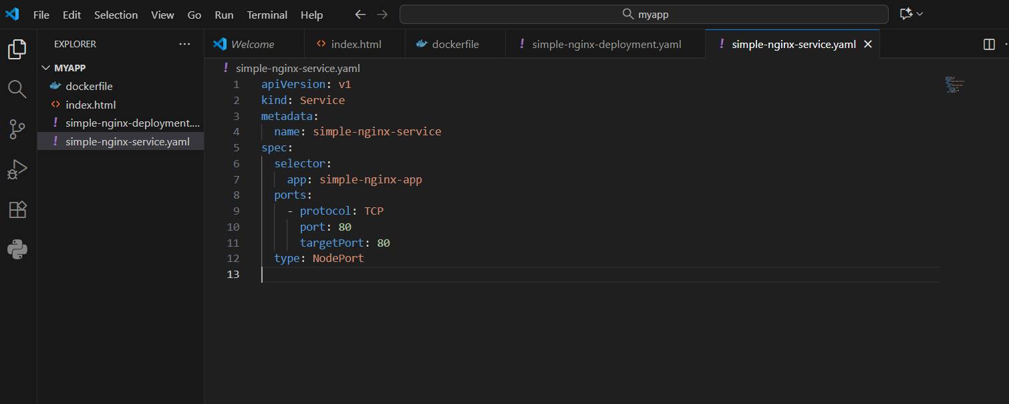
7)
Docker file
FROM nginx:latest
COPY index.html /usr/share/nginx/html/index.html
- docker build -t simple—app
- docker run -d -p 8081:80 simple-app .
9th commnds
kubectl apply -f simple-nginx-deployment.yaml
kubectl apply -f simple-nginx-service.yaml
kubectl get pods
kubectl get svc
kubectl port -forward svc/simple-nginx-service 8081:80

