 

**Placement Empowerment Program**

***Cloud Computing and DevOps Centre***

Host a Static Website Locally: Set Up a Local Server Apache and Host a Simple HTML page with your name

Name: Harivasan S

Department : ADS



**Introduction:**

Hosting a static website locally is a great way to test and develop web pages before deploying them online. This process involves setting up a local web server, such as **Apache**, to serve HTML files directly from your computer. Apache is one of the most widely used web servers, known for its flexibility, reliability, and open-source nature.

By setting up Apache, you can create a local environment that mimics a real web server. This allows you to preview and test your website efficiently. In this guide, we will install and configure Apache on your system and host a simple **HTML page** containing your name.

**Objective:**

1.Understand the basics of Apache and its role as a web server.

2. Install and configure Apache on your system (Windows, macOS, or Linux).

3.Create a simple HTML page displaying your name.

4.Serve the HTML file locally using Apache and access it via a web browser.

5.Gain hands-on experience in local web hosting and testing environments.

**Step-by-Step Overview**

Step 1 :

Click on the "Downloads" option located on the left-hand side of the Apache Lounge website.

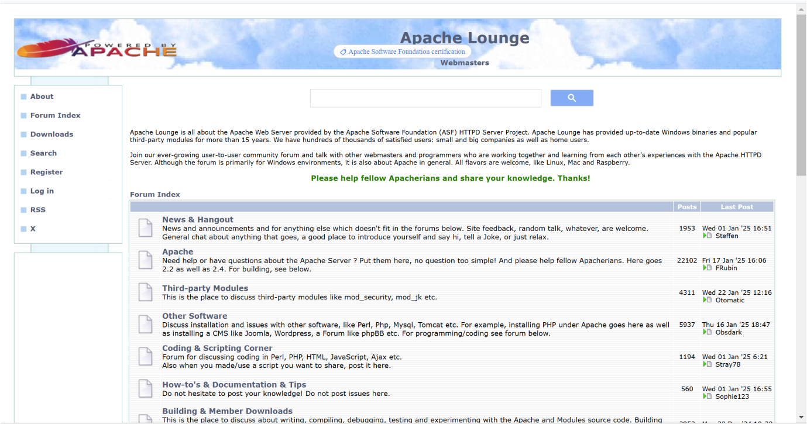

Step 2 :

Download code for displaying starting a new website in html.

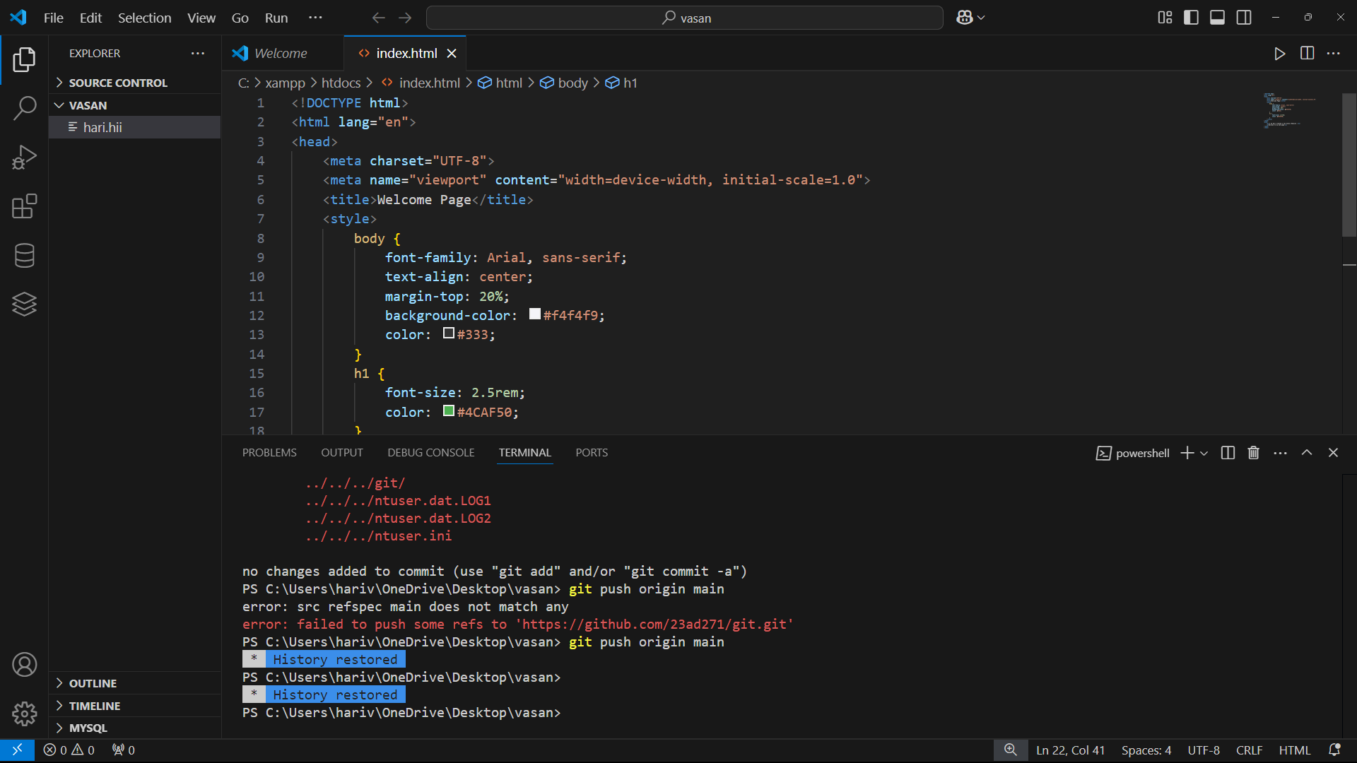

Step 3 :

Save this file in xampp in the folder htdocs with that file name must should save as name.html

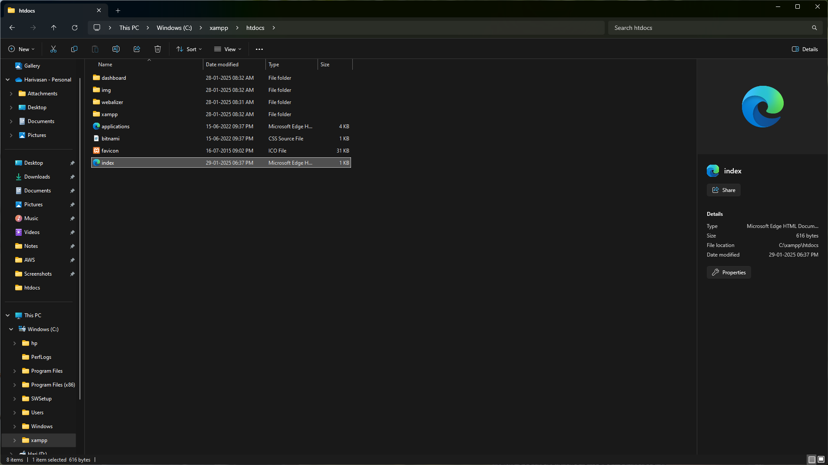

Step 4 :

Now we can Start the apache after saving the file.

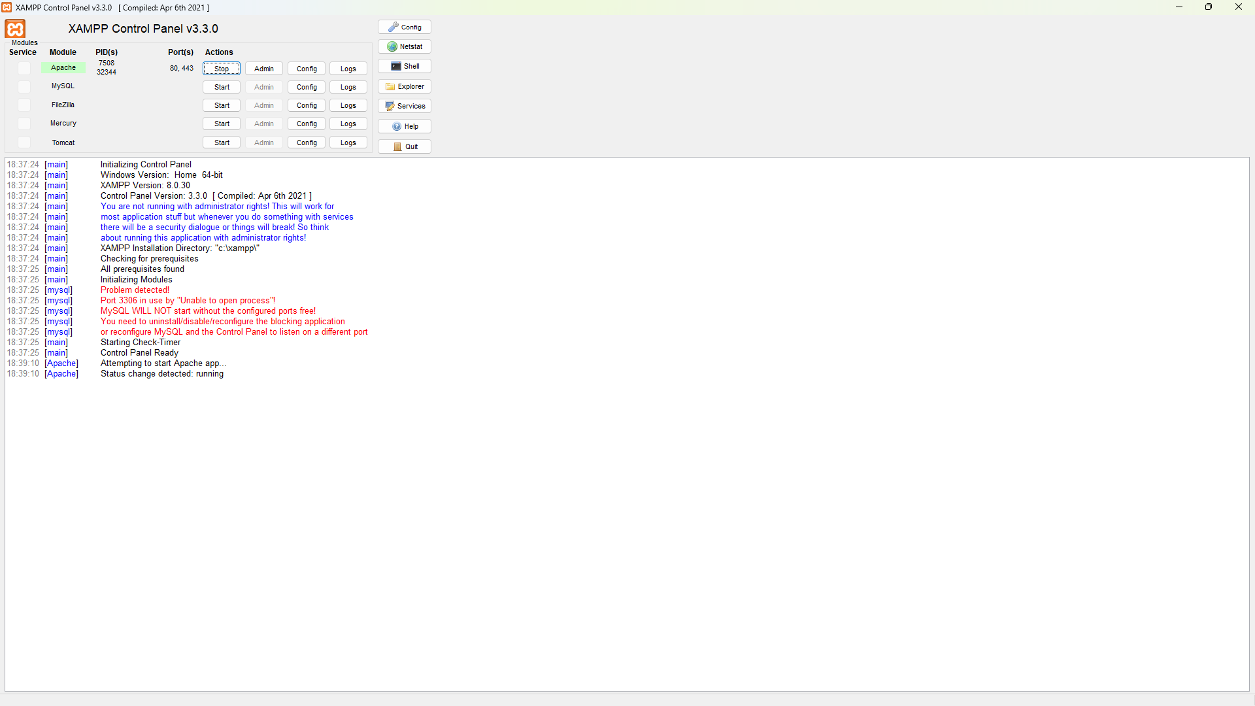

Step 5 :

After starting the apache we will search localhost in a chrome it will display the name we already entered in html file

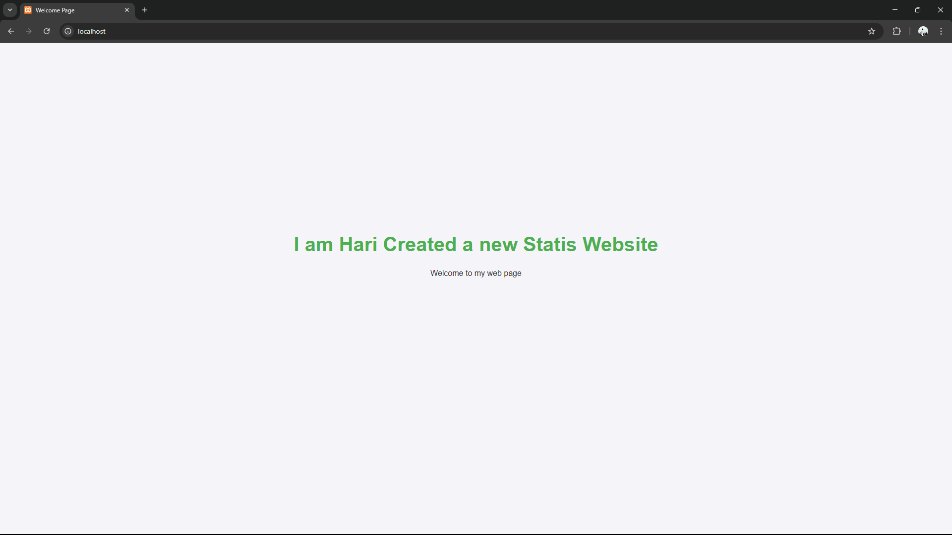

**Expected Outcome**

**Expected Outcome:**

1. **Successfully Set Up Apache Server** – Apache is installed and running locally on your computer.

2. **Host a Static HTML Page** – A simple webpage displaying your name is accessible via localhost in a web browser.

3. **Understand Local Hosting** – You gain hands-on experience with setting up and managing a local web server for testing static websites.