

**Placement Empowerment Program**

***Cloud Computing and DevOps Centre***

Back Up and Restore a Cloud Instance : Take a snapshot of your cloud VM. Terminate the VM and restore it from the snapshot.

Name: Harivasan S

Department: ADS



# Introduction:

In today's cloud-centric environment, maintaining data availability and reliability is crucial. This Proof of Concept (POC) explores the Backup and Restore process for a cloud instance, highlighting how essential data can be securely preserved and efficiently recovered in AWS. By creating a snapshot, terminating the instance, and restoring it from the snapshot, this POC illustrates the seamless and dependable functionality of AWS Elastic Block Store (EBS).

# Overview :

This POC involves working with Amazon Web Services (AWS) to perform the following tasks:

1. Deploy an EC2 instance.
2. Capture an EBS snapshot of the instance's volume to back up its data.
3. Terminate the instance to simulate a failure or optimize costs.
4. Recover the instance by creating a new volume from the snapshot and attaching it to a new EC2 instance.

**Step-by-Step Overview:**

Step 1:

* 1. Go to [AWS Management Console.](https://aws.amazon.com/console/)
  2. Enter your username and password to log in.

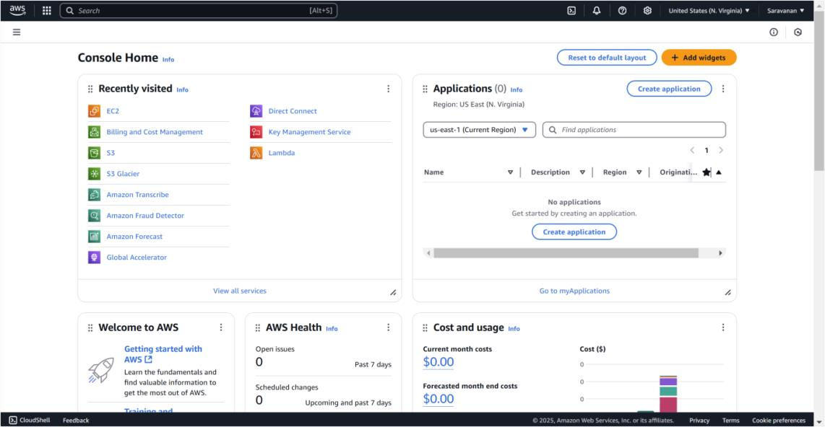

Step 2:

Launch an Ec2 instance.(Backup Instance)

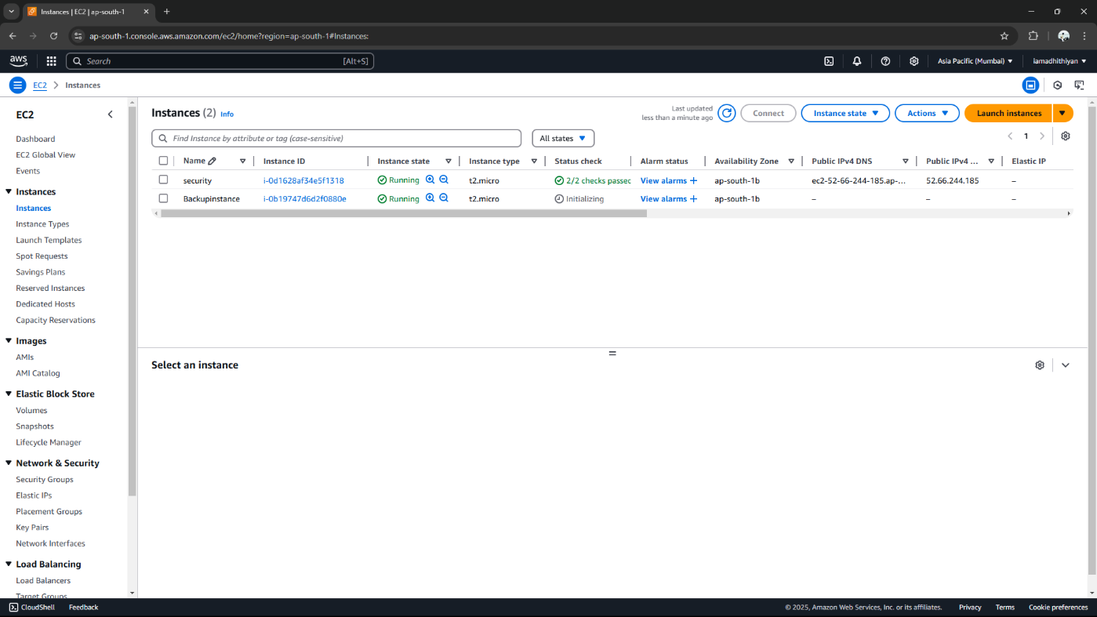

Step 3:

To create a new EBS volume in AWS, go to the EC2 Dashboard in the AWS Management Console by selecting **EC2** from the Services menu. In the left-hand menu, under **Elastic Block Store**, click on **Volumes**, then click the **Create Volume** button. Select **General Purpose SSD (gp3)** for the volume type, set the size (e.g., 8 GiB, within Free Tier limits), and choose the availability zone that matches your EC2 instance (e.g., us-east-1b). Leave the other options as default, then click **Create Volume**. Be sure to note the Volume ID for future reference.

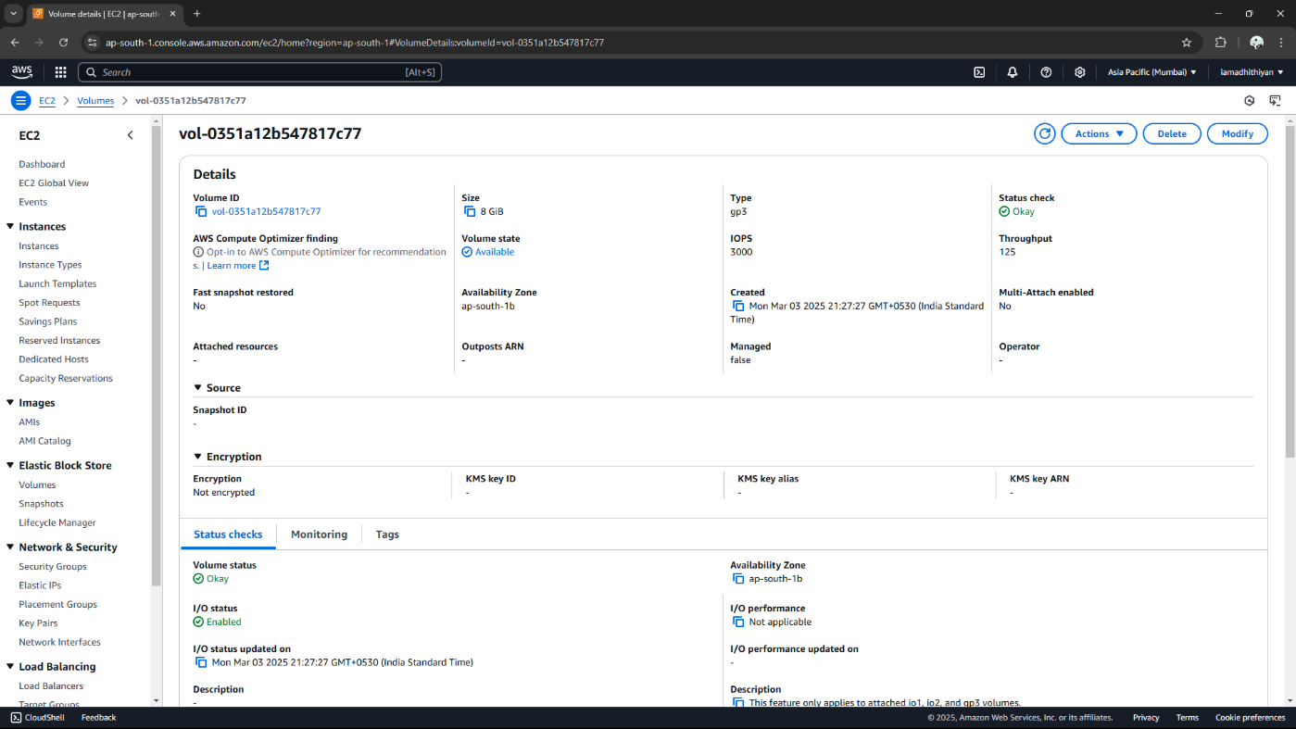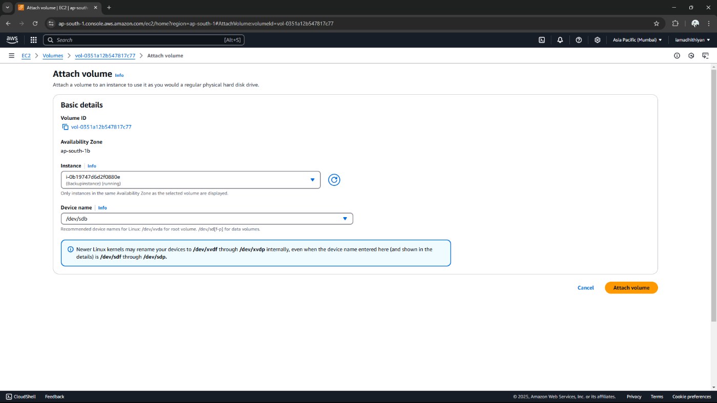

Step 4:

To create a snapshot of your EBS volume, navigate to the EC2 Dashboard in the AWS Management Console and click on **Volumes** under the **Elastic Block Store** section. Locate the volume attached to your instance (it should match the instance name or ID), select it, then click **Actions** > **Create Snapshot**. Add a meaningful description (e.g., "Snapshot of Backup Instance on Feb 7") and click **Create Snapshot**. To monitor its status, go to **Snapshots** under Elastic Block Store in the left menu and wait for the status to change to **Completed**.

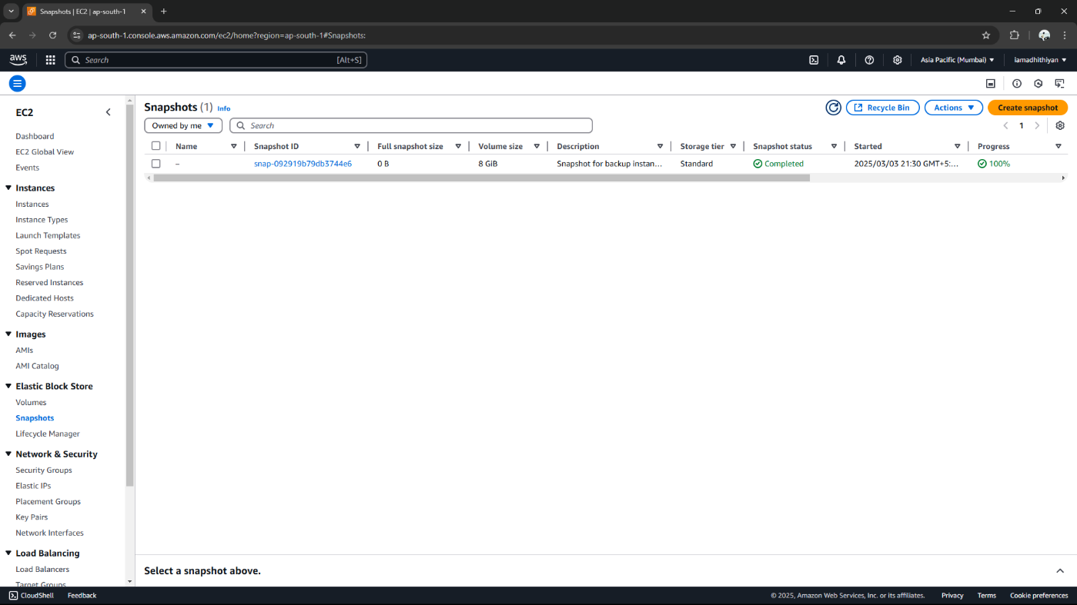

Step 5:

To terminate an EC2 instance, navigate to the EC2 Dashboard in the

AWS Management Console and click on **Instances** under the **Instances** section. Locate the instance you want to terminate, then select it and click **Actions** > **Instance State** > **Terminate Instance**. Confirm the termination by clicking **Terminate**, and refresh the page after a few moments to see the instance state change to **Terminated**.

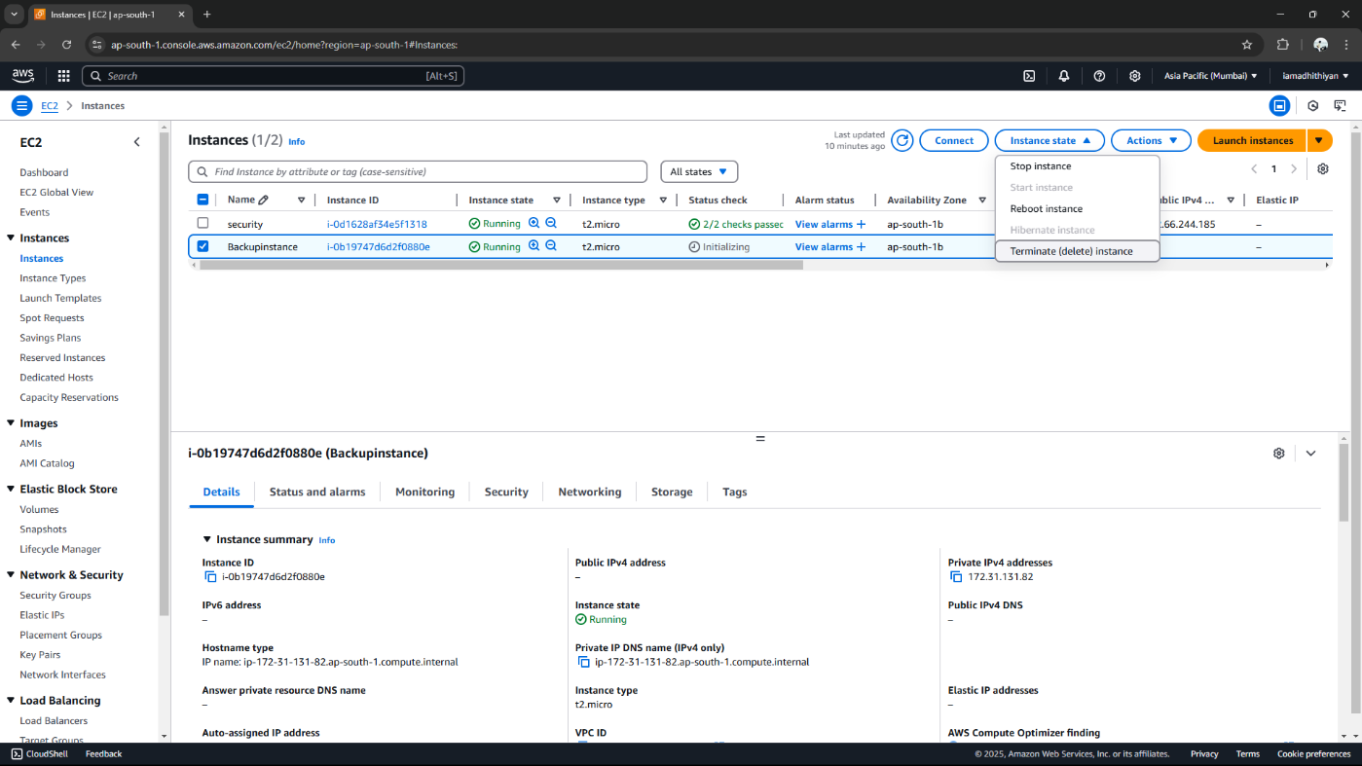

Step 6:

To create a new volume from the snapshot, go to the EC2 Dashboard and click on **Snapshots** under the **Elastic Block Store** section in the left menu. Select the snapshot you created earlier, then click **Actions** at the top and choose **Create Volume**. In the configuration settings, leave the **Size** as is (it will match the snapshot size) and select the same **Availability Zone** where you want to restore your instance (e.g., us-east-1a). Finally, click **Create Volume** to complete the process.

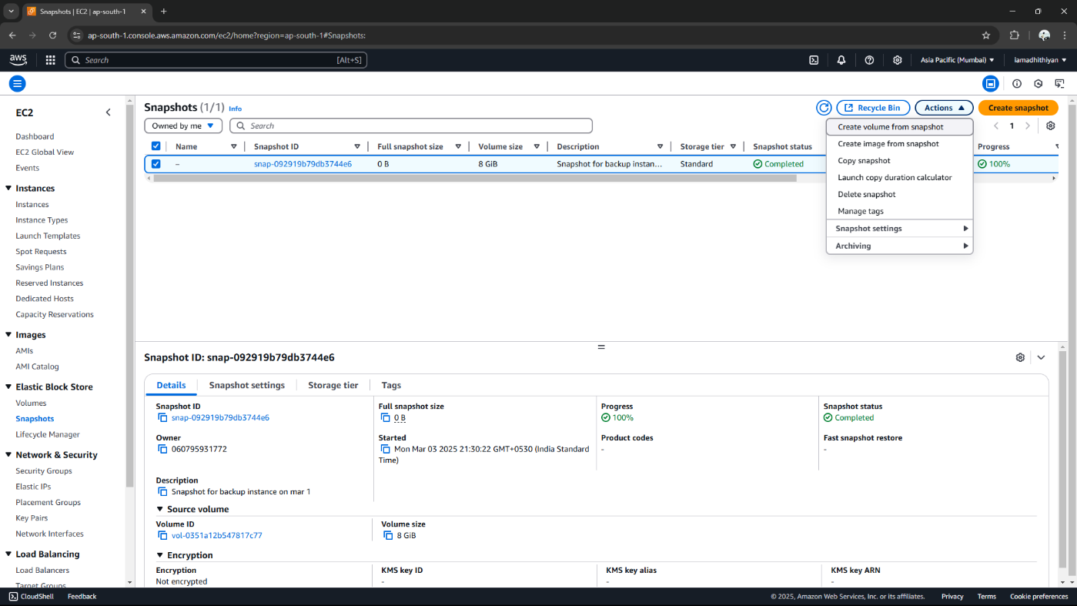

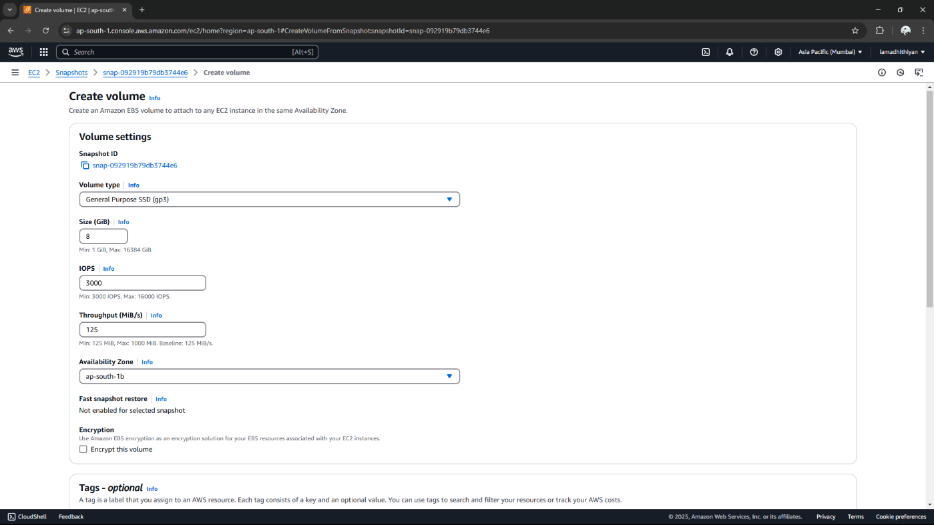

Step 7:

To launch a new instance, go to the EC2 Dashboard and click **Launch Instances**. Set the name of the new instance (e.g., **Restored-POCVM**) and choose the same AMI (e.g., **Amazon Linux 2023 Free Tier eligible**) as the original instance. Select **t2.micro** for the instance type (Free Tier eligible). Configure the instance as needed, but skip the storage section for now.

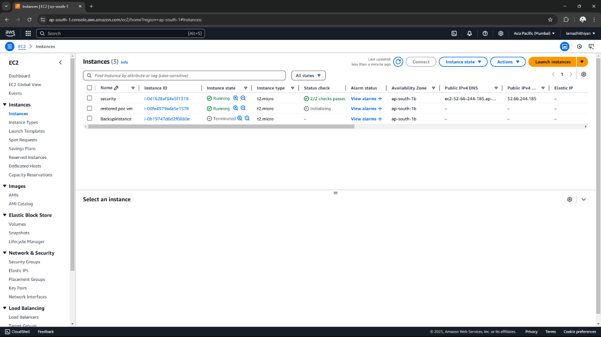

Step 8:

To attach the volume to the instance, first, stop the instance temporarily after it is launched by selecting the new instance, then click **Actions** > **Instance State** > **Stop Instance**. Next, go to **Volumes** in the left menu and select the new volume created from the snapshot. Click **Actions** > **Attach Volume**, and in the pop-up window, choose the new instance to attach the volume.

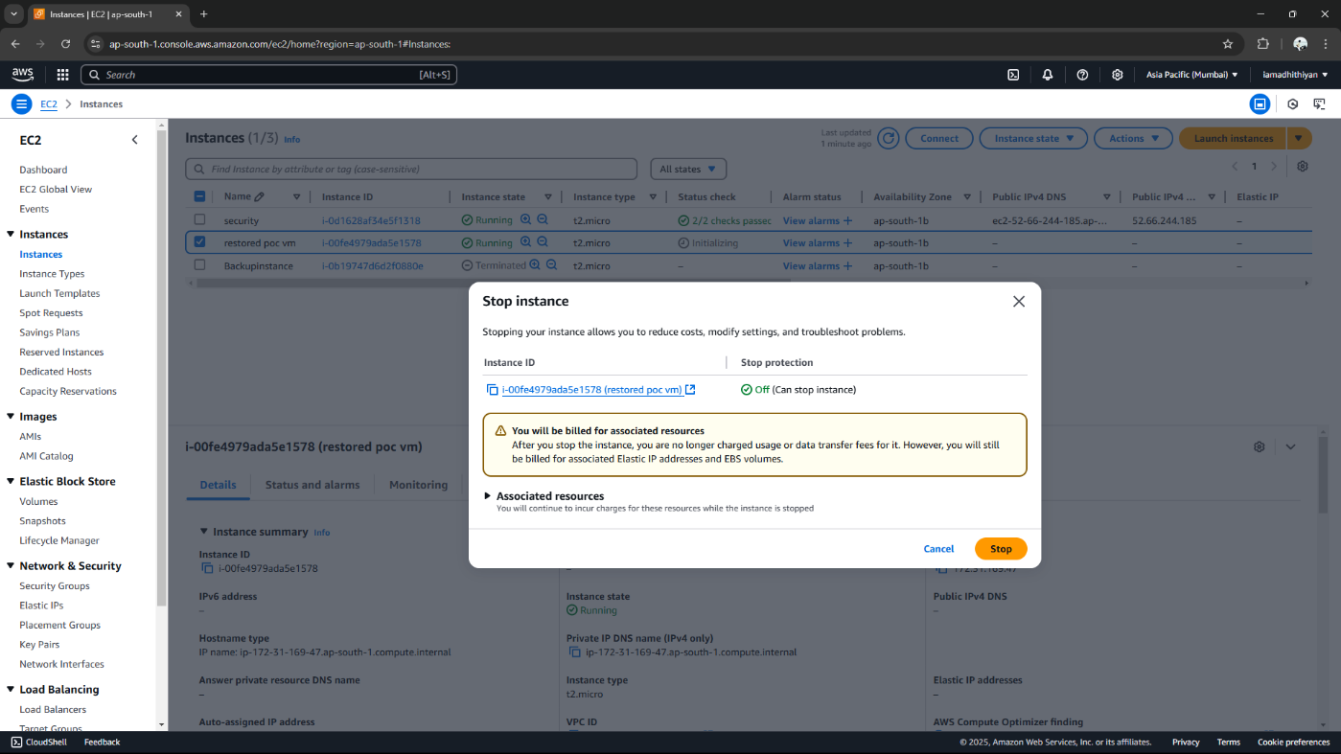

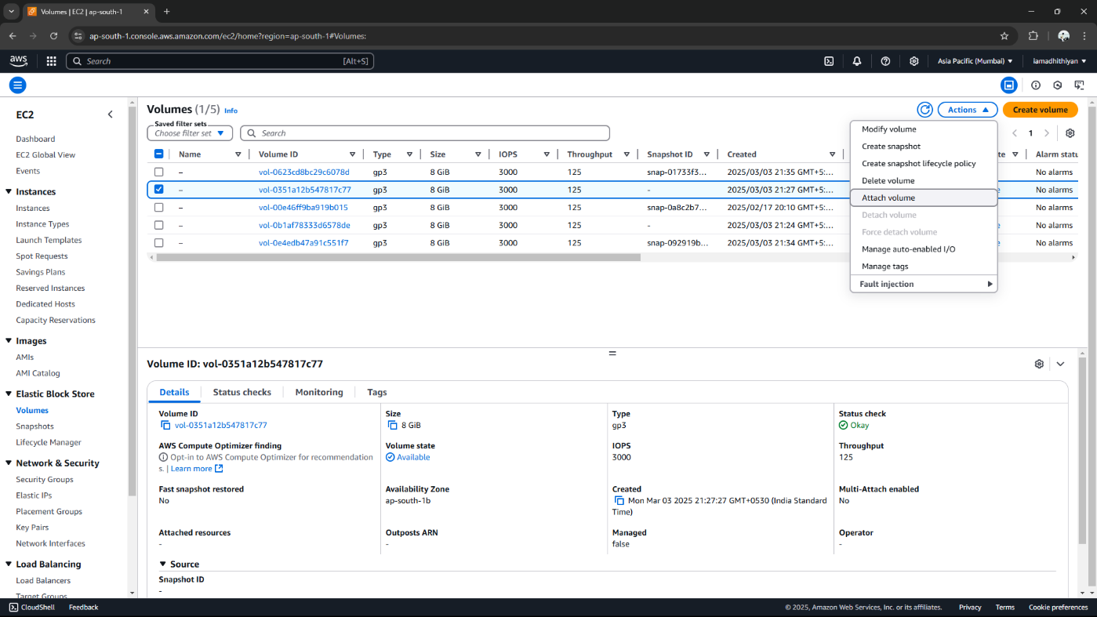

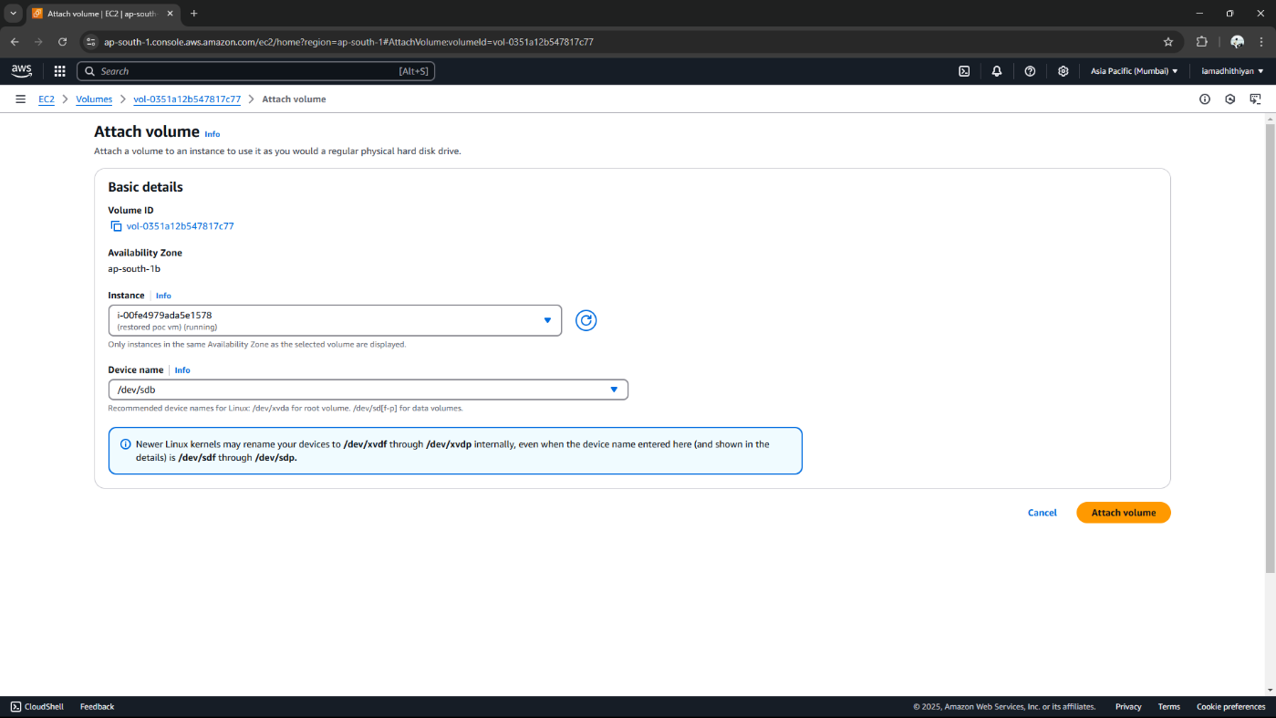

# Verify the Restoration

1. Connect to the instance using SSH or other methods.
2. Check if the files, data, and configurations match the original setup.

# Expected Outcome:

1. Automate the creation and management of EC2 snapshots, ensuring seamless data backup without manual effort.

2. Safeguard critical data by taking snapshots before terminating instances for cost savings or failure simulations.

3. Recreate an instance from a snapshot by generating a new EBS volume and linking it to a new EC2 instance.

4. Validate the restoration process to confirm data integrity and proper system functionality post-recovery.