 

**Placement Empowerment Program**

***Cloud Computing and DevOps Centre***

Install Docker and Run Your First Container: Install Docker and run a basic container (e.g., Nginx). Test accessing the containerized application.

Name: Harivasan S

Department: ADS



**Introduction:**

In cloud computing and DevOps, containerization is essential for efficient application deployment and management. Docker, a leading containerization platform, enables developers to package applications with their dependencies into lightweight, portable containers. This Proof of Concept (POC) demonstrates the installation of Docker and the deployment of an Nginx container to explore the functionality of containerized applications.

## ****Overview:****

## This Proof of Concept (POC) showcases the setup of Docker on Windows, the retrieval of an Nginx image, and its execution within a container. It also covers accessing the containerized application via a web browser, offering practical experience in container management while exploring Docker networking and deployment fundamentals.

**Objectives:**

1. Understand the fundamentals of containerization with Docker.

2. Learn how to install and configure Docker on Windows.

3. Explore how to pull and run a containerized application.

4. Gain experience in managing and troubleshooting Docker containers.

5. Demonstrate the accessibility of a running containerized service.

**Step-by-Step Overview:**

Step 1:

In Google Search for **Docker windows Download**.

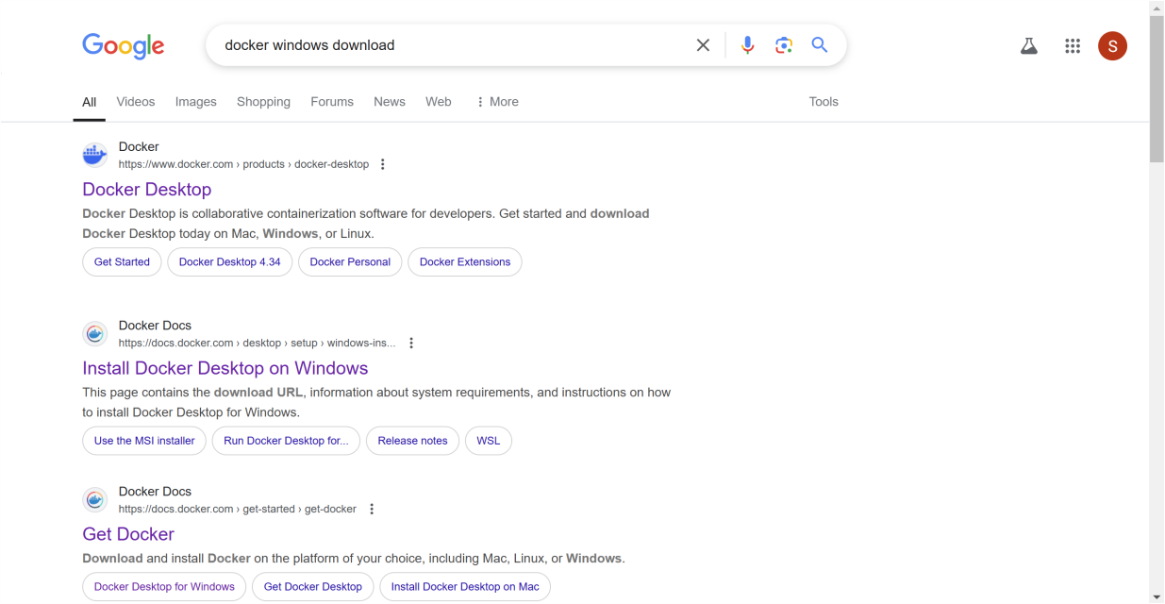

Step 2:

Scroll Down and **Download Docker Desktop**. Complete the installation process.

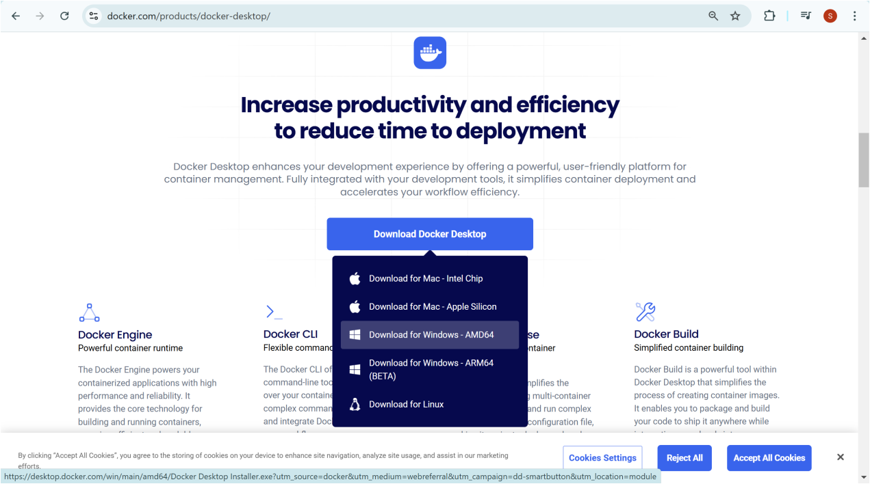

Step 3:

Open Command Prompt and run:

**docker –version**

This should return a version number, confirming Docker is installed.

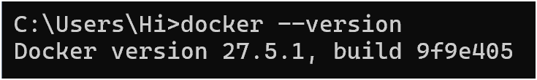

Step 4:

Build your first Docker container(Nginx)

**Pull the Nginx Image:**

**docker pull nginx**

This downloads the latest Nginx image.

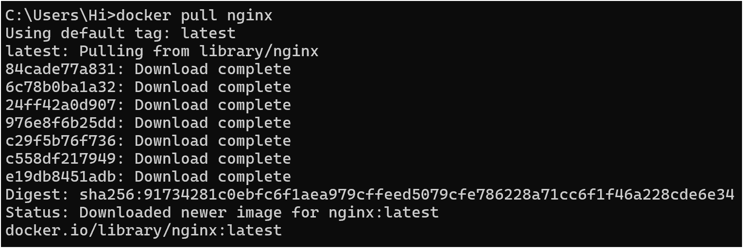

Step 5:

Run the Nginx Container:

**docker run -d -p 8080:80 --name my-nginx nginx**

1. -d: Runs the container in detached mode (in the background).

2. -p 8080:80: Maps port 80 inside the container to port 8080 on your local machine.

3. --name my-nginx: Names the container my-nginx.



Step 6:

**Verify the Running Container:**

**docker ps**

You should see my-nginx running in the list.



Step 7:

Test Accessing Nginx:

1. Open a browser and go to:

http://localhost:8080

1. You should see the default Nginx welcome page.

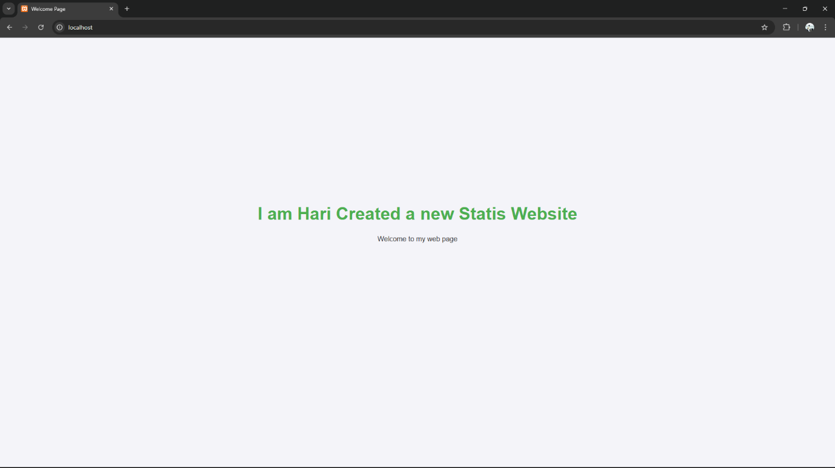

Step 8:

By Opening Docker Desktop App We can see our container running.

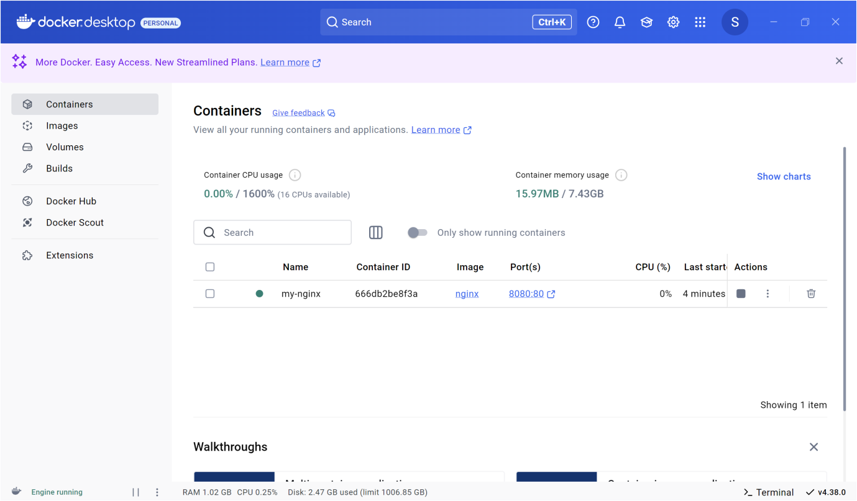

Step 9:

**Stop and Remove the Container**

1. **Stop the container:**

**docker stop my-nginx**

1. **Remove the container:**

**docker rm my-nginx**

You have successfully installed Docker, run your first Nginx container, and tested it!

**Expected Outcomes:**

1. **Install Docker:** Set up Docker on Windows for containerized applications.
2. **Deploy Nginx:** Pull and run an Nginx container as a web server.
3. **Expose & Access:** Map ports to access the Nginx container via a browser.
4. **Manage Containers:** Use Docker commands to start, stop, inspect, and remove containers.
5. **Explore Benefits:** Understand how Docker simplifies deployment, scales applications, and streamlines DevOps.