

**Placement Empowerment Program**

***Cloud Computing and DevOps Centre***

Use Cloud Storage Create a storage bucket on your cloud platform and upload/download files. Configure access permissions for the bucket.

Name: Harivasan S

Department: ADS



# Introduction :

This Proof of Concept (PoC) showcases how to use AWS S3 (Simple Storage Service) to create a storage bucket, transfer files, and set up access permissions for secure file sharing. AWS S3 offers highly scalable, durable, and low-latency cloud storage, making it ideal for managing large datasets. This PoC provides a step-by-step guide to essential S3 operations, offering practical experience in cloud storage management.

# Overview :

1. **Setting Up an S3 Bucket:** Create a storage container to hold data objects.
2. **Uploading Data:** Store files such as documents, images, or binary data in the S3 bucket.
3. **Retrieving Files:** Download stored data from the S3 bucket to a local system.
4. **Managing Access Control:** Configure security policies to restrict or grant access, including public and private file permissions.

**Step-by-Step Overview**

Step 1:

Open AWS management console using name and password.

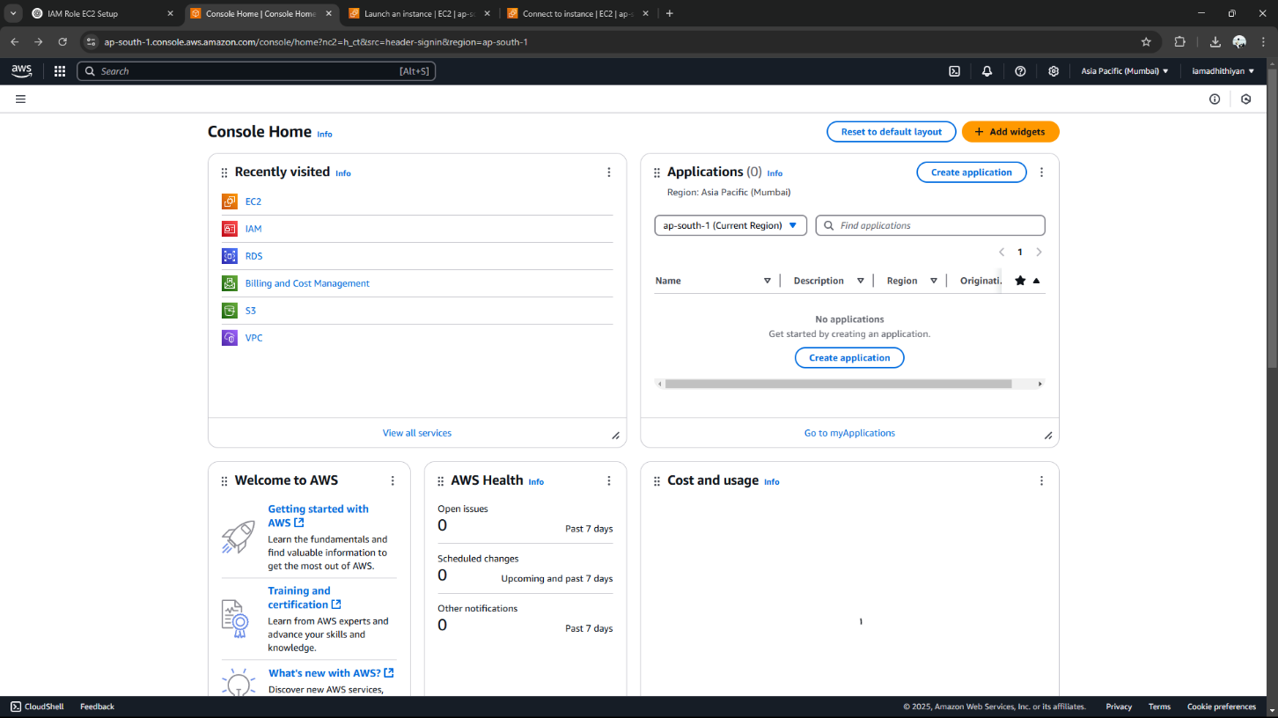

Step 2:

Search for s3 and open s3

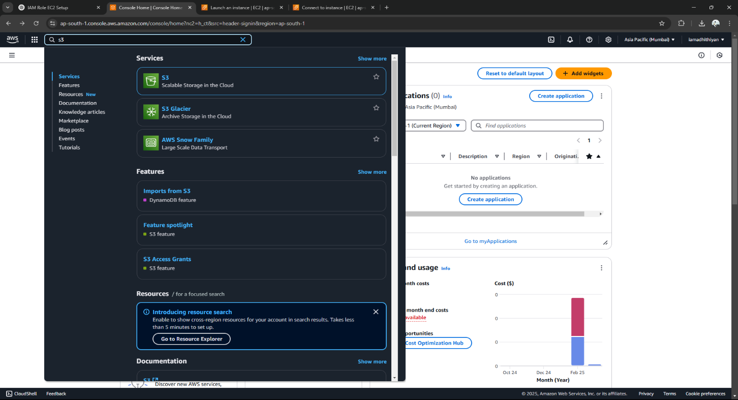

Step 3:

Click **Create bucket** with bucket name

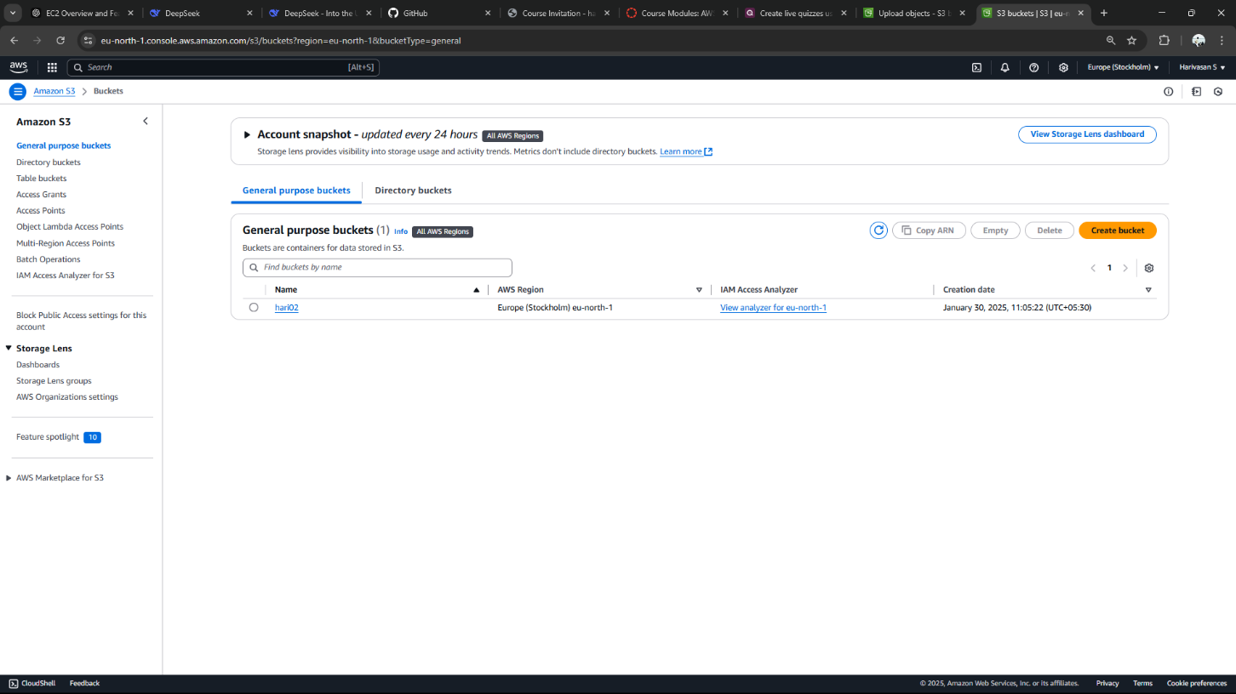

Step 4:

Add files in the bucket

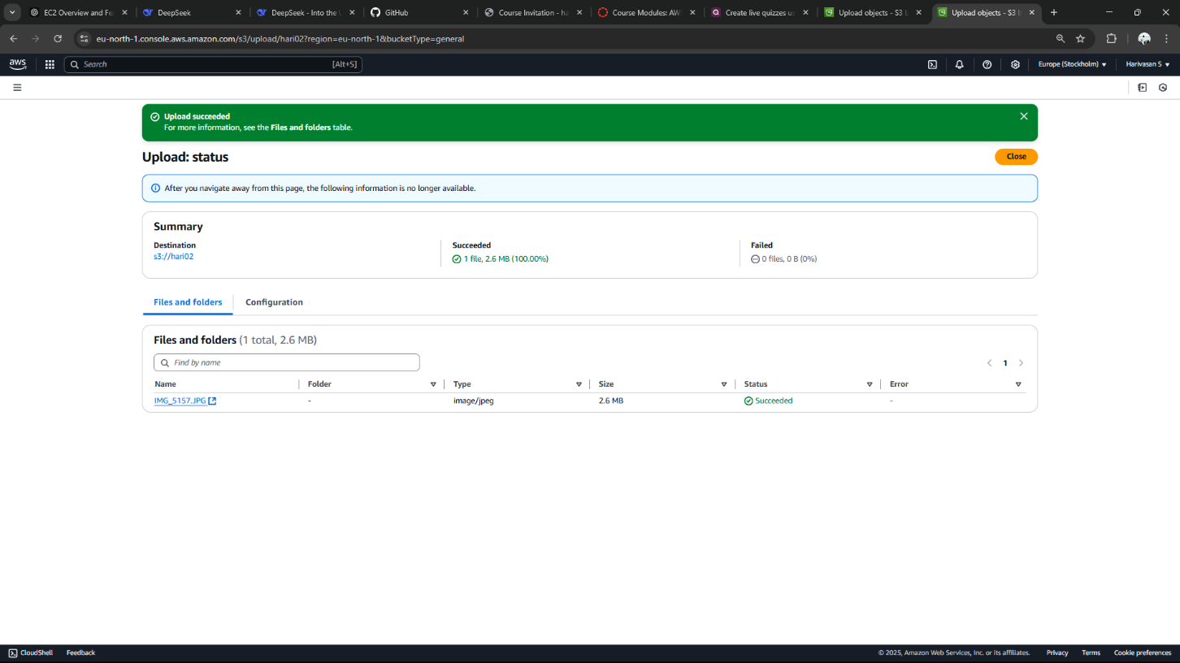

Step 5:

Navigate to the uploaded file inside your bucket.

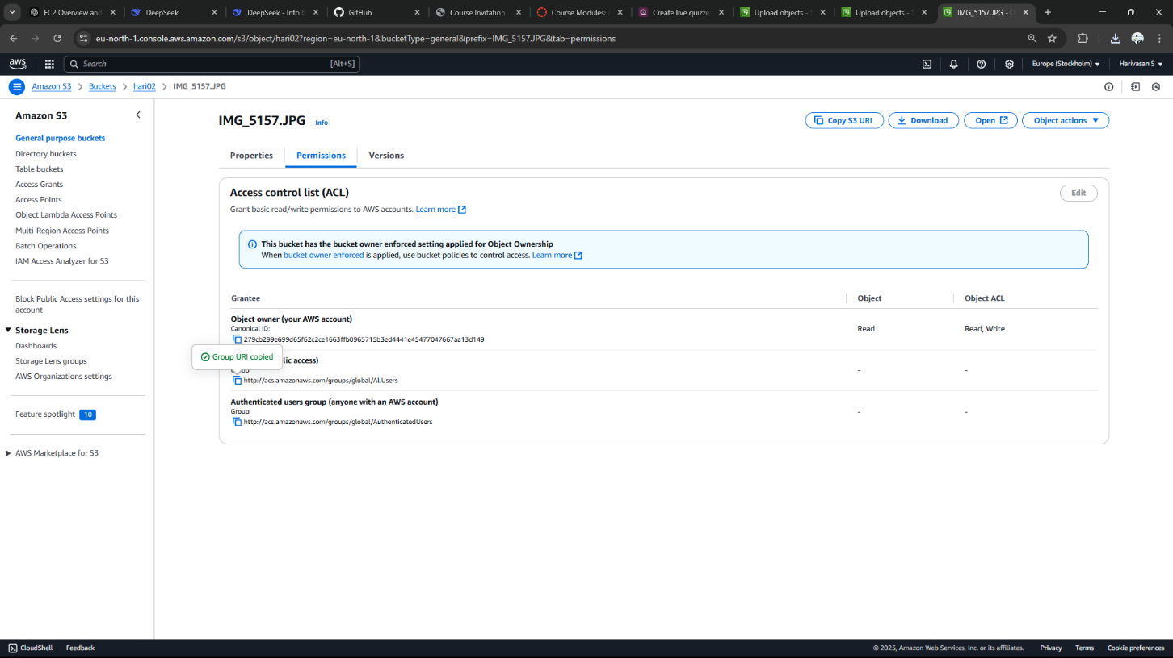

Step 6:

Edit public access in bucket policy

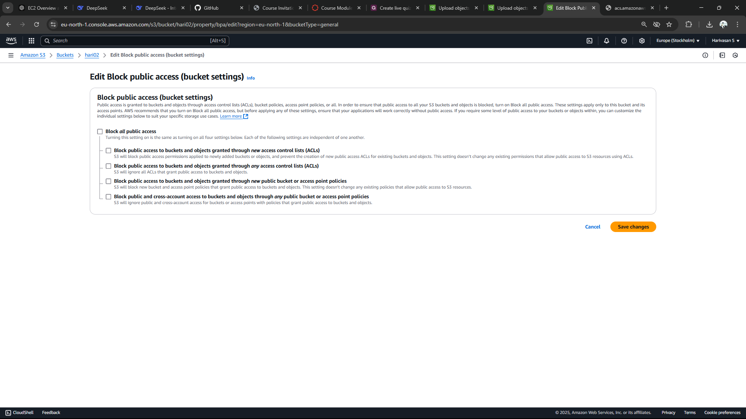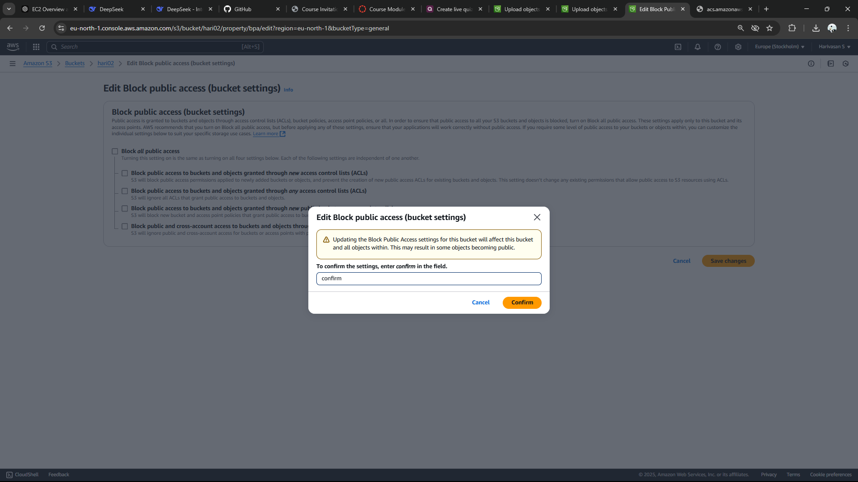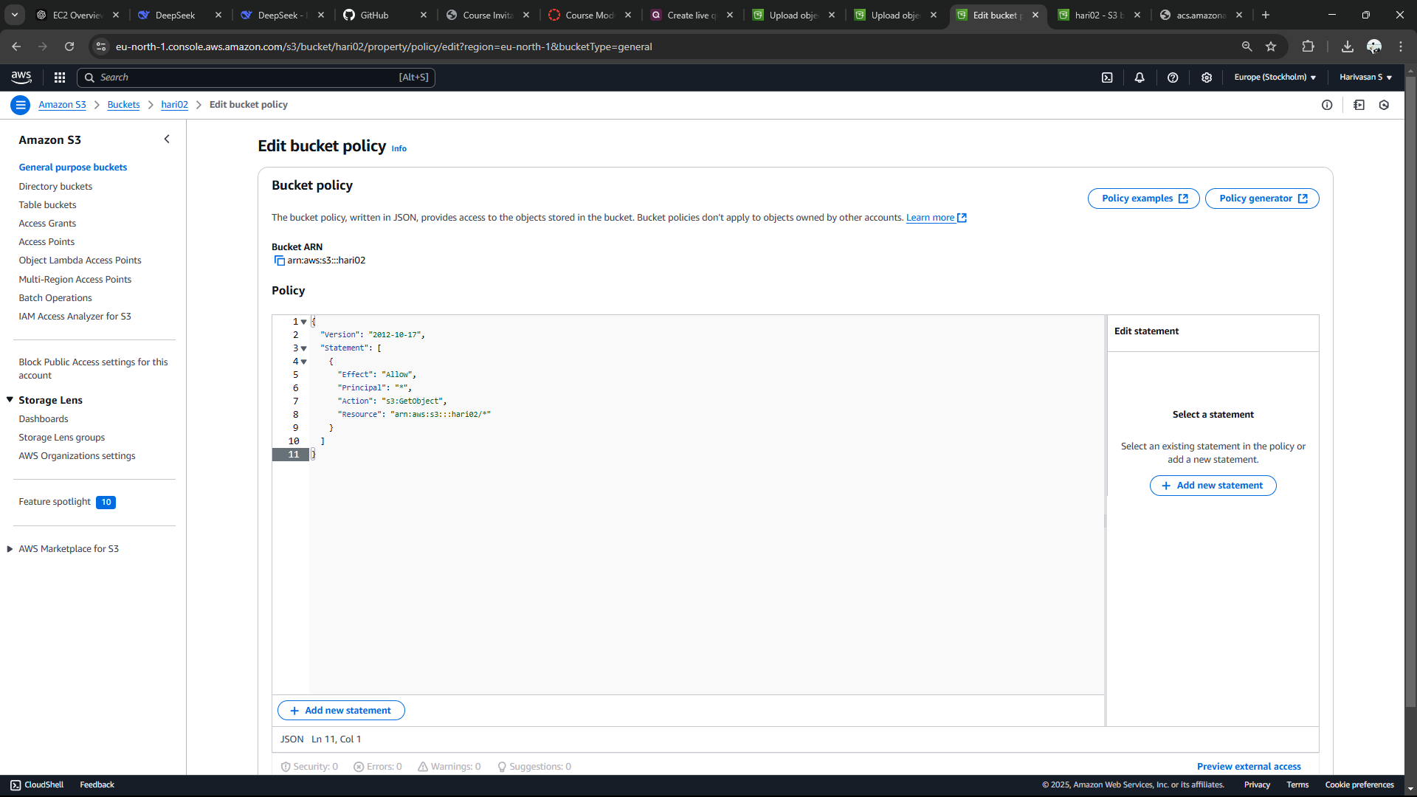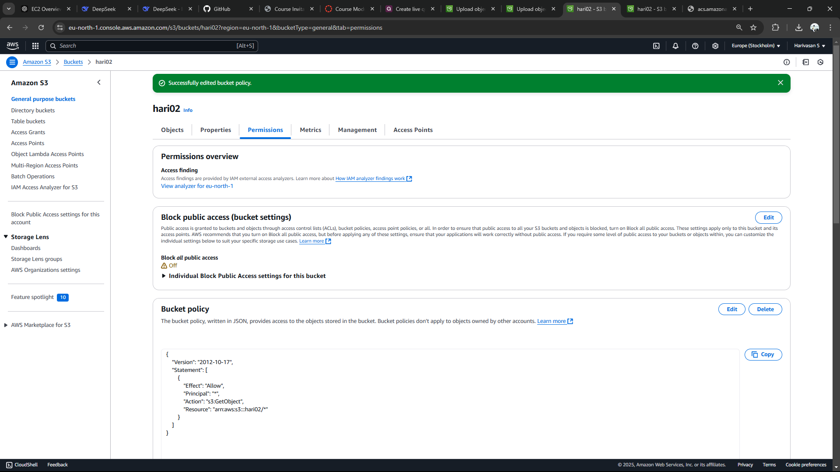

Step 7:

Copy the url in URL option

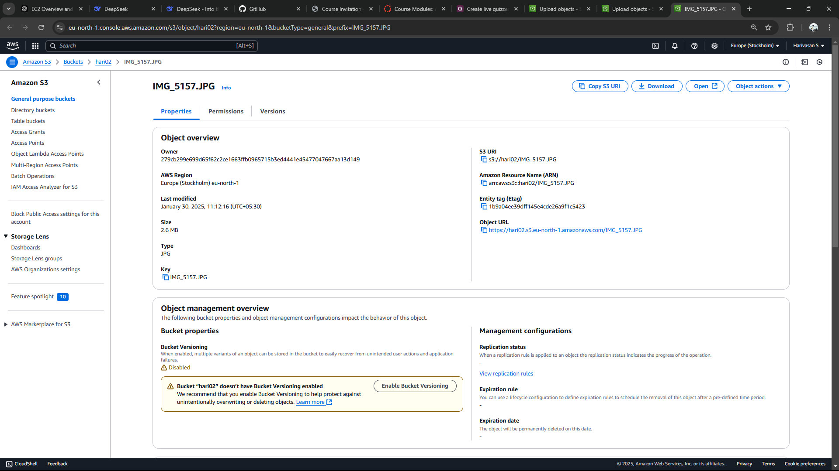

Step 8:

Paste the link in the new tab and you can see the uploaded file.It will display the uploaded file.

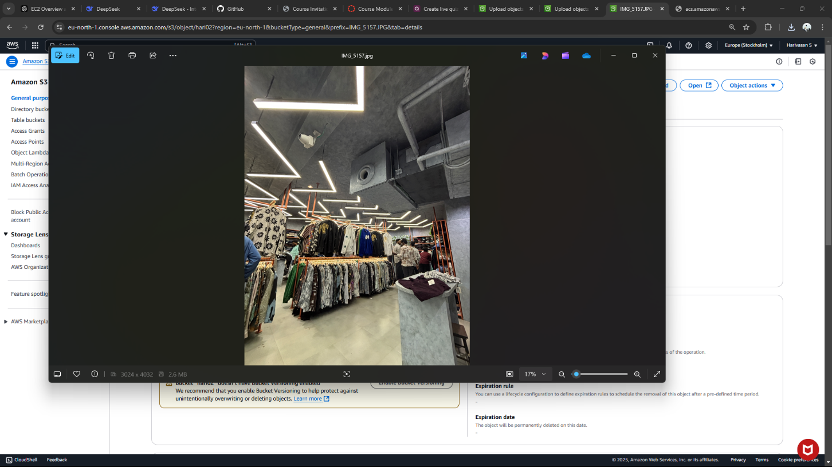

# Expected Outcome:

1. **Set Up and Manage an S3 Bucket:** Discover how to create and organize an S3 bucket for cloud storage.

2. **Transfer Files Seamlessly:** Practice uploading and downloading files securely and efficiently.

3. **Control Access Permissions:** Learn to configure bucket policies and permissions to manage data access effectively.